Beliefs  We believe in Community. We believe in Diversity. We believe in Respect. We believe in Integrity. We believe in Excellence. | Vision  Building a stronger community one life-long learner at a time. | “You’re never going to be happy being anyone other than yourself.”  -Thibaut | School Counselor  Franklin County Schools
Strategoi  Peer groups are offered as well as small groups to focus on topics that students may what to know more about.  Leadership and teamwork skills to work effectively in diverse groups (ASCA, 2021).  Career Counseling is offered as well as career assessments to see what interest students.  We build connections with the community and engage the students.  Guide the students in post -graduation decisions and help them navigate the path they want to take (Brookover, 2021). | Mission  Franklin County Schools will cultivate a dynamic learning environment focused on success beyond the classroom; preparing, inspiring and illuminating the path so that all students will reach their full potential. | 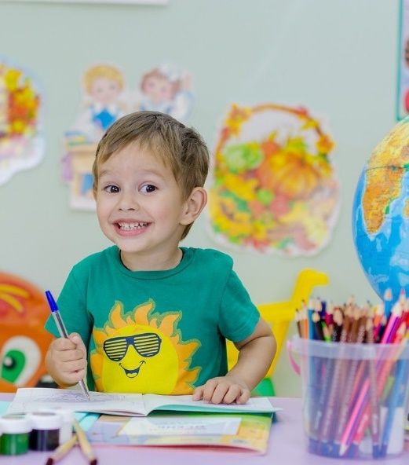 | 
 | 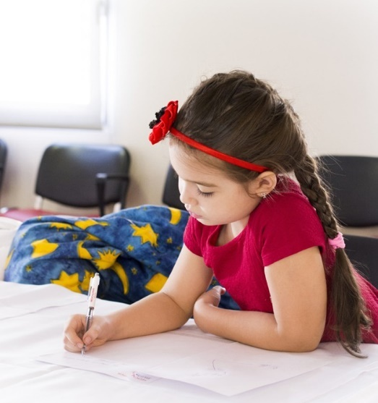 | Bunn Elementary School  •••  686 Bunn Elementary School Rd, Bunn, NC 27508  •••  919 496-4015  •••  meganarnold@fcschools.net  •••  Fcschools.net

Competencies to Advocate for SC roles  A Comprehensive School Counseling Program (CSCP) focuses on the needs of students to ensure that they can make the most of their educational experience. | Career, Social-Emotional, & Academic & Services  Students will always have the support they need whether it is for career readiness, social-emotional, or academics. The hope is all students will feel comfortable seeking help from their counselor. | Strategies for Promoting equity in student achievement and college access  School Counselors provide culturally sustaining instruction, appraisal and advisement, and counseling to help all students demonstrate: Learning strategies, Self-management Skills, and Social Skills (Hines et al., 2019).  All students get what they need to succeed.  We also accommodate different learning styles. |  | 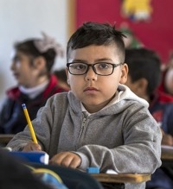
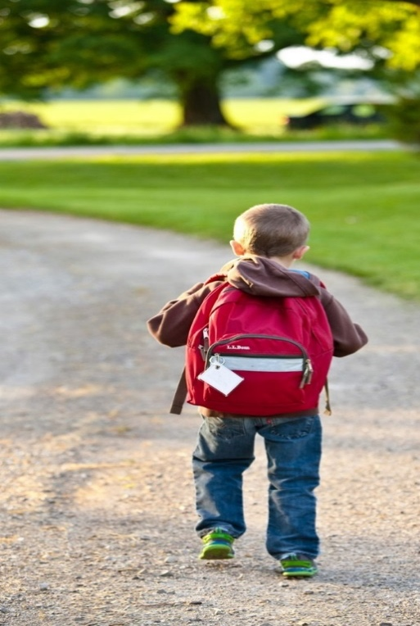 | Counselors Provide:  Classroom lessons focused on social/emotional development, academic achievement and career awareness  Identify and address student needs and struggles  Individual Counseling  Group Counseling  Teach specific coping skills and strategies  Allow partnerships with stakeholders to collect data  Offer support to struggling families by using community resources |  |  | “Every flower must grow through dirt.”  -Laurie Jean Sennott
 | A  Through the school year data is collected and specific programs are offered to those based on their needs assessment.  If the students have a shortage of food then we increase food donations.  If bullying becomes a school wide problem, we will promote a no bullying program and offer strategies for the issue. |  | Direct services can be individual counseling, group counseling, classroom guidance lessons.  Indirect services are parent contact, collaboration, referrals for all needs, and community outreach. | 

References:

American School Counselor Association (2021). ASCA Student Standards; Mindsets and Behaviors for Student Success. Alexandria, VA: Author.

Assessing the development, implementation, and Management of Your Comprehensive School Counseling Program. (2021). The Ultimate School Counselor’s Guide to Assessment & Data Collection. https://doi.org/10.1891/9780826185549.0003
Brookover, D. L. (2021). Access to school counseling and the connection to postsecondary stem outcomes. The Professional Counselor, 11(4), 383–399. https://doi.org/10.15241/dlb.11.4.383
Franklin County Schools / Homepage. / Homepage. (n.d.). Retrieved February 20, 2023, from http://www.fcschools.net/
Hines, E. M., Vega, D. D., Mayes, R., Harris, P. C., & Mack, M. (2019). School counselors and school psychologists as collaborators of college and Career Readiness for students in urban school settings. Journal for Multicultural Education, 13(3), 190–202. https://doi.org/10.1108/jme-02-2019-0015

