Beliefs  Educators and staff at Charleston County Public Schools are passionate about their students and making an impact on their lives. We embrace and honor diversity, counselors and staff advocate for student needs to ensure that students reach their full potential. | Vision  - Students will depart Charleston County Public Schools having gained life-long skills that will equip our pupils to continue to learn and grow. We challenge our pupils academically while also supporting them socially and emotionally to further their success. While the pupils will also gain respect for themselves and others in the world around them. | 2022-2023  School Year  “Counselors, Educators and Advocates for the students of Charleston County Public Schools. | YOU MATTER AT BURKE.  Counseling Department  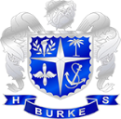
 | Mission  - The counseling department in Charleston County Public Schools seeks to ensure that all students are supported so that they can reach their full potential. The support for the students is aligned with the ethical standards and expectations of the ASCA national standards. School staff seek to reach the “whole student” through social emotional services with skills our pupils will use for a lifetime, advocacy, career exploration and academic support for success. |  | 
 | 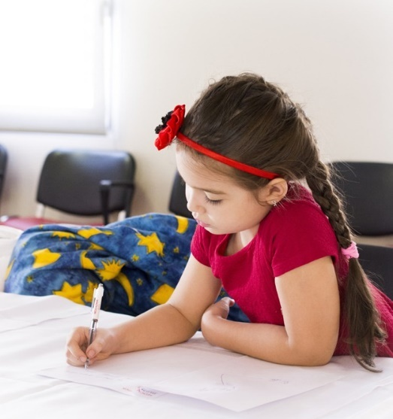 | Burke High School  •••  244 President St.  •••  (843)-579-4815  •••  jmedford@charleston.k12.sc.us  •••  https://www.ccsdschools.com/domain/264

Advocacy Statement  Charleston County Public Schools and their exployees are the front line advocates for their students. Employees are trained and knowledgeable of barriers faced by their students. Through meetings and open communication with ours families Charleston County is progressing and advocating for equity, inclusion and fair treatment for their students because every student should have the resources they need to succeed. Comprehensive School Counseling Programs (CSCP) include an annual individual meeting with counselors to discuss and plan a student’s academic future. Counselor’s also plan bi-annual college and career fairs for students to explore their interests. School Counselor’s and support staff also participate in classroom Social Emotional Learning lessons to connect directly with students in the classroom as well as influence peer interaction. Small groups is an additional strategy to influence positive peer interaction. Group topics could include anger management, test anxiety/stress, and new student groups. | Career, Social-Emotional, & Academic & Peer Intervention Program  - SEL classes conducted by the counseling department staff.  - One on one Career counseling/exploration sessions with all students.  - Bullying prevention, peer mentoring and peer tutoring groups. | Strategies for Promoting equity in student achievement and college success (COSC 661)  - The counseling department has partnered with online educational formats to normal credit and credit recovery courses to prevent students from falling behind and giving students an option to accelerate their learning. Utilizing their media and technology skills to enhance learning and improve scores and the pass-rate of students. E-Learning is also widely used at our school so that even when students are not able to be at school, they can still be learning and studies have shown that E-Learning and the use of technology has a positive impact on students’ academic performance (Sobaih et. al., 2022).  - For students that demonstrate responsibility and self-discipline can enroll in “ingenuity” classes where they can work independently in a study hall setting. These students grades can be tracked to ensure incorporation of independent work is effective for them.  - Students have an opportunity to participate in leadership and teamwork skills such as Student Council Association, clubs, sports or other extracurricular activities. Giving students opportunities for leadership can improve the school climate and decrease the rates of suspensions, expulsions, class failures, students in detention. These opportunities can increase rates of students reaching IEP/504 goals, college acceptance and graduation success rates. |  | 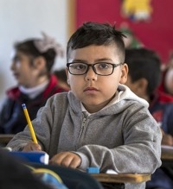
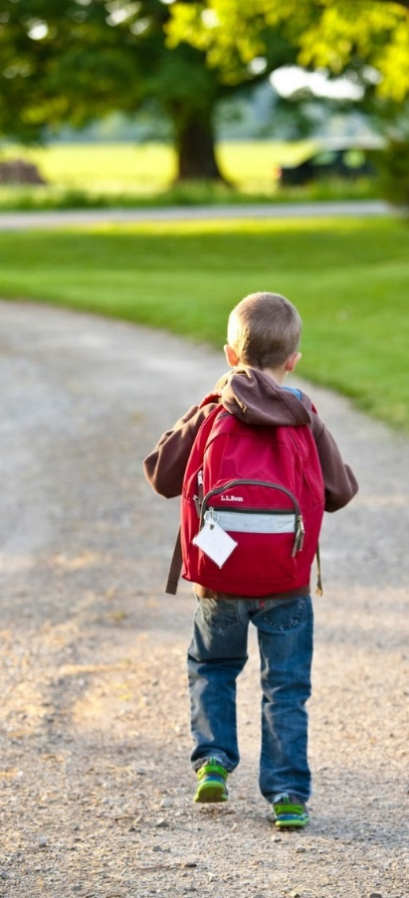 | Strategies to facilitate school and postsecondary transitions (COSC 661)  Counselors at Burke High conduct SAT/ACT practice tests to track students improvement and prepare them for the SAT/ACT.  Success in long-term goals do no go unnoticed! Group and individual rewards enhance student’s academic success and improve motivation for working hard in school and allows for a group of students to grow as a whole (Jaquett, et. al., 2021). The school has teamed up to host events for students who have achieved their long term goals regarding their transition out of high school. Goals could be achieving graduation requirements, completion of dual enrollment/AP courses, completion of certification in a program of technical courses.  Counselors are involved with college visit programs where students can visit colleges for tours/events. The focus is to increase amount of students who apply for college. |  |  | College/Career Readiness Interventions  - Each year the students at Burke complete a Career Interest Inventory Assessment. It measures their interests, but also how a student’s interest changes over time as well. This test taps into the students’ cognitive processes, thoughts, feelings and motivations to determine their interests from this self-reporting assessment (Rodolfo, 2021).  - Students with interest in college can enroll in a high school credit course called “College 101” as an elective. This class includes/assesses SAT/ACT prep, practice college essays, public speaking skills, time management, organization, college applications and financial aid/scholarships. This course hopes to increase the amounts of students who attend college and earn scholarships. All while earning high school credit as well!
 | A  Peer Intervention Strategies  - Classroom guidance lessons for students to practice critical thinking to make informed decisions in a social setting. This is meant to decrease discipline referrals, suspensions and expulsions.  - Small groups available for students with relatable topics that include divorced families, grief groups, anger management and more. These groups are meant to maintain a student’s wellness as well as maintain/improve a student’s grades, preventing grades lowering during a turbulent time in a student’s life.  - More student responsibility roles are to be put into place. Students may apply for a “student job” to earn volunteer hours and in some cases high school credit or a stipend for devoting time to a support position such as sports team manager/support, event concessions, office support, 8th grade tour guides, and so much more. These student jobs seek to add experience to a student’s resume increasing college acceptances and often increasing academic performance given the requirements for a student to be able to hold a student job position.  Philosophy of and methods for data  collection and how you will share results reports with stakeholders (COSC 661)  The counseling department advocates for student resources through data collection. Tracking of student grades determines areas for need for a student. Lower grades demand intervention and when higher grades show improvement. Other assessment such as the career interest inventory reveal which interest areas students are geared towards and the counseling department provides students with courses to explore that content area. Data will be held in a confidential matter and only necessary numerical data for the student population will be shared when applying for grants/funding for school programs to further the success of our students at Burke High School. We believe our students deserve the Data in regards to student progression will be shared to ensure continued funds for new and current school programs. |  | A description of both direct and indirect services provided with examples of individual, group. Classroom, and collaboration and consultation. (COSC 661)  Individual Direct Services offered to students are annual one on one meetings with a counselor to discuss class schedules and future plans/career and college preparation. Students seeking mental health services can be referred from the counseling department to Burke’s mental health counselor, social worker or an outside agency. However, the counseling department’s door is always open for their students.  Counselors are also present in student’s classrooms. Counselors conduct SEL lessons and other various topics based upon class needs.  Many short-term small groups are available for students on a wide range of topics from time-management and test anxiety to grief support groups and anger management.  Counselor’s also advocate for students behind the scenes. They collaborate with other school staff and student families in settings such as IEP and 504 meetings. The whole school is committed to student success. | 

Link to Kaltura Capture Data Presentation

https://watch.liberty.edu/media/t/1_rgbvqtpq

References

Abu Elnasr, E. S., Hasanein, A., & Elshaer, I. A. (2022). Higher Education in and after COVID-19: The Impact of Using Social Network Applications for E-Learning on Students’ Academic Performance. Sustainability, 14(9), 5195. https://doi.org/10.3390/su14095195
Ambiel, R. A. (2020). Taking a test is telling stories: A narrative approach to interest inventories. International Journal for Educational and Vocational Guidance, 21(1), 33–46. https://doi.org/10.1007/s10775-020-09426-3
Jaquett, C. M., Skinner, C. H., Moore, T., Ryan, K., McCurdy, M., & Cihak, D. (2021). Interdependent Group Rewards: Rewarding On-Task Behavior Versus Academic Performance in an Eighth-Grade Classroom Serving Students With Emotional and Behavioral Disorders. Behavioral Disorders, 46(4), 238–252. https://doi.org/10.1177/0198742920934006

