Dear Parent/Guardian,
This letter is to inform you of a variety of small group experiences that will be offered this semester. Small groups provide not only the opportunity for additional learning experiences, but also a time of sharing and a time of growing together with fellow students. Small groups give students a chance to belong, a chance to express themselves, and a chance to benefit from the support of group members. The groups that are currently being offered will include the following topics:

- Dealing With Feelings - providing tools that help students learn how to identify and appropriately express their emotions.
- Friendship Connection - helping students to identify the characteristics of a good friend, and how to proactively make and keep friends.
- School Appropriate Behavior - providing students with the opportunity to practice necessary social skills to aid in success at school, such as listening skills, body language, turn-taking, peer relationship, etc.

The groups will meet once a week, for 20-30 minutes during the school day for about five weeks (depending on the specific group). I will work with teachers to schedule groups at times that minimize the loss of instructional time.
Research states that many parents and teachers whose children have participated in groups like these have reported enhanced family and peer relationships, less frustration around school issues, and positive behavior changes in their children.

At this time, your child was referred to the following group, Social Emotional Learning__X__.

Please complete the form below to indicate whether or not you would like your child to participate in the group. If you have any questions, please do not hesitate to call me at the school (740) 969-7252 (extension is below) or send me an email: lknight@amanda.k12.oh.us.
Sincerely,
Lisa Knight, M.E.d., LPC
Middle School Counselor
Ext: 2205

Permission for small group counseling - Please email this back by _____________.
Date: _____________ Student Name:______________________________ Grade:_____
My child, __________________________________, may participate in a small group.
OR
My child, __________________________________, may NOT participate in a small group.
Parent/Guardian: __________________________________
Group Confidentiality Agreement

Part of being a member of this Group is to make sure everyone feels comfortable. We want everyone to feel they can trust one another and feel comfortable in sharing their thoughts and feelings with one another.
This means: Anything that is said while we are in our Group, CANNOT be repeated to another student outside of our Group. As participants, we need to be capable of being: Trustworthy and Respectful of each other’s feelings. This is called, “Maintaining Confidentiality”.
Most of the time in our group setting, I wouldn’t ever need to talk with another adult about what has been said in group. However, there are some instances when I may need to talk with another adult. Please know, that I will always tell you before discussing with the other adult what has been said in group. Some examples of reasons why I would need to talk with another adult about statements in group:
- If someone is threatening to hurt themselves
- If someone is threatening to hurt someone else
- If someone mentions that they are being hurt by someone else
- If I may need to talk to another professional adult (such as Mrs. Shipe or an outside counseling agency that you may see) to work with you here at school.

Consequences of breaking this Confidentiality Agreement may result in being unable to participate in this Group and/or Future Groups.

By signing this document, YOU promise to be (to both your peers and your School Counselor) : Respectful, Trustworthy and Caring students.
Student Signature:______________________________Date:____________
Counselor Signature:______________________________Date:___________
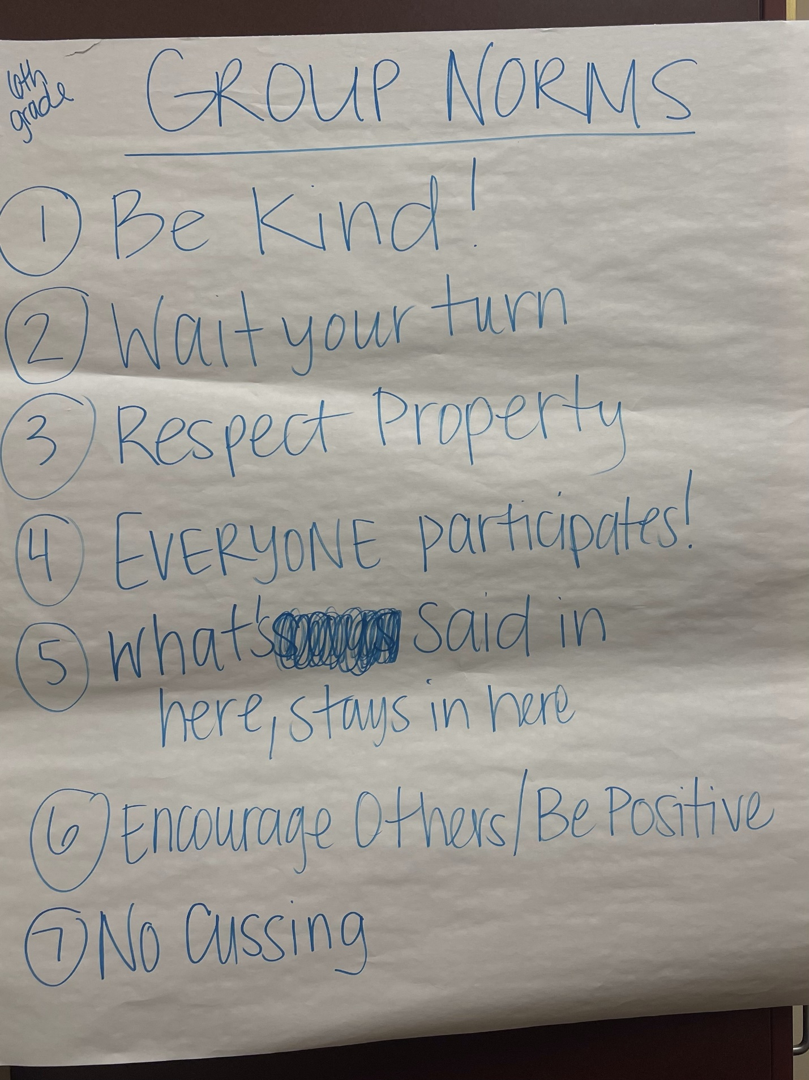
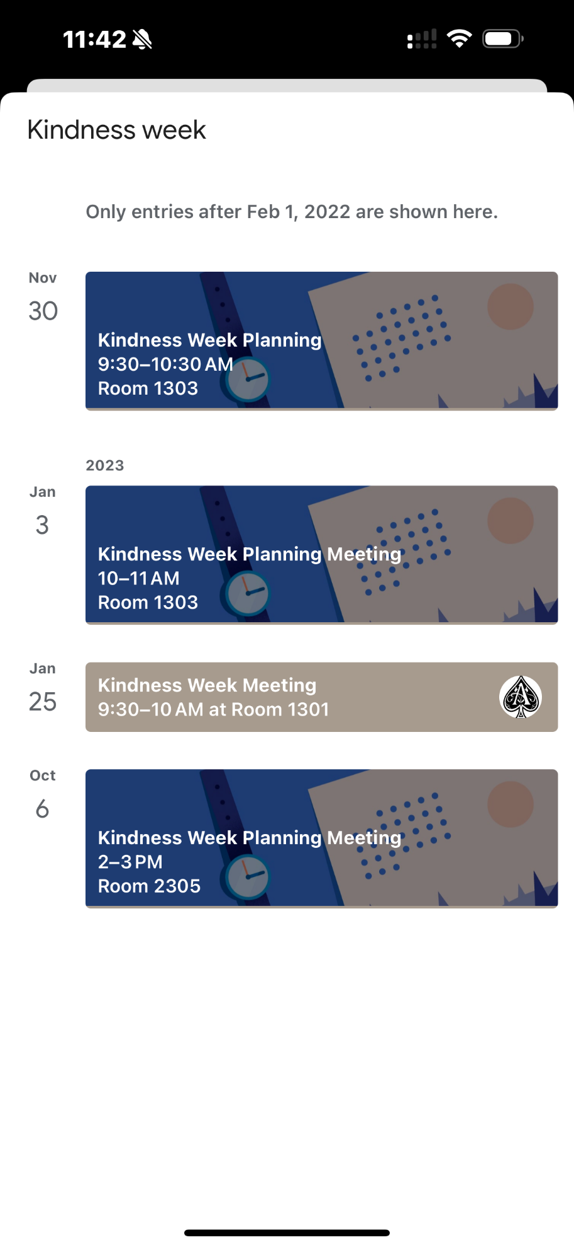
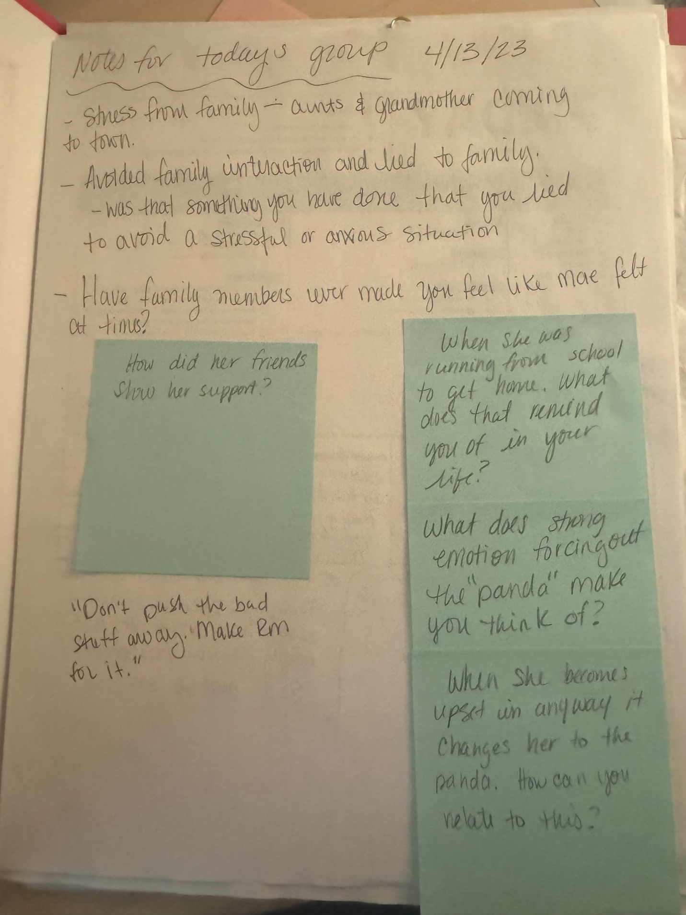

SCStandardsCompetenciesChecklist (1).pdf
ANM_Equity_Self_Assessment.pdf

