Beliefs  At AISJ, we believe that every child can learn and that every child can succeed in a supportive learning environment. We seek to support all students as they move through each developmental phase, progress academically, and grow socially and emotionally. | Vision  AISJ graduates are global citizens who are well-prepared for success after High School. They are well-rounded, lifelong learners who are academically, socially, and emotionally prepared for the inevitable challenges they will encounter. They seek out ways to make meaningful contributions to the world around them. | 2022- 2023  School Year  “AISJ seeks to empower the next generation to lead with kindness, empathy, and respect for all people in their careers and postsecondary educational pursuits.” | AISJ’s School Counseling Department  A brief overview  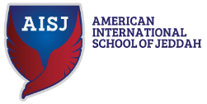
 | Mission  The mission of AISJ’s counselling department is to inspire and facilitate all learners through a data-driven, school-wide counseling program to nurture their passion for knowledge, so they are ready to pursue their dreams and become successful global citizens. | 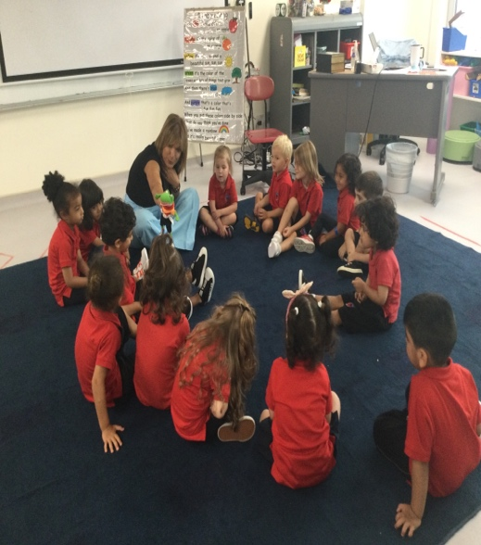 | 
 | 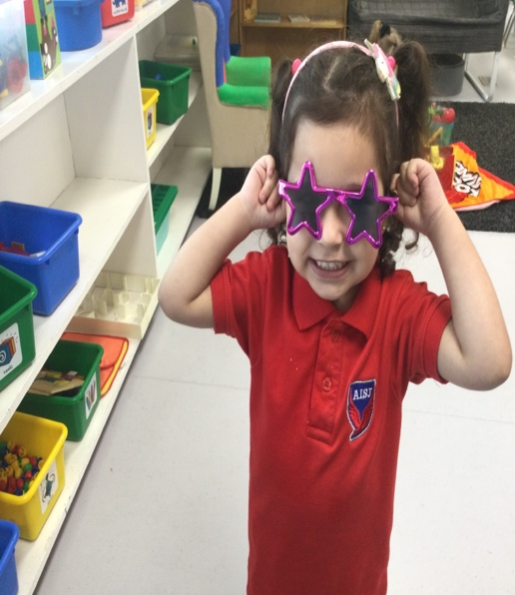 | American School of Jeddah  •••  Jeddah, Saudi Arabia  •••  +966 55 222 3443  •••  info@aisj.edu.sa  •••  www.aisj.edu.sa

Advocacy Statement  The school counselling profession exists to support the mission and vision of the school by promoting social-emotional learning, academic success, and career preparation for all students. By providing accessible and equitable services to all students, school counsellors serve as advocates within the school community. | Career, Social-Emotional, & Academic & Peer Intervention Program  - School-wide Second-Step program for social-emotional learning (SEL)  - SEL program integration within all academic subject areas to promote academic achievement  - Focused on building and strengthening peer relationships  - SEL prepares students for success in their careers  - Promotes a safe school environment for all students | Strategies for Promoting equity in student achievement and college success:  - Advocating for marginalized groups  - Remaining culturally sensitive and aware  - Communicating frequently with stakeholders  - Collaborating with families  - Developing plans to address underrepresented groups in specialized programs  - Using data that can help identify achievement, opportunity, and/or attainment gaps  (ASCA, 2019) |  | 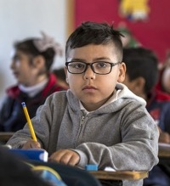
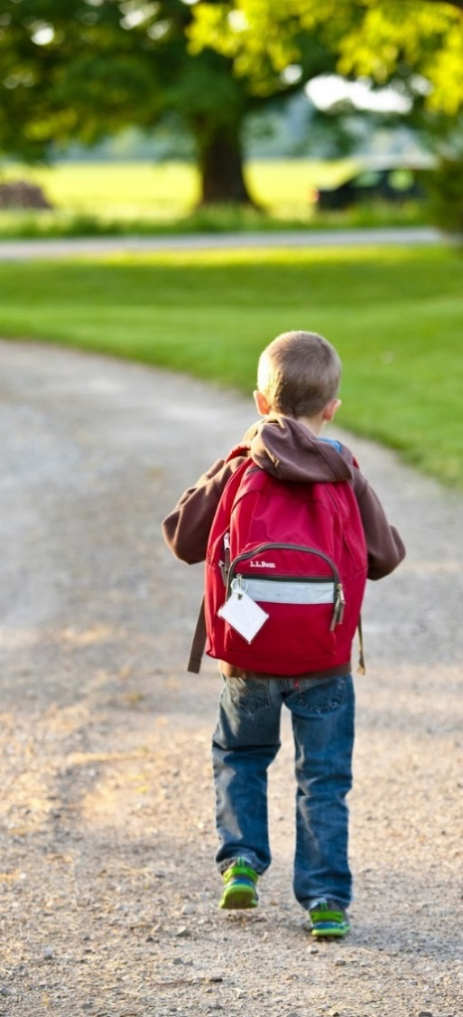 | Strategies to facilitate school and postsecondary transitions:  - Psychoeducational groups that focus on transitions (SEL)  - College and career exploration surveys  - Academic planning for college and career readiness  - College and Career Admission Process seminars  - College Affordability Planning groups  (Bhat & Stevens, 2021) |  |  | “Empowering the next generation of leaders through an authentic American Education.”  aisj.edu.sa
 | A  School Counseling Program is  data-driven:  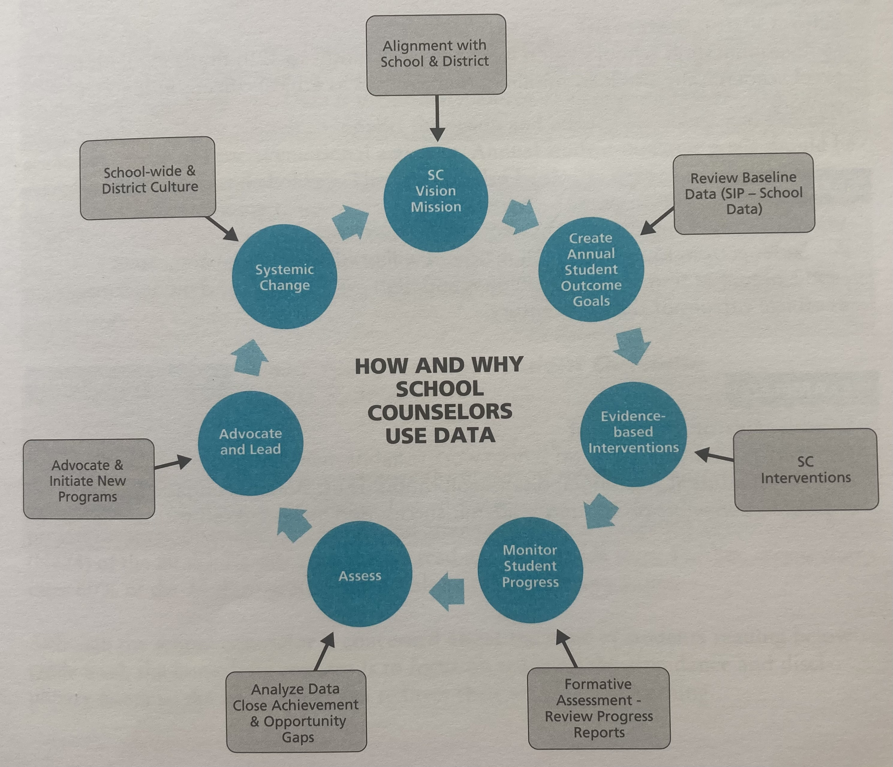  Method for Data Collection: Participation (pre/post-test surveys) that is based on ASCA’s Mindsets and Behaviors, attendance reports, proficiency test scores, enrollment patterns, system practices  Reporting: Results of data analysis will be shared with all relevant stakeholders on an ongoing basis through meetings, workshops, and newsletters.  (Young and Kaffenberger, 2019) |  | Career, SEL, and Achievement School Counseling Support  Direct Services  - Group psychoeducational counseling  - Individual counseling  - Classroom guidance lessons  - Appraisal and advisement  Indirect Services  - Consultation with all relevant stakeholders  - Collaboration with all relevant stakeholders  - Referrals  Program Planning and School Support  - Reviewing school data  - Developing annual student outcome goals  - Creating action plans  - Reporting results to the school community  - Attending annual administrative conference  (ASCA, 2019)

References

ASSOCIATION, A. M. E. R. I. C. A. N. S. C. H. O. O. L. C. O. U. N. S. E. L. O. R. (2019). Asca National Model: A Framework for school counseling programs. AMERICAN SCHOOL COUNSELO.
Bhat, C. S., & Stevens, M. M. (2021). College and Career Readiness Group Interventions for early high school students. The Journal for Specialists in Group Work, 46(1), 20–31. https://doi.org/10.1080/01933922.2020.1856250
Home. American International School of Jeddah. (n.d.). Retrieved February 13, 2023, from https://www.aisj.edu.sa/
Young, A., & Kaffenberger, C. (2019). Making data work. American School Counselor Association.

