Accountability Protocol Project
by
LaNeisha M. Barner

Liberty University
2025

PART 1: Data Collection, Data Analysis, and Guiding Question: In collaboration with the onsite mentor, school leadership, and faculty members, interns will demonstrate the capacity to develop and lead improvement processes through the use of data by designing a measurable guiding question and at least one goal that addresses a problem of practice at the internship site. The goal is to be aligned with current school-improvement processes (NELP 1.2).
(a) Quantitative and Qualitative Data Collection and Analysis
- Provide a 1-2 paragraph narrative detailing quantitative data collection and analysis, explaining how the data inform the need for improvement. Attach data as evidence.

Quantitative data were collected through surveys administered to teachers, students, and parents to evaluate the presence of high-quality relationships at Nottoway High School. Teachers were asked whether they feel they have a positive working relationship with their students; students were asked whether they believe their teacher cares about them; and parents were asked whether anyone from the school has contacted them regarding their child’s academic progress and/or behavioral concerns. Twenty teachers were randomly selected and surveyed across subject areas and grade levels. Thirty students identified as at-risk by the student success team due to poor attendance and/or poor grades were surveyed. The parents of the 30 students surveyed were contacted by phone (20 parents in total). Teacher and student surveys were anonymous to protect participants’ identities and to foster a sense of freedom in sharing honest opinions about school relationships at Nottoway High School. These surveys provided measurable indicators of feelings of engagement and support across key stakeholder groups, offering insight into how perceptions of high-quality school relationships differ among teachers, students, and parents. The results revealed that 78% of teachers reported having a positive relationship with students. Yet only 52% of students agreed that their teacher cares about them, suggesting a disconnect between teachers’ perceptions and students’ experiences. This gap suggests that while teachers feel confident in their relationships, students may not perceive the same level of care, which could impact trust and engagement in the classroom. Of the 30 parents contacted, only 28% confirmed receiving communication from the school, leaving 72% who reported no contact from the school.
This significant gap highlights a systemic issue in outreach and collaboration with families, both of which are needed to support high-quality school relationships that support student success. When parents are not informed about academic progress or behavioral concerns, opportunities for early intervention and partnership are missed. These findings underscore the need for improvement in two key areas: strengthening teacher-student connections and ensuring proactive, consistent communication with families. Addressing these gaps will require intentional strategies, such as increasing teacher visibility through personalized interactions and implementing standardized communication protocols for parents, to create a more supportive and inclusive educational environment. With consistent improvement in these areas, Nottoway High School moves closer to realizing its school mission.

Percentage of Teachers Who Feel They Have Positive Teacher-Student Relationships / Percentage of Students Who Feel Teachers Care About Them/Percentage of Parents Who Contacted by Teachers / Staff Regarding Student Academics and/or Discipline

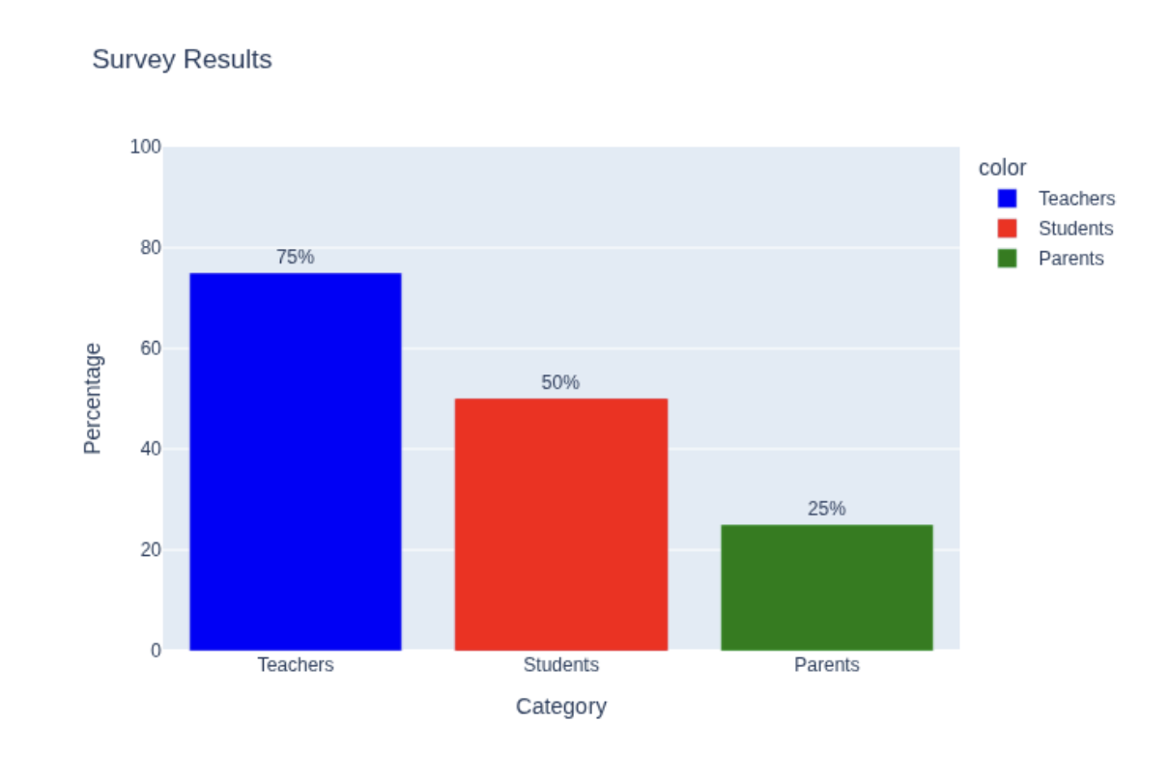

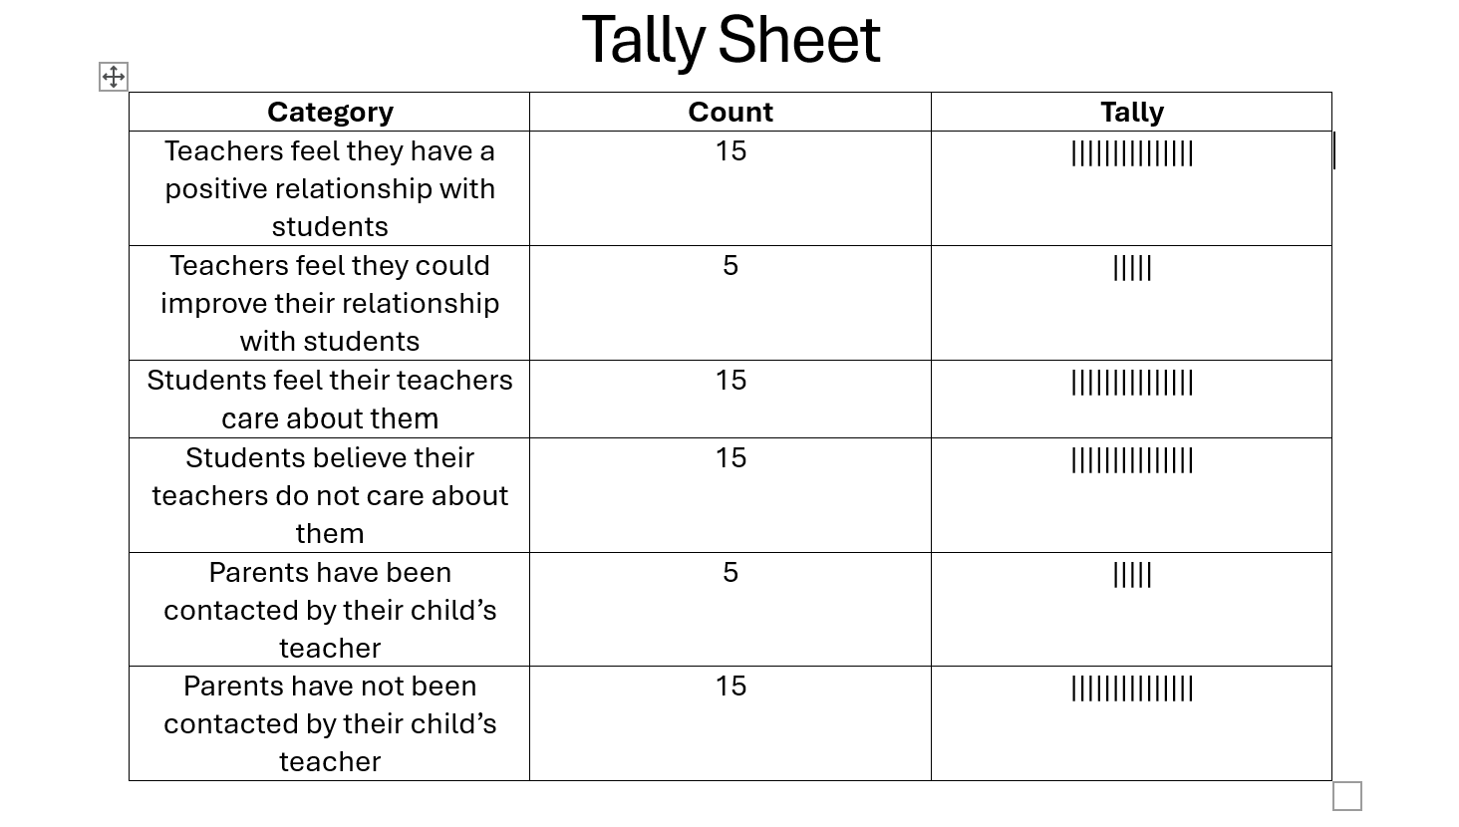

- Conduct interviews with the onsite mentor, a teacher, and a parent or student. Provide a 1-2 paragraph written analysis detailing qualitative data outcomes and how the data inform the need for improvement. Attach transcriptions of all three interviews as evidence. If necessary, research the difference between quantitative and qualitative data collection.

Interview Transcripts
Interview 1: Onsite Mentor
Q: Do you believe strong teacher-student relationships are meaningful?
A: I 100% believe they do. Relationships in general are something that I am focused on enhancing for Nottoway, especially teacher-student relationships. Strong (teacher-student) relationships create a foundation for trust and engagement. When students feel respected and understood, they are more likely to participate actively and take ownership of their learning. It just creates a better learning environment, and that’s the whole point. You know, they become more involved and invested in their own learning. Teachers who build strong relationships can identify challenges early and provide individualized support for students who need it. This connection also reduces behavioral issues because students feel accountable to someone who cares. I just feel that strong relationships all around are what build a positive school culture.

Interview 2: Teacher
Q: How do teacher-student relationships impact classroom performance for students?
A: I think that students definitely perform better when they feel their teacher genuinely cares about their success and well-being. It’s not just about academics; emotional support matters too, you know, the whole hierarchy thing. So many students come into my classroom dealing with issues that no one at the school even knows about. So yeah, I give them the snack when they ask and if I have something for them. I try not to get hung up on the little stuff, like not having a pencil or wrapping up in a blanket. I mean if they are doing their work and they are learning and not causing a ruckus, I’m fine. I mean, it is important to come to class prepared and all, but in the big picture, I just try to focus on meeting the kids where they are. Taking time to get to know my students is so important to me. When they open up and share their experiences, I believe it helps them emotionally and me in understanding their feelings and emotions that may impact their academic or classroom performance. When I take time to get to know my students, I believe they also put forth more effort in their class performance. It develops a higher level of trust. Without that relationship, lessons feel transactional, and my motivation and the students’ motivation just drop. Building rapport takes time, but the payoff is improved participation and academic achievement. Not to mention, class behavior is better. It’s like they just want to be in class, which helps me. Sometimes it even seems that the students enjoy being at school more than being at home. That means something.

Interview 3: Parent
Q: From a parent’s perspective, are teacher-student relationships meaningful?
A: To me, it is. It’s really important for teachers and students to have a good working relationship. I want my child to feel safe and valued at school. When teachers connect personally, it shows in my child’s attitude toward learning. I can tell when my child has had a “good day,” so to speak, at school. When they come home and want to talk about a project or presentation or even a test that they took it lets me know they have actually gotten something out of their time at school. On the other hand, if they come home and are in a not-so-good mood because a teacher at school has rubbed them the wrong way, I can tell too. If the relationship they have with the teacher that they see that day is weak, my child becomes disengaged at home, even after the school day is over. It all just kind of connects. Strong relationships also make communication easier between home and school. I just think that these connections help prevent problems before they escalate. This is big for my younger one. Transitioning to high school was not easy, and I know what day they have English versus when they have history just because of the attitude that day. It only took a short time this year to realize that they were going to bump heads with ____ this year. I mean, we are working on it, but there is still some work to be done.

Qualitative Data Analysis
The interviews reveal recurring themes: trust, engagement, emotional support, and proactive communication. All three stakeholders—mentor, teacher, and parent—emphasize that strong relationships foster motivation, reduce behavioral issues, and improve academic outcomes. These qualitative insights provide depth and context, showing why relationships matter. The data indicate the need for improvement by highlighting that high-quality school relationships are important to stakeholders at Nottoway High School. Consistency and intentionality in communication between teachers, students, and parents is of importance to developing a favorable school climate. While some teachers excel at building rapport, others may lack strategies or time. This suggests professional development and structured relationship-building practices are essential to ensure every student experiences a supportive connection. Additionally, qualitative indicators suggest that positive teacher-student relationships make students feel equally, or more, comfortable at school than at home.

(b) Identify a Problem of Practice and Develop a Guiding Question
- After researching and identifying a problem of practice, design a measurable guiding question that diagnoses the problem of practice using the quantitative and qualitative data collected in the previous step.

Guiding question: To what extent can the implementation of structured relationship-building practices increase the number of high-quality teacher-student relationships at Nottoway High School?

- Provide 1-2 paragraphs detailing a justification for the guiding question and how it aligns with the school’s mission, vision, and current improvement processes already in place at the school. This narrative should include how the data informed the selection of the guiding question (i.e., problem of practice).

Mission Statement: The mission of Nottoway High School is to provide a positive, secure environment which fosters academic, cultural, and social growth. We aspire to cultivate life-long learners who continually grow, adapt, and contribute in a global society.

The guiding question was selected based on both quantitative and qualitative data that revealed gaps in the perception of high-quality teacher-student relationships at Nottoway High School. Quantitative data obtained from survey results showed that while 75% of teachers believe they have positive relationships with students, only 50% of students feel their teachers care about them, and just 25% of parents reported receiving communication from their child’s teacher. These discrepancies indicate a disconnect between teachers’ perceptions and the lived experiences of both students and parents. Qualitative interviews reinforced these findings, highlighting trust, engagement, and proactive communication as factors for student success. Together, these data points informed the problem of practice and shaped the guiding question, which focused on implementing structured relationship-building practices to increase the number of high-quality school relationships at Nottoway High School.

This guiding question aligns closely with the school’s mission of providing a positive, secure environment which fosters academic, cultural, and social growth. Practices that prioritize creating a safe, supportive, and inclusive learning environment where every student can thrive and where parents are included will move Nottoway High School closer to achieving its mission. Current improvement processes at Nottoway High School emphasize academic growth and family engagement, making this focus on relationships a natural extension of those efforts. By addressing the identified gaps, the school can strengthen its commitment to fostering meaningful connections that support both academic and social-emotional development. This alignment ensures that the guiding question not only addresses an urgent need but also reinforces the school’s long-term goals for student success and community partnership.

- Provide 1-2 paragraphs briefly detailing the plan for evaluating the successful implementation of the guiding question (e.g., math scores for 3rd grade students will increase by 5%).
To evaluate the successful implementation of the guiding question, measurable indicators will be tracked using both quantitative and qualitative data. For quantitative measures, the percentage of students who report feeling that their teacher cares about them will increase from 50% to 70%, and parent communication rates will rise from 25% to 60% within the next academic year. Improvements in student engagement will be monitored through attendance rates, aiming to increase attendance rates by 10%. These benchmarks provide clear, data-driven targets that reflect progress toward stronger relationships and communication. Qualitative evaluation will include follow-up interviews and focus groups with teachers, students, and parents to assess perceived changes in trust, support, and collaboration. Observational data from classroom walkthroughs will also be analyzed to determine whether relationship-building strategies are consistently implemented. Combining these methods ensures a comprehensive evaluation of both outcomes and processes, allowing the school to adjust its approach as needed to achieve sustained improvement.

(c) Goal Setting
- Develop at least one strategic and tactical goal that aligns with the guiding question and informs improvement.

Strategic Goal – Increase reported high-quality relationships at Nottoway High School with students who report feeling that their teacher cares about them, rising from 50% to 70% and parents reporting communication from their child’s teacher, rising from 25% to 60% within one academic year.
Tactical Goal – Implement intentional relationship-building activities into each quarter of the school year with participation from 100% of teachers and 60% of students by the end of the school year.

- Provide 1-2 paragraphs discussing the alignment of the goal(s) with the guiding question and the data, and how it informs improvement.

These goals focus on creating a supportive learning environment where students feel cared for, and parents are actively involved in their child’s education. To achieve the strategic goal, intentional acts of kindness and teacher-to-student affirmations will be implemented to enhance teacher-student relationships. Establishing a standardized communication protocol for parents using multiple channels (phone, email, text, Kinvolve) and a standard communication log practice will increase teacher-parent communication. To achieve the tactical goal, Nottoway High School will implement structured relationship-building strategies, such as teacher-student check-ins, weaving student affirmation into daily instructional practice, and visible activities like the Give Them Their Flowers activity. Progress will be monitored through quarterly surveys and communication logs to ensure measurable improvement. The goals align with the guiding question by addressing the core practice problem and supporting the school’s mission of fostering a safe and inclusive community.

- In 1-2 paragraph(s) discuss how the guiding question and goal(s) align with current improvement processes at your site.

The plan to improve teacher-student relationships begins with weekly check-ins, during which teachers will hold short, structured conversations with individual students to discuss academic progress, personal interests, and any challenges they face. These interactions will be documented in a log to ensure consistency. To amplify student voice, quarterly grade-level surveys will be implemented, allowing students to share feedback that teachers can incorporate into routines. Professional development will also play a key role, with two training sessions per year focused on topics such as empathy, active listening, and culturally responsive teaching strategies.

Parent communication will be strengthened through a standardized protocol requiring teachers to contact parents at least once per quarter, providing both positive feedback and any areas needing improvement. Outreach will occur through multiple channels—phone calls for urgent matters, emails for detailed updates, and Kinvolve messages for quick reminders, with translation services available for non-English-speaking families. A centralized school log will track all parent contacts, which administrators will review monthly to ensure compliance and identify families needing additional support. Monitoring and evaluation will include quarterly surveys for students and parents, monthly reviews of communication logs and check-in documentation, and progress reports shared during PLC meetings to maintain transparency and accountability.

PART 2: Accountability Protocol: In collaboration with the onsite mentor, school leadership, and faculty members, interns will demonstrate the capacity to evaluate, develop, and implement a system of supervision, support, and evaluation designed to promote school improvement and student success (NELP 7.4).
(a) Evaluation of District Policies and Instructional Expectations
- In 1-2 paragraph(s) discuss district policies and instructional expectations related to your guiding question and goal(s). Include evidence by attaching or linking policies reviewed.

The NCPS Employee Handbook, Professional Qualities & Instructional Responsibilities for NCPS Teachers and Staff, reinforces the guiding question and goals by emphasizing instructional practices that promote equity, rigor, and student engagement. Its directives on curriculum alignment and differentiated lesson planning ensure that teaching strategies address diverse learning needs, directly supporting goals related to academic growth and inclusion. Requirements for data-driven instruction and assessment align with objectives for continuous improvement and accountability, while expectations for professional conduct and proactive classroom management foster a safe, respectful environment conducive to learning. The handbook underscores the importance of shared responsibility between staff, families, and the community in achieving instructional excellence and student success. By consistently documenting student check-ins and communicating with parents, the guiding questions and goals support handbook expectations.

District policies emphasize maintaining a safe, inclusive, and academically rigorous environment aligned with state standards. The Employee Handbook outlines expectations for professional conduct, instructional planning, and adherence to curriculum guidelines, ensuring educators provide equitable learning opportunities. It stresses the importance of differentiated instruction and compliance with assessment protocols to meet diverse student needs. Similarly, the Student Handbook and Code of Student Conduct establish behavioral norms and expectations for engagement, reinforcing a positive classroom climate that supports instructional goals and clarifying reasonable expectations for an educational environment in which students can reach their full potential. These policies collectively guide educators in fostering student achievement through structured relationship-building practices, consistent classroom management, and the integration of district-approved resources and professional development.

Evidence of these expectations can be found in the linked documents:

Employee_Handbook
Student_Handbook
Code_of_Student_Conduct

- In 2-3 paragraphs, discuss teacher supervision, support, evaluation, and instructional processes in place at your site and how these relate to your guiding question and goal(s). Include evidence by attaching or linking instructional policies reviewed and current forms or processes used for teacher supervision, support, and evaluation.

Teacher supervision and support at the site are grounded in district policies that prioritize instructional quality and professional growth. Administrators conduct regular classroom observations to ensure alignment with state standards and district expectations, as outlined in the NCPS Employee Handbook. These observations focus on lesson planning, differentiation, and classroom management, providing actionable feedback to enhance instructional practices. Support structures include mentoring programs for new teachers and ongoing professional development sessions tailored to identified needs. These processes relate to the guiding question and goals by fostering an environment of continuous improvement and student-centered instruction that is inclusive and supportive of diverse needs through the development of quality professional relationships.
Evaluation procedures are formalized through annual performance reviews that incorporate multiple measures, including classroom observations, student achievement data, and professional contributions. Evaluations are collaborative, with goals selected based on teacher self-evaluation and approved by administrators. Evaluations emphasize growth rather than compliance. Instructional processes are reinforced through curriculum pacing guides, assessment schedules, and collaborative planning meetings, ensuring consistency across subjects and grade levels. These systems collectively promote accountability and instructional excellence, supporting the stated goals and relating to equitable learning opportunities, improved student outcomes, and enhanced high-quality relationships.
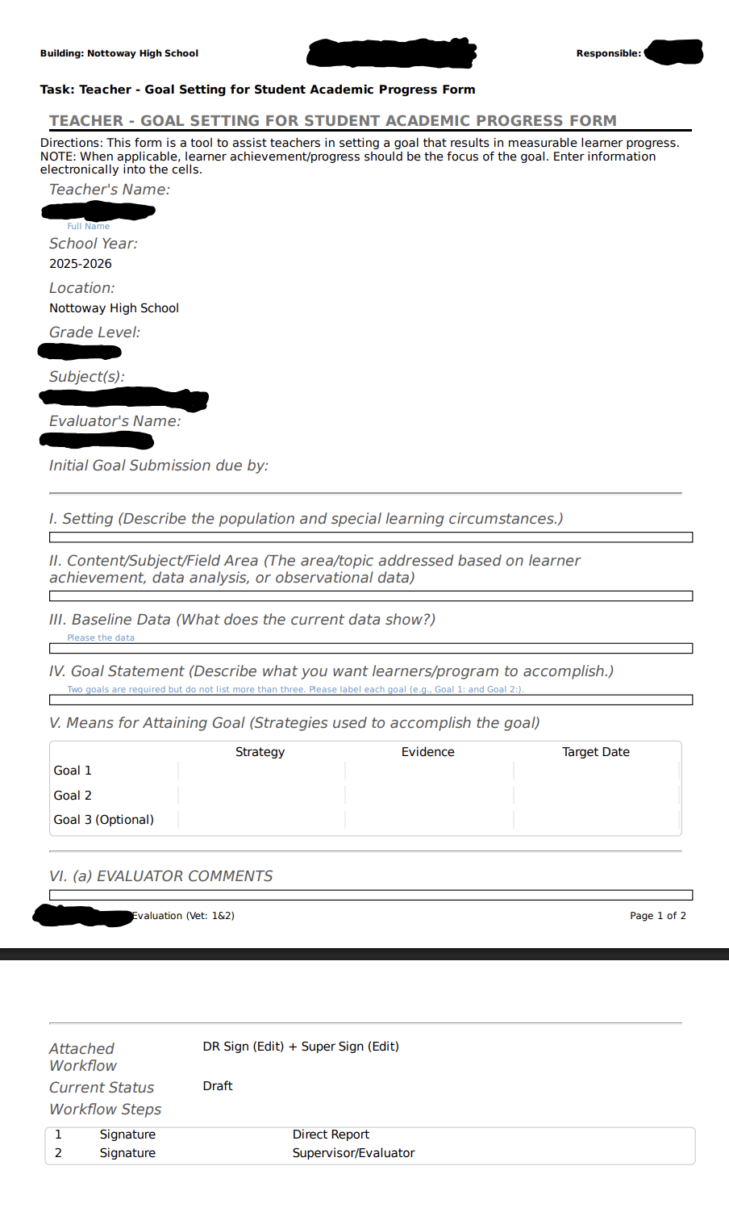
(b) Plan for the Assessment and Improvement of Teacher Performance
- After observing teachers in a variety of classrooms affiliated with the planned improvement process for your accountability project, in 2-3 paragraphs describe measures to assess teacher performance and how the implemented plan will provide actionable feedback to support the improvement goals of your project including how these align with district policies and instructional expectations.

Assessment Measures
Teacher performance will be assessed through a combination of formal observations, walkthroughs, and evaluation rubrics aligned with district expectations outlined in the Nottoway County Public Schools Employee Handbook. Observations will focus on instructional planning, delivery, classroom management, and student engagement, ensuring alignment with the Virginia Standards of Learning. Student attendance data and evidence of relationship-building actions and verbiage will supplement data from these observations. The Teacher Observation and Evaluation for Relationship-Building form provides detailed performance domains, including instructional planning and delivery, classroom environment, professional development opportunities, and student achievement data. These measures ensure consistency, fairness, and alignment with district instructional policies.

Actionable Feedback and Improvement Plan
The Teacher Observation and Evaluation for Relationship-Building plan emphasizes timely, constructive feedback to support the development of high-quality teacher-student relationships. After each observation, administrators will provide written and verbal feedback using the observation form, highlighting strengths and identifying specific areas for improvement. Teachers will collaborate with supervisors to develop professional growth goals that include targeted strategies, resources, and timelines for achieving improvement. This process aligns with district policies promoting continuous professional development and instructional excellence. By linking feedback to measurable goals and providing ongoing support through mentoring and coaching, the plan ensures accountability while fostering a culture of growth and student-centered relationship building.

- In 2-3 paragraphs, detail plans for ensuring teacher growth based on the outcomes of the measures implemented for your accountability project.

Teacher Growth Plan
Using the data from student and teacher surveys, behavioral records, attendance, and classroom observations, administrators and teachers will collaboratively establish differentiated professional learning plans tied to measurable growth targets for each teacher. Growth plans will begin with a teacher-led reflection meeting, where each teacher examines their own strengths and weaknesses surrounding relationship-building, identifies one relational goal and one instructional goal, and co-creates a SMART action plan with an instructional coach or administrator. Those plans will include specific behaviors to practice, evidence to collect, and a timeline for review. Quarterly observation and feedback cycles will be implemented, combining short, focused classroom observations with targeted feedback conversations. Tying student participation and progress to clear relationship-building supports will illustrate teacher growth.

Measuring growth through a multi-source monitoring plan and using results to adapt relationship-building strategies every quarter will support progress towards the accountability goals. Teachers and administrators will benefit from tracking the same validated teacher and student perception items survey used in the baseline to calculate change scores. Triangulating those results with trends in referrals, chronic absenteeism, and assignment completion to assess their impact on student outcomes will highlight the effects on student achievement and engagement. Quarterly data review meetings, where PLC teams examine disaggregated results to identify students who are improving, who need intensified support, and whether interventions show equitable effects across student subgroups, will be effective across subjects and grade levels. These meetings can be used to reassign coaching intensity and scale promising practices schoolwide to build a culture of continuous improvement. Formalizing a long-term sustainability plan that embeds relational skill development into evaluation conversations and the school’s professional learning calendar will support sustained growth beyond the Accountability Protocol Project period.

The survey and report below can be utilized to assist teachers in achieving the relationship-building goals and objectives through peer observations:

Peer Observation and Evaluation for Relationship-Building
Classroom Observation Form
Observer Details

Observer Name | Position
Teacher Details
Teacher Name | Grade/Subject
Observation Details
Date | Time

Observation Sections
Lesson Objectives

Instructional Strategies
- Student Engagement Strategies
- Classroom Management Strategies
- Affirmations/Encouragement Observed
- Teacher Strengths
- Teacher Areas for Improvement

Comments on Instructional Planning and Delivery

Comments on Classroom Environment

Comments on Professional Responsibilities

Comments on Student Achievement Data

Overall Comments

(c) Plan for the Assessment and Improvement of Student Outcomes
- In relation to your guiding question and goals, describe in no less than one (1) paragraph the measures that will be used to assess student development needed to ensure improvement.

To assess student development aligned with the guiding question and project goals, I will use a multi-method, longitudinal set of measures that capture relational, academic, behavioral, and socio-emotional growth. Core measures will include repeated student perception surveys using validated scales for teacher support, belonging, and trust (administered at baseline, midline, and endline), attendance and chronic absenteeism rates, and office referral and in-class incident counts disaggregated by subgroup. Academic engagement, such as assignment completion rates, formative assessment mastery rates, and on-task observation scores, will indicate whether improved relationships translate into learning behaviors. I will also collect sociometric data—counts of students naming at least one trusted adult and frequency of positive student–teacher interactions—to map changes in students’ support networks. Short, validated well-being screeners and counseling referral trends will monitor socio-emotional shifts that often mediate relational work. All measures will be triangulated at the classroom and teacher levels, analyzed for subgroup equity, and reported on a simple dashboard that highlights trends, effect sizes, and teachers or cohorts that need intensified support. Regular student-focused data review meetings will use these measures to refine interventions, set student-centered targets, and confirm that relational improvements are producing meaningful development for learners.

- In relation to your guiding question and goals, detail in no less than one (1) paragraph plans to evaluate the progress of student development.

The student evaluation portion of the Accountability Protocol Project will use multiple data-collection methods aligned with the baseline–midline–endline schedule to determine whether student perceptions of high-quality relationship targets are being met and to guide iterative improvements. Data collection will occur every quarter and include repeated student perception surveys on belonging and teacher support, attendance and chronic absenteeism rates, office referrals and in-class incident counts, on-task observation scores, and sociometric counts of named trusted adults. Each measure will be linked to classroom and teacher identifiers so change can be tracked at the student, class, and teacher levels. Analysis will combine descriptive trend reports, subgroup disaggregation (grade, race/ethnicity, IEP/504 status, gender), and simple inferential checks (pre/post change, effect sizes, and correlation of relational scores with engagement and attendance), with flagging rules to identify students or classrooms needing targeted support. Progress review cycles will be quarterly. Analytic memos will be shared with teachers who will use structured data-review meetings to set or revise SMART student-centered targets. Qualitative touchpoints will include brief student focus groups and teacher reflective memos. Success criteria will be prespecified (e.g., an X-point increase in the percentage of students with positive perceptions; a Y% reduction in chronic absenteeism) and monitored alongside fidelity metrics to ensure any growth is attributable to the implemented relational strategies. The evaluation feedback process will include a sustainability check to determine which practices should be embedded in the ongoing professional development cycle for relationship-building.

- In relation to your guiding question and goals, detail in no less than one (1) paragraph the plans for ensuring increases in student achievement.

To translate improved student–teacher relationships into measurable gains in achievement, relational interventions will be aligned with tightly sequenced instructional goals and regular progress monitoring so that social-emotional supports and academic instruction reinforce one another. Teachers will plan targeted student check-ins for students who exhibit poor attendance, lack of engagement, or poor academic progress, using evidence-based relationship-building strategies shared during relationship-building professional development sessions. Targeted tutoring and intervention blocks will be implemented for students identified by combined relational and academic achievement flags (low perception scores + declining mastery of content), prioritizing the highest-need students and monitoring the quantity of interventions and outcomes of supports. Professional learning communities and student success team interventions will focus on instructional moves that leverage strong relationships, such as clear learning intentions, culturally responsive questioning, scaffolds for engagement, and feedback practices, so teacher growth directly supports student engagement and academic gains. Progress will be evaluated using pre-/post-measures (baseline and endline surveys) and growth percentiles, with disaggregation to ensure equity across subgroups. Fidelity checks (observation forms, contact logs, and attendance in intervention sessions) will confirm that both relational and instructional components are implemented as designed.

PART 3: Training and Professional Development: In collaboration with the onsite mentor, school leadership, and faculty members, interns will implement a training and professional development plan designed to promote reflection, cultural responsiveness, distributed leadership, digital literacy, school improvement, and student success (NELP 7.3).
(a) Planning for Professional Development
- In 1-2 paragraph(s) explain how your professional development plan for this project aligns with the data, the guiding question, and your goal(s).

The professional development (PD) plan is driven by the data collected from student and teacher perception surveys, behavioral and attendance records, classroom observations, and data-based student success team recommendations, so every PD activity targets empirically identified needs. Monthly PLCs will address relational skills, restorative practices, and instructional implementation identified as priorities through survey gaps and observation fidelity scores, with each teacher’s PD goals tied to their relationship-building observation plan indicators and SMART targets. PD content is sequenced to move from foundational relational strategies (e.g., affirmations, restorative prompts, culturally responsive rapport-building) to integrated practices that pair those relational moves with concrete instructional techniques (e.g., formative assessment routines, feedback protocols) shown to improve mastery and engagement. Ongoing progress monitoring is built into PD through practice cycles, classroom artifacts, and short-term improvement surveys so instructional coaches and teachers can use real-time evidence to adjust relationship-building techniques and strategies. By aligning PD to disaggregated data and the guiding question about strengthening student–teacher relationships, the plan ensures professional learning is both targeted and responsive to equity gaps.

The PD plan also embeds structures for accountability and sustainability that align directly with the project’s goals: quarterly data reviews, fidelity checks, clear expectations, and opportunities for peers to disseminate effective relational-instructional practices. Instructional coaches and administrators will use the same measures that define project success—changes in perception scores, reductions in referrals and chronic absenteeism, and gains in formative-assessment mastery—to evaluate PD effectiveness and reallocate supports where needed. Induction and mentoring components ensure that new teachers receive early relationship-building skill development aligned with the project’s benchmarks, maintaining momentum beyond the accountability period. The PD includes clear success indicators and a handoff plan that incorporates sustainable relational practices into the school’s professional learning calendar and evaluation conversations, so growth is maintained and scaled after the project concludes.

- Evaluate the professional capacity of the staff and management practices of leadership; then in 1-2 paragraph(s), reflect on how these might influence improvement.

Staff demonstrate strong professional capacity, characterized by deep content knowledge, experience in classroom management, and growing proficiency in restorative and culturally responsive practices. Many teachers already use formative assessment and small-group instruction effectively, and several serve as informal teacher-leaders who model high-quality relationship-building strategies for peers. Gaps exist in the consistency and depth of strategy used across grade levels and subject content, as well as in teacher and student perceptions of high-quality relationships. Some teachers need more sustained, job-embedded support to translate strategies into reliable quarterly routines and to encourage regular outreach and communication with parents. Time constraints, competing priorities, and uneven access to high-quality observation feedback limit the scale and fidelity of implementation across the faculty. Professional capacity building will therefore require differentiated coaching, clear expectations for parent outreach, and common instructional and relational frameworks so teachers can move from isolated competency to collective, sustainable practice.

Leadership practices combine pragmatic support with variable implementation of distributed leadership and data use. School leaders will prioritize student well-being and intentional relationship-building in classroom routines for teachers. Administrative leaders will be committed to relational improvement, with managerial structures focused on decision-making that supports building a favorable school culture. When administrators can delegate authority to instructional coaches and teacher-leaders, freeing administrators to attend to other responsibilities, improvement will occur at a faster rate and be more sustainable. Where relationship-building observations, improvement plan approvals, and schedules are bottlenecked, momentum stalls. Strengthening distributed leadership, clarifying roles for coaching and data review, and aligning evaluation with capacity-building will amplify teacher growth and accelerate measurable gains in student–teacher relationships and achievement. Leaders who consistently model data-informed decision-making, provide timely resources, and remove logistical barriers, thus creating conditions for teachers to grow beyond their comfort zone.

- In 1-2 paragraph(s), explain how your professional development plan for this project will promote teacher self-reflection.

The PD plan embeds structured reflective cycles that make reflection routine, concrete, and evidence‑based. Teachers will begin each session by reviewing individualized dashboards (student perception data, formative-assessment trends, attendance, referrals, and observation notes) and writing a short reflective memo identifying one specific relational and one instructional practice to improve; these memos will serve as the basis for goal-setting with their evaluator. Regular reflection cycles pair short classroom recordings or focused observation notes with guided reflection prompts that ask teachers to describe what happened, interpret student responses, and plan one micro-adjustment for the next teacher-student interaction. Peer‑observation opportunities, including roles of observer, observed, and analyst, will use a standard rubric so reflections include both self-assessment and colleague feedback tied to observable behaviors. Reflection products will be reviewed quarterly to document growth and recalibrate SMART goals.

Coaching and leadership structures reinforce reflective practice by making it supported and iterative rather than evaluative and one‑time. Instructional coaches conduct non-evaluative debriefs that use reflective questioning to move teachers from description to interpretation to action, and coaching logs record commitments and follow-up evidence for accountability. PLCs dedicate time to structured reflection protocols in which teachers present a brief case, receive focused feedback, and rehearse next-step strategies, promoting collective learning and the normalization of reflective risk-taking. Reflection is explicitly tied to student outcomes: teachers track a small set of student indicators linked to their goals, reflect on the impact of changes, and adjust practice immediately when evidence shows insufficient progress. Over time, this cyclical, supported approach builds teacher metacognition and instructional agency, so that reflection becomes a habitual driver of continuous improvement rather than an occasional compliance task.

- In 1-2 paragraph(s), explain how your professional development plan for this project will promote cultural responsiveness.

The PD plan centers on culturally responsive pedagogy by beginning with data that surface students' identities, languages, and cultural assets, so learning is grounded in the realities of the school community. Instructional coaches and PLCs will engage teachers in learning modules that unpack cultural humility, anti-bias practices, and asset-based framing, paired with concrete classroom strategies such as culturally relevant phrasing, curriculum adaptations, and affirming classroom rituals. Each module includes classroom practice, artifacts, and reflection prompts to help teachers translate theory into action. Teachers will analyze disaggregated student data with a culturally responsive lens to identify where relationships and outcomes differ by race, language, or other identity markers, then co-design targeted relational moves and curriculum choices that validate student backgrounds. Job-embedded supports, such as peer observations and intentional reflections, will spotlight equitable interaction patterns (who is called on, whose work is amplified, whose perspectives are centered) and set measurable fidelity indicators tied to both relational climate and academic access. Parent and student voices will be continuously incorporated through structured outreach, authentic interactions, and feedback loops that ensure relationship-building methods resonate with students’ cultural contexts.

PD practices will build teacher capacity to sustain culturally responsive instruction by making equity the default criterion for professional learning decisions and outcomes. Instructional coaches will use reflective protocols that prompt teachers to examine their expectations, biases, and classroom routines and to adjust practices based on student feedback and outcome data. These reflections will be documented and revisited across coaching cycles to show growth. Professional learning will highlight classrooms where students report high belonging and achievement despite systemic barriers. The relationship-building methods exemplified in these classrooms will be used to promote peer-led modeling and scaling of culturally sustaining strategies. Evaluation of PD effectiveness will explicitly track equity indicators (reduction in perception gaps, narrowing of referral and attendance disparities, and improved mastery for historically marginalized groups) to measure, reward, and iteratively enhance cultural responsiveness. Over time, the plan aims to normalize culturally responsive decision-making across planning, instruction, and leadership so responsiveness becomes a structural, schoolwide practice rather than an add-on.

- In 1-2 paragraph(s), explain how your professional development plan for this project will provide opportunities for identifying and engaging staff in leadership roles.

The PD plan creates intentional pathways for identifying emerging leaders through data-driven observation processes, ensuring leadership roles are matched to demonstrated strengths and interests. Teachers who consistently demonstrate strong relational practice, improved student outcomes, or effective facilitation in PLCs will be invited to take on micro-leadership roles such as restorative practice mentors, formative-assessment leads, or teacher-leaders. These roles begin with short, supported pilots so candidates can build competence without the risk of a complete role switch. Formalized selection criteria (student perception gains, fidelity scores, peer nominations, and coach recommendations) ensure transparency and reduce bias, while short-term leadership stipends, release time, and clear role descriptions provide practical supports for participation. Each of these incentives for enhanced leadership responsibility are currently in place and can be utilized to entice emerging leaders into micro-leadership positions. Regular rotation and succession planning ensure opportunities circulate broadly, preventing role concentration and widening the pool of skilled teacher-leaders.

Engagement strategies move beyond appointments to build distributed leadership structures that amplify teacher voice and ownership. Teacher-leaders will co-design PD modules, lead classroom demonstration lessons, and facilitate data-review meetings, creating visible career pathways that connect classroom impact to school improvement influence. Mentoring pairs link aspiring leaders with experienced instructional coaches for one-on-one support and guided practice in tasks such as running PLC protocols, leading restorative circles, or presenting outcome reports to stakeholders. Evaluation of leadership roles uses the same evidence base as instructional work—teacher impact on relational measures, student outcomes, and fidelity of peer supports—so leadership contributions are measured and celebrated. Over time, this approach builds internal capacity, embeds leadership in daily practice, and creates sustainable peer-led change that reinforces both teacher growth and schoolwide improvement.

- In 1-2 paragraph(s), explain how your professional development plan for this project will utilize digital technology in ethical and appropriate ways to foster professional learning.

The PD plan leverages secure, school-approved digital tools to make professional learning timely, evidence‑based, and accessible. A centralized dashboard will display disaggregated indicators (student perception scores, attendance, referrals, formative‑assessment trends), allowing teachers and instructional coaches to review real-time evidence and set data‑informed goals. Access will be role‑based and logged to preserve confidentiality. Teachers will use time‑stamped feedback tools, such as Google Forms, so reflections remain concrete and growth‑focused. To ensure equitable access, the plan includes device and connectivity checks, low‑bandwidth alternatives (downloadable PDFs), and scheduled on‑site time for staff who lack reliable home access.

Digital tools will be used with clear ethical guidelines, training, and governance to protect privacy and build trust. All data use will follow FERPA and local district policies. Only de‑identified student data will be shared in broader forums. Professional norms will be established for digital communication—response windows, respectful feedback language, and boundaries around off‑hours contact—to protect teacher well‑being and model healthy practices. Instructional coaches will receive training in constructive digital feedback and in using platform analytics responsibly to avoid punitive interpretations of participation metrics. Ongoing evaluation of the technology suite will solicit staff feedback on usability and impact, so tools are iteratively pruned or replaced when they do not demonstrably support relational and instructional goals.

(b) Professional Development Implementation
- In a bulleted or numbered format, outline a series of planned professional development activities informed by your data, guiding question, and goal(s) that support school improvement.

Professional Development Outline
• Data Launch and Goal-Setting
• Whole-staff kickoff to review baseline dashboards and set teacher SMART goals
• Distribute dashboard access and SMART goal templates
• Technology and Data Literacy Training
• Hands-on dashboard walkthrough and secure data practices
• Provide low-bandwidth alternatives and on-site access times
• Relational Foundations Workshop
• Interactive modules on affirmations, culturally informed language, restorative practices, and rapport development routines
• Practice scenarios and role-play with observable success indicators
• Instruction–Relationship Integration Labs
• Job-embedded co-planning that pairs relational moves with instructional strategies
• Biweekly labs with lesson adjustments and formative checks
• Coaching Cycles
• Nine-week cycles: pre-conference, timestamped coach feedback, teacher reflection memo, post-conference action steps
• Coaching log entries: teacher, coach, start date, focus skill, evidence collected, agreed next steps
• Peer Observation
• Role rotations (observer/teacher/analyst) using a common rubric
• Structured feedback during post-conference and PLC times and immediate application
• Formative Assessment and Data Use Clinic
• Design formative checks, analyze item-level data, and plan one-cycle instructional adjustments
• Share formative item banks and feedback reports
• Equity and Cultural Responsiveness
• PLC and PD Sessions on cultural humility, bias interruption, curriculum adaptation, and family voice integration
• Classroom application tasks and disaggregated data analysis
• Restorative Mentor Program
• Identify and train mentors to lead PLCs, model de-escalation, and support peers
• Track number of PLC sessions and fidelity checks
• Leadership Pathways and Facilitation Training
• Development for aspiring teacher-leaders (facilitation, data facilitation, coaching basics)
• Co-facilitation opportunities and short-term leadership pilots
• Family Engagement Workshops and Tools
• Training on culturally responsive outreach and home–school communication templates
• Provide toolkits for teachers to share learning targets with families
• Quarterly Data Review and Celebrations
• Structured data-review sessions to recalibrate goals, reallocate coaching, and celebrate growth
• Produce short analytic memos and teacher showcases
• Observation and Reflection Structures
• Use the Classroom Observation Rubric (10 indicators, 1–4 scale) for consistent feedback
• Post-observation debrief template: top strength, focused growth target, next-step actions, evidence to collect, follow-up date
• Quick Coaching Conversation Protocol (15 minutes)
• Pre-brief (teacher goal), observation highlight (strength + gap), reflective question, action planning, follow-up agreement
• PD Implementation and Sustainability Checklist for Leaders
• Ensure dashboards are published, SMART goals are submitted, coaching schedules are posted, PLC times protected, mentors trained, family templates ready, and quarterly reviews scheduled
• Closing Sustainability Session and Induction Integration
• End-of-year handoff plan to embed relational-instructional practices into induction and PD calendar
• Revise evaluation rubrics to include relational fidelity indicator

- Develop a table that depicts a professional development schedule you will implement for this project that includes a list of dates, times, locations, etc.

PD Calendar (Aug 2026 — May 2027)
August 2026
Date | Time | Event | Location | Primary Owner(s)
Aug 12, 2026 | 8:30 AM–3:30 PM | Data Launch & Goal-Setting Workshop | Media Center | Principal; Data Coach
Aug 19, 2026 | 12:30 PM–4:00 PM | Technology & Data Literacy Training | Computer Lab | IT Lead; Data Coach
September 2026
Date | Time | Event | Location | Primary Owner(s)
Sep 2, 2026 | 8:30 AM–12:00 PM | Relational Foundations Workshop Part 1 | PD Room A | Instructional Coaches
Sep 9, 2026 | 8:30 AM–12:00 PM | Relational Foundations Workshop Part 2 | PD Room A | Instructional Coaches
Sep 16, 2026 | 3:30 PM–4:30 PM | Coaching Cycle Orientation | PD Room B | Instructional Coaches
Sep 22, 2026 | 3:30 PM–4:30 PM | Integration/Equity Lab Launch | Media Center | PLC Leads; Instructional Coaches
Sep 29, 2026 | 3:30 PM–4:30 PM | Integration/Equity Lab (Biweekly Series begins) | Media Center | Instructional Coaches; PLC Leads
October 2026
Date | Time | Event | Location | Primary Owner(s)
Oct 7, 2026 | 8:30 AM–12:00 PM | Formative Assessment Clinic | PD Room A | Assessment Lead
Oct 13, 2026 | 3:30 PM–4:30 PM | Integration/Equity Lab (biweekly) | Media Center | Instructional Coaches; PLC Leads
Oct 21, 2026 | 3:30 PM–4:30 PM | Micro-Teaching Launch | Media Center | Teacher-Leaders; PLC Facilitators
Oct 27, 2026 | 3:30 PM–4:30 PM | Integration/Equity Lab (biweekly) | Media Center | Instructional Coaches; PLC Leads
November 2026
Date | Time | Event | Location | Primary Owner(s)
Nov 4, 2026 | 8:30 AM–12:00 PM | Restorative Mentor Training | PD Room A | Teacher-leaders
Nov 10, 2026 | 3:30 PM–4:30 PM | Integration/Equity (biweekly) | Media Center | Instructional Coaches; PLC Leads
Nov 24, 2026 | 3:30 PM–4:30 PM | Integration/Equity Lab (biweekly) | Media Center | Instructional Coaches; PLC Leads

January 2027
Date | Time | Event | Location | Primary Owner(s)
Jan 13, 2027 | 8:30 AM–12:00 PM | Midyear Data Review & Adjustments | PD Room A | Leadership Team; Instructional Coaches
Jan 26, 2027 | 3:30 PM–4:30 PM | Integration/Equity Lab (make-up/session) | Media Center | Instructional Coaches; PLC Leads
February 2027
Date | Time | Event | Location | Primary Owner(s)
Feb 3, 2027 | 3:30 PM–4:30 PM | Targeted Tutoring & Intervention Launch | Media Center | Intervention Coordinator; Teachers
Feb 17, 2027 | 3:30 PM–4:30 PM | Coaching Cycle Round 2 Start | Media Center | Instructional Coaches
Feb 23, 2027 | 3:30 PM–4:30 PM | Integration/Equity Lab (make-up/session) | Media Center | Instructional Coaches; PLC Leads
March 2027
Date | Time | Event | Location | Primary Owner(s)
Mar 3, 2027 | 3:30 PM–4:30 PM | Peer Leadership & Facilitation Practice | Media Center | Teacher-Leaders; Instructional Coaches
Mar 10, 2027 | 3:30 PM–4:30 PM | Integration/Equity Lab (ongoing) | Media Center | Instructional Coaches; PLC Leads
Mar 24, 2027 | 3:30 PM–4:30 PM | Integration/Equity Session 3 | Media Center | Equity Coach
April 2027
Date | Time | Event | Location | Primary Owner(s)
Apr 7, 2027 | 2:00 PM–4:00 PM | Family Engagement Workshop | Cafeteria | Family Engagement Lead; Teachers
Apr 14, 2027 | 3:30 PM–4:30 PM | Integration/Equity Lab (final cycles) | Media Center | Instructional Coaches; PLC Leads
Apr 21–May 5, 2027 | Various during the school day | Pre-Endline Data Collection & Fidelity Observations | Various Classrooms | Data Coach; Observation Team
May 2027
Date | Time | Event | Location | Primary Owner(s)
May 6–May 13, 2027 | Assessment windows (school day) | Endline Student Perception Survey & Summative Measures | Computer Lab; Classrooms | Assessment Lead; Data Coach
May 20, 2027 | 8:30 AM–3:30 PM | Year-End Review, Celebrations & Sustainability Planning | Media Center | Leadership Team; Instructional Coaches; Teacher-Leaders

PART 4: Implementation of Accountability Project: In collaboration with the onsite mentor, school leadership, and faculty members, interns will implement the accountability protocol project at the site, developing and engaging staff in a professional culture designed to promote school improvement, teacher retention, and the success and well-being of each student and adult in the school (NELP 7.2).
(a) Implementation Details
- Describe in 2-3 paragraphs the details of the implementation of your accountability plan. Considering your data and observations, reflect on the successes and failures of implementation and how these may have impacted school improvement and the success and well-being of the students and teachers.

Implementation of the accountability plan is centered on transparent, role‑based data use, regular coaching cycles, and clear follow‑through timelines. The building principal has published a secure dashboard with disaggregated indicators and granted the student success team access. Teachers can currently view dashboard information when collaborating with the student success team. In the future, dashboard metrics will be used during PLC meetings and during relationship-building evaluation observations. I have collaborated with special education case managers to conduct PLC meetings incorporating training on cultural awareness, inclusion, confidentiality, and special education regulations. Covered processes translate into classroom actions, and restorative actions outlined in the guiding question, which can be tracked using criteria outlined in the Accountability Protocol Project, such as teacher and student perceptions, attendance data, and referral trends. To ensure the ethical use of information, survey results were de‑identified, and teacher and student data were used in broader forums.
Reflections on the implementation of the Give Them Their Flowers activity show both tangible gains and important limitations. Successes included stronger feelings of high-quality relationships by both teachers and students. Distributed leadership during the implementation of the project—school counselor, teachers, and teacher-assistants—helped sustain momentum and reduced reliance on the building administrator. Failures emerged when implementation fidelity dropped: inconsistent teacher explanations of the project’s intent and failure to conduct the project with each class, which prevented some students who wanted to participate from doing so. Additionally, less than half of the teachers participated in the teacher-to-student portion of the project. Uneven teacher participation and the lack of opportunity for all students to participate in the kindness flower distribution limited the data available to show the whole-school impact of the Give Them Their Flowers activity. Administrative delays in updating dashboard indicators occasionally limited timely decision-making regarding parent feedback. In some classrooms, overemphasis on general observations during classroom walkthroughs, without contextual feedback, led teachers to feel surveilled rather than supported during classroom observations, negatively affecting staff morale.

These mixed outcomes unevenly shaped school improvement. Where transparency for observations and data use was made clear, student perception scores, engagement indicators, and formative growth showed notable improvements. Teachers there reported greater professional confidence and more explicit instructional focus. Conversely, inconsistency in accountability practices widened disparities. When teachers report not knowing the purpose of observations or how data would be used (punitive, informative, growth-centered), they feel uncomfortable with the process and perceive that instructional effectiveness and practice strategies decline, highlighting the need for clearer expectations during observations. Moving forward, I will prioritize recalibrating accountability: clarifying the purpose of observations and collected data, simplifying feedback, and implementing regular well-being check‑ins for staff and students so accountability drives learning and relationship-building practices.

- Explain in 1-2 paragraph(s) how the implementation of your accountability project impacted teachers and how it promotes teacher engagement and teacher retention.

The Accountability Protocol Project strengthened teachers’ professional agency by making relationship-building actions intentional and data-driven. Transparent, actionable, and teacher-owned activities give teachers ownership of their outreach efforts to students and parents. PLC training on cultural awareness, inclusion, confidentiality, and special education regulations gave teachers a clearer understanding of actions to take when working with diverse student groups. The Give Them Their Flowers activity provided teachers with a job‑embedded opportunity to practice relationship-building practices and receive specific feedback from students, professional peers, and leadership, as well as see measurable student progress tied to their efforts. When leaders protected non‑evaluative observation and used de‑identified data for collaborative problem‑solving, many teachers reported increased feelings of connectedness to students, increased job satisfaction, reduced isolation, and a stronger sense of collective responsibility for student well-being.

These shifts supported engagement and retention by aligning professional learning with day‑to‑day challenges surrounding building rapport with students. Distributed leadership helped the building principal feel a stronger sense of professional closeness with teachers without adding to his administrative responsibilities. By distributing leadership, teachers moved from passive recipients to active facilitators of improvement. Teacher‑leaders and teacher-assistants gained meaningful leadership roles, which created pathways for growth and recognition without leaving the classroom. Where accountability felt supportive rather than punitive, focused on growth, well‑being checks, and realistic documentation expectations, teachers reported higher job satisfaction, which is traditionally associated with intent to stay. Increased teacher-reported job satisfaction and high-quality engagement with students and parents will, over time, aid in teacher retention.

- Describe in 1-2 paragraph(s) how your comprehensive accountability project provided school community members with a healthy, professional, and culturally aware school environment.

The Accountability Protocol Project established clear, respectful routines for evidence use, feedback, and decision making that normalized professionalism and psychological safety across the school. Transparent dashboards, role‑based access, and non‑evaluative observations made expectations predictable while protecting staff from punitive surveillance; regular well-being check‑ins reinforced healthy work–life boundaries. Awareness PLC sessions provided structured opportunities for intentionally developing relationship-building practices for classroom use. Having students participate in the Give Them Their Flowers activity allowed them to share their voices and recognize teachers they felt a connection with, while students who did not participate were able to see flowers displayed on teachers’ doors and read kind words their peers shared about teachers in the building. This models both kindness and relationship-building for non-participant students, strengthening trust among teachers and students. Cultural awareness is intentionally woven into every element of the Accountability Protocol Project to create a professional culture that centers dignity, belonging, and culturally responsive pedagogy for both students and adults.

- In 1-2 paragraph(s) discuss the role of relationships, trust, and well-being in the development of a healthy and effective school professional culture and how you attended to these constructs during the implementation of your accountability project.

Relationships, trust, and well-being are the bedrock of a healthy professional culture because they shape whether staff feel safe to learn, take instructional risks, and sustain the hard work of continuous improvement. In this project, relationships, trust, and well-being were the main focus. The intent is to continuously improve these factors of the school culture. The foreground of the project involves relational moves — routines for affirmations, structured restorative circles, and teacher-led sharing of positive verbiage when communicating with students and parents — so that data and feedback landed in contexts of mutual respect rather than judgment. Trust was built through transparent and genuine communication that emphasized growth of high-quality relationships.

To support well‑being, we set professional boundaries, embedded regular well-being check‑ins into PLC and leadership routines, and distributed leadership so workload and recognition were shared. Teacher-leaders used strength-based affirmations to strengthen teacher-student relationships and reduce school-based stressors for students. These intentional moves not only improved the quality of professional learning but also helped sustain teacher capacity, morale, and the relational conditions students need to thrive.

(b) Collaboration
- Detail in 1-2 paragraph(s) how you collaborated about the data that informed the development of your accountability protocol project.

The Accountability Protocol Project began by convening a cross-role data team, including the building principal, school community liaison, student success team, teacher‑leaders, and teacher-assistants to inventory and validate the data sources (student perception surveys, attendance, referrals, and classroom observation notes). In collaboration, the team determined the information needed to develop the school information dashboard. The principal and the student success team agreed on role‑based access and de‑identification rules. Teachers and teacher-assistants provided valuable feedback on the best way to roll out the Give Them Their Flowers activity. Teacher-assistants played an integral role in preparing the flowers for the project and distributing completed flowers to students and staff once kind messages were written on them. The teachers and teacher-assistants made the distribution of leadership manageable for project completion.

Collaboration continued through iterative reviews of the project’s impact on teacher-student relationships. Feedback from teachers and students provides the foundational data for initiating the Accountability Protocol Project. Classroom walkthroughs with the principal additionally provided a baseline of existing classroom practices that either support high-quality teacher-student relationships or require improvement. The student success team reviewed attendance and referral trends to align relational interventions. Consent, privacy, and ethical practices for the accountability protocol project were established with administrative guidance and permission. Teacher and student perception surveys felt transparent and voluntary due to reassurances of anonymity. These collaborative processes produced an accountability protocol project that teachers helped design, increasing buy‑in, reducing perceived surveillance, and making the system responsive to on-the-ground realities.

- Detail in 1-2 paragraph(s) an explanation of how you collaborated on the implementation of your accountability protocol project at your internship site.

Implementation of the Accountability Protocol Project was deeply collaborative. I coordinated with instructional and support staff to align roles, timelines, and evidence collection so the Accountability Protocol Project felt practical and distributed rather than top‑down. The photojournalism teacher and their students, together with teacher assistants, played a key role in the Give Them Their Flowers activity by photographing recipients, preparing signage, and collecting and distributing kindness week flowers across classrooms and staff spaces; their work ensured visible, high‑quality documentation that fed directly into our student‑perception and community‑engagement measures. Career strategies teachers, English teachers, the economics and personal finance teacher, and the in‑school suspension facilitator each carried out specific responsibilities—organizing student teams, drafting outreach scripts and reflection prompts, and coordinating respectful delivery protocols—so the project integrated curricular skills, social‑emotional learning, and logistical responsibility.

These cross‑role partnerships strengthened implementation fidelity and teacher ownership by matching tasks to expertise and existing schedules, reducing add‑on burden. Regular check-ins with participating teachers, joint problem-solving during check-ins, and shared artifacts (photos, student reflections, distribution logs) allowed us to monitor, reach, and impact in real time, celebrate successes publicly, and quickly address concerns about equitable participation or workload. Embedding the Give Them Their Flowers activity within the Accountability Protocol Project provided a tangible, culturally responsive way to measure relational climate while building teacher leadership, student agency, and positive morale across the school.

- Detail in 2-3 paragraphs how you collaborated on improving teaching practices, student achievement, and school programming related to the implementation of your Accountability Protocol Project. Attach or link evidence of collaboration. (Test any internet links to ensure that they are functioning.)

Collaboration focused on feedback cycles and tightly aligned data use, so instructional changes were both practice‑based and measurable. I worked side‑by‑side with teacher‑leaders and support staff to co-plan PLC training sessions to inform teachers’ instructional delivery. I worked with instructional teachers to implement classroom lessons to encourage student engagement in relationship-building activities to improve the overall school climate. These lessons paired free-writing prompts with relational routines to strengthen teacher-student relationships. This iterative, evidence‑driven approach improved fidelity to agreed practices and created visible links between teacher moves and student response data, which teachers used to refine high-quality relationship-building practices.

To drive student achievement and strengthen programming, cross-department collaboration—career strategies, English, economics, and personal finance, and ISS facilitators—integrated real‑world tasks and reflection prompts that elevated student ownership and provided varied evidence of student achievement and learning beyond traditional tests. The Give Them Their Flowers activity and Kindness Week were embedded as relational measures. Distribution logs and photo documentation were analyzed to gauge the climate’s influence on engagement and mastery of life skills aligned with the school’s mission. Where collaboration was most consistent, classrooms showed improved classroom management and student engagement in the assigned lesson.

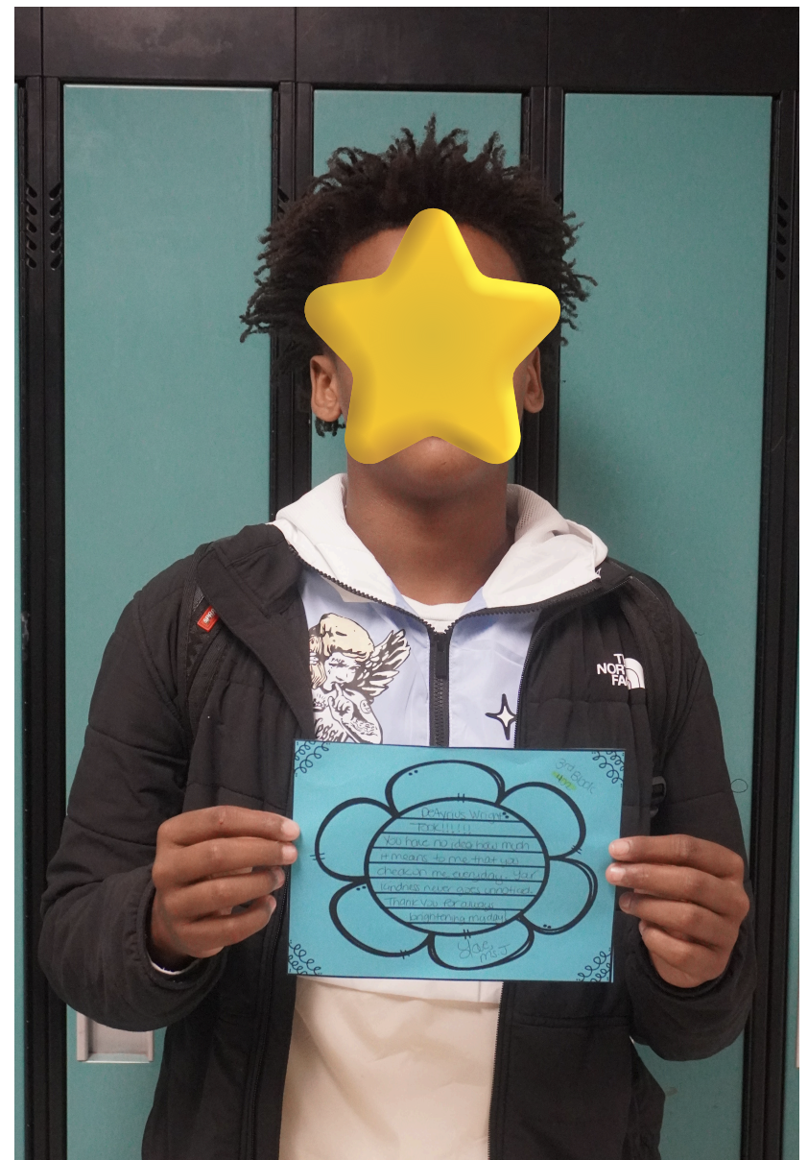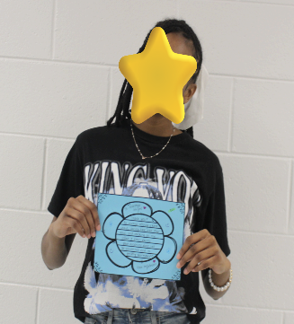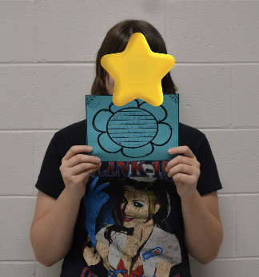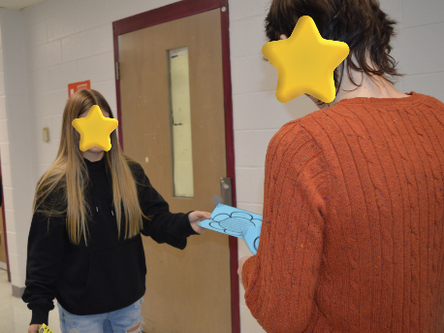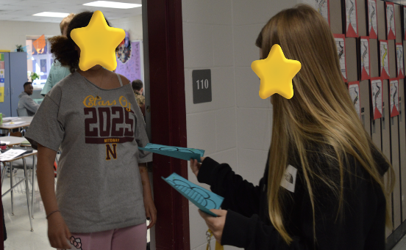

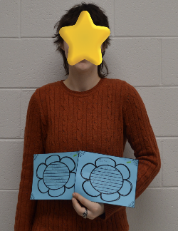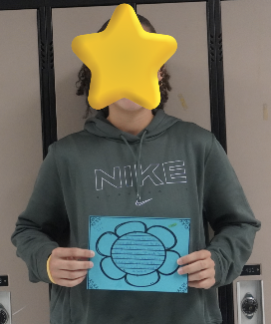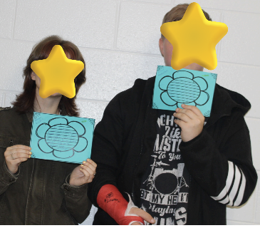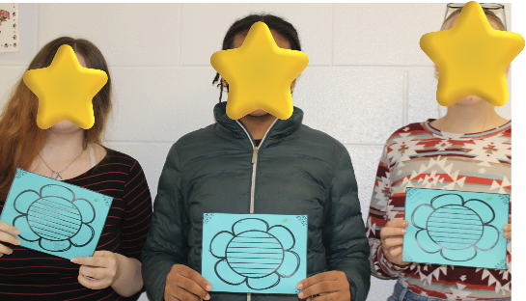

Give Them Their Flowers Activity Teacher-to-Student Give Them Their Flowers Activity Student-to-Teacher

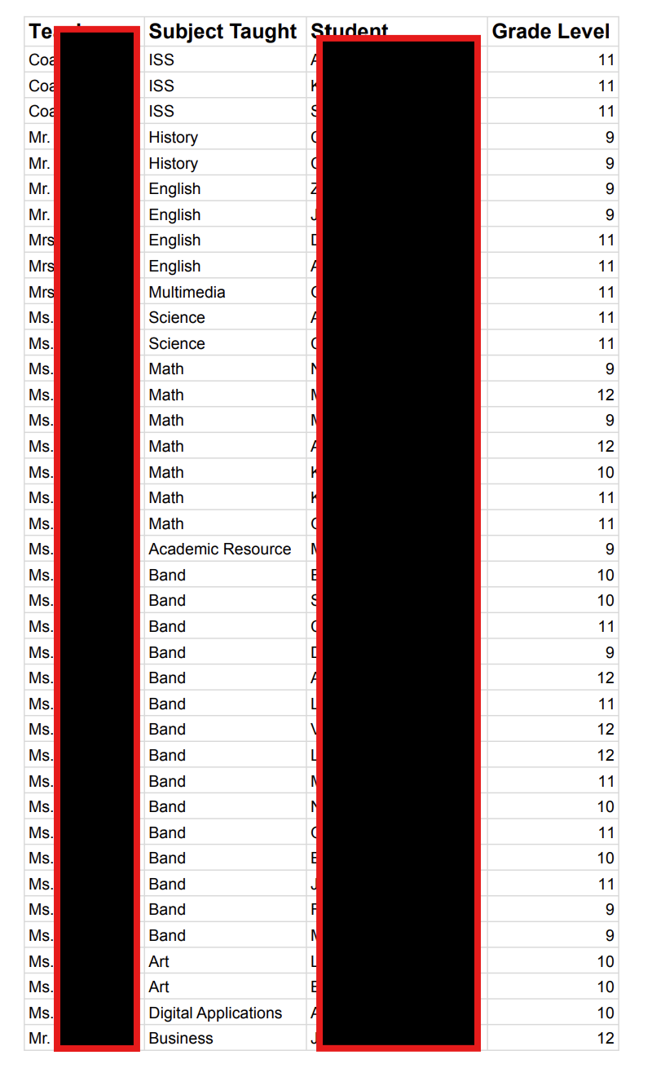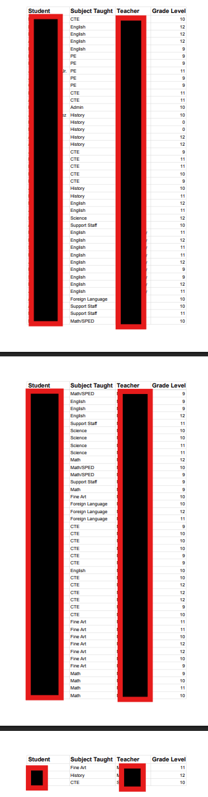

- Describe in 1-2 paragraph(s) how you modeled and fostered effective collaboration and communication throughout the implementation of this project.

Throughout the Accountability Protocol Project, I modeled collaboration by consistently engaging staff in shared planning, transparent data discussions, and co‑facilitated professional learning sessions. I demonstrated effective communication by establishing clear agendas, documenting action items, and ensuring that project outcomes were visible and accessible to all stakeholders. By using data-collection spreadsheets and research notes, I demonstrated how information could be shared in ways that were both professional and supportive, setting the tone for a culture of openness and mutual respect.

I also fostered collaboration by distributing leadership responsibilities and inviting diverse voices into decision‑making. Teachers and students were encouraged to co‑design activities, such as the Give Them Their Flowers activity, and to reflect together on outcomes. Communication was strengthened through regular check‑ins and structured reflection opportunities, which helped stakeholders feel both informed and valued. This intentional modeling of collaborative practices not only improved implementation fidelity but also reinforced a professional culture where trust, shared responsibility, and collective problem‑solving were the norm.

PART 5: Accountability Report: In collaboration with the onsite mentor, school leadership, and faculty members, interns will demonstrate in their Accountability Protocol Project the capacity to evaluate, develop, and implement management, communication, technology, school-level governance, and operations systems that support student learning needs and promote the mission and vision of the school (NELP 6.1).
(a) Evaluate the Effectiveness of the Accountability Project
- Using an electronic survey tool (e.g., SurveyMonkey, Google Forms) create and distribute a survey with a minimum of five (5) questions to your onsite mentor, school leadership, and participating faculty members auditing the effectiveness of your accountability project. Attach or link the survey and the data outcomes as evidence. The link to the online survey must be functional and assessable by the university supervisor.

Survey Link: https://forms.gle/5RQffZDy3SfnBfSu7

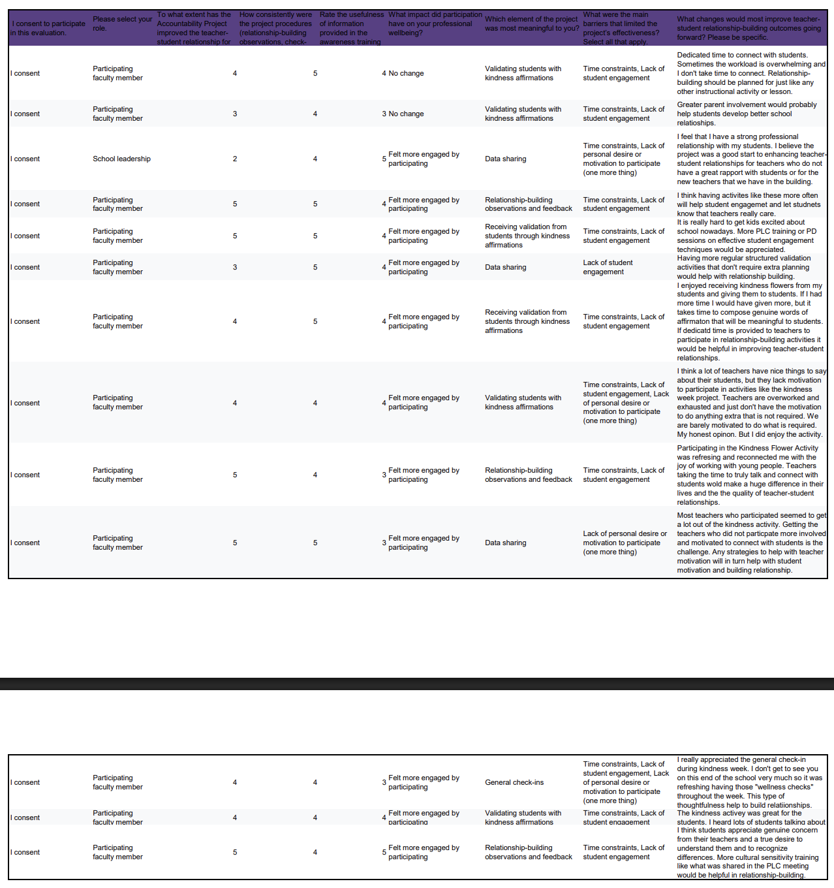
- Write a 2-3 paragraph synopsis of data outcomes, based on stakeholder feedback and personal observation, of the implementation and effectiveness of your accountability project and how/if it impacted the areas of management, communication, assessment, school-level governance (administration/leadership), technology, and operating systems.

Stakeholder feedback and personal observation indicate that the Accountability Protocol Project produced meaningful gains in communication and classroom-level engagement while leaving assessment and formal governance largely unchanged. Teachers reported that the Kindness Flower activity and related check-ins created dedicated opportunities to connect with students, and many described renewed energy and clearer rapport with students who received attention. Staff called the activity “refreshing” and noted that students discussed the flowers with peers. At the management level, the project encouraged small, practical shifts, scheduling brief wellness check-ins, and creating short, structured validation activities that made relationship-building more visible and repeatable for participating teachers. Communication improved through regular briefings and wellness check-ins that reached staff across the building. Still, these improvements were mostly operational and did not translate into changes in assessment practices, which remained unchanged. Leadership permission enabled the pilot, yet administrators were not deeply involved, so the project did not alter school-level governance or decision-making processes.
The data also highlights persistent constraints that limit broader impact: teacher workload and motivation emerged repeatedly as barriers, with many staff saying they are too overextended to add non-required activities even when they see value in them. Respondents recommended embedding relationship-building into the schedule as an instructional priority, offering PLC training or PD on student engagement and culturally responsive approaches, and designing validation activities that require minimal to no teacher planning, so participation does not add a significant time burden. Technology needs were minimal and met the project’s requirements. The tools used to create and copy flower signage were adequate, so tech was not a limiting factor. Operating systems and formal assessment structures likewise showed no measurable change, suggesting that for sustainability, the project must be paired with explicit administrative support (time allocations, role responsibilities, and PD) and targeted strategies to increase teacher buy-in so the initial positive effects on student experience and teacher-student relationships can be scaled schoolwide.
- Considering your personal observation and the outcomes of your surveys with stakeholders, discuss in 1-2 paragraph(s) obstacles or barriers you experienced in the implementation and effectiveness of your project, specifically in the areas of resource allocation, operational issues, time, personnel, technology challenges, and funding.

The primary obstacle for the pilot activity of the project was teacher and student buy-in to participate in the Give Them Their Flowers activity. To justify its need, the Accountability Protocol Project must gain the support of schoolteachers and students, who must buy into its purpose: to increase high-quality teacher-student relationships within Nottoway High School. Year-one needs—modest stipends for facilitators, substitute coverage for observations, and a small materials fund—were manageable, but scaling to Year 2 (trainings, expanded coaching, and full-time staffing) requires district buy-in that will be difficult to secure without stronger administrative sponsorship offering support for needed high-quality relationships in the building. Operationally, the project revealed schedule friction: finding consistent, protected blocks of time for relationship-building and forced trade-offs with other teacher responsibilities, and made regular participation uneven across departments. Time constraints were repeatedly cited by staff as a barrier. Many teachers reported being too overworked to add nonrequired activities even when they valued them, which reduced participation and limited the project’s reach. Personnel capacity was another constraint—teacher leaders carried additional duties without formal workload adjustments, which risked burnout and made fidelity fragile when key people were absent.

Technology and funding posed smaller but real barriers that affected efficiency and scale. For the Kindness Flower activity, available tech was adequate for creating signage, but more sophisticated data tools and personnel to track results would have reduced manual entry and reporting time. Funding beyond one-time materials and stipends is uncertain, so long-term roles remain aspirational rather than guaranteed, constraining strategic planning. The combination of limited funding, unclear role formalization, and insufficient schedule protection means that promising practices will depend on individual goodwill rather than embedded systems. Overcoming these barriers will require explicit administrative commitments—time carved into the master schedule, funded position adjustments, and modest technology investments—so that relationship-building and the project’s routines can move from pilot to sustainable practice.

- Analyze in 2-3 paragraphs, the impact of your project on resource allocation, personnel decisions, student experiences, and student development.

The Accountability Protocol Project redirected limited resources toward targeted supports that drive instruction: time was reallocated to regular PLC meetings and protected collaborative planning, materials were centralized for easy teacher access for the activity, and existing technology resources were utilized for data entry. That reallocation reduced redundancy and made it easier to see where small investments, such as a shared spreadsheet, a stipend facilitator, a weekly substitute, or a volunteer to plan relationship-building activities, would yield considerable gains in teacher coordination and follow-through. At the same time, the project surfaced trade-offs. When planning, and PLC time is protected, other initiatives need to be deprioritized, creating clearer choices about what the school values and will fund going forward.

Potential personnel decisions became more evidence-informed with teacher feedback from the protocol audit and supported requests for an instructional coach or data clerk to aid in tracking progress and identifying future needs, without adding additional strain to the existing student success team. Peer observation data identified staff who would most benefit from targeted mentoring in relationship-building. These findings justify role necessity and increase role clarity, helping leadership make defensible staffing and/or volunteer requests tied to measurable classroom supports rather than abstract needs. For some teachers, participation led to redistributed responsibilities (e.g., teacher-leaders taking on facilitator roles to implement the classroom engagement activity for students), which built internal capacity and reduced long-term reliance on external PD.

Student experiences and development showed early directional gains tied to more consistent teacher communication and having a window to voice student feelings about teachers who have positively impacted their lives. Students will benefit from predictable routines, knowing that they will have regularly scheduled opportunities to make meaningful connections with trusted adults in the school building. Over time, these changes will support stronger relationship-building practices and more equitable responses to gaps in perceived high-quality relationships between teachers and students, improving engagement and accelerating targeted skill growth for students who have previously been overlooked. Continued attention to workload balance and teacher motivation will be necessary to sustain these gains and translate initial improvements into measurable long-term growth in teacher-student relationship-building.
- Provide evidence in the form of attachments or functioning links of what data sources were analyzed and interpreted to determine the success of the implementation of your accountability project; provide a short explanation of each attachment. Data sources should include qualitative and quantitative data, formative/summative student assessments, teacher observations/evaluations, anecdotal reports, individual feedback, meeting notes, etc.

The table below illustrates teacher and student survey responses after the Give Them Their Flowers activity concluded. There was a 20% increase in the number of teachers who felt they had a positive relationship with students, and a 60% decrease in the number who felt they could improve their relationship with students. There was an equal 26.67% increase in the number of students who felt their teachers cared about them and in the number who felt their teachers did not care about them.

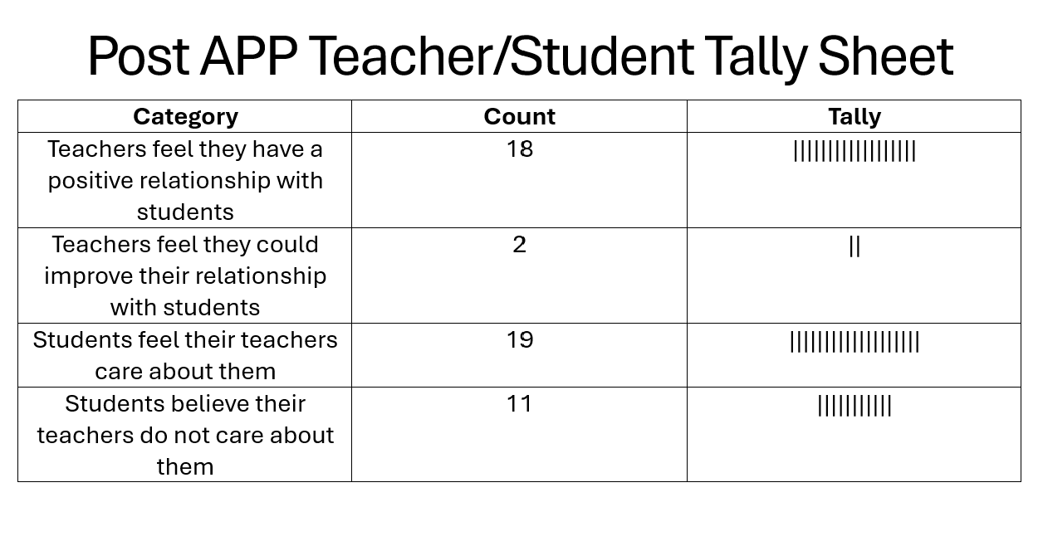

(b) Sustainability
- Identify in 1-2 paragraph(s) how your accountability project informs strategic and tactical challenges to the school’s systems.

Strategically, the Accountability Protocol Project sharpened the school’s ability to prioritize initiatives by translating broad improvement goals into concrete, measurable practices that leadership can justify. The project produced evidence about the types of activities and routines that will foster increased high-quality teacher-student relationships and yield the highest return on an improved school climate, allowing budgets and professional learning investments to be aligned with documented impact. It also exposed important trade-offs: protecting collaborative planning time and adding wellness checks, among other culture-enhancing initiatives, to leadership strategies to improve teacher morale. Strategic choices about long-term investments (for example, hiring an instructional coach for relationship-building or a data clerk) must be weighed against short-term needs. By supplying role-specific data from observations and feedback cycles, the project supports more transparent, evidence-based personnel requests and long-range staffing plans. Over time, this alignment reduces waste, focuses resources where they matter most, and creates a clearer strategic narrative for stakeholders about how resources produce student belonging and engagement gains.

Tactically, the Accountability Protocol Project identified day-to-day operational barriers that limit consistent implementation and must be addressed to ensure sustainability. In practice, inconsistent adoption across departments and insufficient scheduled time for making meaningful connections with students reduced the initiative’s fidelity and diluted early gains. Tackling these issues requires concrete changes: revising the use of planning or PLC time so the work required for meaningful connections with students and parent outreach does not become an extra task, increasing teacher involvement in student success team meetings with students, and assigning clear facilitator responsibilities for future planned relationship-building activities. The project also showed the value of small process fixes that reduce teacher workload while maintaining accountability, making tactical improvements both feasible and acceptable to staff. When these operational adjustments are implemented, the school can preserve instructional momentum and translate initial improvements into reliable, system-wide practices.

- Provide a 1-2 paragraph(s) narrative detailing how your accountability project promotes continuous and sustainable school improvement.

The Accountability Protocol Project builds continuous improvement by embedding routine data-driven administrative strategies for improving teacher morale and motivation to make meaningful connections with students and parents into everyday practice so decisions are timely, transparent, and tied to student learning. Regular check-ins, brief coaching cycles, and shared databases create predictable rhythms for reviewing evidence, testing minor changes, and scaling what works, which reduces reliance on one-off initiatives and external consultants. By concentrating on low-burden, high-impact practices—shared monitoring tools, short collaborative planning windows, and quick fidelity checks—the project minimizes added workload while increasing instructional consistency, making sustained adoption more realistic for staff. It also cultivates distributed leadership: teacher-leaders and facilitators take ownership of initiatives to build a favorable school climate, thereby growing internal capacity and preserving institutional knowledge should roles shift. Over time, these mechanisms produce iterative refinements rather than episodic reforms, so improvements accrue cumulatively and become part of the school’s operating system.

Sustainability is reinforced by linking resources and personnel decisions to observable results, thereby strengthening the case for targeted investments and institutional support. The project’s evidence base makes it easier to justify hiring decisions, schedule adjustments, or modest resource allocations that support fidelity, and it provides concrete metrics for monitoring return on those investments. Built-in feedback loops ensure practitioner voice shapes adaptations, increasing relevance and buy-in and reducing resistance that often undermines long-term change. By emphasizing simple, repeatable protocols and short-cycle evaluations, the project creates a resilient improvement process. When challenges or staff turnover occur, the school can reintroduce practices quickly and continue refining them without restarting from scratch.

- In a table, show a multiple-year (year 1, year 2, year 3) resourcing plan aligned with your school’s vision, mission, and improvement processes listing what is needed for assessing and maintaining the necessary resources for the sustainability of your project.

Multi-year resourcing plan (Year 1–3) aligned to school vision, mission, and improvement processes

This table summarizes the core resources, yearly investments, and how each will be assessed and maintained to sustain the Accountability Protocol Project while supporting the school’s mission for equitable, student-centered learning that uses data and collaboration to improve instruction. Each yearly cell lists the primary action or allocation for that resource; assessment and maintenance notes indicate the metric or process used to confirm ongoing need and fidelity.

Resource | 2025-2026 (launch) | 2026-2027 (scale) | 2027-2028 (sustain) | Assessment and maintenance
Protected collaborative planning time | Schedule weekly 30–45 min planning time for relationship-building activities; pilot in two departments | Expand dedicated planning time to all departments | Maintain dedicated planning time in master schedule; Establish full-time facilitator role ($40K) | Track meetings held; attendance %; teacher survey on usefulness; admin review quarterly
Instructional coaching capacity | Fund substitutes for coverage for teacher-leaders ($20K) | Fund part-time coach or stipend for teacher-leaders ($30K) | Fund full-time coach; embed coaching in relationship-building evaluation cycles ($40K) | Coaching logs; pre/post teacher practice ratings; coach workload audit each semester
Data systems and tools | Standardize shared spreadsheet for data collection and sharing | Fund part-time data collection clerk/relationship-building activity planner ($25K) | Fund full-time data collection clerk/relationship-building activity planner with assigned duties ($35K) | Data completeness %; turnaround time for reports; annual cost-benefit review
Professional learning and materials | Hold two 90-min PD sessions; relationship-building strategies/cultural sensitivity | Offer quarterly refreshers; train teacher-leaders | Ensure annual refresh; onboarding module for new staff | Fidelity checklists; PD participation rates; post-PD application evidence
Substitute coverage/release time | Budget for 6–8 half-day subs for observations ($20K) | Increase to cover coaching cycles and peer observations ($40K) | Ongoing sub-budget allocated in annual staffing plan ($45K) | Number of observations completed; teacher feedback on release adequacy
Role clarity and personnel adjustments | Define facilitator and teacher-leader roles; update job descriptions | Adjust workload allocations | Institutionalize role in staffing chart; include in job postings | Role occupancy; time-use logs; inclusion in annual staffing requests
Small technology & materials fund | One-time allocation for printables, binders, and devices ($500) | Replenish consumables; minor hardware upgrades ($1K) | Line-item in instructional budget for upkeep ($2K) | Inventory checks; request turnaround time; fund utilization reports
Communication and stakeholder engagement | Launch monthly progress brief for staff and parents | Quarterly community briefings; leadership walkthroughs | Annual report included in school improvement plan | Stakeholder survey feedback; leadership review

PART 6: Communication of Results and Outcomes: In collaboration with the onsite mentor, school leadership, and faculty members, interns demonstrate the capacity to communicate through oral, written, and digital means with the larger organizational, community, and political context when advocating for the needs of their school and community (NELP 5.3).
- Considering your multi-year resource plan, in 1-2 paragraph(s) discuss your resource plan in relation to the district and policy context of your internship site.

The multi-year resource plan is designed to align with the district’s budgeting cycles, staffing processes, and existing policy constraints so requests are realistic and defensible. In Year one, we prioritize low-cost, high-impact investments (protected planning blocks, protocol templates, modest stipend coverage) that can be absorbed within school-level discretionary funds or reallocated end-of-year funds, making early wins feasible without awaiting district approval. Budgetary items requested in year two are framed as targeted, measurable investments tied to demonstrated year one outcomes so district leaders can see return on investment during mid-cycle budget planning. The plan explicitly anticipates policy realities, so each request includes options for phased implementation (stipend positions versus FTE comparisons) and clear metrics that speak to district priorities (equity, achievement, and cost-effectiveness). By packaging requests with evidence from our pilot year, an itemized cost-benefit narrative, and named responsible parties, the plan supports advocates in making concise, policy-aware cases to central office and school boards.

To sustain the plan politically and operationally, communication tactics are embedded across years so stakeholders see progress and can authorize follow-on resources without repeated advocacy. Quarterly briefings for district curriculum and finance leads, anonymized evidence summaries for school board packets, and short practitioner testimonials linked to student progress create multiple entry points into the district’s decision-making channels. The plan also proposes alignment with existing district initiatives (e.g., school improvement goals, professional learning priorities, Title allocations, where eligible) to reduce perceived competition for funds and maximize the likelihood of braided funding. Attention to timelines and the submission of stipend/FTE proposals ahead of fiscal year budget planning workshops, aligned with district procurement cycles, reduces friction and shows respect for administrative processes, which builds trust. Ultimately, the combination of staged requests, clear evidence, and proactive stakeholder communication increases the likelihood that the district will absorb successful elements into routine budgets and policy, making the Accountability Protocol Project sustainable beyond the internship.

- Considering your communication strategies, discuss in 1-2 paragraph(s) how you advocated for the needs of your school and your community during the implementation and execution of your accountability project.

I framed advocacy around evidence and educator voice to ensure school and community needs guided every implementation step. I regularly shared concise, data-focused briefs from teacher check-ins with the school administrator, highlighting concrete staff and student engagement and feedback. Teacher-reported impacts on workload determined teacher needs. Requests for time to meet individually with students, to contact parents, or to take a restroom break were tied to observable returns rather than abstract appeals. I elevated faculty perspectives by sharing anecdotal notes with building administration to explain the need for classroom intervention or improved leadership support strategies. This advocacy provided teachers with a platform to present their experiences and/or concerns to leadership, thus distributing the advocacy burden and making requests more credible. I also discussed the activity audit details with the building principal, providing charts that display staff participants’ feedback for his later review and consideration for future implementation. This data tracking was used to guide the three-year resourcing plan, which builds momentum for resource commitments.

I connected school-level needs to community and district priorities to broaden support and reduce competition for scarce resources. I highlighted alignment between the project’s goals (equity, measurable student growth, professional capacity-building) and district strategic metrics when discussing year two and year three requests, showing how modest investments would advance systemwide goals. I navigated policy constraints proactively by proposing phased options and timing formal requests to align with district budget cycles. Transparency is maintained by sharing results, acknowledging limitations, and proposing realistic next steps, positioning the project as a collaborative, evidence-driven effort rather than a unilateral demand.

- Provide a table with 2 columns that list the types of communication used in the left column (e.g., oral, email, workshops, meetings, website, newsletter, etc.) and the audience in the right column (e.g., parents, students, teachers, district office, administration, community) for each communication. Attach evidence, such as a link, a transcript, an email, a script, etc., for each type of communication listed on the table. (Test any internet links to ensure that they are functioning.)

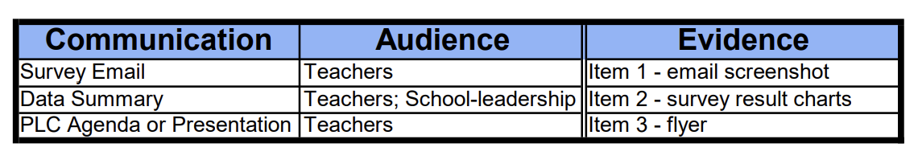

Item 1 – Survey Email

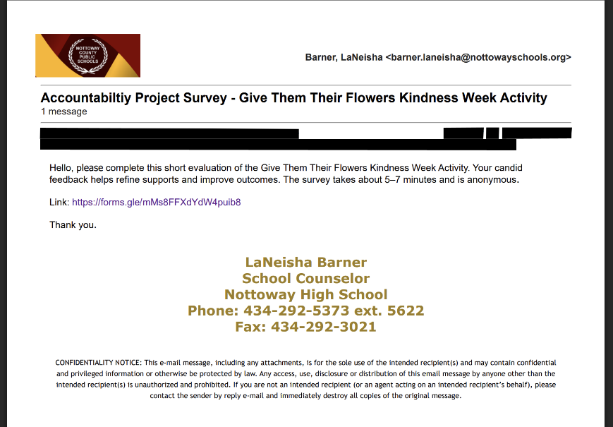

Item 2 – Survey Results Charts

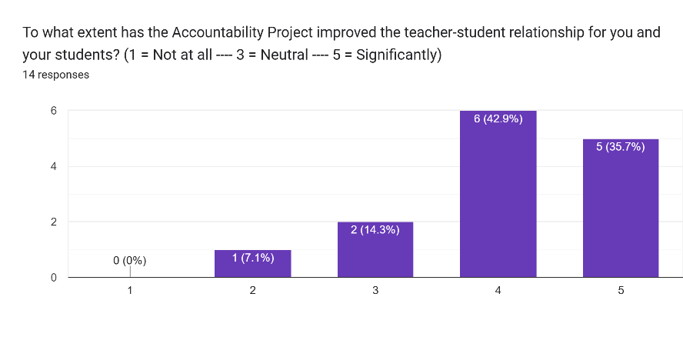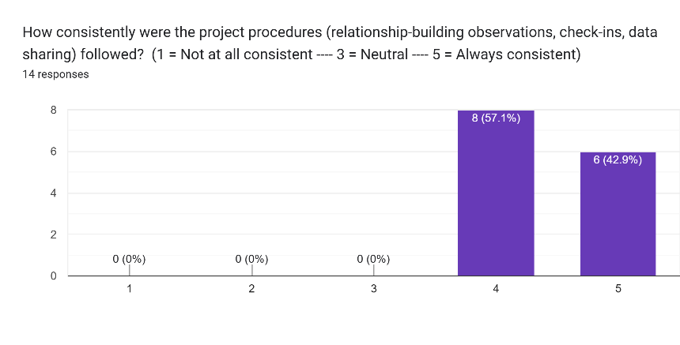

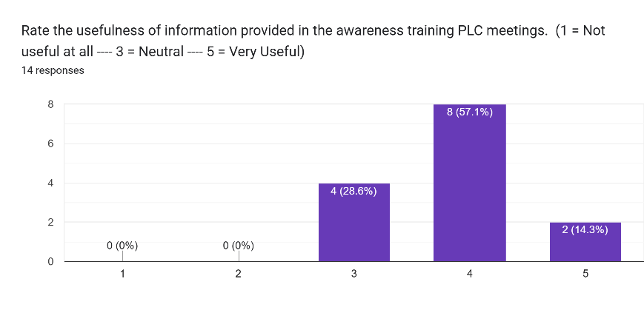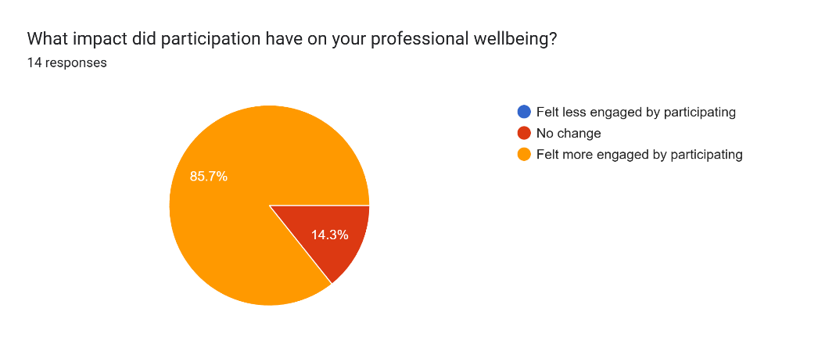

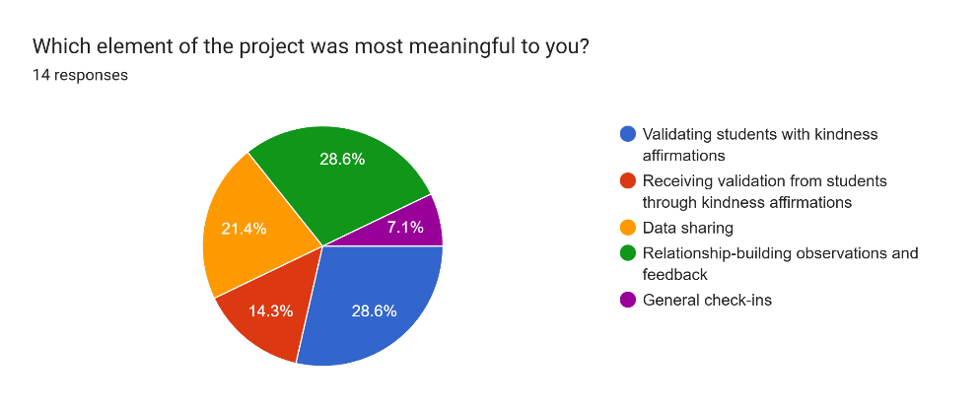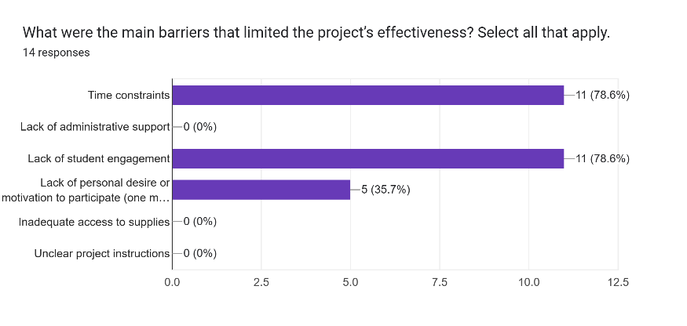

Item 3 – PLC Flyer

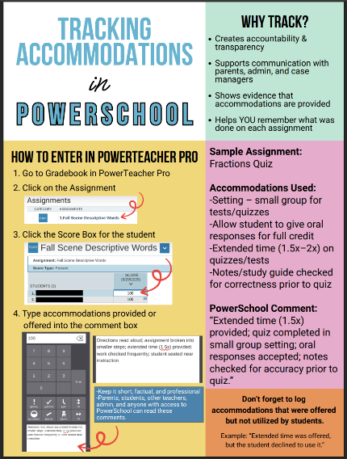

- Discuss in 1-2 paragraph(s) how the items on your communications table informed the larger organizational, community, and political contexts when advocating for the needs of the school community.

The mix of oral, written, and digital communications created multiple, targeted entry points that moved the Accountability Protocol Project from a classroom-level initiative to a district-relevant case for support. PLC meeting presentations and observational feedback built internal consensus and surfaced classroom-level evidence that became the foundation for requests to administration, while weekly in-person check-ins enhanced teacher morale and made staff feel recognized by office personnel. Data briefs and the survey summary translated practitioner experience into concise metrics and visualizations that will resonate with district office staff and school board members, helping to reframe requests as evidence-based investments. Parent contact results extended transparency to families, generated informal public support, and reduced friction between the school and the community. Together, these channels ensure that advocacy is not a single plea but a coordinated narrative showing impact, feasibility, and alignment with district priorities. In sum, the communications strategy translated building-level relationship-building practices into a multi-audience advocacy campaign that grounded the need for enhanced teacher-student connections to credible evidence and sustained teacher buy-in.

