Community Resources Alignment Project: Demographic Study

LaNeisha M. Barner
School of Education, Liberty University

Author Note
LaNeisha M. Barner
I have no known conflict of interest to disclose.
Correspondence concerning this article should be addressed to LaNeisha M. Barner. Email: lbarner@liberty.edu
Abstract
This research aims to review demographic factors that impact the community of Nottoway County. This study gathers demographic statistics, analyzes those data, and explains the related implications of those data on the community and schools within. These aspects highlight how socio-economic factors such as income, employment, poverty level, race, and residential stability impact academic outcomes for school-age students in Nottoway County. It is hypothesized that school demographic statistics will indicate community demographics, and the graduation and dropout rates will provide insight into community needs.

Demographic Study
Understanding the demographic structure of Nottoway High School and the community of Nottoway County provides valuable information that can be used to assess educational needs. A greater understanding of needs increases opportunities for student academic success and educational outcomes. Aligning school and community needs and resources can achieve more significant academic progress.
The demographic make-up of Nottoway High School for the current school year consists of 509 students with the following classifications: Asian (~1%), African American (~45%), White (~37%), Hispanic (~11%), Multiple Race Categories (~6%). The 2024 graduation rate of 93.8% is up ten percent from the previous year. The 2024 dropout rate of 4.65% is down 8.21% from the prior year. These numbers are expected to reflect the county’s community race/ethnicity and socioeconomic makeup. The most up-to-date statistics available are presented.
Nottoway County Demographic Data Report
Race/Ethnicity
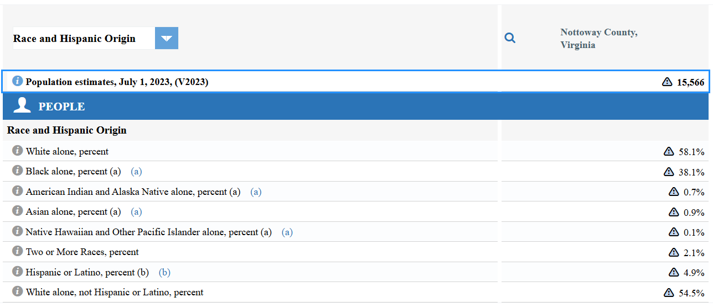
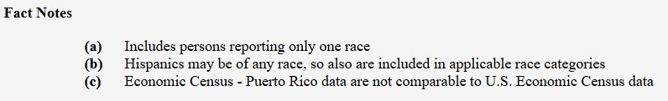
(United States Census Bureau, 2023)
Language
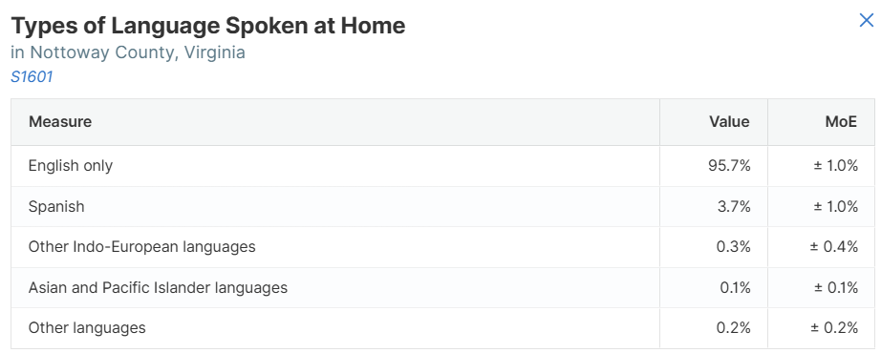
(United States Census Bureau, 2023)
Age/Gender
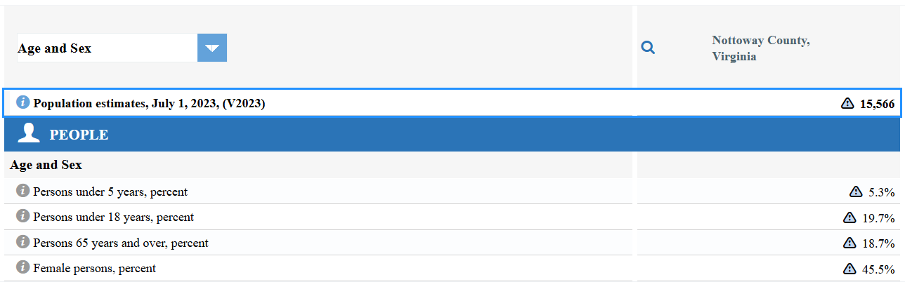
(United States Census Bureau, 2023)
Income/Socioeconomic Status
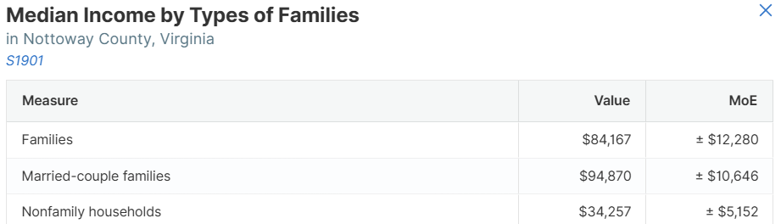
(United States Census Bureau, 2023)
Religion
Nottoway County, Virginia, is home to over fifty churches representing diverse religious denominations. The church community provides various outreach and support programs to assist the residents of Nottoway County with multiple needs. Per the Nottoway County, Virginia (2023) web resource, religious affiliations represented within the county include the following: Apostolic, Assemblies of God, Baptist, Catholic, Christian, Church of Christ, Church of God, Episcopal, Jehovah’s Witness, Methodist, Latter-Day Saints (Morman), Nazarene, Pentecostal, Presbyterian, and Seventh-Day Adventist.
Educational Attainment
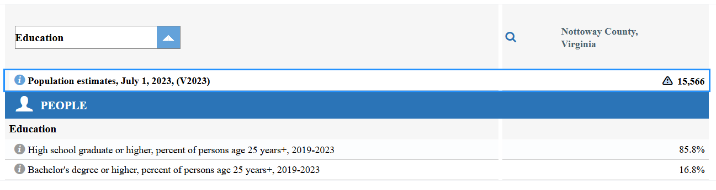
(United States Census Bureau, 2023)
Unemployment Rate
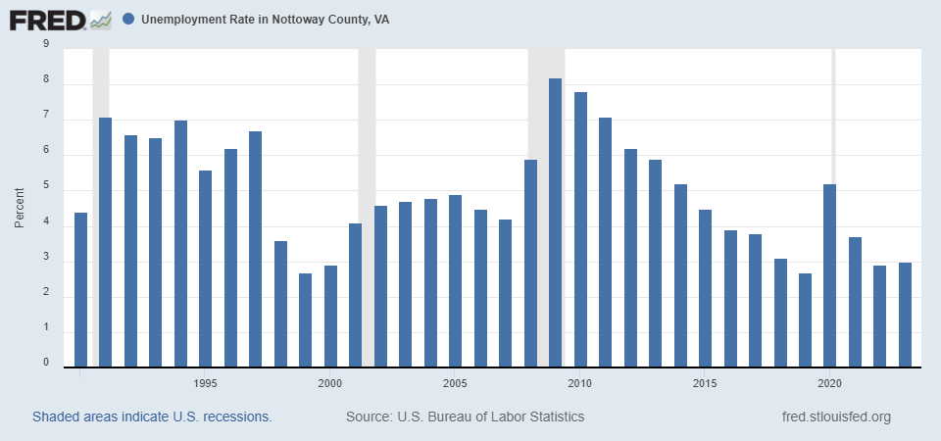
Nottoway High School Demographic Data Report
Race/Ethnicity
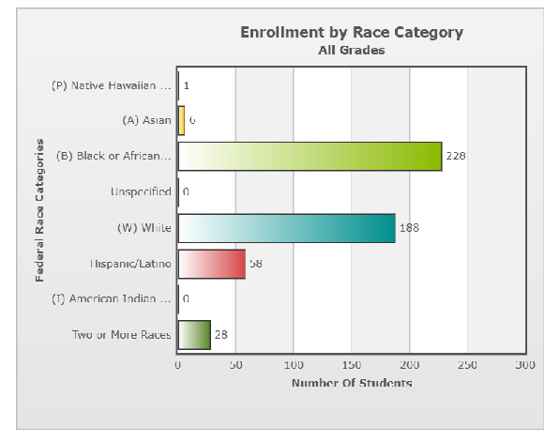
(Nottoway High School PowerSchool, 2024)
Language
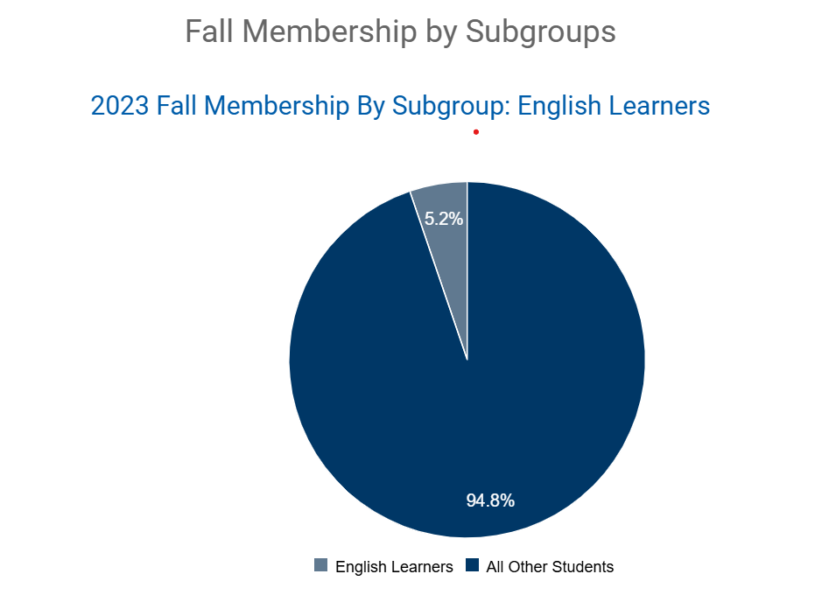
Source URL: https://schoolquality.virginia.gov
(VDOE Virginia School Quality Profiles, 2023)

Age/Gender

Enrollment Summary Report
Grade Level/Age | Total in Grade | (I) American Indian or Alaska Native | (A) Asian | (B) Black or African American | (P) Native Hawaiian / Other Pac Islander | (W) White | Hispanic/Latino | Two or More Race Categories | Unspecified
9 / 13-14 | 124  M 62 /F 62 | 0  M 0 /F 0 | 2  M 1 /F 1 | 56  M 26 /F 30 | 0  M 0 /F 0 | 41  M 20 /F 21 | 19  M 12 /F 7 | 6  M 3 /F 3 | 0  M 0 /F 0
10 / 14-16 | 150  M 74 /F 76 | 0  M 0 /F 0 | 1  M 1 /F 0 | 69  M 33 /F 36 | 0  M 0 /F 0 | 47  M 29 /F 18 | 23  M 9 /F 14 | 10  M 2 /F 8 | 0  M 0 /F 0
11 / 15-17 | 108  M 53 /F 54 / +1 | 0  M 0 /F 0 | 1  M 0 /F 1 | 40  M 21 /F 19 | 1  M 1 /F 0 | 49  M 22 /F 26 / +1 | 10  M 5 /F 5 | 7  M 4 /F 3 | 0  M 0 /F 0
12 / 16-19 | 127  M 61 /F 66 | 0  M 0 /F 0 | 2  M 1 /F 1 | 63  M 27 /F 36 | 0  M 0 /F 0 | 51  M 27 /F 24 | 6  M 4 /F 2 | 5  M 2 /F 3 | 0  M 0 /F 0
Total | 509  M 250 /F 258 / +1 | 0  M 0 /F 0 | 6  M 3 /F 3 | 228  M 107 /F 121 | 1  M 1 /F 0 | 188  M 98 /F 89 / +1 | 58  M 30 /F 28 | 28  M 11 /F 17 | 0  M 0 /F 0
The Federal Ethnicity and Race view displays aggregate student data as required by the Federal Ethnicity and Race Categories from the U.S. Department of Education.

(Nottoway High School PowerSchool, 2024)

Income/Socioeconomic Status
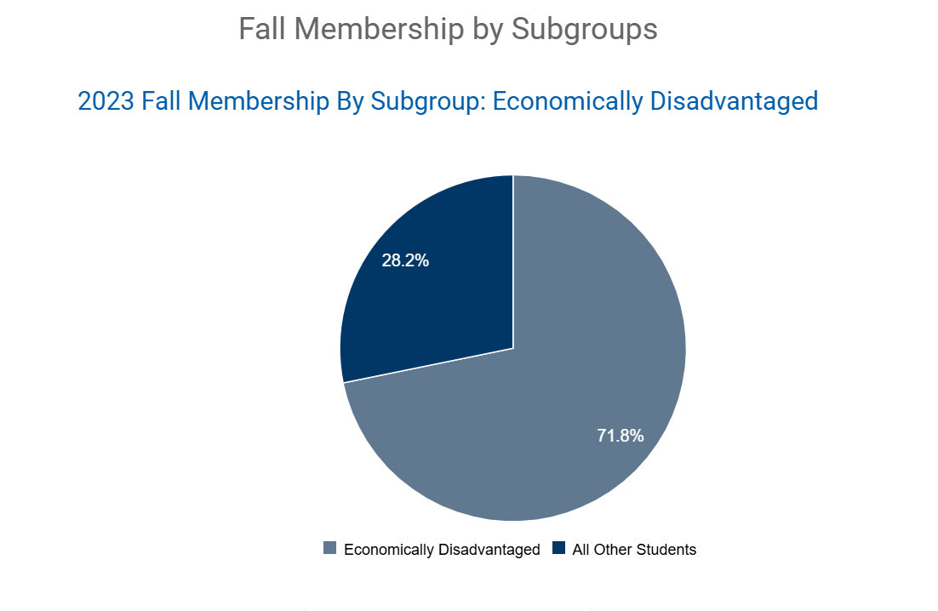Source URL: https://schoolquality.virginia.gov
(VDOE Virginia School Quality Profiles, 2023)

Educational Attainment
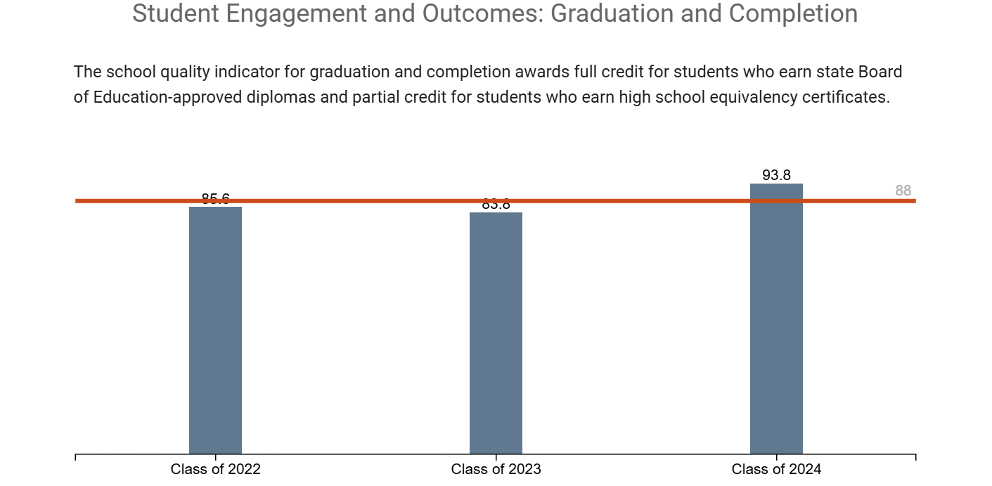
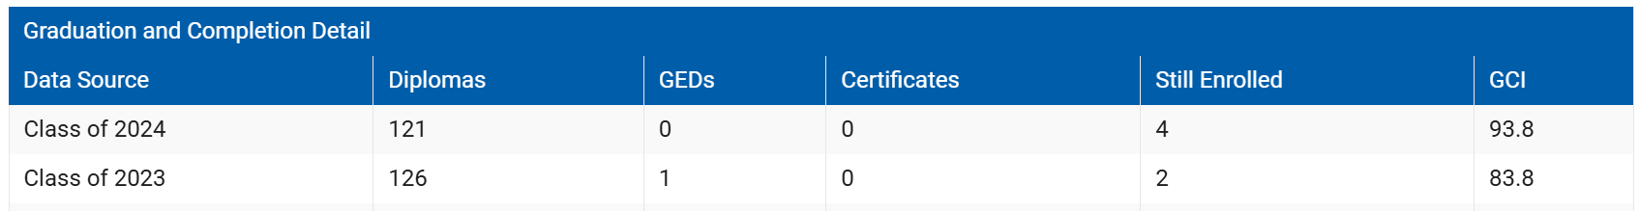
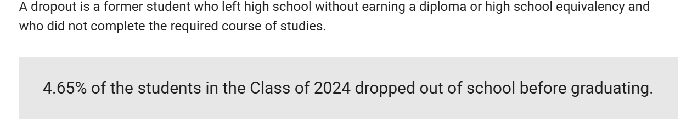
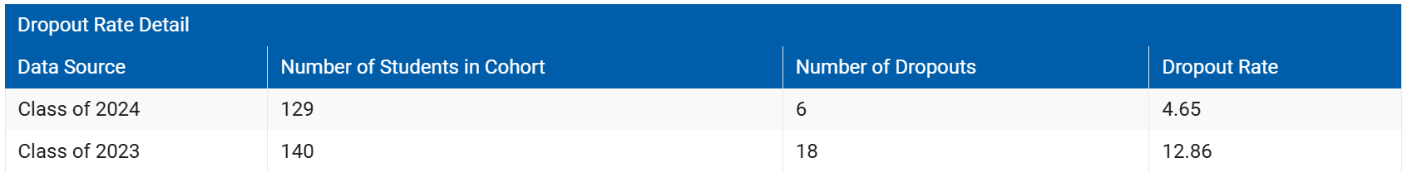
Source URL: https://schoolquality.virginia.gov
(VDOE Virginia School Quality Profiles, 2023)
Religion
Specific statistics on religious affiliations for students at Nottoway High School are not available.
Unemployment Rate of School Parents
Specific statistics on the unemployment rate of school parents for students at Nottoway High School are not available.
Demographic Data Analysis
An analysis of the data for Nottoway County compared to Nottoway High School reveals that most of the county’s race is White. In contrast, the race majority within the high school is African-American. Other race aspects are similar for the two entities. English is the primary language spoken in both the community and the school, with Spanish being distantly noted as the second most spoken language for both school and community. As a point of personal knowledge, it is worth noting that Spanish is the only foreign language course offered to students attending Nottoway High School. While females make up just under half of the community population, they make up just over half of the school population. Within the county, households with children have lower income levels than those without children, which aligns with the school statistical data of most enrolled students from economically disadvantaged families. Nottoway High School graduation and school completion rates for the past two years are comparable to Nottoway County community statistics for residents aged twenty-five or older who earned a high school diploma.
Noted similarities in statistics could indicate that those who graduate from Nottoway High School continue to reside locally within the community. The school community looks to the societal community as a support resource. Though the educational leader is traditionally recognized as an individual who is highly educated and visible in professional settings, leadership can be found in untraditional individuals and settings as well. Youssef (2013) Principle 17 explains how leaders can be found and developed in individuals who have not been seen as leaders in the past and may not view themselves as leaders. These characteristics may need to be discovered and polished to develop homegrown leadership outside of the classroom, but that will have a significant impact inside the classroom. The development of such partnerships within the community will support the district’s strategic plan objectives of “organization responsiveness and communication” and “building stakeholder engagement and support” (Nottoway County Public Schools, 2023, p. 2).
Implications
Nottoway High School follows the district’s strategic plan. This Nottoway County Public Schools Strategic Plan (2023, p. 1) expresses, “Educational accountability is a shared responsibility between student home, school, and community.” This shared responsibility places learners’ achievement in their hands and the hands of parents, with assistance provided by teachers, staff, and educational leaders within the school. Areas of importance impacting learners’ academic achievement and outcomes include physical presence or regular school attendance. The school system assists by providing transportation, but families must contribute by sharing the value of school attendance and participation.
School supplies and tangible resources are needed for students to feel prepared and capable of academic success in the school setting. Many community church groups and civic organizations hold back-to-school supply drives each year and donate these items to families and schools within the community to alleviate some of the financial strain placed upon families to prepare students for the school year. Community resource organizations such as the extension office have agents collaborating with the school system to provide workshops and supplies to students and families throughout the school year (County of Nottoway, 2023).
Another ideation from the Nottoway County Public Schools Strategic Plan (2023, p. 1) is that “every child can learn.” The importance of this concept is explored throughout this course. Regarding leadership styles and reinforcing the idea to stakeholders that each student can learn Youssef (2013, p. 151), Principle 14 is applied with the understanding that “authentic leaders turn doubters into believers.” Jesus continually works in His followers’ lives to show them their potential and work through others to encourage individuals’ personal growth. God wants each student and educator to realize the strength of their abilities. He wants “His children” to recognize that they “can learn” and achieve greatness.

References
County of Nottoway. (2023) Churches. Nottoway County. https://nottoway.org/community/about_nottoway/churches.php
Nottoway County Public Schools. (2023) Strategic Plan. Nottoway County Public Schools. https://drive.google.com/file/d/1-Y5G6aE_ceeY9osV8t80W05QWBqNqcen/view
Nottoway High School PowerSchool. (2024). Enrollment summary. Nottoway High School.
U.S. Bureau of Labor Statistics. (2023). Unemployment Rate in Nottoway County, Va. FRED, Federal Reserve Bank of St. Louis. https://fred.stlouisfed.org/series/LAUCN511350000000003A
U.S. Census Bureau. (2023). 2022 Age in Nottoway County, Virginia. U.S. Census Bureau. https://www.census.gov/quickfacts/fact/table/nottowaycountyvirginia/PST045223
Virginia Department of Education. (2023). Nottoway County Public Schools - Virginia School Quality Profiles. Virginia School Quality Profiles. https://schoolquality.virginia.gov/divisions/nottoway-county-public-schools#desktopTabs-3
Youssef, M. (2013). The leadership style of Jesus: How to make a lasting impact. Harvest House Publishers.

Community Resources Alignment Project: Needs Assessment

LaNeisha M. Barner
School of Education, Liberty University

Author Note
LaNeisha M. Barner
I have no known conflict of interest to disclose.
Correspondence concerning this article should be addressed to LaNeisha M. Barner. Email: lbarner@liberty.edu
Abstract
Discussions with stakeholders for Nottoway High School revealed the need for a more structured use of time by classroom instructors and the addition of specialized middle leadership positions to distribute responsibilities within the school and the district. While nationally, the education profession is experiencing a shortage of qualified teachers, which is reflected in Nottoway County schools by its placement of inexperienced or underqualified teachers and substitutes in the classroom, it is hypothesized that if instructional time is used with greater purpose, it will prove that there is adequate dedicated staff available to provide quality instruction to learners. There is a greater need for additional staffing in leadership positions that can support instructional staff when dealing with cases of repeat disciplinary offenders, technology issues, and overall communication within the school. If these areas of concern are addressed, other areas of need will, in turn, be resolved.

Community Resources Alignment Project: Needs Assessment
Nottoway County High School experiences issues common to rural school districts with limited staff. Teachers and administrators are held responsible for additional duties as assigned. These duties are required based on school and district needs. Staff contracts each year reference that employees are held accountable for “other duties as assigned” by administrative leaders, who, too, wear many hats that must be juggled to ensure all necessary school operations are overseen and given proper attention. This needs assessment aims to acquire stakeholder insight into what areas can be improved to create a more productive work and learning environment within Nottoway High School. Student, staff, and parent input is examined. The needs assessment report makes recommendations for institutional change and improvement.
Collaboration and Communication
Students, staff, and parents are surveyed annually to determine school needs as perceived from each stakeholder’s perspective. Once the results are compiled, school leaders share findings with stakeholders. In my years of experience working for Nottoway County Public Schools, the administration has not made noticeable changes after reviewing survey results. Collaboration to carry out the survey occurs, but follow through for change after receiving this communication is not recognized by stakeholders.
For this assessment, I decided to converse with a small selection of stakeholders to evaluate their report of need compared to last year’s annual survey. Stakeholders interviewed for this needs assessment included a student in grade eleven at Nottoway County High School, a parent with a child attending Nottoway County High School who is also a school employee and Nottoway County High School’s assigned resource officer. This variety of stakeholders allows for various vantage points in areas of need for the school.
Student concerns center on classroom management and the use of instructional time. Parent/employee concerns were over effective communication between the school, families, teachers, and students. Resource officer concerns included upper-administration micromanagement of staff and building-level administrators, who were spread too thin to complete essential tasks efficiently and in totality. When building-level administrators and staff are pulled in many directions regularly, it creates inconsistencies in procedures and the inability to handle crucial tasks accurately and thoroughly.
To relay these concerns, it is suggested that a safe environment be created where students, parents, and staff feel comfortable having candid conversations with administrative decision-makers. Once school decision-makers devise feasible actions the school can take to address stakeholders’ concerns, it is suggested that a semi-open forum such as a school board meeting be used to share intended action items the school will take on in response to stakeholder concerns.
Interview
The grade eleven student identified the strategic use of class time as an issue. Classes at Nottoway High School are 90 minutes long, with four classes each day. This student expressed that their teachers do not use the entire time for instruction, and the independent or group work does not take much time to complete, resulting in considerable unstructured time during class. This shed light on the idea of the existence of time poverty for adequate teacher preparation versus insufficient knowledge of proper use of time among teachers and a possible need for professional development for teachers who do not bring the background of an educational professional with them to the profession and the classroom (Creagh et al., 2023). Additionally, in some classes, with teachers who did not have sufficient classroom management skills or in classes that had a challenging combination of students, discipline became an instructional issue for the teacher. It also distracted students trying to focus on assignments.
The dual-purposed parent-employee interviewed was concerned that communication from their child’s teachers was non-existent or inconsistent. Some teachers would call, text, or email, while others did not communicate with parents at all other than during parent-teacher conferences or by report card or progress report. The preferred method of communication seemed to be a weekly class newsletter that one teacher shared electronically through Canvas and email. This was viewed as effective because of its regularity, predictability, inclusiveness of all pertinent classroom information, and conciseness. This letter went out to all students and parents, and if individual communication were required, the teacher would either call or send individual emails to specific parents. From the employee perspective, it was shared that connecting with some parents was a challenge. Frequently, parents would not respond to correspondence, and contact information would be inaccurate. Parents who were contactable or who showed up for conferences often are those of students doing well academically. Additionally, it was noted that teachers must regularly cover classes during planning periods due to insufficient substitute teacher availability.
A Nottoway County Sheriff’s Department Seargent serving as a school resource officer for Nottoway County High School shared that building-level administrators are regularly unavailable for building-level needs during the school day because they are pulled away from the office or building for excessive meetings. Students notice this and take advantage of the absence of administrative presence in the building. This gives leeway to disciplinary issues and disputes that could be avoided with greater visibility. If additional middle-level administrative leaders were on staff, it is believed that a portion of the disciplinary issues that occur would not be of consequence (Lipscombe et al., 2023). It was shared that students tend to find ways to get away from class to meet up with peers for mischief. With the size of the building, multiple administrative eyes are necessary to keep mischievous behavior to a minimum. Increased surveillance cameras in the building are helpful when investigating and working to resolve issues, but preventing undesired student behavior is ideal.
Identified Needs
School and community needs that school-community partnerships could meet include increased student supervision at the start and end of the day and during lunch. Community church groups have offered their presence in the building to serve as mentors. These community members who are retired or available during school hours could be present at lunch and the start and end of the day. They are willing to work with Nottoway High School students and staff to forge positive relationships. Partnerships between these individuals could also spill over into the instructional realm since most volunteers are retired professionals in various career fields. Volunteers could share their work experiences and assist instructional staff in developing career paths, interests, and skills with students. This conversation could be held between the church members and building administrators to recruit them as regular building volunteers.
The current community partnership with the Nottoway Sheriff’s Department, which provides school resource officers in each school building in the district, provides a valuable programming resource for the school system. These resource officers provide push-in lessons to the classroom to discuss social-emotional learning topics such as bullying, character development, and substance abuse prevention. The presence of these officers in the school building also builds increased trust between students, parents, and police officers in the community. This is the first school year that each school building has had a dedicated resource officer. A positive impact is noticed when observing interactions between students and officers. In pointing out the relationship needs between the community, the school system, and law enforcement, it is important to remember that significant change does not happen all at once. However, over time, many changes can come to fruition through active efforts from all stakeholders who stand to benefit from change (Blank et al., 2023). When gradual change occurs, it allows for the cleansing of unfit actions, thoughts, and beliefs, making room for order and sense to take root (New International Bible, 1978/2011, Luke 11:24-25). This is God’s chosen fashion of engaging positive change.

References
Blank, M., Harkavy, I., Quinn, J., Villarreal, L., & Goodman, D. (2023). The Community Schools Revolution: Building Partnerships, Transforming Lives, Advancing Democracy. Collaborative Communications Group, Inc.
Creagh, S., Thompson, G., Mockler, N., Stacey, M., & Hogan, A. (2023). Workload, work intensification and time poverty for teachers and school leaders: A systematic research synthesis. Educational Review, 1–20. https://doi.org/10.1080/00131911.2023.2196607
Lipscombe, K., Tindall-Ford, S., & Lamanna, J. (2023). School middle leadership: A systematic review. Educational Management Administration & Leadership, 51(2), 270–288. https://doi.org/10.1177/1741143220983328
New International Bible. (2011). The NIV Bible. https://www.thenivbible.com (Original work published 1978)

Community Resources Alignment: Resources Report

LaNeisha M. Barner
School of Education, Liberty University

Author Note
LaNeisha M. Barner
I have no known conflict of interest to disclose.
Correspondence concerning this assignment should be addressed to LaNeisha M. Barner.
Email: lbarner@liberty.edu
Abstract
On average, Nottoway County household incomes fall nearly $30,000 below the average household income for the Commonwealth of Virginia (United States Census Bureau, 2023). All students in this school district qualify for free lunch, with the district meeting the 2023 Community Eligibility Provision threshold of 25% of students being certified to receive free school meals through qualifying for family financial assistance programs. With Nottoway County being a low-income area, it is vital to have various community resources available to assist families in navigating the economic, social, and emotional hardships they encounter. This report identifies community resources available to residents of the Nottoway community. Public social services agencies, private non-profit organizations, counseling services, and local businesses providing aid to families of Nottoway are detailed.

Community Resources Alignment: Resources Report
Nottoway County consists of three rural towns, Blackstone, Crewe, and Burkeville, having a combined 2023 population of 15,566 (United States Census Bureau, 2023). It has two elementary schools, Blackstone Primary School (PK-4) and Crewe Primary School (PK-4), and one each, intermediate, middle, and high schools, Nottoway Intermediate School (5-6), Nottoway Middle School (7-8), and Nottoway High School (9-12). With the school district serving 1,818 students total for the 2023-2024 school year and the population of the county being 15,566 with 6,799 housing units in the county for the year 2023, the school system touches nearly 27% of households in Nottoway County (Virginia Department of Education, 2023; U.S. Census Bureau, 2023).
The total enrollment at Nottoway High School for the 2024-2025 school year is 505 students (Nottoway High School PowerSchool, 2024). This is down from the 537 students enrolled in the 2023-2024 fall membership count for the Virginia Department of Education (2023). With declining school enrollment, educational leaders must examine the needs of the school and community and collaborate with community stakeholders on effective strategies to revive and sustain the population of Nottoway County and the enrollment of students in our schools. This collaboration benefits the economy of Nottoway County and aids in maintaining local, state, and federal funding for the public school system. This summary emphasizes the extensive support available to students and families in Nottoway County and focuses on enhancing educational and social outcomes through community partnerships. This list highlights available community resources for students and families in Nottoway County.

Annotated Directory
Public Social Service Agencies
Public social service agencies available to Nottoway County residents and the Nottoway County Public School system provide the public with a feeling of safety and security. These services are available to stakeholders as needed. Emergency services are requested while school-level services, such as the presence of school resource officers, are available during regular school day operations.
Organization/Service: Nottoway County Emergency Services
Resources/Services Provided: Nottoway Emergency Services collaborates with the school system to provide education to prevent drunk driving, including accident and response team simulations. Staff training and professional development opportunities for emergency response services are provided along with community emergency response services and education programs.
Contact Information:
Name – Aubrey W. “Buddy” Hyde, Jr.
Address – P.O. Box 92, Nottoway, VA 23955, 344 W. Courthouse Rd, Crewe, VA 23930
Phone – 434-645-8696 (0), 434-645-8667 (f)
Website Link: https://nottoway.org/departments/emergency_management/index.php
Possible or Current Assistance to School: Yes, at request.

Organization/Service: Nottoway County Emergency Squad, Inc.
Resources/Services Provided: 911 emergency medical services are provided to the residents of Nottoway County in Virginia. On-site response team presence is provided at Nottoway High School sporting events, along with other medical services as needed for community engagements. Nottoway Emergency Squad provides CPR training for coaches and other school staff at request.
Contact Information:
Name – Brandon Jenkins, Executive Director
Address – 501 East Virginia Ave., Crewe, VA 23930
Phone – 434-645-7548
Website Link: https://sites.google.com/nottowayrescue.org/nottowayemergency/home
Possible or Current Assistance to School: Yes.

Organization/Service: Virginia State Police
Resources/Services Provided: The Virginia State Police provides a canine unit for periodic drug and weapons search and detection within Nottoway High School and for community needs deemed necessary by local law enforcement.
Contact Information:
Name – Ted Jones, Captain
Address – Area 7 Office, Petersburg, 2565 Simpson Road, Petersburg, VA 23803
Phone – 804-733-8219
Website Link: vsp.virginia.gov/
Possible or Current Assistance to School: Yes, at request.

Organization/Service: Nottoway Sheriff’s Office
Resources/Services Provided: The Nottoway Sheriff’s Office provides deputies for district school event presence, security, and protection. Services are provided for community engagement events and law enforcement for citizens of Nottoway County. School resource officers are designated for all Nottoway County district school buildings. Resource officers conduct classroom action programs on bullying identification and prevention, as well as Too Good for Drugs, Child Safe, Project Lifesaver, and Hidden in Plain Sight programs. The county Sheriff’s office provides Freedom of Information Act (FOIA) assistance for school district-related matters.
Contact Information:
Name – Robert L. Jones, Sheriff
Address – P.O. Box 6, 266 W. Courthouse Rd, Nottoway, VA 23955
Phone – 434-645-9044 (o), 434-645-1915 (f)
Website Link: http://www.nottowaysheriff.org/
Possible or Current Assistance to School: Yes.

Private Non-Profit Organizations
Private Non-Profit Organizations provide services to Nottoway County residents based on individualized needs and affordability. These services assist with specialized housing, living needs, and life-saving health needs. They may be free of charge or provided at a cost. Resources and services provided by these organizations allow residents access to essential life needs.

Organization/Service: Steps, Inc.
Resources/Services Provided: Steps, Inc. assists community members with housing, education, workforce, and economic development needs. Secure Document Destruction and Recycling services are provided to the school district. The support provided aims to empower community members to become self-sufficient and goal-oriented, improving their personal quality of life.
Contact Information:
Name – Katy Hamlett
Address – 225 Industrial Park Road, Farmville, VA 23901
Phone – 434-315-5909
Website Link: steps-inc.org
Possible or Current Assistance to School: Yes, at request.

Organization/Service: Southside Electric Cooperative
Resources/Services Provided: Southside Electric Cooperative provides scholarship opportunities for members/students. Educational and career exploration programs are offered for students through their Day in the Life of a Lineworker and Youth Tour programs. Community engagement service projects and economic development opportunities are available to the community. Electrical safety educational activities are available for children.
Contact Information:
Name – Joy Stump, Community Relations Coordinator
Address – 2000 W. Virginia Avenue, Crewe, VA 23930
Phone – 434-645-3219 (o), 434-294-5932 (c)
Website Link: sec.coop
Possible or Current Assistance to School: Yes

Organization/Service: Nottoway County Emergency Squad, Inc.
Resources/Services Provided: 911 emergency medical services are provided to the residents of Nottoway County in Virginia. The Nottoway County Emergency Squad, Inc. offers on-site presence and services as needed at Nottoway High School sporting events. CPR training is available for coaches and other school staff at request.
Contact Information:
Name – Brandon Jenkins, Executive Director
Address – 501 East Virginia Ave., Crewe, VA 23930
Phone – 434-645-7548
Website Link: https://sites.google.com/nottowayrescue.org/nottowayemergency/home
Possible or Current Assistance to School: Yes, at request.

Organization/Service: Crewe Volunteer Fire and EMT Department
Resources/Services Provided: Fire safety and emergency medical services are provided in Nottoway County. Fire and EMT personnel are present at Nottoway High School football games. The organization collaborates with the school district for the back-to-school parking lot party event.
Contact Information:
Name – David Roberts
Address – 1105 West Virginia Avenue, Crewe, VA 23930
Phone – 434-645-9549
Website Link: Facebook page - https://www.facebook.com/people/Crewe-Volunteer-Fire-Department/100064624452271/
Possible or Current Assistance to School: Yes

Counseling Services
Counseling services available to the community may be in the school building, in the home, or require transportation to the service provider’s office. Counseling services benefit those dealing with mental health concerns, help achieve family stability, and help students develop coping strategies to aid them in school success and life challenges.
Organization/Service: Crossroads Community Services Board
Resources/Services Provided: A Crossroads counselor is on-site for in-school student counseling, in-home counseling, counseling and behavioral health services, and case management for children and families. Crossroads provides on-site and in-office referral services.
Contact Information:
Name – Rebecca Johnson, MA
Address – 60 Bush River Drive, Farmville, VA 23901
Phone – 434-392-3187 (o), 434-808-9479(c), 434-391-1238 (f)
Website Link: N/A – Contact School
Possible or Current Assistance to School: Yes

Organization/Service: Fulcrum Counselors, LLC
Resources/Services Provided: School-based counseling is provided by Fulcrum Counselors, LLC. Family partnership is offered if required on a case-by-case basis. Trauma-focused recovery services and therapeutic mentoring are available, among other counseling services.
Contact Information:
Name – Shannon Kern, MA
Address – Fulcrum Counselors, 5301 Farmville Road, Farmville, VA 23901
Phone – 804-372-7016 (c)
Website Link: fulcrumcounselors.com
Possible or Current Assistance to School: Yes

Organization/Service: Jennifer Bunn, LPC Private Practice Counseling Services
Resources/Services Provided: Private counseling services are provided for community teens and adults. Specializations include issues such as depression, anxiety, trauma, PTSD, low self-esteem, emotional distress, and addiction counseling. In-person and video counseling are available.
Contact Information:
Name – Jennifer Bun, LPC
Address – 609 Church Street, Blackstone, VA 23824
Phone – 434-294-7486
Website Link: Facebook - https://www.facebook.com/Jenniferbunnlpc/
Possible or Current Assistance to School: No – Private Practice Community Services Available

Organization/Service: Nottoway County Social Services
Resources/Services Provided: Nottoway Social Services provides community public services and support for various types of abuse and neglect, child support and child care, medical assistance, food assistance, adult care and assistance, safe haven resources, foster care, and adoption.
Contact Information:
Name – Shannon Reed, Director
Address – P.O. Box 26, 288 West Courthouse Road, Nottoway, VA 23955
Phone – 434-645-8494
Website Link: https://www.dcfoffices.org/city/va-nottoway
Possible or Current Assistance to School: Yes, at request. Services provided to the community

Local Businesses
Local businesses are the heart and soul of small-town communities such as Nottoway County. They support the community’s economic development, provide a sense of community cohesiveness, and provide employment for the county’s residents. These businesses also contribute to the school system with charitable donations and acts of generosity that benefit students and staff.
Organization/Service: Wal-Mart
Resources/Services Provided: Wal-Mart employs Nottoway High School students and parents of Nottoway County Public Schools students. The business provides technology and gift card donations to Nottoway High School. Food and clothing donations are provided to local food/clothing pantries to support community needs.
Contact Information:
Name – Janice Johnson
Address – 1451 South Main Street, Blackstone, VA 23824
Phone – 434-292-5898
Website Link: Walmart.com/store/2645-blackstone-va
Possible or Current Assistance to School: Yes

Organization/Service: McDonald’s
Resources/Services Provided: McDonald’s employs Nottoway High School students and parents of Nottoway County Public Schools students. Gift card donations are provided to Nottoway High School, and food fundraising opportunities are available for Nottoway County Schools, including space for car washes and time slots for families to eat at the restaurant, with a portion of proceeds to be donated to a Nottoway County district schools to support students and educational needs.
Contact Information:
Name – Maurice Eppes, Associate (General Manager position currently vacant)
Address – 303 Main Street, Blackstone, VA 23824
Phone – 434-292-4977
Website Link: https://www.mcdonalds.com/us/en-us/location/va/blackstone/303-main-st/11035.html
Possible or Current Assistance to School: Yes

Organization/Service: Citizen’s Bank and Trust Company
Resources/Services Provided: Citizen’s Bank and Trust Company provides internship and employment opportunities for Nottoway High School students, as well as scholarships and job shadowing opportunities for local students. The bank is a vendor for back-to-school events for Nottoway County Public Schools and supports/sponsors staff during teacher appreciation week. The bank provides school supplies for students and offers financial literacy education to students and families of the community.
Contact Information:
Name – Lindsey May
Address – 101 North Main Street, Blackstone, VA 23824
Phone – 434-292-8171
Website Link: cbtva.com
Possible or Current Assistance to School: Yes

Organization/Service: Watkins Jewelers, Inc
Resources/Services Provided: Watkins Jewelers, Inc. collaborates with Blackstone Primary School and local church groups to provide food assistance to 20 students/families per month.
Contact Information:
Name – Polly Watkins
Address – South Main Street, Blackstone, VA 23824
Phone – 434-292-3230
Website Link: watkinsjewelers.net
Possible or Current Assistance to School: Yes

Gaps in Services
While educational leaders will agree that it is essential to provide employment opportunities for students who need to earn income to assist with household expenses or who desire to attain work experience, we are more concerned that employers understand that these young workers are students first. In my experience as a high school counselor and in my role as a member of our student success team, I have witnessed more occasions than I am comfortable with where underage workers are working full-time hours at part-time jobs. This practice has a negative impact on some students’ academic outcomes. Two areas where gaps are created by students working extensive hours are students missing out on the opportunity to engage in the high school student experience at full capacity and, more crucially, the impact on future career and economic potential if students do not meet graduation requirements due to work obligations. Excessive work hours during high school negatively impact student academic outcomes when excessive absenteeism persists. This has been noted during interventions with target students for the Nottoway High School student success team (Nottoway High School, 2024). On multiple occasions, representatives from the school have reached out to employers on behalf of our students to advocate for more reasonable hours for students without employment repercussions so that the students can focus on meeting graduation requirements.
Continuing with a focus on the economic forecast of Nottoway County but shifting to the impact for adults, gaps in additional areas are noticed. There is a lack of local jobs offering a living wage for adults in the household and a lack of opportunities for adults to further their education locally. Equity in transportation and advanced technology availability must be considered in Nottoway County. Many families do not have reliable transportation to travel a great distance for employment, so they must accept lower-paying local jobs. This factor also plays into students taking on “part-time” employment or not participating in school activities and tutoring opportunities due to the need to be home to tend to household responsibilities. Additionally, the lack of advanced technology, such as devices and internet connection, limits adults’ ability to explore online educational options. The nearest on-campus colleges (either two- or four-year) are thirty to forty-five minutes away by car, which is not plausible for some adults needing childcare after hours or who do not have transportation.

Conclusion
The Center for High School Success outlines in its roadmap to ninth-grade success the importance of relevant quantitative and qualitative data and having “school-level data champions” who possess strong data literacy skills (Center for High School Success, 2020, p. 3). Teams such as the student success team established at Nottoway High School, which structure and monitor the success of ninth-grade students transitioning to high school and seniors preparing for life after graduation, are vital to early and sustained student success. Such a team aids academic instructors by implementing intervention strategies that utilize available community resources such as those listed in this report. With proper support, instruction can be more effectively delivered by classroom leaders and received by young learners. Every action taken by the education system and community stakeholders should be carefully considered for their impact on our students, who are our future. In his book Engage Every Family (2021, p. 98), Constantino states, “We may think that these small gestures are not worth our trouble.” Still, he indicates that worldwide, successful organizations pay attention to the small details and value a positive stakeholder experience. School systems should take the same approach to the educational experience for staff and learners. They should utilize any community connections available to make learning a pleasurable experience for all stakeholders.

References
Center for High School Success. (2020). CHSS roadmap for 9th grade success. Center for High School Success. https://highschoolsuccess.org/
Constantino, S. M. (2020). Engage every family: Five simple principles. Corwin Press, Inc.
Nottoway High School PowerSchool. (2024). Enrollment summary. Nottoway High School.
Nottoway High School Student Success Team. (2024). Student success team minutes. Nottoway High School.
U.S. Census Bureau. (2023). QuickFacts Virginia; Nottoway County, Virginia. U.S. Census Bureau. https://www.census.gov/quickfacts/fact/table/VA,nottowaycountyvirginia/IPE120223
Virginia Department of Education. (2023). Nottoway County Public Schools - Virginia School Quality Profiles. Virginia School Quality Profiles. https://schoolquality.virginia.gov/schools/nottoway-high#fndtn-desktopTabs-enrollment

Community Resources Alignment Project: Advocacy Plan

LaNeisha M. Barner
School of Education, Liberty University

Author Note
LaNeisha M. Barner
I have no known conflict of interest to disclose.
Correspondence concerning this article should be addressed to LaNeisha M. Barner. Email: lbarner@liberty.edu
Abstract
The Community Resources Alignment Advocacy Plan aims to present practical, thoughtfully crafted strategies for implementation within Nottoway High School and the surrounding community of Nottoway County, Virginia. These strategies are proposed for the consideration of stakeholders and decision-makers within Nottoway’s school system, as well as for local service organizations that engage with our students. It is hypothesized that when community service providers share goals and values that are aligned with those of the school system, students will develop a stronger pride in both their school and community. This alignment is expected to foster an increased interest in academic success and help students formulate a clearer vision for their future career pathways.

Community Resources Alignment Project: Advocacy Plan
This community resource alignment advocacy plan aims to enhance public relations among educational leaders, school staff, and community figures dedicated to students’ well-being within Nottoway’s public education system. Its goal is to create brighter futures for each student by providing a strong educational foundation that equips them to succeed in higher education or the workforce. Through gradual yet continuous changes and advocacy for stronger school-community relationships, all students in the district will benefit at every level of education.
This advocacy plan will address school and community needs by enhancing communication among stakeholders and optimizing their time as a resource for improved instructional pedagogy. Drawing on feedback from the community resources alignment project needs assessment, these focus areas have been identified as needing enhancement. Available community resources will be evaluated as points of engagement for school improvement and the strengthening of community relations.
Advocacy for Meeting School-Community Needs
Since open communication among teachers, parents, students, and community stakeholders is an area needing improvement, the initial step for communication advocacy will involve implementing policies and procedures to ensure this outreach takes place. This will include weekly communication logs exchanged between classroom teachers and parents, documenting any interactions between the school and a student’s household for reference and staff accountability. Follow-ups to ensure completion can be managed by introducing middle leadership positions within the school that focus on school-to-family relations and communication. Placing these additional administrative advocates within the building will relieve the lead building administrator of this demanding yet necessary responsibility (Lipscombe et al., 2023). With this enhanced communication strategy, additional positive outcomes, such as a stronger professional bond between teachers and students, will be evident. Students will also be more likely to take pride in their academic progress when they feel supported by a positive system within the school (Martin & Collie, 2019).
Parents need to be informed about important school and classroom events on the educational calendar. This goes beyond band concerts and sporting events; it includes tests, presentations, and project deadlines as well. Parents should be made aware of upcoming assignments so they can advocate for student success and assist the classroom teacher in keeping students on track for academic achievement. If parents can observe their child giving a presentation or conducting an experiment, they should have the chance to witness their child’s academic achievements firsthand, just as they can cheer for them during extracurricular activities.
The second focal point addresses the effective use of instructional time. This concern relates to disruptive and problematic classroom behavior during instruction. Research indicates that strong teacher-student relationships positively impact “student outcomes such as reduced problem behavior, increased academic achievement, enhanced school engagement, and improved social standing among peers,” making it worthwhile for the school to invest time and resources into professional development on this issue (Poling et al., 2022, p. 100). With seven provisionally licensed teachers (22 for the district), nine out-of-field teachers (32 for the district), two inexperienced teachers (16 for the district), and two out-of-field and inexperienced teachers (15 for the district) on staff at Nottoway High School for the 2023-24 school year, and considering Nottoway is a small rural district, administrative leaders should responsibly implement district-wide professional development on efficient use of instructional time (Virginia Department of Education, 2023). This series of professional development opportunities will include sessions on curriculum alignment, classroom management, and cultural sensitivity to support all instructional staff. Current top-level educational leaders overseeing curriculum and development practices will be responsible for organizing this professional development series.
Community Advocacy for Communication & Distribution
Since Nottoway High School lacks a dedicated public relations professional, mid-level leaders will once again be utilized to lead community advocacy and communication efforts. Nottoway High School is fortunate to have two staff members shared among all district schools, who are housed in the building and responsible for school-community advocacy and family engagement. These individuals are ideally positioned to assist the school in raising awareness, communicating opportunities, and distributing information to promote the resources available in the community that can benefit Nottoway High School households. They will play a critical role in connecting families in need of services with community contacts that can provide assistance and help families achieve goals they may not have realized were attainable.
The school community advocate and family engagement coordinator will collaborate to create public service videos and flyers for display on the school website, social media platforms, and in local newspapers. Community outreach will be conducted with the local radio station to enlist their help in sharing school-community resources. Local restaurants will be contacted to request that they display flyers for patrons to see when visiting these local retail locations. These outlets will be updated regularly to ensure community members have access to the most accurate information from the school.

Advocacy for Sustained Access
Consistent access to community resources will require ongoing interaction with resource contacts and school personnel. This is where the school-community advocate position will be crucial. This individual will need to spend more time in the field than in the office. Regular meetings with contacts from each agency listed in the community resources report will be organized. It will be beneficial to form subgroup committees with similar resource agencies and designate a chairperson for each subgroup. With the establishment of these subcommittees and chairs, less time will be necessary to coordinate contacts from each agency. Instead, shorter, more focused interactions between the subgroup chair and the school leader will occur. The subgroup chair will rotate regularly to benefit both the community agencies involved and the school leader. This will enable all stakeholders to exchange information. Over time, improved communication between community leaders will strengthen both the school system and the community.
It may be challenging to schedule times and locations for consistent, meaningful meetings at the beginning of this collection of partnerships. However, this process will become smoother with time, as is often the case with worthwhile endeavors (New International Bible, 1978/2011, Luke 11:24-25). School leaders will need to model the desired changes. Transformational leadership from administrators who commit to this cause and prioritize their responsibility to foster change will be essential in establishing successful school-community public relations (Northouse & Lee, 2021). As staff, parents, and students observe a sustained commitment to addressing their concerns, support from these stakeholders will grow. Strengthening community relations has the potential to enhance parent interest and involvement in school initiatives, motivating both teachers and students. Increased motivation from parents and other community sources provides greater opportunities for students to benefit. These efforts will elevate the likelihood of classroom teachers delivering a positive and supportive social-emotional environment for learners, alongside higher quality teaching practices for educators (Hughes, J., 2012; Li et al., 2022).
Conclusion
Advocating for enhanced communication among teachers, parents, students, and community stakeholders and promoting professional development for educators focused on the meaningful use of instructional time will strengthen teacher-student relationships and positively influence classroom discipline. This professional initiative will address identified community needs and have a beneficial impact on instructional pedagogy. Steps to achieving this involve the intentional alignment of community resources and improved public relations efforts. The target audience encompasses school instructional staff, middle and upper-level administrators, parents, students, and community stakeholders. Sustained collaboration among these groups over time will foster an educational environment in which young learners at Nottoway High School can thrive academically, socially, and emotionally.
Enhancing communication between families and classroom teachers will help bridge the gap between Nottoway High School educators and households. This will facilitate increased parent engagement and improve public relations. Providing professional development for current staff at Nottoway High School will address concerns regarding the underutilization of instructional time. Additionally, it will support the growth of staff who enter the profession without formal educational training or teaching experience. Given the current national climate surrounding the education profession, this support for existing staff is crucial. The Educational Resources Alignment Project advocacy plan integrates Nottoway County’s demographic characteristics with the expressed needs of the school-community and available resources, aiming to address areas of weakness and enhance the school community over time.

References
Hughes, J. N. (2012). Teacher-student relationships and school adjustment: progress and remaining challenges. Attachment & Human Development, 14(3), 319–327. https://doi.org/10.1080/14616734.2012.672288
Li, X., Bergin, C., & Olsen, A. (2022). Positive teacher-student relationships may lead to better teaching. Learning and Instruction, 80. https://doi.org/10.1016/j.learninstruc.2022.101581
Lipscombe, K., Tindall-Ford, S., & Lamanna, J. (2023). School middle leadership: A systematic review. Educational Management Administration & Leadership, 51(2), 270–288. https://doi.org/10.1177/1741143220983328
Martin, A., & Collie, R. (2019). Teacher-student relationships and students’ engagement in high school: Does the number of negative and positive relationships with teachers matter? APA PsycNet, 111(5), 861-876.
New International Bible. (2011). The NIV Bible. https://www.thenivbible.com (Original work published 1978)
Northouse, P., & Lee, M. (2021). Leadership Case Studies in Education. SAGE Publications, Incorporated.
Poling, D., Van Loan, C., Garwood, J., Zhang, S., & Riddle, D. (2022). Enhancing teacher-student relationship quality: A narrative review of school-based interventions. Educational Research Review, 37, 100–459. https://doi.org/10.1016/j.edurev.2022.100459
Virginia Department of Education. (2023). Nottoway County Public Schools - Virginia School Quality Profiles. Virginia School Quality Profiles. https://schoolquality.virginia.gov/schools/nottoway-high#fndtn-desktopTabs-teachers

