Module 7 Data Presentation
School Counselor Mr. Alden May COSC 661


Explanation of Survey
PURPOSE: WE WANTED TO GATHER A
WIDE RANGE OF DATA THAT COVERED ACADEMIC, CAREER AND SOCIAL/EMOTIONAL NEEDS OF STUDENTS
TECHNOLOGY USED WAS GOOGLE
FORMS
THE FORMAT WAS 8 QUESTIONS
ANSWER OPTION: STRONGLY AGREE,
AGREE, NEUTRAL, DISAGREE, STRONGLY DISAGREE

This was a needs assessment that I created using google forms. The answers were all anonymous and the overall results can be shown in a graph. There were 5 answer options. The answered followed a lickert scale format. This is one of the options to conduct a needs assessment. (Young and Kaffenberger, 2019)

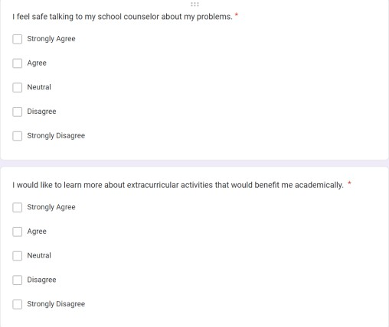
Survey Question Examples

Survey results
- Summary of survey results (narrative in the notes section)

For this needs assessment, we wanted to get a better understanding of the career, academic and social/emotional needs of the students. This survey consisted of 8 questions that covered career, academic and social/emotional questions. The questions were short and concise. We did not want to confuse students with long questions. The school counselors at our school are looking at the results of each question and coming up with different interventions that can be implemented to address the needs that came up in the results of the survey. Over all the results show that students have an interest in learning about different ways that they can be better in the career, academic and social/emotional areas of their lives. Also, the school counselors are going to try to meet with all of the students on a more regular basis.

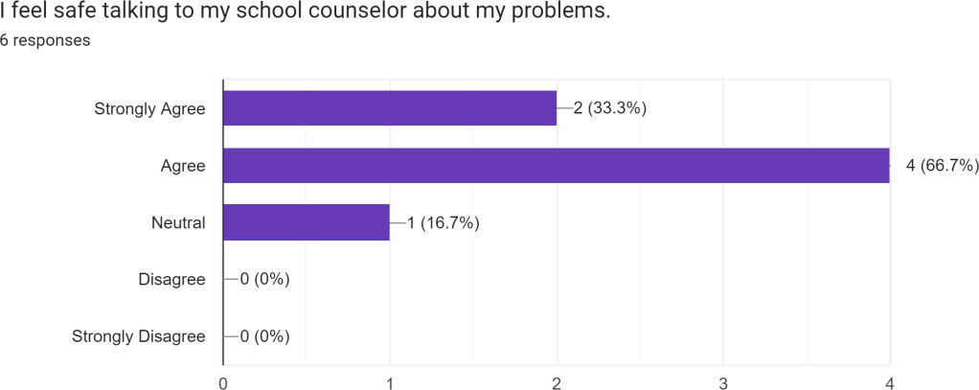

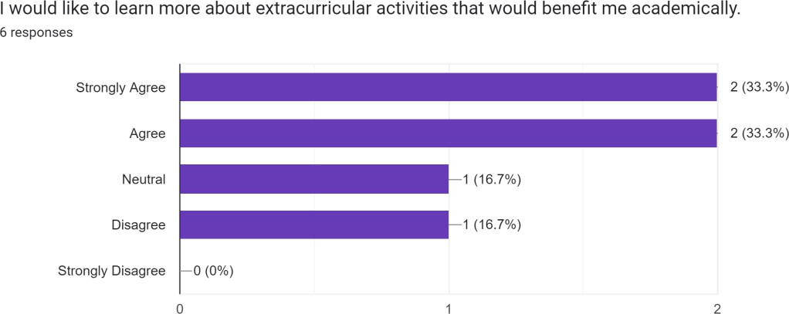

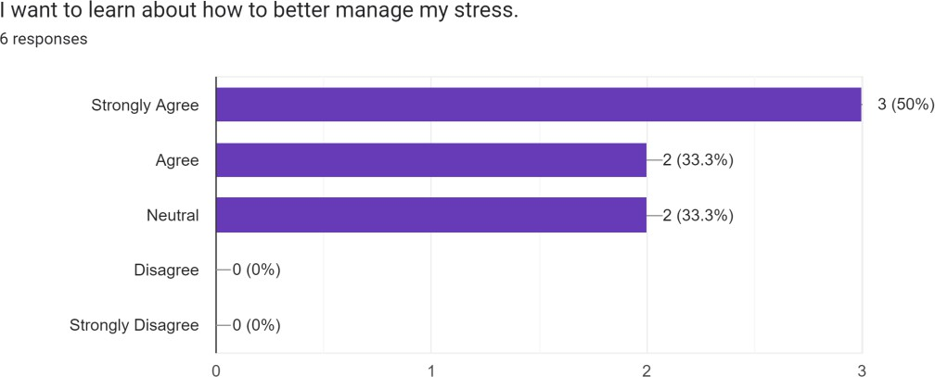

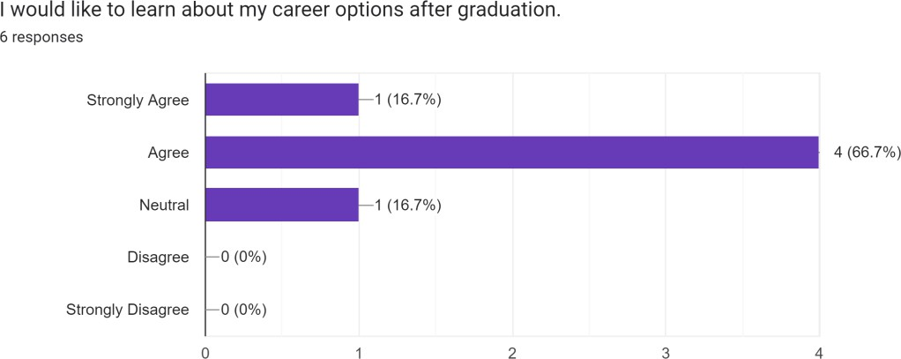

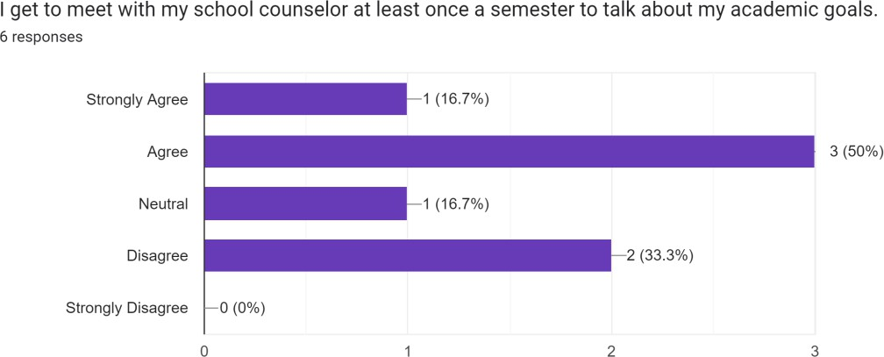

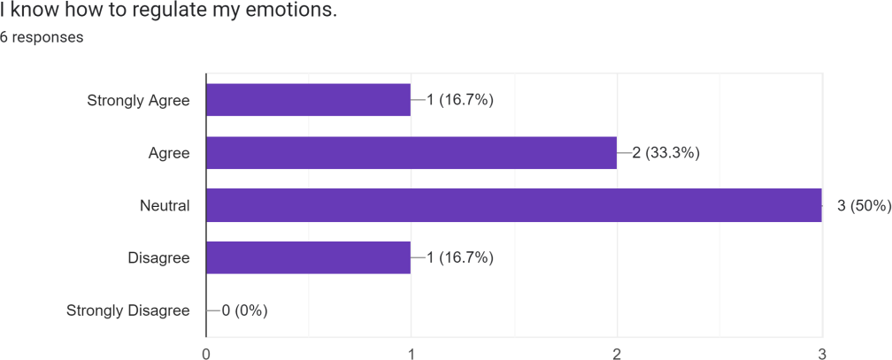

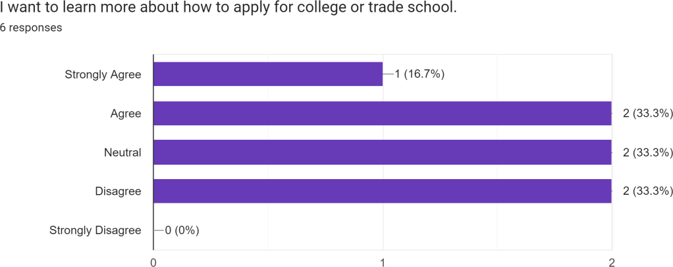

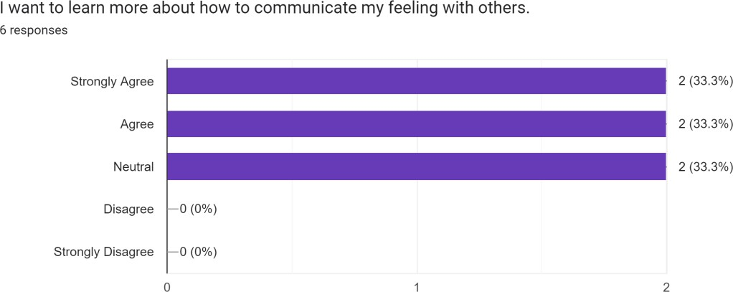

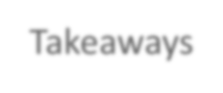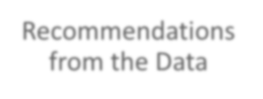
Interpretation of Results
Takeaways
- We need to teach more lessons on career, academic and social
emotional needs that students have.
- We need to find a way to meet with students on a more regular basis. This includes tier 1, 2, and 3 interventions.
Recommendations
from the Data
- Increase the number of school counselors so we can meet with
students on a more regular basis
- Increase the amount of group lessons on career, academic, and social/emotions needs of the students.
- Organize more club fairs and career/ college fairs.

After we looked at the data and analyzed it, we came out with 2 major takeaways. The 1st takeaway is that we need to do more to teach students about their career, academic and social/emotional needs and options. The other major takeaway is that we need to find away to meat with students on a more regular basis. Currently our school has a ration of about 400:1 is regards to our school counselors. In order for the counselors to best address the needs of the student population, we will try to get the ratio down to 250:1. This is the recommended ratio of students to school counselors. (Association, A.S. C., 2019) Implementing classroom guidance lessons has been proven to let school counselors reach more students and improve choses outcomes. (Dack and Merlin-Knoblich, 2019)

Evidence Based Interventions

Direct student services
- Classroom counseling lesson
  - How to manage stress
- Individual counseling
  - Setting S.M.A.R.T. goals for academics
- College and career planning
*planning for post secondary life (Association, A.S. C., 2019)
Indirect student services
- Referrals
  - Outside services
- Consultation
School counselor will meet with teachers to go over how to address certain needs
- Collaboration
  - Teachers, parents, and community members (Association, A.S. C., 2019)

After we analyzed the results from our needs assessment survey, we decided on 3 direct student intervention and 3 indirect student interventions. The classroom lessons will use lesson plans specifically created to address the academic, career, and social/emotional needs of the students. The individual counseling will be used to help student set S.M.A.R.T. goals for their academic performance. We will also meet with students and have group lessons on how to plan for college and post secondary jobs. (Association, A.S. C., 2019) We will use referrals for students that may need more help with learning to manage stress and emotions. We will consult with teachers about the results of the needs assessment survey to help them better understand how they can recognize when a student needs help. Also, we will collaborate with teachers, parents and other stake holders in the community to address the different needs of the students that came up in the needs assessment surevey.

Systemic Focus
- Resources should be the same for all students
- Not enough funding for the school counseling program
- Low income students may have to work to help support their family instead of doing extracurricular activities

Strategies that could influence systemic change related to the proposed interventions.
- Collaboration with stakeholders
- Make extra curricular activities assessable to all students
- Students should have equal resources (Ainscow, 2020)

It is important that students have equitable opportunities in school. We will collaborate with the community and school to help address any inequities that are present in the school. It will help to have the community involved in removing the barriers that students face. (Ainscow, 2020)

Implementation plan and how we will assess for Effectiveness
Participation data

*keep track of who and how many students

ASCA Mindsets ad Behavior data
*We will have classroom guidance lessons that address 3 different ASCA standards
*make sure students are achieving the goals outlined Outcome data
  - pre/post test will be given (Association, A.S. C., 2019)

We will implement our plan by having students in 11th and 12th grade participate in different interventions that will help them in 3 different ways. The school counselor will work with the advisory counsel to best assess for effectiveness. The different areas that will be addressed are career, academic and social/ emotional learning. We will have at least 1 classroom guidance lesson for each standard. The students will take a pre and post test assessment so the school counselor can look at the data.

ASCA Mindsets and Behaviors
- M 6. Understanding that postsecondary education and lifelong learning are necessary for long-term success
- M 1. Belief in development of whole self, including a healthy balance of mental, social/emotional and physical well-being
- B-LS 10. Participation in enrichment and extracurricular activities
- (Association, A.S. C., 2019)

M 6. Is addressed by the classroom guidance lesson that will be conducted with the students. It is relevant to the implementation plan because this is one of the main areas that our lessons will be focusing on. The student will learn how to be successful in their post secondary life. (Association, A.S. C., 2019)
M 1 is addressed by individual and group counseling.
B-LS 10 is relavent to the plan because it is a goal of our school counseling program to educate students on extracurricular activities that will help them academicaly.

Announce
- Include a specific plan on how you will share your results to your stakeholders. Develop a plan for multiple groups of stakeholders including
- Teachers/ administration
- Parents/ community members
*Community presentation and data report
- Students
- Group counseling session to go over the
results
(Colbert et al, n.d.)

We will share the results with the teachers/ administrators and parents/ community members by presenting the results through a presentation at a after school meeting. We will choose a time that works for the most amount of people. We will also have a data report form made to give to everyone so they can better see the results and how we are going to use the data to make the school counseling program better. (Young and Kaffenberger, 2019)
We will announce the results to the students by having group counseling sessions and letting students know that we are going to focus on helping them with the issues that were highlighted in the needs assessment survey. The results of the survey show that we need to do more in addressing the career, academic, and social/emotional needs of the students. Students that participate in guidance lessons can approve their achievement outcomes. (Colbert et al, n.d.)


Use of Data to Advocate for
Programs and Students

Design | Career, academic, and social emotional needs of the students
Ask | Student take a needs assessment survey using google forms
Track | The results show that the majority of students want to learn more about ways to help them career, academics, and social/emotional
Announce | The results show that we need more lessons on career, academic and social/ emotional needs. We will analyze the data we receive from pre/post test assessments.

References
- Kaffenberger, A.Y.&. C. (2019). Making DATA Work (4th ed.). American School Counselor Association. https://mbsdirect.vitalsource.com/books/978-1-929289-56-1
- Association, A.S. C. (2019). The ASCA National Model (4th ed.). American School Counselor Association. https://mbsdirect.vitalsource.com/books/978-1-929289-61-5
- Colbert, Pérusse, Bouknight and Ballard. (n.d.) Developing School Counselor Advocacy Competencies Within a Leadership Role in Education Reform. American Counseling Assossioation.
https://www.counseling.org/docs/default-source/vistas/developing-school-counselor-advocacy-competencies-within-a- leadership-role-in-education- reform.pdf?sfvrsn=10
- Mel Ainscow (2020) Promoting inclusion and equity in education: lessons from international experiences, Nordic Journal of Studies in Educational Policy
https://www.tandfonline.com/doi/full/10.1080/20020317.2020.1729587?scroll=top&needAccess=true
- Dack and Merlin-Knoblich (2019) Improving Classroom Guidance Curriculum With Understanding by Design. The Professional Counselor. https://tpcjournal.nbcc.org/improving-classroom-guidance-curriculum-with-understanding-by-design/

