
Kindergarten Worry/Anxiety Small Group

Alden May


Small Group Goal

Recognize the feeling of being anxious
The different thoughts and emotions that anxiety can feel like
Learn anxiety coping skills




Teacher observation data
Data
Teachers commented on some of there students dealing with different instances of anxiety/worry

Parental observation data
Some parents of students called the school counselor asking if their child could join a small group



Screening Process

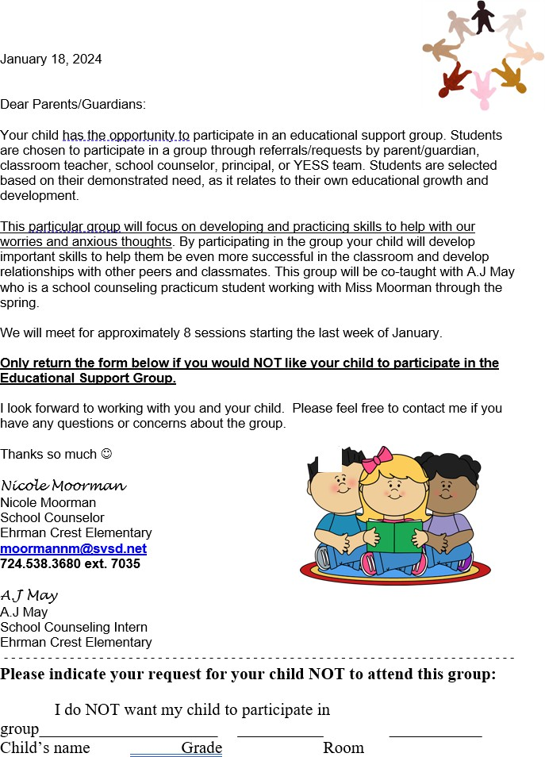

AIA Standards

Prevention & Intervention
- We worked on students' social emotional development
Diversity & Advocacy
- Throughout the group we promoted equity for the students so that they can succeed to the best of their abilities.
Collaboration & Consultation
- The students for this group were chosen by consulting with the teachers and families of the students.



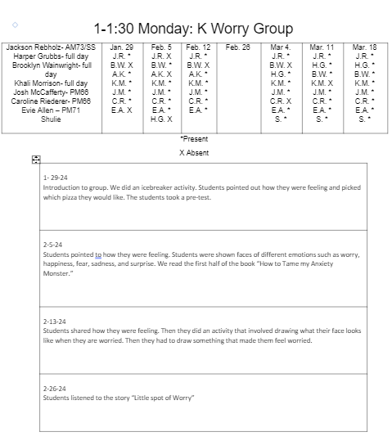
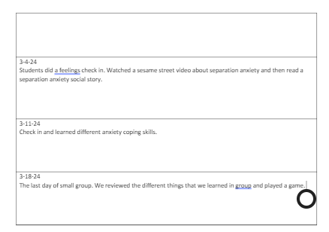
Worry Group Schedule



Pre/post Test Example

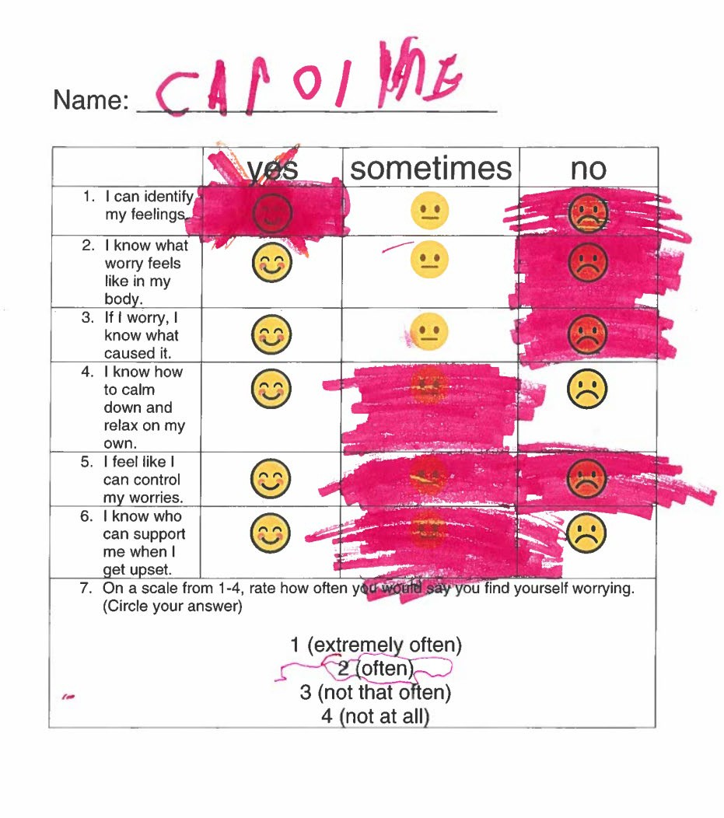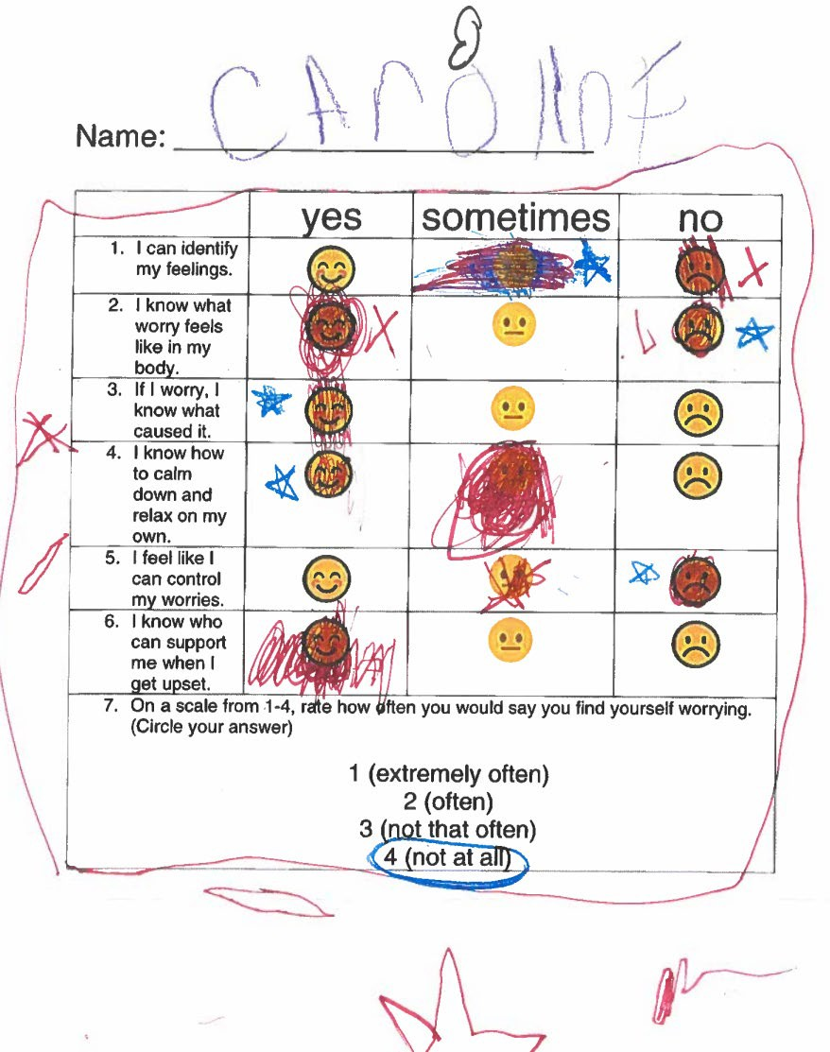

Culturally Sensitive

Every student had the opportunity to share how they were feeling at the beginning of every group.
The students helped to create the group rules and signed them.
The students never were forced to come to group and did not have to share if they did not want to.



Student Successes

One student had trouble
going to the bathroom because they were afraid of how loud the flushing sound was.
That student does not
have a problem with the flushing now.
One student had separation
anxiety in the morning coming to school.
It was observed that
the student got better at saying goodbye in the morning after our small group.

Improvements in the Future

1
I would like to have a better pre/post test for kindergarten age children.
2
I would like to have more data before the group and after.
- Nurse data, attendance data, social/emotional data

