Beliefs  We believe in fostering an inclusive environment that respects and values diversity. We are committed to ensuring equitable access to counseling services for all students. | Vision  Our vision is to be an inclusive school environment where students are inspired to reach their full potential. We cultivate resilient, empathetic, and confident individuals who embrace learning, demonstrate strong character and are well prepared to pursue college and career opportunities. | June 2024  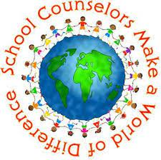 | WISE OWLS SCHOOL COUNSELING  Celebrating diversity, cultivating empathy and resiliency    by Unknown Author is licensed under CC BY-SA-NC
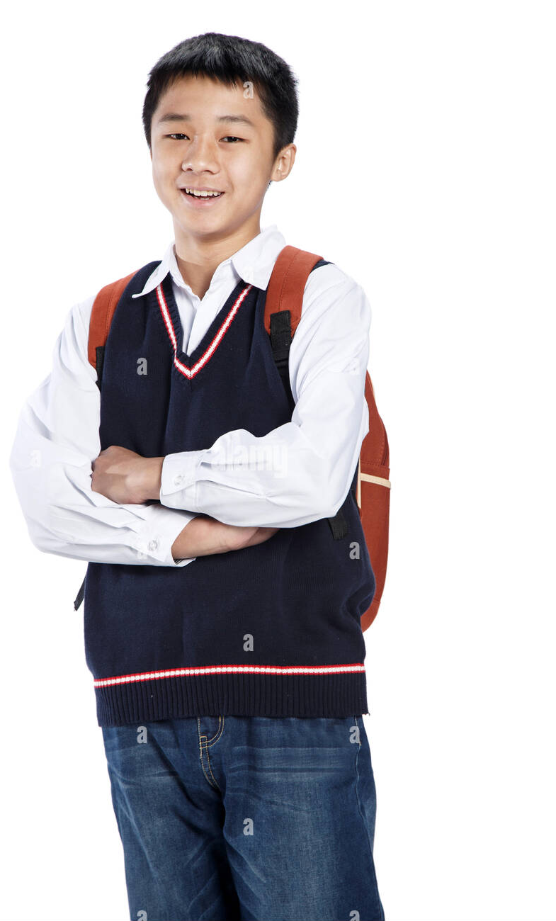 | Mission  Our mission is to empower middle school students with comprehensive and equitable school counseling services that help them thrive academically, socially, and emotionally, preparing them for success in high school and beyond. | 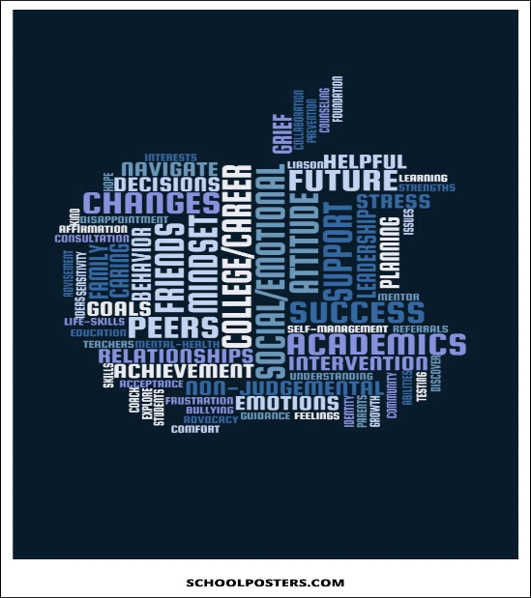 | 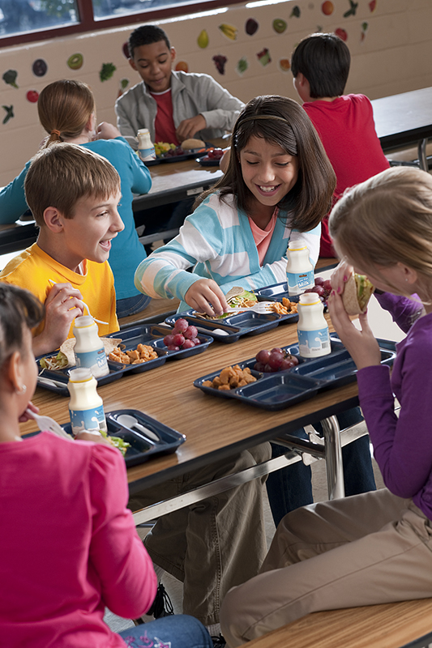
 | 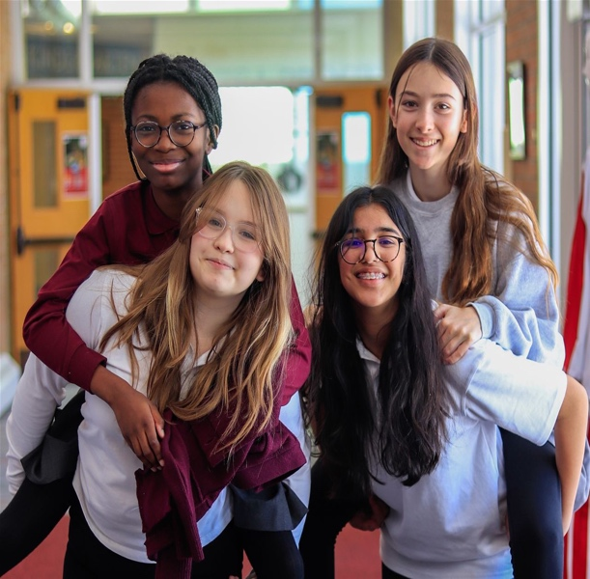 | Wise Owls Middle School  •••  0123 Darcy Rd, Ashburn, VA  •••  571-312-6713  •••  Wiseowled@wise.edu  •••  Wiseowlmiddle.com

Advocacy Statement  At Wise Owls Middle School, the School Counseling Department is dedicated to fostering an equitable and empowering environment for all students.  We advocate for students, collaborate with all stakeholders, and provide personalized support.  Our comprehensive counseling program will equip students with the skills and resiliency needed to thrive as responsible and productive individuals who are ready for life beyond middle school (Lee et al., 2021). | CAREER, SOCIAL-EMOTIONAL, & ACADEMIC PROGRAMMING  Goal Setting Workshops – We help students develop a growth mindset and enhance their academic motivation.  Academic Support Groups - We help address specific challenges students may face with their studies (B -SMS 3, 6, 7, B-LS 4., ASCA, 2019).  Social Emotional Curriculum for all We develop personal and social skills with an emphasis on effective communication and social interaction skills.  Peer Mentorship Program – encourages relationship building and working with diverse teams (B-SS 2, 7, 9., ASCA, 2019).  Career Exploration Workshops – Facilitate career exploration and awareness.  Individual career counseling sessions – personalized guidance to help student set goals and plan for their future (B-SMS 5., M.4., ASCA, 2019). | - We create a culturally inclusive school climate valuing the diverse backgrounds of our students and families (M.5, M.7., ASCA, 2019).  - We have a comprehensive School Counseling Program as we believe all students can achieve and deserve equitable access to all opportunities  (M 2., ASCA, 2019).  - We implement College and Career Readiness Programs recognizing the importance of preparing all students for post-secondary and career success (M.3., ASCA, 2019), |  | 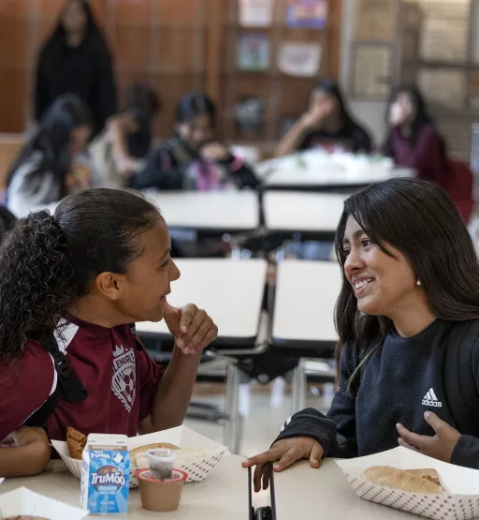
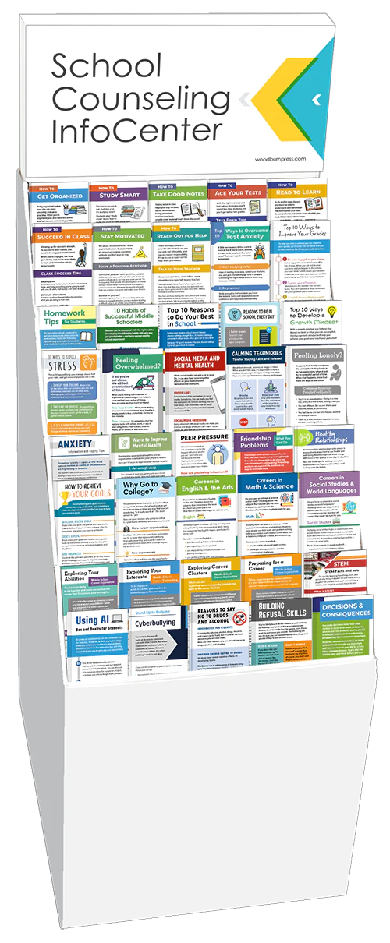 | STRATIGIES TO PROMOTE GRADUATION RATES  - Parental Involvement. We strive to establish strong communication to keep you informed about your child’s progress and behavior.  - Early Intervention and Support Programs. We help to identify at-risk students early on through academic assessments, behavioral observations, and teacher input.  - Individualized Education Plans (IEPs) and Personalized Learning. At Wise Owls we work together to implement an individual plan that tailors to your child’s specific needs.  (M 5., ASCA, 2019), |  |  | “Intelligence plus character that is the goal of true education” – Martin Luther King Jr.
 | A  PEER INTERVENTION PROGRAMS:  Peer Leadership Program:  ● We train a group of peer leaders who can serve as positive role models and intervention agents.  ● We provide training on active listening, empathy, conflict. resolution, and culturally aware communication skills (B-SS 7., ASCA, 2019).  Peer Support Groups:  ● We facilitate peer support groups focused on specific topics such as friendship building, mental wellness, and emotion regulation (M 3., ASCA, 2019). “Peer support is an underused resource in global mental health” (Moran et al., 2020).  Conflict Resolution Programs:  ● We coordinate conflict resolution programs that empower students to resolve issues and teach them effective communication skills (B-SS 1, B-SS 9., ASCA, 2019). |  | PREPERATION FOR COLLEGE AND CAREER READINESS  Career Assessment Tools and Interest Inventories:  This helps students identify their strengths, interests, and values and what occupations might fit them best.  Academic Planning and Goal Setting:  We can help your child set academic goals and create a plan for achieving those goals.  Career Exploration Programs:  We expose our students to a variety of industries and professions by inviting guest speakers, arranging field trips, and attending college and career fairs.  (M3., ASCA, 2019). | 

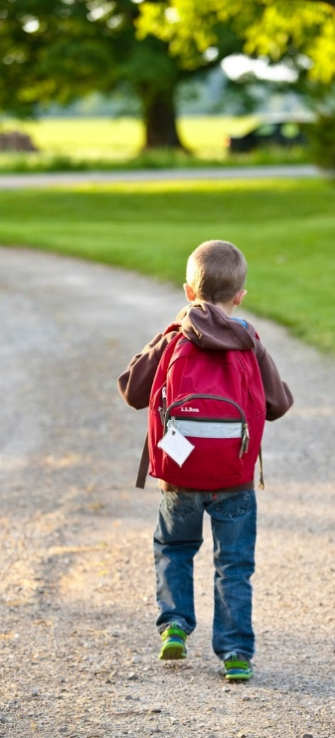 | A  PHILSOPHY AND METHODS FOR DATA COLLECTION  Student- Centered Approach:  ● recognize and respect individual differences (B-PF 6)  ● foster a positive and inclusive school environment  Preventative:  ● early identification of potential issues  ● proactive interventions  Methods:  ● Observations  ● Individual and Group Counseling (B-SS 3)  ● Surveys and Assessments  ● Collaboration with Teachers and Parents (B-SS 6)  Stakeholders:  ● Clear Communication  ● Regular Meetings  ● Visual Aids  ● Recommendations (B-PE 5., ASCA, 2019). | DIRECT and INDIRECT SERVICES OFFERED TO STUDENTS:  Direct Services:  *Individual counseling/goal setting  *Group counseling/peer mentorship program  *Career exploration workshops  *Classroom social emotional guidance teaching/Advisory  (ASCA, 2019)  Indirect Services:  *Collaboration with teachers to help students succeed academically and socially  *Collaboration with Administrators to develop  and implement school-wide programs  that promote a positive school climate  *Partnership between school and home to help families understand their child’s needs and progress  *Relationships with community organizations and agencies that provide resources and support for students and families  *Advocate for students’ needs ensuring every student has access to the resources and services they need  (ASCA, 2019) | “In the hands of a caring school counselor, uncertainty transforms into clarity, and obstacles become stepping stones”

References

American School Counselor Association. (2019). ASCA National Model: A framework for school counseling programs (4th ed.)
Lee, J. A., Heberlein, E., Pyle, E., Caughlan, T., Rahaman, D., Sabin, M., & Kaar, J. L. (2021). Evaluation of a Resiliency Focused Health Coaching Intervention for Middle School Students: Building Resilience for Healthy Kids Program. American Journal of Health Promotion : AJHP., 35(3), 344–351. https://doi.org/10.1177/0890117120959152.
Moran, G. S., Kalha, J., Mueller-Stierlin, A. S., Kilian, R., Krumm, S., Slade, M., Charles, A., Mahlke, C., Nixdorf, R., Basangwa, D., Nakku, J., Mpango, R., Ryan, G., Shamba, D., Ramesh, M., Ngakongwa, F., Grayzman, A., Pathare, S., Mayer, B., & Puschner, B. (2020). Peer support for people with severe mental illness versus usual care in high-, middle- and low-income countries: study protocol for a pragmatic, multicentre, randomised controlled trial (UPSIDES-RCT). Trials, 21(1), 371. https://doi.org/10.1186/s13063-020-4177-7

