CASE STUDY

Ayden, 2nd Grade

PART 1:

PRE-ASSESSMENT

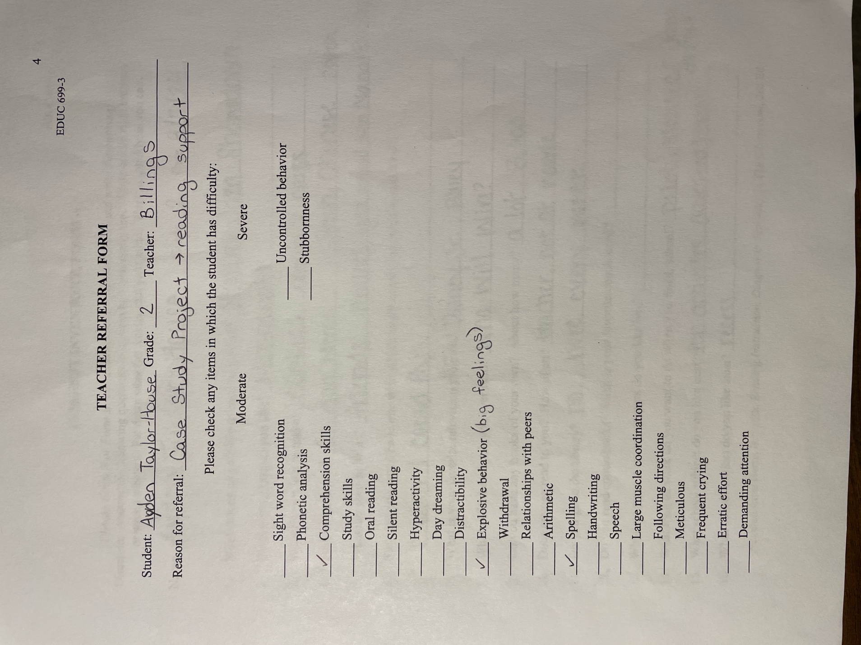
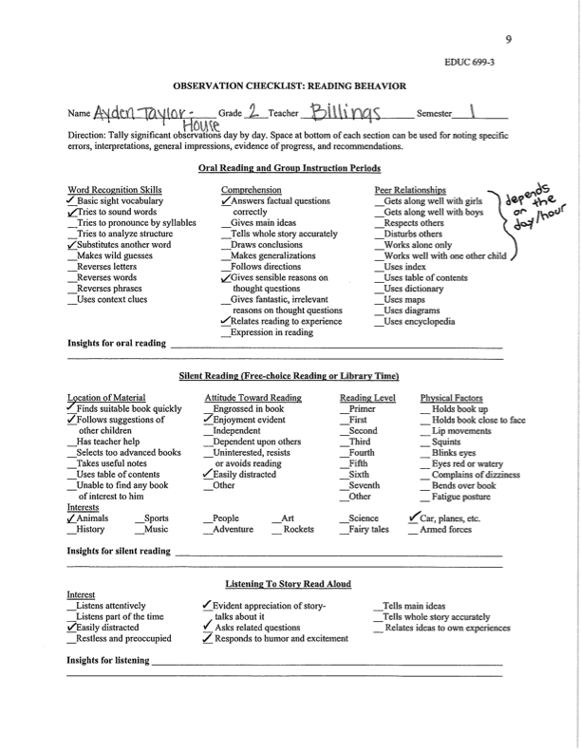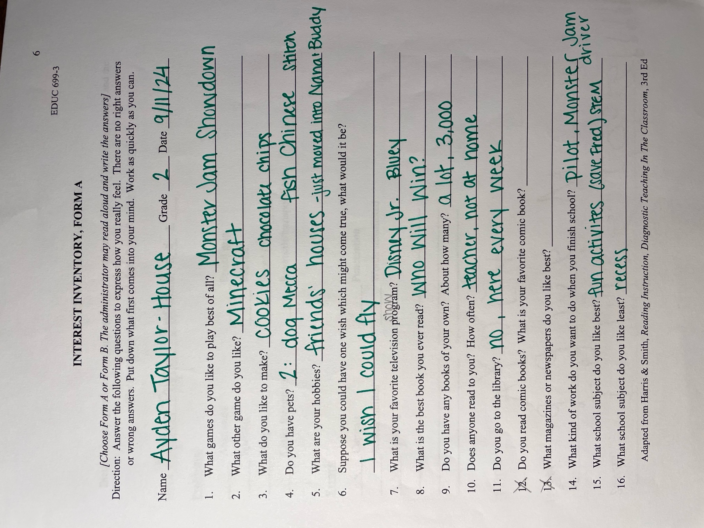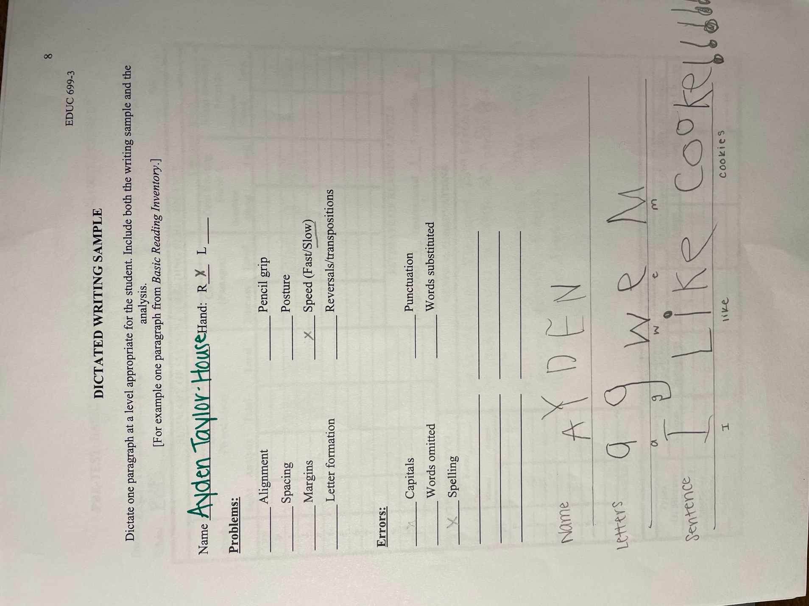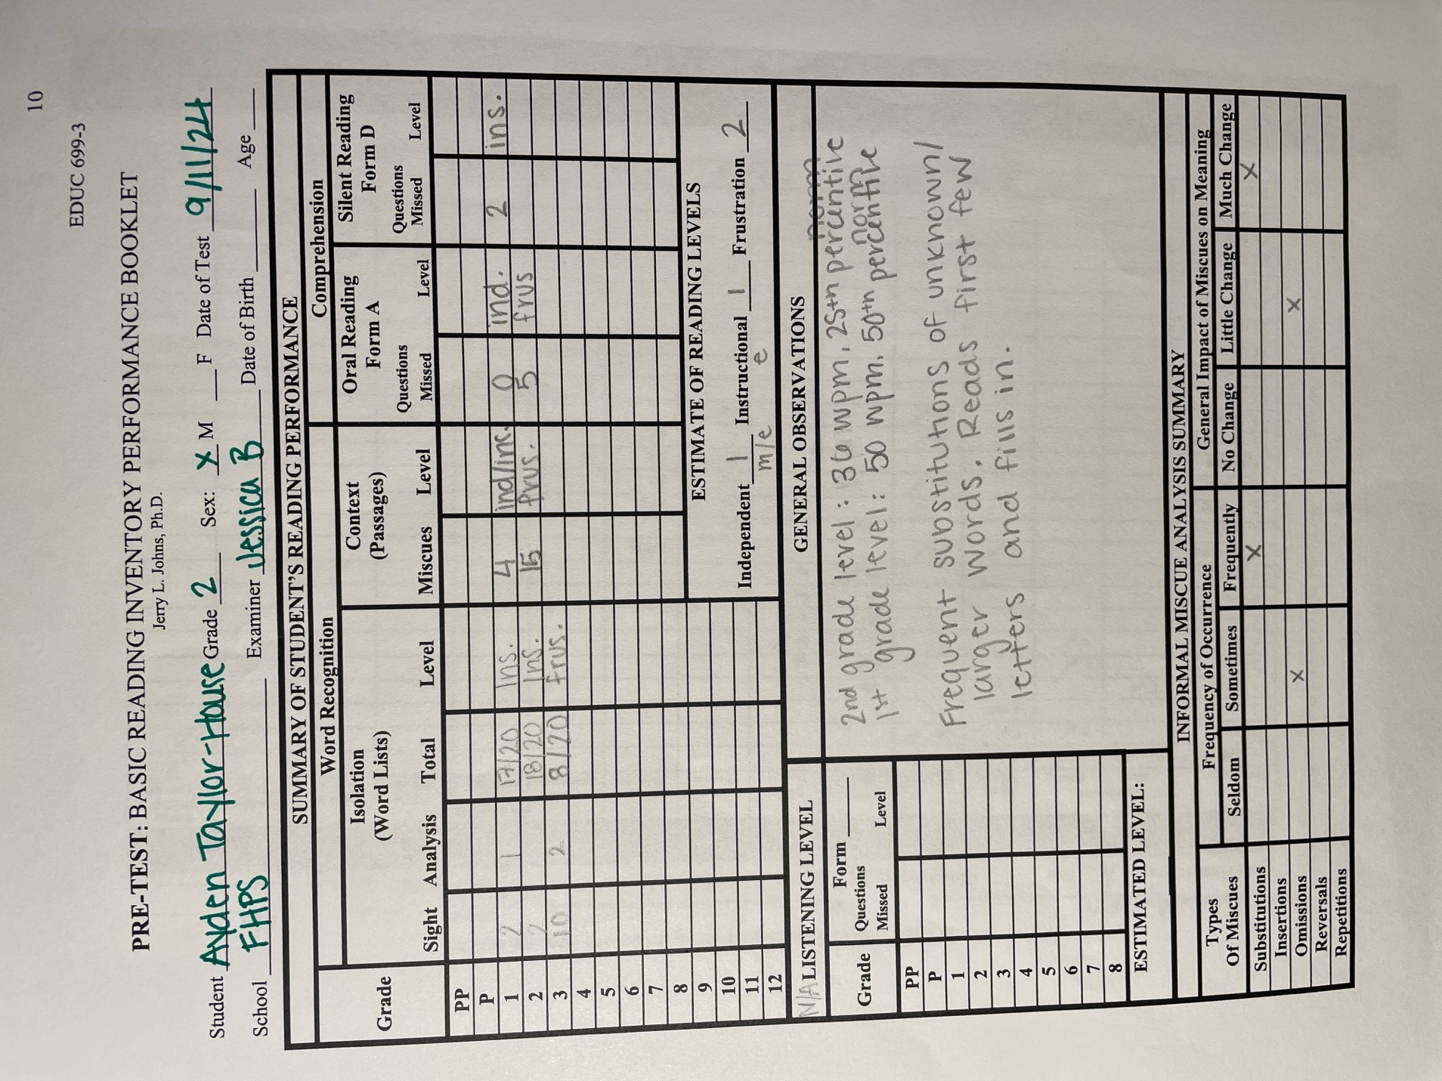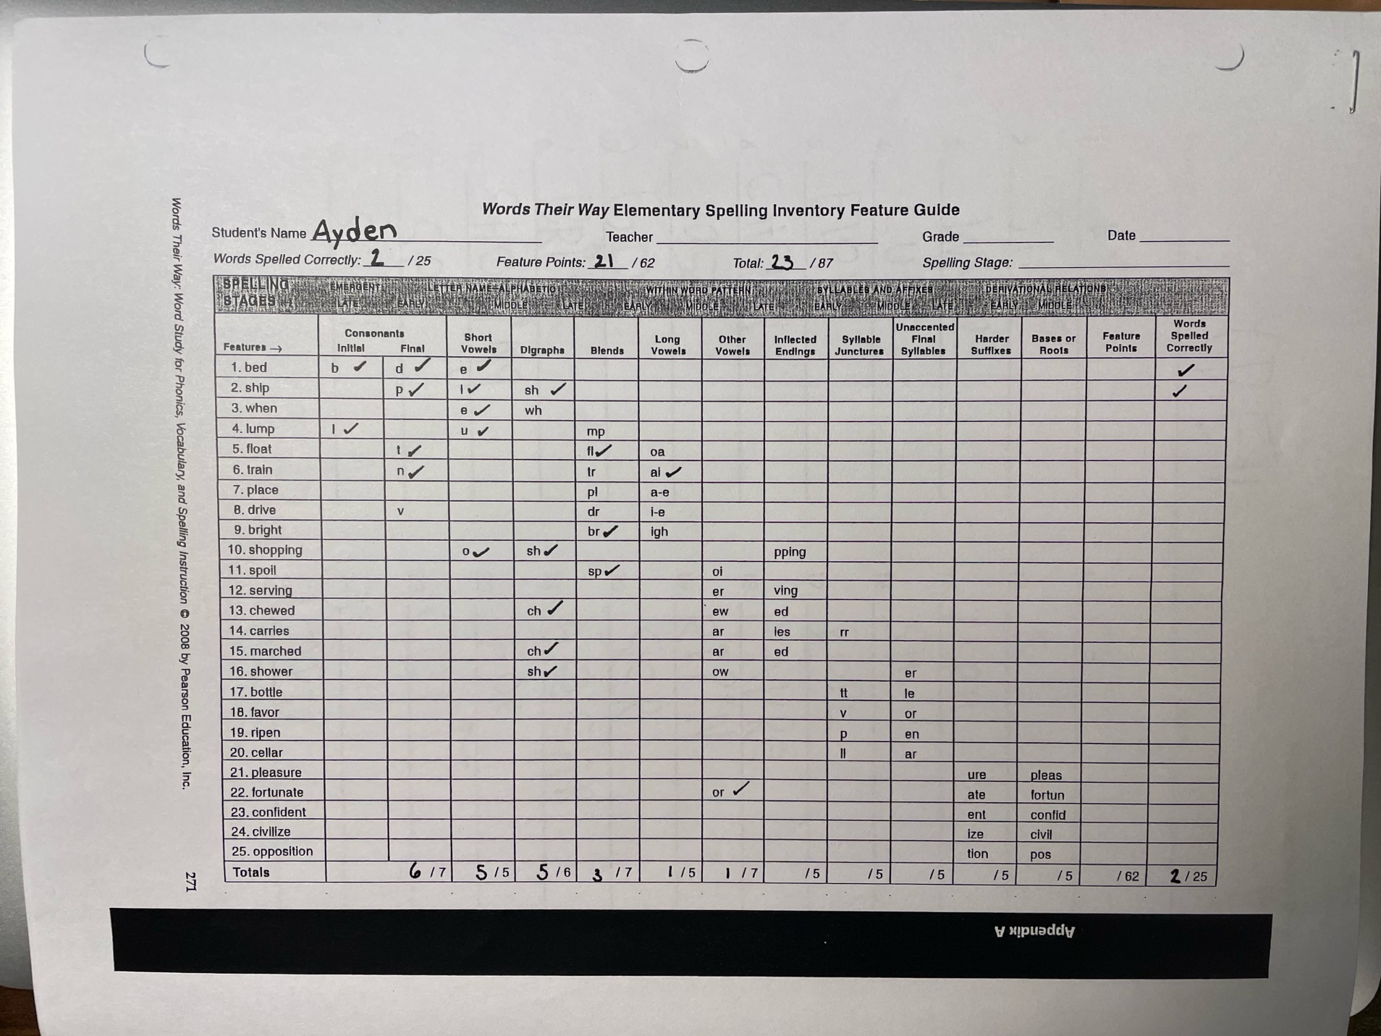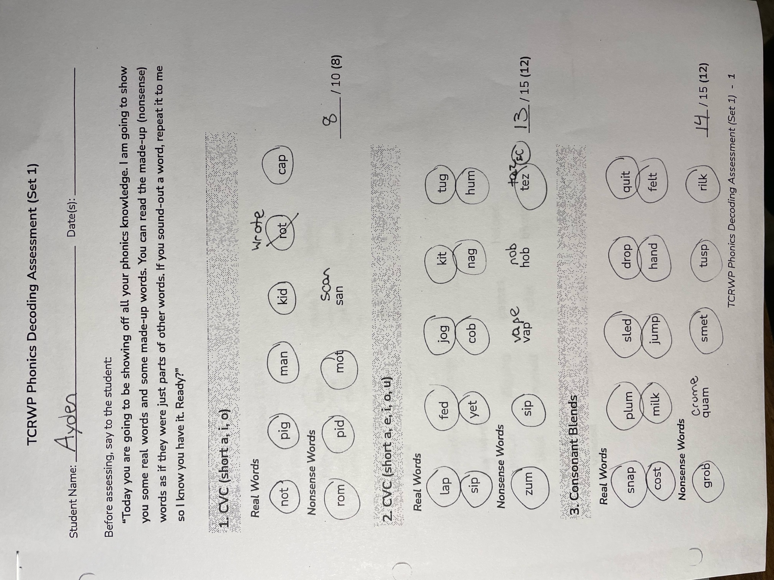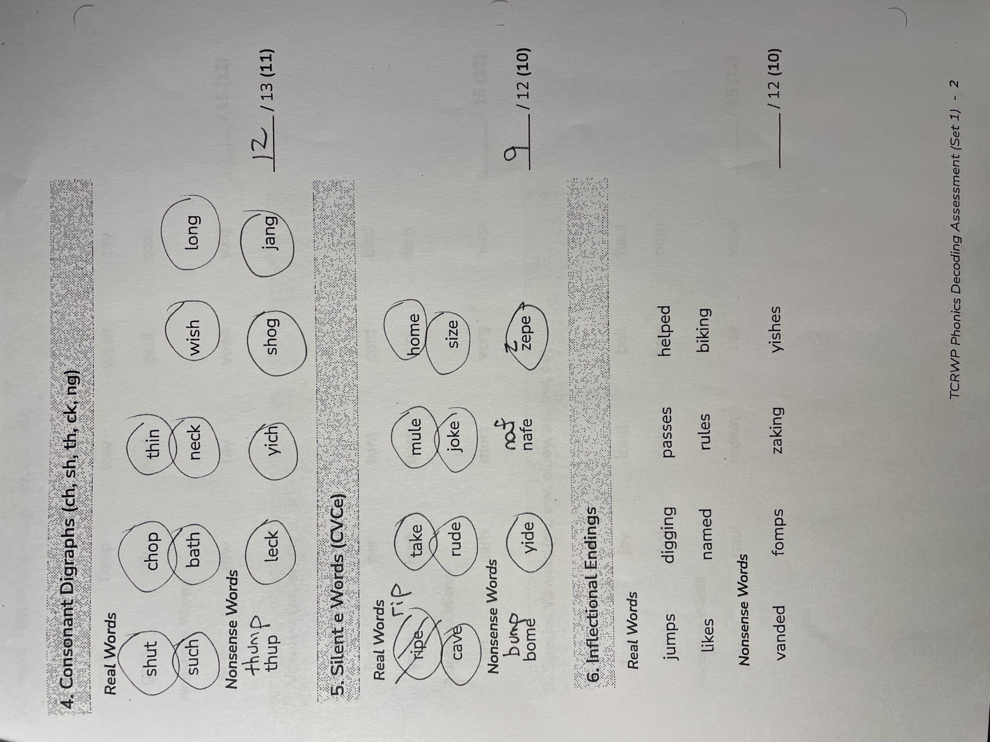
Pre-Assessment Summary:
Each assessment had different purposes, ranging from relationship building to concrete evidence of student performance. I began with the teacher referral form, which gave me a brief idea of why the classroom teachers had chosen this child to work with me in small group or one on one time. In my time with the student, I found the interview instrument potentially the most helpful of all the assessments. This allowed me to build a relationship with the student, understanding his home and family life, attitude toward school, friendships, likes and dislikes, and attitude about reading. The writing assessment showed me information about his letter identification and handwriting directionality as well as spelling skills and knowledge of sentence structure. For reading, I administered the BRI word lists and could identify a starting point for reading and was able to determine the student’s instructional reading levels based on fluency and comprehension and in the process identify concrete skills to work on to improve fluency, comprehension, and confidence. This test I find tedious in scoring, especially in front of a student. Each time I moved the pencil he became nervous about doing something wrong, and I felt unable to make notes as quickly as need be.
After meeting with the teacher, where we filled out the ____ form together, we were able to look through his NWEA MAP scores as well as his Words Their Way initial assessment. The classroom teacher’s biggest concern with this student is his ability to write, and within that, focusing on his confidence and stamina within writing. Since this is her goal for him, the Words Their Way assessment gave me very detailed and concrete data on a good starting point and ideas for growth in writing.
Each of these instruments was beneficial in building well-rounded knowledge of this student’s literacy skills. This covered interests, attitudes, fluency, comprehension, writing, spelling, and handwriting. Each test truly uncovered more of the “puzzle”, allowing me to understand the student as a whole with each new assessment. This is all incredibly useful information.
This particular set of assessments worked very well for this student and we were able to complete them all successfully. My other case study student had a very different background and school experience, leading to a necessary change in questions and set of assessments. I believe this flexibility is necessary as a reading specialist, the need to adjust to what students or teachers need to best help and equip all learners.

PART 2:

TEACHER COLLABORATION

Date of Collaboration: September 20, 2024

Names of Teachers: Samantha Billings

Teacher Collaboration Summary:

My time with Samantha Billings was lovely. We discussed her new role in the school as a second-grade teacher, previously in first. I began with asking her more about Ayden and why she chose Ayden specifically for this project. We reviewed all data I had collected well as school-collected data – the Words Their Way assessment and his NWEA MAP scores.
I shared what trends I was seeing through the collected data and asked her to elaborate on how the data reflected what she has seen from him in the classroom in the last five weeks. Samantha articulated that everything seemed to line up with what she is seeing from Ayden in the classroom. He is around an end of first grade reading level, he is struggling with spelling, he is excited about reading and substitutes/omits words and grows easily frustrated with writing. I told Samantha I had some ideas of goals to create for Ayden – decoding skills, fluency, and writing based on comprehension. I asked Samantha her thoughts on what would be the most beneficial use of our learning sessions and what, in her opinion, would be most valuable for my time with Ayden. Samantha believes that the greatest use of time would be with writing, as he is easily frustrated and gives up, and she is only minimally able to assist in adjusting that mindset and provide the needed one on one assistance.
Therefore, we decided that the best use of time would to be in working on decoding and fluency strategies, boosting knowledge needed for spelling, and following up those activities with a writing and spelling portion. We reviewed the curriculum used in the classroom, the curriculum as well as approved resources for Tier 2 instruction. With my allotted time being with Ayden once per week, we decided it would be more useful to find cohesive resources that built on each other and worked toward our goals for Ayden rather than choose a curriculum and teach one lesson per week. I have access to their decodable resources and handwriting program, which will assist me in building lessons focused on decoding, fluency, and writing.

PART 3:

INSTRUCTION

Learning Goals (by November 26, 2024):
- Ayden will complete 9 fluency/comprehension/writing tasks, identifying appropriate blends or long vowels, reread for fluency, and answer a comprehension question with careful handwriting.
- Ayden will show enthusiasm toward writing, completing 10 writing tasks. These will focus on complete sentences, spelling, and handwriting.
- Ayden will read a 2nd grade level BRI test with 7 or less miscues and 7/10 comprehension questions.
- Ayden will write 3 dictated sentences that include blends and long vowels with correct letter placement on handwriting lines, appropriate capital and lowercase letters, and all words spelled correctly.
Strategy:
- The teacher will use prompt feedback strategies with Ayden in both fluency and writing instruction.
- The teacher will provide multi-sensory strategies for learning.
- The teacher will incorporate engaging writing prompts to engage Ayden in his writing. The teacher will use encouragement strategies to promote and instill writing confidence.
Research:
- The ultimate goal of reading words is fluency, which leads to comprehension (Cooper et al., 2018). A focus on fluency will foster deeper comprehension.
- The student should read content correlating to word patterns they have been taught, following the sequential pattern of simpler to more complex patterns, so they are able to read increasingly complex texts (Spear-Swerling, 2019).
- Teach the writing process approach: brainstorming (graphic organizers, drawing), drafting (decoding and writing), revising (improvements), editing (corrections), and publishing (sharing work). The age of students and assignment dictate the length of time in each stage (Reading Rockets, n.d.)
- Incorporate fun! (Anxiety and Achievement, n.d.). Work on taking out anxiety and frustration and focus on the ways literacy is fun.
- Educate the student on mindset: keeping an open mind, encourage students to ask questions, make a commitment, keeping a positive and determined state of mind (Anxiety and Achievement, n.d.).

Lesson Plan #1 10/9/2024

Objective: | - The teacher & student will build a routine.  - The teacher & student will establish an incentive.  - The student will go through the deck of blend/digraph flashcards.  - The student will identify the blend, practice the focus words, and highlight the blend within the story. The student will read three times and write the answer to a comprehension question with accurate capitals and lowercase letters.  - The student will write based on the given prompt.
Activities: | Incentive:  Introduce reward chart – 10 stars to color in for focused and hard work. Discuss what that looks like. Student and teacher will decide incentive prize: one on one Rubble time.  Drill:  Flash cards – together, create flash cards with all blends/digraphs. The teacher will say the blend/digraph aloud and the student will identify which two letters make the sounds. The student will create the flash cards on cut thick paper. Practice the first round of flash cards. Prompt feedback – if one is incorrect, it goes back in the stack. If it is stated correctly, it’s put down. Timer for 3 minutes.  (bl, cl, fl, gl, pl, sl, br, cr, dr, fr, gr, tr, pr, sk, sm, sn, sp, st, sw, sh, th, ch, wh)  Reading:  Introduce decodable readers. This week we will focus on L blends. Model how to read the focused skill words at the top, tapping each one. Have the student highlight the blend.  Then, the student will look through the story and highlight the spotlight words.  After reading 3 times (using a pointer for tracking and filling out a star for each read), the student will rewrite his favorite sentence and illustrate the meaning below.  Writing:  Introduce the “writer’s journal”. Decorate the front with stickers and write a dictated list about what is hard in writing and what is fun/easy about writing. Create an “All About the Author” front page, including a self-portrait and short bio. (“My name is Ayden and I am in 2nd grade. I like to ______. I like ______.)
Results: | Incorporating an incentive as well as clarifying what learning behavior was expected was beneficial for Ayden’s mindset while working together. He was motivated by the reading prompts and stated he enjoyed the activity. He did not read a single word incorrectly, but we did work on fluency in the reading while focusing on punctuation, emotion based on content, and finding a good pace. Initially, he was disappointed we would be working on writing but was motivated by the creation of his own writing journal (especially with the monster truck stickers I had purchased). After, his attitude was much more motivated and he was excited to write his author introduction.
Rationale: | *See above.

Lesson Plan #2 10/16/2024

Objective: | - The student will go through the deck of blend/digraph flashcards.  - The student will identify the blend, practice the focus words, and highlight the blend within the story. The student will read three times and write the answer to a comprehension question with accurate capitals and lowercase letters.  - The student will write based on the given prompt.
Activities: | Drill:  The teacher will say the blend/digraph aloud and the student will identify which two letters make the sounds. The student will create the flash cards on cut thick paper. Practice the first round of flash cards. Prompt feedback – if one is incorrect, it goes back in the stack. If it is stated correctly, it’s put down. Timer set for 3 minutes.  (bl, cl, fl, gl, pl, sl, br, cr, dr, fr, gr, tr, pr, sk, sm, sn, sp, st, sw, sh, th, ch, wh)  Reading:  This week we will focus on R blends. Model how to read the focused skill words at the top, tapping each one. Have the student highlight the blend.  Then, the student will look through the story and highlight the spotlight words.  After reading 3 times (using a pointer for tracking and filling out a star for each read), the student will rewrite his favorite sentence and illustrate the meaning below.  Writing:  The teacher will share a sealed letter written to the student. The student will read, teacher assisting if needed. Show the model of writing a letter. The student will choose someone to write a letter to in their notebook and complete the name, writing, and signature.  Emphasis on prompt feedback, correct capital/lowercase letters, and in the lines writing. Help with spelling as needed, using reading strategies.
Results: | Ayden and I have run lower on time and skipped out on the flash cards. We focused on finding the blends within the reading and again, he was able to read every word confidently. We worked again on fluency – he remembered how to read with emotion and self-corrected on the first read to work on pausing for commas and stopping for periods. Writing took a bit longer this time around, he worked hard to distract me in order to avoid writing himself. Note: will need to find a more secluded space to work in.
Rationale: | *See above.

Lesson Plan #3 10/23/2024

Objective: | - The student will go through the deck of blend/digraph flashcards.  - The student will identify the blend, practice the focus words, and highlight the blend within the story. The student will read three times and write the answer to a comprehension question with accurate capitals and lowercase letters.  - The student will write based on the given prompt.
Activities: | Drill:  The teacher will say the blend/digraph aloud and the student will identify which two letters make the sounds. The student will create the flash cards on cut thick paper. Practice the first round of flash cards. Prompt feedback – if one is incorrect, it goes back in the stack. If it is stated correctly, it’s put down. Timer set for 3 minutes.  (bl, cl, fl, gl, pl, sl, br, cr, dr, fr, gr, tr, pr, sk, sm, sn, sp, st, sw, sh, th, ch, wh)  Reading:  This week we will focus on S blends. Model how to read the focused skill words at the top, tapping each one. Have the student highlight the blend.  Then, the student will look through the story and highlight the spotlight words.  After reading 3 times (using a pointer for tracking and filling out a star for each read), the student will rewrite his favorite sentence and illustrate the meaning below.  Writing: “Tell Me How”  The student will pretend to write to a space alien who doesn’t know anything about our culture. This alien does everything exactly as it’s said or written. The student’s job is to choose an everyday task, like brushing her teeth or making a sandwich. Then, he needs to write step-by-step directions about how to do the task for the alien. When he’s done, the teachers will pretend to be the alien and try to follow the steps exactly as the student wrote them, reading each step aloud.
Results: | Ayden remembered how to begin our reading right away and got started by himself. He paused while reading for clarification and we talked about how that was an excellent thing to do. He read three times while focused on the emotion within reading, no “reading like a robot”. The writing prompt inspired a lot of enthusiasm – he was very excited! With limited time and a field trip coming back through the hallway, we finished organizing his ideas and I completed his writing. He organized his ideas well and had fun with the prompt.
Rationale: | *See above.

Lesson Plan #4 10/30/2024

Objective: | - The student will go through the deck of blend/digraph flashcards.  - The student will identify the blend, practice the focus words, and highlight the digraphs within the story. The student will read three times and write the answer to a comprehension question with accurate capitals and lowercase letters.  - The student will write based on the given prompt.
Activities: | Drill:  The teacher will say the blend/digraph aloud and the student will identify which two letters make the sounds. The student will create the flash cards on cut thick paper. Practice the first round of flash cards. Prompt feedback – if one is incorrect, it goes back in the stack. If it is stated correctly, it’s put down. Timer set for 3 minutes.  (bl, cl, fl, gl, pl, sl, br, cr, dr, fr, gr, tr, pr, sk, sm, sn, sp, st, sw, sh, th, ch, wh)  Reading:  This week we will focus on digraphs. Model how to read the focused skill words at the top, tapping each one. Have the student highlight the blend.  Then, the student will look through the story and highlight the spotlight words.  After reading 3 times (using a pointer for tracking and filling out a star for each read), the student will rewrite his favorite sentence and illustrate the meaning below.  Writing: Young Reporter  Student and teacher will take a walk around the school, pretending it is their first time ever to walk through the doors. Notebook in hand, the student and teacher will pause to write down 4-5 observations of things they see that are unique.
Results: | Getting into a routine has worked incredibly well for Ayden. Today, he was excited to dive in and guess what the focus of the day was for reading. He was a bit distracted due to eating his snack during our work time. He read emphatically and we were able to touch on slowing down to read accurately without guessing. In writing, he was excited to open a letter of his own and, with a little frustration with mistakes from moving too fast, was able to finish a short letter of his own. By 25 minutes, his attention has wavered.
Rationale: | *See above.
Lesson Plan #5 This lesson was unable to happen due to unplanned student absences.

Objective: | - The student will go through the deck of long vowel flashcards.  - The student will identify the long vowel, practice the focus words, and highlight the long vowel patterns within the story. The student will read three times and write the answer to a comprehension question with accurate capitals and lowercase letters.  - The student will write based on the given prompt.
Activities: | Drill:  Flash cards – together, create flash cards with all long vowels. The teacher will show the card aloud and the student will state the long vowel sound. The student will create the flash cards on cut thick paper. Practice the first round of flash cards. Prompt feedback – if one is incorrect, it goes back in the stack. If it is stated correctly, it’s put down.  Long A: (ate, ake, ame, ace, ade, ane, ape, ave, ale, ay, ail, ain)  Long E: (eat, eal, ean, eam, ee, eep, eet, eek)  Long I: (ice, ide, ike, ime, ine, ive, ight)  Long O: (ope, one, ole, oke, oat, ow)  Long U: (u_e, ue oo, ew)  Reading:  This week we will focus on long A vowel sounds. Model how to read the focused skill words at the top, tapping each one. Have the student highlight the blend.  Then, the student will look through the story and highlight the spotlight words.  After reading 3 times (using a pointer for tracking and filling out a star for each read), the student will rewrite his favorite sentence and illustrate the meaning below.  Writing: Picture Game  The teacher will provide photos cut out from web search images based on student interest. The student will glue a couple images into a notebook. Then ask the student to write about one of them. (Prompts: ask the student to include what he sees, what the people might be thinking, what will happen next, etc.).
Results:

Rationale:

Lesson Plan #6 11/13/2024

Objective: | - The student will go through the deck of long vowel flashcards.  - The student will identify the long vowel, practice the focus words, and highlight the long vowel patterns within the story. The student will read three times and write the answer to a comprehension question with accurate capitals and lowercase letters.  - The student will write based on the given prompt.
Activities: | Drill:  The teacher will show the card aloud and the student will state the long vowel sound. Practice the first round of flash cards. Prompt feedback – if one is incorrect, it goes back in the stack. If it is stated correctly, it’s put down.  Long A: (ate, ake, ame, ace, ade, ane, ape, ave, ale, ay, ail, ain)  Long E: (eat, eal, ean, eam, ee, eep, eet, eek)  Long I: (ice, ide, ike, ime, ine, ive, ight)  Long O: (ope, one, ole, oke, oat, ow)  Long U: (u_e, ue oo, ew)  Reading:  This week we will focus on long E vowel sounds. Model how to read the focused skill words at the top, tapping each one. Have the student highlight the blend.  Then, the student will look through the story and highlight the spotlight words.  After reading 3 times (using a pointer for tracking and filling out a star for each read), the student will rewrite his favorite sentence and illustrate the meaning below.  Writing: Field Notes  Warm up by playing “I Spy” with descriptive words. Touch a few textured/scented items around the room – how do they smell/feel?  The teacher will ask the student to recall a favorite memory and tell the story. Then, the student and teacher will write together sentences about the 5 sentences the student experienced while in that memory. (I taste, I smell, I touch, I feel, I see.)
Results: | Today Ayden excelled at the long vowel sounds – was able to identify all forms of long vowel combinations using his knowledge from UFLI! We focused on reading with confidence and reading with inflection, almost as if we are telling a story.  Writing was difficult today – plenty of enthusiasm for the topic, but very distracted by students in the hallway and others’ issues. Plenty of ideas, but few were written down. May discontinue the fluency portion to work on the writing.
Rationale: | See above.

Lesson Plan #7 11/18/2024

Objective: | - The student will go through the deck of long vowel flashcards.  - The student will identify the long vowel, practice the focus words, and highlight the long vowel patterns within the story. The student will read three times and write the answer to a comprehension question with accurate capitals and lowercase letters.  - The student will write based on the given prompt.
Activities: | Drill:  The teacher will show the card aloud and the student will state the long vowel sound. Practice the first round of flash cards. Prompt feedback – if one is incorrect, it goes back in the stack. If it is stated correctly, it’s put down.  Long A: (ate, ake, ame, ace, ade, ane, ape, ave, ale, ay, ail, ain)  Long E: (eat, eal, ean, eam, ee, eep, eet, eek)  Long I: (ice, ide, ike, ime, ine, ive, ight)  Long O: (ope, one, ole, oke, oat, ow)  Long U: (u_e, ue oo, ew)  Reading:  This week we will focus on long I vowel sounds. Model how to read the focused skill words at the top, tapping each one. Have the student highlight the blend.  Then, the student will look through the story and highlight the spotlight words.  After reading 3 times (using a pointer for tracking and filling out a star for each read), the student will rewrite his favorite sentence and illustrate the meaning below.  Writing:  Introduce revising and editing/peer review. Revise a previously written piece (pretend third grade student, written by teacher) based on feedback. Use highlighters/pens to highlight changes.
Results: | Ayden and I were able to take some time during this lesson to reflect on his writing and go back to see how far skills such as idea creation, stamina, and handwriting have come. Acknowledging hard work brought success and more focus! Ayden is also using UFLI skills in reading and referencing specific lessons.
Rationale: | *See Above

Lesson Plan #8 This lesson was unable to happen due to unplanned student absences.

Objective: | - The student will go through the deck of long vowel flashcards.  - The student will identify the long vowel, practice the focus words, and highlight the long vowel patterns within the story. The student will read three times and write the answer to a comprehension question with accurate capitals and lowercase letters.  - The student will write based on the given prompt.
Activities: | Drill:  The teacher will show the card aloud and the student will state the long vowel sound. Practice the first round of flash cards. Prompt feedback – if one is incorrect, it goes back in the stack. If it is stated correctly, it’s put down.  Long A: (ate, ake, ame, ace, ade, ane, ape, ave, ale, ay, ail, ain)  Long E: (eat, eal, ean, eam, ee, eep, eet, eek)  Long I: (ice, ide, ike, ime, ine, ive, ight)  Long O: (ope, one, ole, oke, oat, ow)  Long U: (u_e, ue oo, ew)  Reading:  This week we will focus on long O vowel sounds. Model how to read the focused skill words at the top, tapping each one. Have the student highlight the blend.  Then, the student will look through the story and highlight the spotlight words.  After reading 3 times (using a pointer for tracking and filling out a star for each read), the student will rewrite his favorite sentence and illustrate the meaning below.  Writing: Dog Instructions  The teacher will explain the assignment – you need someone to take care of your dog for a whole day! What will they need to do? The teacher will show an example of her own. Write the instructions step by step, labeling the times.
Results: | This lesson was unable to happen due to unplanned student absences.
Rationale:

Lesson Plan #9 11/25/24

Objective: | - The student will go through the deck of long vowel flashcards.  - The student will identify the long vowel, practice the focus words, and highlight the long vowel patterns within the story. The student will read three times and write the answer to a comprehension question with accurate capitals and lowercase letters.  - The student will write based on the given prompt.
Activities: | Drill:  The teacher will show the card aloud and the student will state the long vowel sound. Practice the first round of flash cards. Prompt feedback – if one is incorrect, it goes back in the stack. If it is stated correctly, it’s put down.  Long A: (ate, ake, ame, ace, ade, ane, ape, ave, ale, ay, ail, ain)  Long E: (eat, eal, ean, eam, ee, eep, eet, eek)  Long I: (ice, ide, ike, ime, ine, ive, ight)  Long O: (ope, one, ole, oke, oat, ow)  Long U: (u_e, ue oo, ew)  Reading:  This week we will focus on long U vowel sounds. Model how to read the focused skill words at the top, tapping each one. Have the student highlight the blend.  Then, the student will look through the story and highlight the spotlight words.  After reading 3 times (using a pointer for tracking and filling out a star for each read), the student will rewrite his favorite sentence and illustrate the meaning below.  Writing: “I am” Statements  In practicing confidence building, have the student create a list of everything “he is”. Remind the student about his heart, his mind, his strength, his background, his family, his friends, his personality, etc. The teacher will work on expanding vocabulary.
Results: | Today, we had to move some preemptive testing into the lesson instead of the fluency focus. We did the word lists from BRI to determine a good place to start next week. Ayden had a great attitude and used 2nd grade phonics knowledge to sound out unknown words. He even wanted to try the “hardest” list and sounded out some 11th grade words!  Our writing was more focused this week, still with distractions, but Ayden liked writing about himself. He wrote “I am wild. I am helpful <3. I want to change the world!”
Rationale: | See above.

Lesson Plan #10 11/26/24

Objective: | - Student will complete end of project testing.  - The student will reflect on writing over the past few months, identifying points of pride and growth.
Activities: | Testing:  Student will complete testing.  Writing: Reflection & Sentence Writing  The teacher has added an “award” page to the notebook with gold stickers. Which pieces win each award?  The student will review the writing notebook with the teacher. Which piece is he most proud of? Which piece did he take his most time on? Which piece was the most fun to write? Which piece is the handwriting his best work?  Most Proud Of  Took My Time  Most Fun  Excellent Handwriting
Results: | This lesson allowed Ayden to take time to reflect on his past work and go over what was most fun, which was his most focused writing and how it impacted his work, how his handwriting has improved, and what he enjoys writing about.  In addition, Ayden was able to show off his growing reading skills, something we were able to celebrate!
Rationale: | See above.

Summary of Instruction:
In Ayden’s instruction, we focused on fluency and writing. In our fluency focus, I began with skills he was already mostly proficient in – blends and digraphs – so we could focus on the fluency aspect. We moved onto silent e’s, the area of instructional focus the data reflected, while also focusing on the reading fluency. In writing, we focused on different genres of writing and brainstorming ideas along with intentional handwriting.
The research behind the goals is what built the strategies the teacher used. The ultimate goal of reading words is fluency, which leads to comprehension (Cooper et al., 2018). A focus on fluency will foster deeper comprehension for Ayden. We began our fluency reading in areas Ayden was mostly proficient in and then moved to skills he was working on, as students should read content correlating to word patterns they have been taught, following the sequential pattern of simpler to more complex patterns, so they are able to read increasingly complex texts (Spear-Swerling, 2019). I worked to teach the writing process approach: brainstorming (graphic organizers, drawing), drafting (decoding and writing), revising (improvements), editing (corrections), and publishing (sharing work). The age of students and assignment dictate the length of time in each stage (Reading Rockets, n.d.). In Ayden’s case, we had about a half an hour for reading and writing, so our writing time was around 15 minutes. This meant a brief overview of the stages each time we wrote. In these lessons, we were able to incorporate fun! (Anxiety and Achievement, n.d.). We worked on taking out anxiety and frustration and focus on the ways literacy is enjoyable and fun. In this, we focused on mindset: keeping an open mind, encouraging Ayden to ask questions, make a commitment, keeping a positive and determined state of mind (Anxiety and Achievement, n.d.).
I used fluency passages that I had previously purchased and used both blends, digraphs, and silent e words. Each passage had focused words to review and tap, where we underlined the skill. The passage we read three times aloud, coloring in a star for each read. We did a rough read, a practice read, and a confident read – each time improving self-corrections, voice intonations and inflections, and a focus on punctuation. Below was to draw a picture for comprehension and rewrite a favorite sentence, but we did run out of time for that area most sessions. For writing, I had purchased a handwriting notebook for Ayden that we decorated. Each prompt was focused on second grade interests and skill levels with a different writing genre each session. This was to explore different ways to write – some fun, some practical, some reflective, and some academic.

Reflection of Instruction:
In Ayden’s sessions, I quickly discovered strategies that were effective and those that were not. The difficulty we experienced was a lack of consistency. Ayden was often taken out of school or absent on our scheduled session days. We were scheduled at the end of the day, and he would not often miss his first half of the day Mandarin immersion experience, but often left during his English literacy block with his English teacher. In addition to my two scheduled off weeks, it was difficult to practice consistency and get into a steady routine. Ayden was great at falling back into our routine, but the learning and identified goals would have been much more cohesive had these lessons actually happened weekly as anticipated.
I did not experience any unexpected results with Ayden, but I also did not anticipate the heart-to-heart conversations we would have about big feelings, especially frustrations with others and self. Our time spent on social emotional learning was unexpected and good for his processing, letting him let go of frustrations and focus on the tasks at hand.
Looking forward, there are several instructional resources I recommend Ayden begin or continue. Ayden often used his UFLI lesson skills to decode words and reference the specific lesson while doing so. I believe the explicit approach with a structured routine helps him greatly and the spiraling of concepts and consistent repetition helps with memory retention. In addition, I recommend writing practice with both tutor and at home, finding ways to practice writing for both life skills and enjoyment!
Both case study participants struggle with big emotions, short attention spans, and plenty of physical energy. I ended up using similar phrasing, brain breaks, and motivators for both students. The students’ academic goals were different with similar needs for the heart and attitude.
I think the experience was overall successful in the way that it was able to build Ayden’s confidence in literacy in a one-on-one setting. For a student with a big heart and big feelings to have the one-on-one time to focus on a subject of frustration, working with quick feedback and encouragement on skills of difficulty, made a big difference in mindset and attitude.

PART 4:

POST-ASSESSMENT

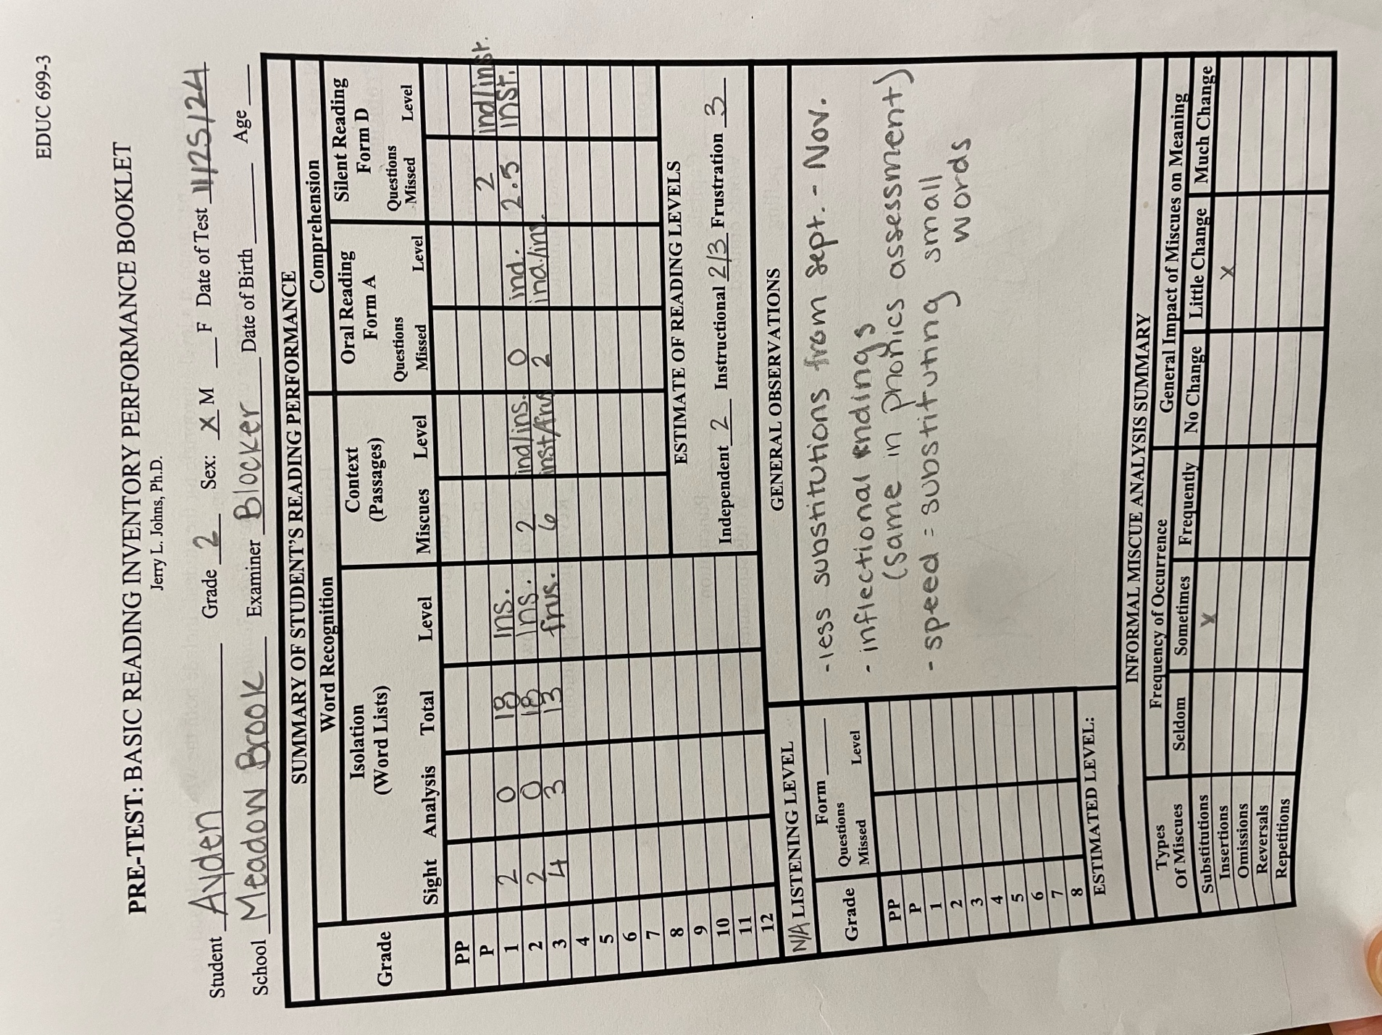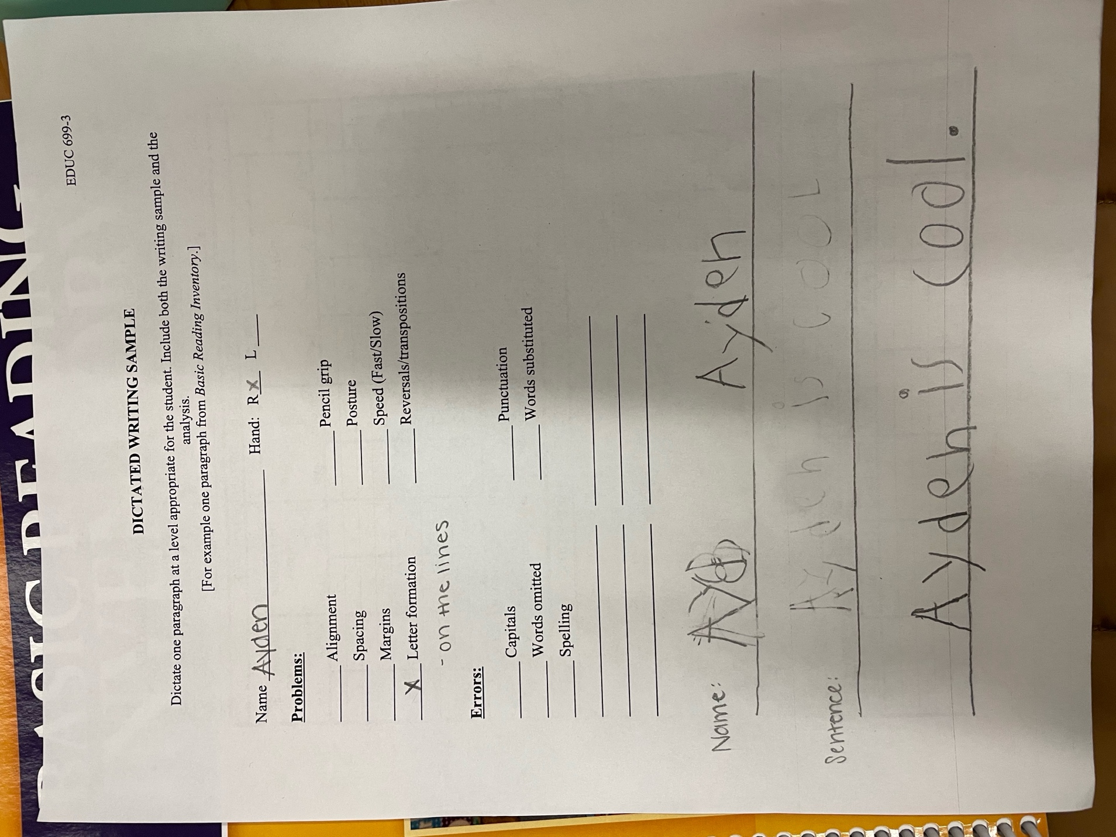
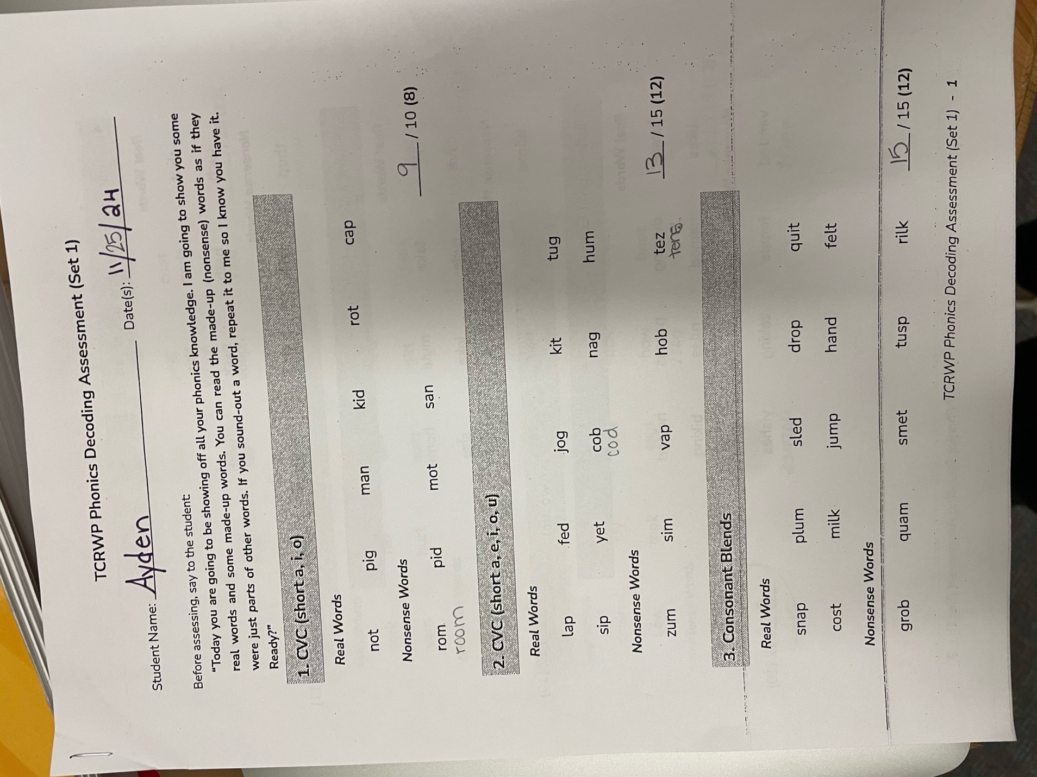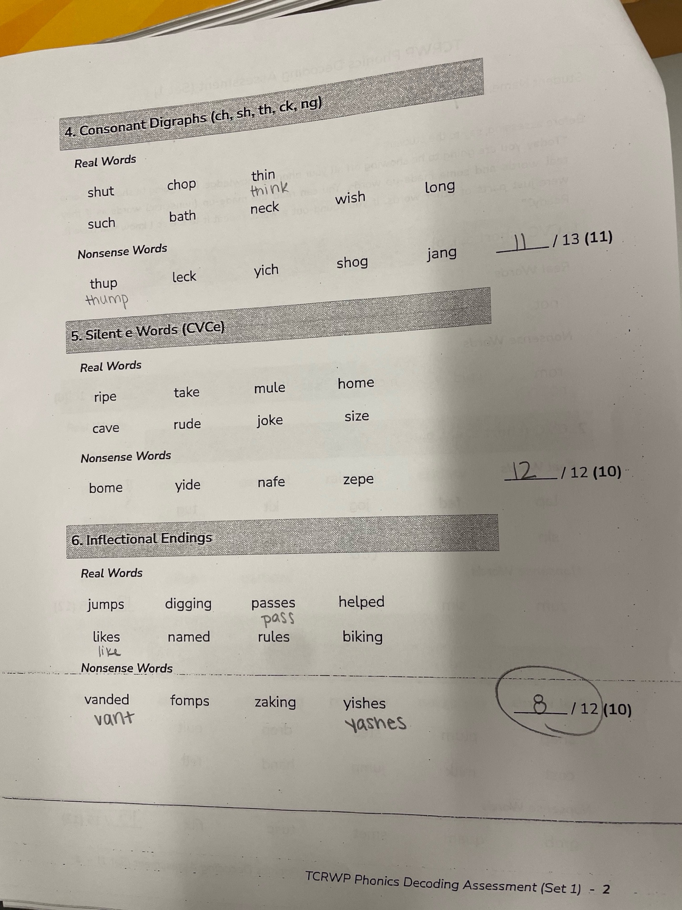

Reflection of Post-Assessment:

Ayden has had some incredible growth over the last two and a half months. His independent/instructional reading abilities moved from a 1st to 2nd grade level and an instructional/frustration level at a 3rd grade level, showcasing his ability to both decode and understand new and bigger words. In terms of comprehension, Ayden moved from an independent rating of comprehension at a first-grade level and frustration at a 2nd grade level, and has now grown to an instructional/frustration level at a 3rd grade level. In silent reading, Ayden’s comprehension improved from a 1st-grade level to a 2nd-grade level, reflecting his developing ability to process and understand text independently. In a 2nd-grade reading passage, Ayden initially required 2.5 minutes and made 15 miscues. As of November, he now reads a passage at the same level in 90 seconds with only 2 miscues. This reflects Ayden’s growing abilities in pacing, accuracy, and confidence. In writing, Ayden has shown growth in mindset, creativity, and determination as well as enhanced skills in self-correcting and editing his own work.
In addition to his incredible classroom teacher, Ayden did benefit from our work together in both fluency and writing. Our assessment results in each category reflect his hard work and growth in these areas. These results were expected, as Ayden has put in a lot of classroom effort, WIN time effort, and effort in time pulled out with me.
I have several suggestions for continued growth for Ayden. First, for building comprehension, the inclusion of silent reading activities with guided questioning to strengthen independent skills, using comprehension strategies taught in class/WIN. This is mostly for his tutor who will be present at the meeting. In terms of fluency, continue to implement repeated reading strategies to enhance Ayden’s growing fluency skills. Then, continue UFLI instruction in both classroom work and WIN groups – Ayden is referencing specific skills and lessons while decoding, excited to share his new knowledge. Concrete, systematic, and explicit teaching is doing wonders for Ayden. With writing, for his tutor and mom I will suggest journaling or writing of necessary daily home tasks (grocery lists, letters, etc.) at home to practice writing for self-expression, need-based writing while practicing mechanics and handwriting. For his teacher and classroom writing, I will suggest step by step check-ins for a mental break and frequent feedback. Lastly, I will encourage everyone to continue to celebrate growth – providing regular verbal or written acknowledgement of determination and positive mindset, highlighting specific achievements!

PART 5:

COMMUNICATING ASSESSMENT RESULTS

Dates of Assessment Results Meetings: 12/4/2024

Names of Parents, Teachers, and Administrators with whom Assessment Results were shared:
Sam Billings
Ashley Jones
Emily (tutor)
Alana (mom)

Written Report of Assessment Results
Data Slides

Overview
This report details Ayden’s progress in reading and writing over the past 2.5 months. The data demonstrates significant growth in word recognition, comprehension, fluency, writing, and phonics. Ayden’s improvements reflect his hard work and determination, along with the targeted support provided during this period.

Areas of Data Growth
- Basic Reading Inventory (BRI) – Word Recognition
  - Ayden progressed from an independent/instructional level at a 1st-grade reading level to an independent/instructional level at a 2nd-grade reading level.
  - He has advanced to an instructional/frustration level at the 3rd-grade reading level, indicating increasing familiarity with more complex words.
- Basic Reading Inventory (BRI) – Comprehension
  - Initially, Ayden demonstrated independent comprehension at a 1st-grade level and frustration at a 2nd-grade level. He has now grown to an independent/frustration level at the 3rd-grade level.
  - In silent reading, Ayden’s comprehension improved from a 1st-grade level to a 2nd-grade level, reflecting his developing ability to process and understand text independently.
- Fluency
  - In a 2nd-grade reading passage, Ayden initially required 2.5 minutes and made 15 miscues. As of November, he now reads a passage at the same level in 90 seconds with only 2 miscues.
  - This improvement highlights enhanced decoding accuracy, pacing, and confidence in reading fluency.
- Writing
  - Ayden has shown growth in mindset, creativity, and determination during writing activities.
  - He has shown an increased ability to self-correct and refine his work, indicating a developing understanding of writing mechanics and vocabulary usage.
- Phonics
  - Ayden progressed from working at a silent-e phonics instructional level to moving to inflectional endings.
  - He has also shown improvements across most preceding phonics categories, demonstrating a solid foundation in phonetic principles and the ability to apply them effectively.

Suggestions for Continued Growth
Included in Google Slides presentation.

Summary of Conferences to Share Assessment Results:

Ayden’s teacher and tutor showed up, his mom had a work call that went long. I emailed her my slides afterward, written below.
“I first want to say that I have had the BEST time working with Ayden over these past few months! He is such a truly wonderful boy - you have so much to be proud of. He has been working so hard this year and has the most excellent mom, teacher, and tutor to guide and support him as he grows, and all that love and support is incredibly evident.
I've included some of the data I collected with Ayden to track growth over the last few months along with a slide dedicated to explaining the areas of growth in each area and some suggestions for home, school, and tutoring. The last slide is my favorite Ayden writing piece from our time together ”
In our meeting, we were able to go simultaneously agree all the ways Ayden has grown this semester and see the same areas that need growth. It was nice to have both tutor and teacher together in this meeting so we could focus on instructional practices to implement and in which setting they would be best implemented in. Ayden’s teacher and I both gave his tutor some concrete ideas and focuses, which were both asked for and well-received.
The results and recommendations were all received well, and we were all able to agree on Ayden’s growth and goals looking forward. We were all able to give specific input on the creation of these goals, working together to support Ayden.

PART 6:

CASE STUDY REPORT

CASE STUDY REPORT

Examiner’s name: Jessica Blocker
Client’s name [FIRST NAME ONLY]: Ayden
Client’s age: 8 | Grade: 2

Client background
Ayden lives with his mom and has gone to Meadowbrook for his whole school career. He is often cared for by his grandma and has a tutor 1x a week. Mom is very involved in his school life. Ayden is sweet and thoughtful, very creative. Ayden does struggle with attention (usually due to excitement and commotion from others) and is working on controlling and letting go of big emotions. Ayden’s teacher expresses that he struggles with fluency, which is affecting comprehension.

Test behavior and test results
We tested on 9/11/2024. Ayden enjoyed working through our testing after building a relationship with the client survey. He was excited to show off his reading skills but grew easily frustrated when the reading became hard. While writing, Ayden was especially distractable and ready to talk instead of work.
Ayden’s initial assessments showed a reading level of independent/instructional at a 1st grade level for oral reading, an independent level of comprehension at 1st grade and frustration level of 2nd, and 1st grade silent reading instructional level. His reading had frequent substations of unknown or larger words, affecting comprehension. He acknowledged “handwriting isn’t my favorite, I can’t always make the letters right” in reference to writing, and did struggle to decode 2 words and use correct directionality in handwriting, but brainstormed his own sentence and used correct punctation.

Summary of instruction
In Ayden’s instruction, we focused on fluency and writing. In our fluency focus, I began with skills he was already mostly proficient in – blends and digraphs – so we could focus on the fluency aspect. We moved onto silent e’s, the area of instructional focus the data reflected, while also focusing on the reading fluency. In writing, we focused on different genres of writing and brainstorming ideas along with intentional handwriting.
The research behind the goals is what built the strategies the teacher used. The ultimate goal of reading words is fluency, which leads to comprehension (Cooper et al., 2018). A focus on fluency will foster deeper comprehension for Ayden. We began our fluency reading in areas Ayden was mostly proficient in and then moved to skills he was working on, as students should read content correlating to word patterns they have been taught, following the sequential pattern of simpler to more complex patterns, so they are able to read increasingly complex texts (Spear-Swerling, 2019). I worked to teach the writing process approach: brainstorming (graphic organizers, drawing), drafting (decoding and writing), revising (improvements), editing (corrections), and publishing (sharing work). The age of students and assignment dictate the length of time in each stage (Reading Rockets, n.d.). In Ayden’s case, we had about a half an hour for reading and writing, so our writing time was around 15 minutes. This meant a brief overview of the stages each time we wrote. In these lessons, we were able to incorporate fun! (Anxiety and Achievement, n.d.). We worked on taking out anxiety and frustration and focus on the ways literacy is enjoyable and fun. In this, we focused on mindset: keeping an open mind, encouraging Ayden to ask questions, make a commitment, keeping a positive and determined state of mind (Anxiety and Achievement, n.d.).
I used fluency passages that I had previously purchased and used both blends, digraphs, and silent e words. Each passage had focused words to review and tap, where we underlined the skill. The passage we read three times aloud, coloring in a star for each read. We did a rough read, a practice read, and a confident read – each time improving self-corrections, voice intonations and inflections, and a focus on punctuation. Below was to draw a picture for comprehension and rewrite a favorite sentence, but we did run out of time for that area most sessions. For writing, I had purchased a handwriting notebook for Ayden that we decorated. Each prompt was focused on second grade interests and skill levels with a different writing genre each session. This was to explore different ways to write – some fun, some practical, some reflective, and some academic.
Recommendations
1. Comprehension Development
o Silent reading activities with guided questioning to strengthen independent skills, using comprehension strategies taught in class/WIN.
2. Fluency Practice
o Reader’s theater – incorporate reading stories aloud or reader’s theater for performance, confidence, and engagement (whether alone or in a small class group).
o Continue implementing repeated reading strategies to enhance Ayden’s growing fluency skills.
3. Phonics
o Continue UFLI instruction in both classroom work and WIN groups – Ayden is referencing specific skills and lessons while decoding, excited to share his new knowledge. Concrete, systematic, and explicit teaching is doing wonders for Ayden.
4. Writing
o Encourage journaling or writing of necessary daily home tasks (grocery lists, letters, etc.) at home to practice writing for self-expression, need-based writing while practicing mechanics and handwriting.
o Classroom writing – step by step check-ins for a mental break and frequent feedback.
5. Celebrate growth!
o Regular verbal or written acknowledgement of determination and positive mindset, highlighting specific achievements!
Summaries and reflections
Part 1: Pre-Assessment
Each assessment had different purposes, ranging from relationship building to concrete evidence of student performance. I began with the teacher referral form, which gave me a brief idea of why the classroom teachers had chosen this child to work with me in small group or one on one time. In my time with the student, I found the interview instrument potentially the most helpful of all the assessments. This allowed me to build a relationship with the student, understanding his home and family life, attitude toward school, friendships, likes and dislikes, and attitude about reading. The writing assessment showed me information about his letter identification and handwriting directionality as well as spelling skills and knowledge of sentence structure. For reading, I administered the BRI word lists and could identify a starting point for reading and was able to determine the student’s instructional reading levels based on fluency and comprehension and in the process identify concrete skills to work on to improve fluency, comprehension, and confidence. This test I find tedious in scoring, especially in front of a student. Each time I moved the pencil he became nervous about doing something wrong, and I felt unable to make notes as quickly as need be.
After meeting with the teacher, where we filled out the ____ form together, we were able to look through his NWEA MAP scores as well as his Words Their Way initial assessment. The classroom teacher’s biggest concern with this student is his ability to write, and within that, focusing on his confidence and stamina within writing. Since this is her goal for him, the Words Their Way assessment gave me very detailed and concrete data on a good starting point and ideas for growth in writing.
Each of these instruments was beneficial in building well-rounded knowledge of this student’s literacy skills. This covered interests, attitudes, fluency, comprehension, writing, spelling, and handwriting. Each test truly uncovered more of the “puzzle”, allowing me to understand the student as a whole with each new assessment. This is all incredibly useful information.
This particular set of assessments worked very well for this student and we were able to complete them all successfully. My other case study student had a very different background and school experience, leading to a necessary change in questions and set of assessments. I believe this flexibility is necessary as a reading specialist, the need to adjust to what students or teachers need to best help and equip all learners.

Part 2: Teacher Collaboration
My time with Samantha Billings was lovely. We discussed her new role in the school as a second-grade teacher, previously in first. I began with asking her more about Ayden and why she chose Ayden specifically for this project. We reviewed all data I had collected well as school-collected data – the Words Their Way assessment and his NWEA MAP scores.
I shared what trends I was seeing through the collected data and asked her to elaborate on how the data reflected what she has seen from him in the classroom in the last five weeks. Samantha articulated that everything seemed to line up with what she is seeing from Ayden in the classroom. He is around an end of first grade reading level, he is struggling with spelling, he is excited about reading and substitutes/omits words and grows easily frustrated with writing. I told Samantha I had some ideas of goals to create for Ayden – decoding skills, fluency, and writing based on comprehension. I asked Samantha her thoughts on what would be the most beneficial use of our learning sessions and what, in her opinion, would be most valuable for my time with Ayden. Samantha believes that the greatest use of time would be with writing, as he is easily frustrated and gives up, and she is only minimally able to assist in adjusting that mindset and provide the needed one on one assistance.
Therefore, we decided that the best use of time would to be in working on decoding and fluency strategies, boosting knowledge needed for spelling, and following up those activities with a writing and spelling portion. We reviewed the curriculum used in the classroom, the curriculum as well as approved resources for Tier 2 instruction. With my allotted time being with Ayden once per week, we decided it would be more useful to find cohesive resources that built on each other and worked toward our goals for Ayden rather than choose a curriculum and teach one lesson per week. I have access to their decodable resources and handwriting program, which will assist me in building lessons focused on decoding, fluency, and writing.
Part 3: Instruction
In Ayden’s sessions, I quickly discovered strategies that were effective and those that were not. The difficulty we experienced was a lack of consistency. Ayden was often taken out of school or absent on our scheduled session days. We were scheduled at the end of the day, and he would not often miss his first half of the day Mandarin immersion experience, but often left during his English literacy block with his English teacher. In addition to my two scheduled off weeks, it was difficult to practice consistency and get into a steady routine. Ayden was great at falling back into our routine, but the learning and identified goals would have been much more cohesive had these lessons actually happened weekly as anticipated.
I did not experience any unexpected results with Ayden, but I also did not anticipate the heart-to-heart conversations we would have about big feelings, especially frustrations with others and self. Our time spent on social emotional learning was unexpected and good for his processing, letting him let go of frustrations and focus on the tasks at hand.
Looking forward, there are several instructional resources I recommend Ayden begin or continue. Ayden often used his UFLI lesson skills to decode words and reference the specific lesson while doing so. I believe the explicit approach with a structured routine helps him greatly and the spiraling of concepts and consistent repetition helps with memory retention. In addition, I recommend writing practice with both tutor and at home, finding ways to practice writing for both life skills and enjoyment!
Both case study participants struggle with big emotions, short attention spans, and plenty of physical energy. I ended up using similar phrasing, brain breaks, and motivators for both students. The students’ academic goals were different with similar needs for the heart and attitude.
I think the experience was overall successful in the way that it was able to build Ayden’s confidence in literacy in a one-on-one setting. For a student with a big heart and big feelings to have the one-on-one time to focus on a subject of frustration, working with quick feedback and encouragement on skills of difficulty, made a big difference in mindset and attitude.
Part 4: Post-Assessment
Ayden has had some incredible growth over the last two and a half months. His independent/instructional reading abilities moved from a 1st to 2nd grade level and an instructional/frustration level at a 3rd grade level, showcasing his ability to both decode and understand new and bigger words. In terms of comprehension, Ayden moved from an independent rating of comprehension at a first-grade level and frustration at a 2nd grade level and has now grown to an instructional/frustration level at a 3rd grade level. In silent reading, Ayden’s comprehension improved from a 1st-grade level to a 2nd-grade level, reflecting his developing ability to process and understand text independently. In a 2nd-grade reading passage, Ayden initially required 2.5 minutes and made 15 miscues. As of November, he now reads a passage at the same level in 90 seconds with only 2 miscues. This reflects Ayden’s growing abilities in pacing, accuracy, and confidence. In writing, Ayden has shown growth in mindset, creativity, and determination as well as enhanced skills in self-correcting and editing his own work.
In addition to his incredible classroom teacher, Ayden did benefit from our work together in both fluency and writing. Our assessment results in each category reflect his hard work and growth in these areas. These results were expected, as Ayden has put in a lot of classroom effort, WIN time effort, and effort in time pulled out with me.
I have several suggestions for continued growth for Ayden. First, for building comprehension, the inclusion of silent reading activities with guided questioning to strengthen independent skills, using comprehension strategies taught in class/WIN. This is mostly for his tutor who will be present at the meeting. In terms of fluency, continue to implement repeated reading strategies to enhance Ayden’s growing fluency skills. Then, continue UFLI instruction in both classroom work and WIN groups – Ayden is referencing specific skills and lessons while decoding, excited to share his new knowledge. Concrete, systematic, and explicit teaching is doing wonders for Ayden. With writing, for his tutor and mom I will suggest journaling or writing of necessary daily home tasks (grocery lists, letters, etc.) at home to practice writing for self-expression, need-based writing while practicing mechanics and handwriting. For his teacher and classroom writing, I will suggest step by step check-ins for a mental break and frequent feedback. Lastly, I will encourage everyone to continue to celebrate growth – providing regular verbal or written acknowledgement of determination and positive mindset, highlighting specific achievements!

Part 5: Communicating Assessment Results
Ayden’s teacher and tutor showed up, his mom had a work call that went long. I emailed her my slides afterward, written below.
“I first want to say that I have had the BEST time working with Ayden over these past few months! He is such a truly wonderful boy - you have so much to be proud of. He has been working so hard this year and has the most excellent mom, teacher, and tutor to guide and support him as he grows, and all that love and support is incredibly evident.
I've included some of the data I collected with Ayden to track growth over the last few months along with a slide dedicated to explaining the areas of growth in each area and some suggestions for home, school, and tutoring. The last slide is my favorite Ayden writing piece from our time together ”
In our meeting, we were able to go simultaneously agree all the ways Ayden has grown this semester and see the same areas that need growth. It was nice to have both tutor and teacher together in this meeting so we could focus on instructional practices to implement and in which setting they would be best implemented in. Ayden’s teacher and I both gave his tutor some concrete ideas and focuses, which were both asked for and well-received.
The results and recommendations were all received well, and we were all able to agree on Ayden’s growth and goals looking forward. We were all able to give specific input on the creation of these goals, working together to support Ayden.

Part 6: Case Study Report
Overall, my experience was incredibly beneficial in putting my coursework knowledge to use. I was able to use what I have learned through Liberty’s classes, combined with my own experiences, to create goals and a plan for a student. I was also able to learn what can and will go wrong, even with all the best lesson plans, goals, and intentions. Through this experience, I’ve learned increased flexibility, the importance of both collecting and using data, and quality communication with guardians and educators.

References
Cooper, J. D., Robinson, M., Slansky, J., & Kiger, N. (2018a). Literacy: Helping students construct meaning. Cengage Learning.
Liberty University School of Education. (n.d.). Anxiety and Achievement. https://canvas.liberty.edu/courses/635236/pages/watch-anxiety-and-achievement?module_item_id=71260753
Spear-Swerling, L. (2019a, August 11). Here’s why schools should use structured literacy. International Dyslexia Association.
https://dyslexiaida.org/heres-why-schools-should-use-structured-literacy/

