CASE STUDY

Caleb, 1st Grade

PART 1:

PRE-ASSESSMENT

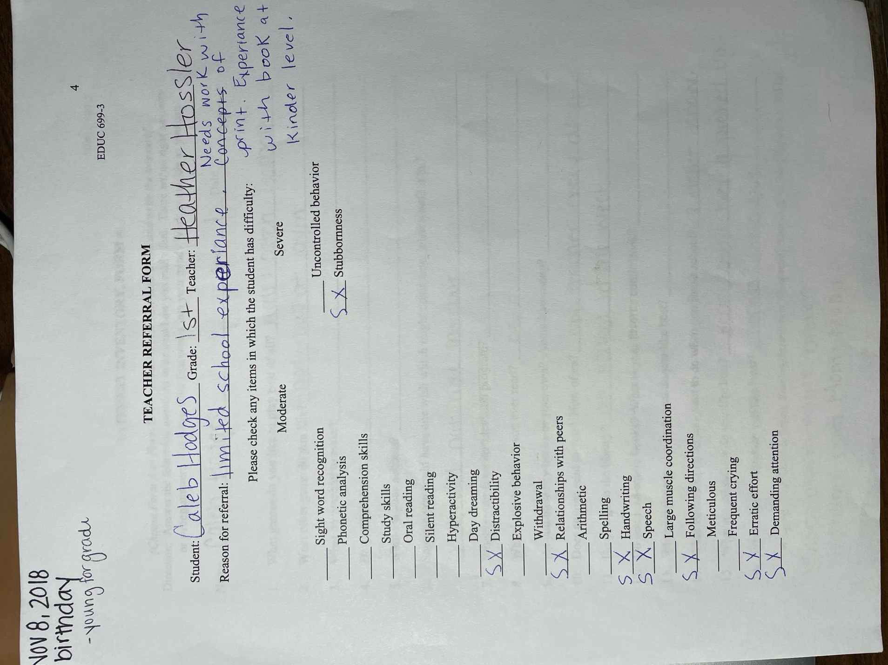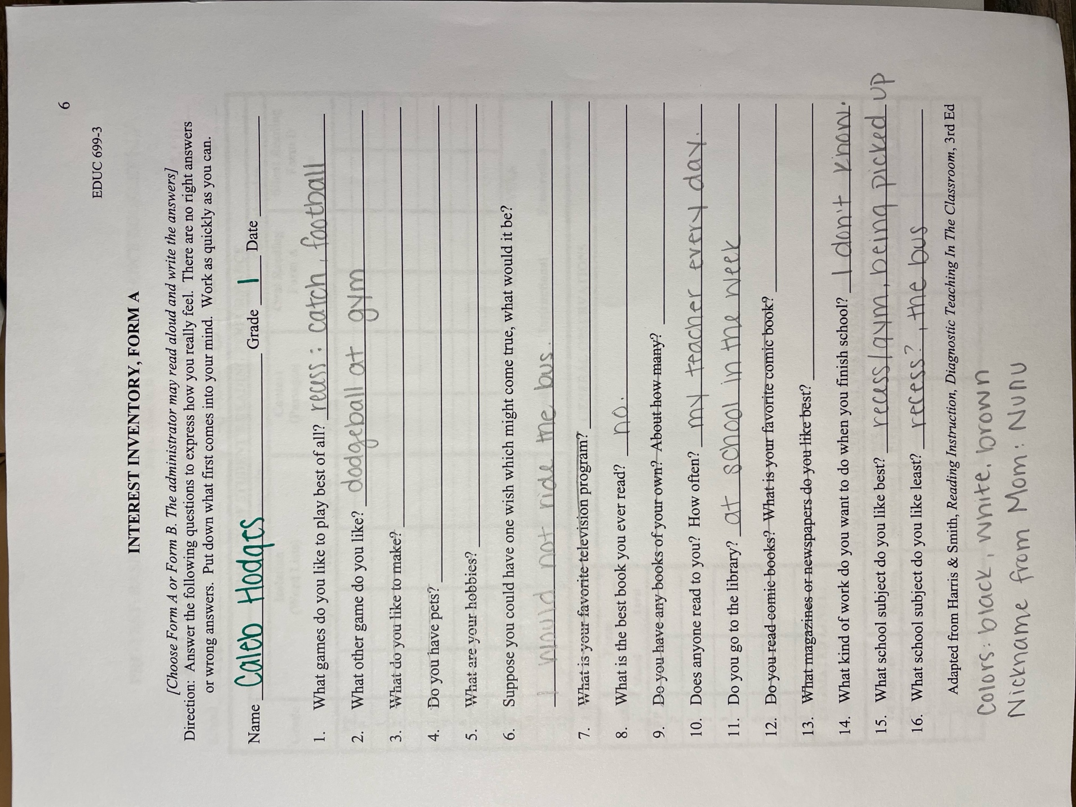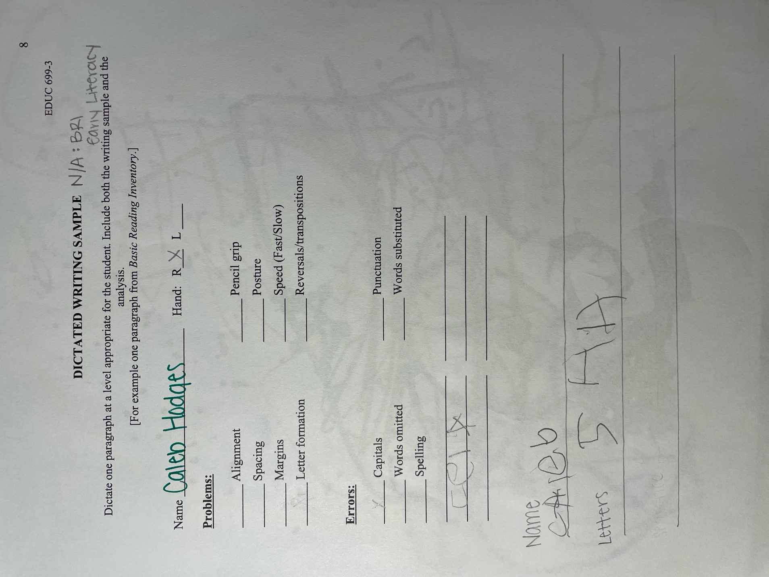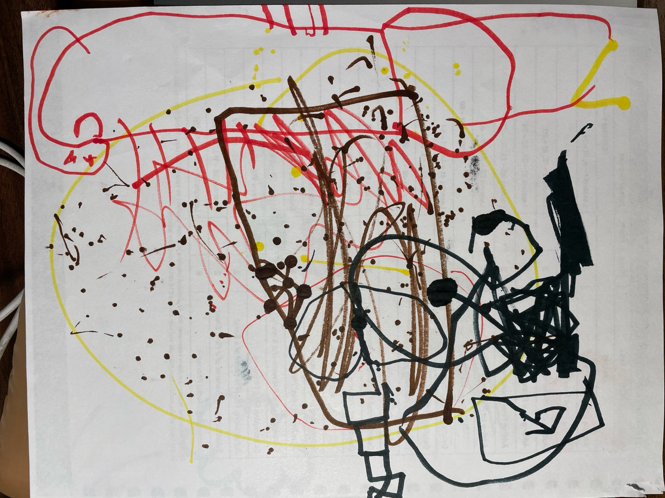
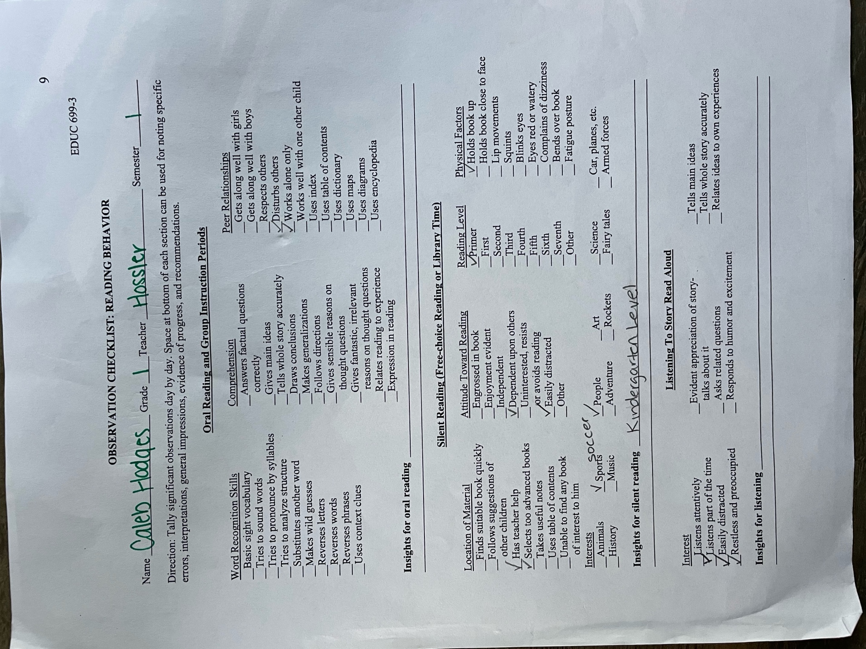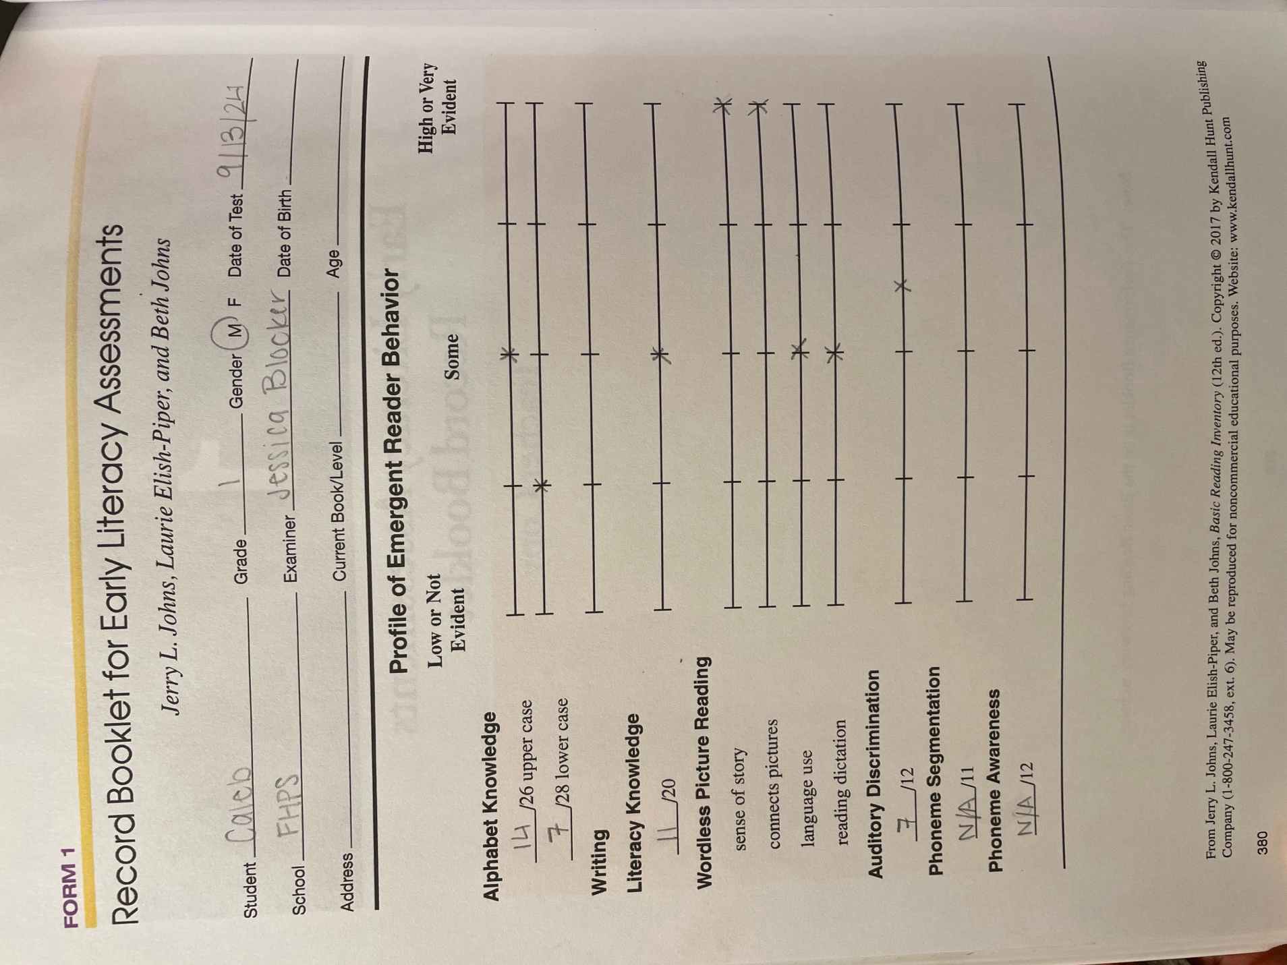
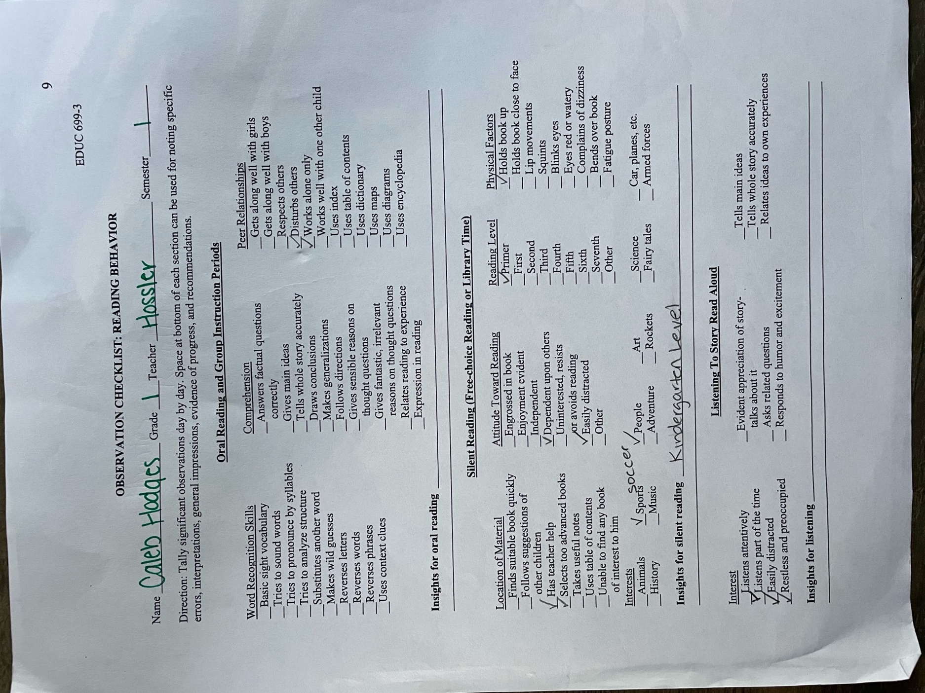
Pre-Assessment Summary:

Each assessment had different purposes, ranging from relationship building to concrete evidence of student performance. I began with the teacher referral form, which gave me a brief idea of why the classroom teachers had chosen this child to work with me in small group or one on one time. The interview assessment, based on a short briefing I had about the student’s background, I quickly realized would be too long and not be appropriate for the type of home he comes from. I rewrote some of the questions before asking and was able to discern some favorites, attitude about school, important values, and attitude about learning. The writing assessment showed me information about his letter identification and handwriting he is capable of, and quickly realized I would be capped at asking him for a few letters and getting him to write his first name.
For reading, I realized I would not be able to use the BRI provided for us and set a second session to administer the early literacy version of the test. In this, we dove deep into letter names and sounds, concepts of print, verbal dictation skills of storytelling, and an auditory assessment. We were unable to complete any phonemic awareness, as he refused after three unknown answers and his stamina had depleted.
Each of these instruments was beneficial in building well-rounded knowledge of this student’s literacy skills.. Each test truly uncovered more of the “puzzle”, allowing me to understand the student as a whole with each new assessment. This is all incredibly useful information as I set up goals and a plan for this student.
This particular set of assessments was difficult to administer to this student. He comes from a difficult background and missed half of kindergarten, also struggling from trauma and potential attention deficits. Even the questions of the interview needed to be rephrased, as to not be a potential trigger. The early childhood test did give me much more information necessary to work with the student on very specific goals and I am thankful to have had that resource available.

PART 2:

TEACHER COLLABORATION

Date of Collaboration: September 22, 2024

Names of Teachers: Heather Hossler

Teacher Collaboration Summary:

Heather and I were able to sit down and conference about Caleb, each showing the other some recently collected data. I began with having Heather tell me a few more details about his background and what the school was able to work on right now. The mother is currently open to creating an IEP as of the past 10 days, and the child study team is currently collecting data to support that decision. Though I had had some previous conversations with her about background and expectations, this was a good debrief of how to frame and structure each of our sessions.
I first showed Heather our data, which corresponded well with what she is seeing in the classroom. She was able to pull up his NEWA MAP testing, which showed Caleb in the 2nd percentile for first graders. Based on his strengths and weaknesses in the scoring and what the test was prioritizing for him, it corresponded similarly to the goals I had outlined based on my own data.
Together, we decided a short time at the beginning of the mornings was best, as he is able to give about 5 minutes of attention to any lesson currently. I will be working with him for 15 minutes, adding an extra 5 of fine motor skill play as incentive and extra needed motor skill practice. We will ensure it is talked about very positively, that if he is emotionally regulated, he will get to come work with me on designated days. We came up with an overall incentive for attending and working during our sessions as well. In this time, we also discussed sending his mother a growth report instead of hosting a meeting, as she has often changed her mind on decisions at school.
Our academic goals will focus on letter names and sounds as well as letter writing/handwriting. We discussed their handwriting program and Caleb’s need for kinesthetic and multisensory learning. We believe this program would be easiest done activity based, based on LETRS principles and activities from FCRR, which is a district supported resource.

PART 3:

INSTRUCTION

Learning Goals (by November 26, 2024):
- Caleb will be able to show knowledge of concepts of print, scoring 20/20 on the early literacy BRI.
- Caleb will be able to identify 20/26 letters, using the early literacy BRI.
- Caleb will be able to identify 18/26 lowercase letters, using the early literacy BRI.
- Caleb will be able to identify 18/26 sounds, using the early literacy BRI.
Strategy:
- The teacher will us auditory, visual, and kinesthetic teaching methods.
- The teacher will introduce concept of print and increase both interest and confidence by pulling books that match interests.
- The teacher will use skill-related incentives to drive motivation for learning.
- The teacher will use explicit and systematic skill building and strategies to foster growth.
Research:
- The teacher will model the skills needed to orally respond to reading, fostering comprehension and constructing meaning with literacy discussion (Cooper et al., 2018).
- The teacher will place emphasis on time spent providing prompt feedback to the student and build a strong relationship with student to build confidence in his skills (Moats, 2020),
- Incorporate daily phonological awareness routines (International Dyslexia Association, 2020). This will be used weekly in our alphabet song as well as building a routine within our session.
- Incorporate multisensory methods: learning with more than one sense (Schlesinger and Gray, 2017). We will incorporate multimodal learning our sessions.

Lesson Plan #1 (September 25, 2024)

Objective: | - The student will match capital letters (26/26) accurately using manipulatives.  - The student will practice following dotted lines on a page using different coloring materials.  - The student will identify main parts of a book: cover, title page, illustration, sentence. The student will identify which way pages are turned and what direction the words are read.  - The student will answer comprehension questions based on the book being read.  - The student will use fine motor skills to build with small Legos.
Activities: | Alphabet (Letters and Sounds): Alphabet Arc  The student will receive capital letter manipulatives and an alphabet arc. He will pull one letter out at a time.  Teacher: “What letter is this?” (prompt feedback) “This is the letter ___.” “What sound does it make?” (prompt feedback) “The letter ____ says ____.”  The student will place the letter on the correct space on the alphabet arc mat.  The student will place all 26 letters in the correct space.  Handwriting: Maze Tracing  The student will trace several mazes on a page with 3 different options of writing tools: pen, marker, crayon. The focus is on holding the instrument lightly, with correct positioning (hand holding and feet on floor) while accurately tracing the lines (slowly). A sticker is rewarded when complete.  Concepts of Print: Read-Aloud Book  The teacher will show the read-aloud of the day, introducing “gems”. “Gems” are small sticky notes to be collected, each with an important question or word. These “gems” will be focused on print concepts and story comprehension.  “Before” questions:  What does the author do? Write the story.  What does the illustrator do? Creates the pictures.  Point out: This is the front of the book, this is the spine, and this is the back of the book. Do we begin reading from the front or back of the book? The front.  Let’s look at the picture on the front. What do you think the story is about? Tell me using complete sentences. Complete sentence answer.  “After” questions:  Talk about if the student liked the story, and why, using complete sentences. “I liked the story because… I didn’t like the story because…”  Book: If You Give a Mouse a Cookie  Gems: What do you think the mouse will draw? What does this picture show? What is a milk mustache? Point to each word in this sentence with me. The mouse is drawing, does that make him an author or illustrator?  Incentive Fine-Motor Skill: Legos  If there is time and the student has continuously worked at giving his best effort, we will be able to use Legos for fine motor work.
Results: | Caleb was able to accurately match each letter in the arc and correctly identified 12/26 capital letters and 8/26 of their sounds.  Caleb repeated the different parts of the book and roles of author and illustrator.  Caleb found each “gem” and answered the questions. Caleb was able to correctly answer comprehension and story-related questions and needed teacher guidance on tapping the words in the sentence.
Rationale: | *See above.

Lesson Plan #2 (October 2, 2024)

Objective: | - The student will listen to/begin learning the Better Alphabet song.  - The student will match lowercase letters in a stack, playing a game and following playing rules with the teacher.  - The student will practice writing each capital letter using a pointer finger in sand, following the stated rules for use.  - The student will identify main parts of a book: cover, title page, illustration, sentence. The student will identify which way pages are turned and what direction the words are read.  - The student will answer comprehension questions based on the book being read.  - The student will use fine motor skills to build with small Legos.
Activities: | Alphabet (Letters and Sounds): Introduce Better Alphabet song.  Handwriting: Trace capital letter (manipulatives in a jar) into sand, saying the sound.  The student will receive capital letter manipulatives and a tray of sand. Student will choose a letter from the pile, say its sound, and write it in the sand until all are gone.  Teacher: “What letter is this?” (prompt feedback) “This is the letter ___.” “What sound does it make?” (prompt feedback) “The letter ____ says ____.”  Concepts of Print: Read Aloud Book  The teacher will show the read-aloud of the day, introducing “gems”. “Gems” are small sticky notes to be collected, each with an important question or word. These “gems” will be focused on print concepts and story comprehension.  Before story questions:  What does the author do? Write the story.  What does the illustrator do? Creates the pictures.  Point out: This is the front of the book, this is the spine, and this is the back of the book. Do we begin reading from the front or back of the book? The front.  Let’s look at the picture on the front. What do you think the story is about? Tell me using complete sentences. Complete sentence answer.  Finishing the story questions:  Talk about if the student liked the story, and why, using complete sentences.  Book: Oddbird  Gems: “Watch my finger move as I’m reading this sentence.” “Count the number of words in this sentence with me.” “What do you predict will happen?” “How does this group of birds feel about the new bird?”  Incentive Fine-Motor Skill: Legos
Results: | Caleb was motivated by the game, especially after we decided the game would be better played standing instead of sitting on the chair. He was able to identify about 50% of the letters correctly and we worked on directionality within his lowercase writing. Caleb was able to identify the front and back of the book and enjoyed this week’s reading. He watched as I moved by finger while reading and was able to answer the “gem” questions correctly, all focused on the story itself. We need to work on the author and illustrator purposes next week.
Rationale: | *See above.

Lesson Plan #3 (October 9, 2024)

Objective: | - The student will listen to/begin learning the Better Alphabet song.  - The student will match lowercase letters in a stack, playing a game and following playing rules with the teacher.  - The student will practice writing each capital letter by following the teacher’s example with a wet sponge, dry sponge, and chalk.  - The student will identify main parts of a book: cover, title page, illustration, sentence. The student will identify which way pages are turned and what direction the words are read.  - The student will answer comprehension questions based on the book being read.  - The student will practice quick movements, gross motor skills, and reaction time with a motor skills game.
Activities: | Sing the Better Alphabet song.  Alphabet (Letters and Sounds): Letter Tap Stack  Handwriting: Wet Dry Try  Have the student wet a sponge cube and squeeze it out so it’s not dripping with water. Write a letter on the slate so your child has a model. Next, ask her to write the letter using a wet sponge. Then ask him to trace it with a dry sponge. Finally, ask him to write the letter using chalk.  Concepts of Print: Read Aloud Book  The teacher will show the read-aloud of the day, introducing “gems”. “Gems” are small sticky notes to be collected, each with an important question or word. These “gems” will be focused on print concepts and story comprehension.  Before story questions:  What does the author do? Write the story.  What does the illustrator do? Creates the pictures.  Point out: This is the front of the book, this is the spine, and this is the back of the book. Do we begin reading from the front or back of the book? The front.  Let’s look at the picture on the front. What do you think the story is about? Tell me using complete sentences. Complete sentence answer.  Finishing the story questions:  Talk about if the student liked the story, and why, using complete sentences.  Book:  Gems:  Incentive Fine-Motor Skill: TP/Paper Towel Rolls & Broom (Sprinkle in Learning)
Results: | The instructions and materials were too much for our shorter time together. I’ll need to rewrite some lessons to incorporate less moving parts. He did enjoy the book of the week and identified the front and back of the book, and we really focused on the purpose of authors and illustrators. We did need to redirect attention and motivation halfway through, talking about learning behaviors and the reminder of the Rubble incentive. We finished strong and played the fine-motor skill game for a short amount of time – will potentially need to play again next time, maybe with letters?
Rationale: | *See above.

Lesson Plan #4 (October 30, 2024)

Objective: | - The student will listen to/begin learning the Better Alphabet song.  - The student will write each lowercase letter and say its sound, one at a time.  - The student will identify main parts of a book: cover, title page, illustration, sentence. The student will identify which way pages are turned and what direction the words are read.  - The student will answer comprehension questions based on the book being read.  - The student will use fine motor skills to draw outdoors with sidewalk chalk.
Activities: | Sing the Better Alphabet song.  Alphabet (Letters and Sounds): Ziplock Gel Letter Writing  “Fill a freezer-sized ziplock bag with a couple dollops of colored hair gel. (You could also use clear hair gel and add food coloring or glitter.) Seal it tightly, taping over the top to make sure it stays closed.” The student will place the bag on a table and smooth it out until it’s flat. The student will use his finger or the eraser end of a pencil to practice writing words or letters. (The resistance of the hair gel will help him feel how the letters are formed.) The student will pick up one letter card at a time, (lowercase letters) say its sound, and write it on the bag until all are gone.  Teacher: “What letter is this?” (prompt feedback) “This is the letter ___.” “What sound does it make?” (prompt feedback) “The letter ____ says ____.”  Concepts of Print: Read Aloud Book  The teacher will show the read-aloud of the day, introducing “gems”. “Gems” are small sticky notes to be collected, each with an important question or word. These “gems” will be focused on print concepts and story comprehension.  Before story questions:  What does the author do? Write the story.  What does the illustrator do? Creates the pictures.  Point out: This is the front of the book, this is the spine, and this is the back of the book. Do we begin reading from the front or back of the book? The front.  Let’s look at the picture on the front. What do you think the story is about? Tell me using complete sentences. Complete sentence answer.  Finishing the story questions:  Talk about if the student liked the story, and why, using complete sentences.  Book: Summer Ends, Autumn Begins  Gems: “What clues do we have that fall is coming?” “What animals do you see in this picture?” “Count the number of words in this sentence with me.” X2 What is the boy wearing/why would he be wearing that?  Incentive Fine-Motor Skill: Outdoor Sidewalk Chalk
Results: | This was a better writing alternative and a good one for a sensory experience. We focused on the lower-case letters and Caleb was able to identify more than half in our time focused on letter writing. We are working on starting letters from the “top” not the “bottom”.  Focus was lost during this book, but he was able to keep attention to answer/find 3 of the 5 “gems”. He was uninterested in the parts of the book – will need to find a different or faster way to review. Did not make it to outdoor sidewalk chalk.
Rationale: | *See above.

Lesson Plan #5 (October 30, 2024)

Objective: | - The student will begin singing along to the Better Alphabet song.  - The student will, with help, identify words in a sentence and count the correct number of words.  - The student will identify main parts of a book: cover, title page, illustration, sentence. The student will identify which way pages are turned and what direction the words are read.  - The student will answer comprehension questions based on the book being read.  - The student will use fine motor skills to pop bubble wrap.
Activities: | Alphabet (Letters and Sounds):  Sing the Better Alphabet song. Work on singing along to the song.  Words in a Sentence:  The student will receive a bag of colored magnets. The teacher will present a whiteboard. The teacher will tell the student that she will write a sentence and she and the student will match one magnet to each of the words in the sentence.  (5 sentences, building in length.)  I like bananas. (Model.)  I like to play outside. (Together.)  First grade is fun. (Student tries.)  Caleb is a hard worker. (Student tries.)  Rubble is a sweet and patient dog. (Student tries.)  Concepts of Print: Read Aloud Book  The teacher will show the read-aloud of the day, introducing “gems”. “Gems” are small sticky notes to be collected, each with an important question or word. These “gems” will be focused on print concepts and story comprehension.  Before story questions:  What does the author do? Write the story.  What does the illustrator do? Creates the pictures.  Point out: This is the front of the book, this is the spine, and this is the back of the book. Do we begin reading from the front or back of the book? The front.  Let’s look at the picture on the front. What do you think the story is about? Tell me using complete sentences. Complete sentence answer.  Finishing the story questions:  Talk about if the student liked the story, and why, using complete sentences.  Book: The Book with No Pictures  Gems: “Count the words in this sentence with me” x3, “Why would the writing be in this color?” x3  Practice: Words in a sentence – Read a sentence. Clap for each word. Count words in a line of print to ensure the correct number of claps.  Incentive Fine-Motor Skill: Bubble Wrap
Results: | I am still trying to fit too much into lessons, as Caleb is now back from time away helping family and with pneumonia. His attention span is around 3-4 minutes per activity, and after 2 tasks has done too much. He accurately wrote and stated the sounds for 14/18 letters, and we focused on letter directionality. We did not finish the book, as he kept wandering away through the hallway. He could accurately show me the front and back of a book. He could accurately answer the comprehension questions in the book, but only used several words or incomplete sentences to do so. We ended early to take a walk through the hallway with some heavy carrying to do.
Rationale: | *See above.

Lesson Plan #6 (November 4, 2024)

Objective: | - The student will identify the letter name of all capital and lowercase letters with some guidance.  - The student will identify main parts of a book: cover, title page, illustration, sentence. The student will identify which way pages are turned and what direction the words are read.  - The student will answer comprehension questions based on the book being read.  - The student will use fine motor skills to blow bubbles.
Activities: | Alphabet (Letters and Sounds): Air Writing  The teacher will hold up flash cards of capital and lowercase letters. There is a candy prize for getting through each stack. The student will look at the card and say its name, tracing it in the air.  Concepts of Print: Read Aloud Book  The teacher will show the read-aloud of the day, introducing “gems”. “Gems” are small sticky notes to be collected, each with an important question or word. These “gems” will be focused on print concepts and story comprehension.  Sentence Strips: Using a sentence from the book, write out on a lined strip. Copy on a second strip and cut out each word and put it back in order, matching to the first strip. Repeat with the student dictating a second sentence.  Before story questions:  What does the author do? Write the story.  What does the illustrator do? Creates the pictures.  Point out: This is the front of the book, this is the spine, and this is the back of the book. Do we begin reading from the front or back of the book? The front.  Let’s look at the picture on the front. What do you think the story is about? Tell me using complete sentences. Complete sentence answer.  Finishing the story questions:  Talk about if the student liked the story, and why, using complete sentences.  Book: Can YOU make a scary face?  Questions: “Can you count the words in this sentence with me?”x2, “Why do you think the words are written so large right here?”, “How is the bug feeling in this picture?”x2  Incentive Fine-Motor Skill: Bubbles/Bubble Wrap
Results: | Today we began with another tray of sand, rather than air writing, as I received word from the speech path working with him that attention was low. I switched to sand for more of a sensory experience and I traced a letter while saying its name and sound on one side and had Caleb copy the movement, letter name, and letter sound on the other side of the tray. I gave him a book choice to provide more decision in the matter, and he chose the book that was more interactive. (I got rid of the “gems” and just asked questions through the book instead.) He was able to accurately show me the front and back covers as well as the spine of the book, and we reviewed the author and illustrator roles. We were able to accurately talk about emotions, display them on his face, move around, and count words accurately in the shorter sentences. At the end, he was able to tell me his favorite part of the story for the first time in our lessons. We finished with enough time to pop some bubble wrap, which had him incredible focused and working hard on the fine motor skill practice of the activity.
Rationale: | *See above.

Lesson Plan #7 (November 13, 2024)

Objective: | - The student will, with help, identify words in a sentence and count the correct number of words.  - The student will identify main parts of a book: cover, title page, illustration, sentence. The student will identify which way pages are turned and what direction the words are read.  - The student will answer comprehension questions based on the book being read.  - The student will use fine motor skills to transfer water from one cup to another using a syringe.
Activities: | Handwriting/Letter Sounds: Magnet Letters  All lowercase letters are on a magnetic tray with their storage bag held open by the teacher. As the student takes 1 letter at a time, he will say its name and sound as he puts it away in the bag. Repeat if time allows.  Concepts of Print: Read Aloud Book  Before story questions:  What does the author do? Write the story.  What does the illustrator do? Creates the pictures.  Point out: This is the front of the book, this is the spine, and this is the back of the book. Do we begin reading from the front or back of the book? The front.  Let’s look at the picture on the front. What do you think the story is about? Tell me using complete sentences. Complete sentence answer.  Finishing the story questions:  Talk about if the student liked the story, and why, using complete sentences.  Book: The Book with No Pictures  Gems: How many words does this sentence have?x2, If there are no pictures on this page, did the book need an illustrator? Who wrote all these words? These words are a small size and these words are a large size – which words do you think the author wants me to read loudly and which words does the author want me to read quietly?  Incentive Fine-Motor Skill: Syringes & Eyedroppers  Using a syringe/eye dropper, student will transfer colored water from one cup to another carefully – no drops, quickly.
Results: | We completed every part of this lesson successfully. I am finding more ways to keep Caleb’s attention for longer – this time I introduced a fidget to keep under the table while I read aloud. The book was shorter with no pictures and we were able to focus much longer as well as count the number of words in sentences more frequently. The letter sorting was about a 60% success, with a lot of difficulty with M/W, stating “g” as a letter frequently, and making the incorrect mouth shape for a few letters. He did start to look at my mouth when corrected and we celebrated that strategy. Caleb correctly identified the front, back, and spine of a book as well as where to begin reading the book and a sentence. We reviewed how to count words vs. letters. The syringe activity was very fun, but very difficult in terms of fine motor skills.
Rationale: | See above.

Lesson Plan #8 (November 18, 2024) This lesson had to be skipped due to the student’s frequent absences this semester due to illness, poor attendance, and travel. These factors have impacted his classroom learning as well as our 1:1 instructional time.

Objective: | - The student will find each letter and state its name, write the letter, and state its sound.  - The student will identify main parts of a book: cover, title page, illustration, sentence. The student will identify which way pages are turned and what direction the words are read.  - The student will answer comprehension questions based on the book being read.  - The student will use fine motor skills to peel and place stickers on a page.
Activities: | Concepts of Print: Read Aloud Book  Before story questions:  What does the author do? Write the story.  What does the illustrator do? Creates the pictures.  Point out: This is the front of the book, this is the spine, and this is the back of the book. Do we begin reading from the front or back of the book? The front.  Let’s look at the picture on the front. What do you think the story is about? Tell me using complete sentences. Complete sentence answer.  Finishing the story questions:  Talk about if the student liked the story, and why, using complete sentences.  Book: Chicka Chicka Boom Boom  Gems:  Alphabet (Letters and Sounds)/Handwriting: Chicka Chicka Alphabet Hunt  Student will look for all the letters of the alphabet, capital and lowercase, displayed in the hallway, and trace them on the tracking sheet. Student will say each letter’s name aloud when found, then state its sound after writing.  Incentive Fine-Motor Skill: Peeling and placing stickers
Results: | This lesson was unable to take place due to frequent student absence this semester.
Rationale: | This lesson had to be skipped due to the student’s frequent absences this semester due to illness, poor attendance, and travel. These factors have impacted his classroom learning as well as our 1:1 instructional time.

Lesson Plan #9 (November 25, 2024)

Objective: | - The student will identify chosen letters, state their name, write them on a sheet of lined paper, and state their sound.  - The student will identify main parts of a book: cover, title page, illustration, sentence. The student will identify which way pages are turned and what direction the words are read.  - The student will answer comprehension questions based on the book being read.  - The student will use fine motor skills to paint with Q-tips.
Activities: | Alphabet (Letters and Sounds)/Handwriting: Apple Letter Cards  As the student “picks” apple letter cards from the tree, he will say their name and write them on a lined piece of paper. After he writes them, he will point to the letter and say its name.  OR (dependent on mood)  Jack Hartman Letter Runs  Concepts of Print: Read Aloud Book  Punctuation highlight: Review what each means – period, comma, exclamation mark, and question mark. While reading through the story, highlight punctuation and have the student review what it means.  Before story questions:  What does the author do? Write the story.  What does the illustrator do? Creates the pictures.  Point out: This is the front of the book, this is the spine, and this is the back of the book. Do we begin reading from the front or back of the book? The front.  Let’s look at the picture on the front. What do you think the story is about? Tell me using complete sentences. Complete sentence answer.  Finishing the story questions:  Talk about if the student liked the story, and why, using complete sentences.  Book: I Want My Hat Back  Incentive Fine-Motor Skill: Q-Tip Painting
Results: | Caleb has qualified for special education in the past week.  We did some preemptive testing for the early literacy BRI and Caleb scored much higher than his initial assessment, with anticipated errors. Caleb was able to identify many parts of a book (concepts of print). The letter runs were too fast – even the slowest, but he did give it effort. The read aloud book kept his attention (mostly) and he accurately inferred what was happening (author doesn’t state – have to use picture and knowledge clues.) No time for fine motor skills today.
Rationale: | See above.

Lesson Plan #10 (November 26, 2024) This lesson had to be skipped due to the student’s frequent absences this semester due to illness, poor attendance, and travel. These factors have impacted his classroom learning as well as our 1:1 instructional time. We did take this time to

Objective: | - The student will sort letters into capital and lowercase.  - The student will identify all capital and lowercase names and sounds, with assistance as needed.  - The student will identify main parts of a book: cover, title page, illustration, sentence. The student will identify which way pages are turned and what direction the words are read.  - The student will answer comprehension questions based on the book being read.  - The student will use fine motor skills to blow bubbles.
Activities: | Alphabet (Letters and Sounds): Matching  Using a full set of both capital and lowercase magnet letters, the student will match the magnet letter to the correct category (capital or lowercase) and state its name. Once they are all placed, we will together state its sound.  Concepts of Print: Read Aloud Book  The teacher will show the read-aloud of the day, introducing “gems”. “Gems” are small sticky notes to be collected, each with an important question or word. These “gems” will be focused on print concepts and story comprehension.  Before story questions:  What does the author do? Write the story.  What does the illustrator do? Creates the pictures.  Point out: This is the front of the book, this is the spine, and this is the back of the book. Do we begin reading from the front or back of the book? The front.  Let’s look at the picture on the front. What do you think the story is about? Tell me using complete sentences. Complete sentence answer.  Finishing the story questions:  Talk about if the student liked the story, and why, using complete sentences.  Book:  Gems:  Incentive Fine-Motor Skill: Cereal races and tweezers – transfer cereal pieces from cup to cup as fast as possible using larger tweezers.
Results: | This lesson was unable to take place due to frequent student absence this semester.
Rationale: | This lesson had to be skipped due to the student’s frequent absences this semester due to illness, poor attendance, and travel. These factors have impacted his classroom learning as well as our 1:1 instructional time.

Summary of Instruction:
In Caleb’s sessions, we focused on goals of learning the alphabet letter names and sounds as well as focusing on concepts of print. Each session included multisensory learning as well as a clear and concise systematic routine. The books used matched student interests, the skills practiced included necessary and needed fine motor skills, and each lesson included skill-related incentives.
The research behind the goals is what built the strategies the teacher used. The teacher worked to model the skills needed to orally respond to reading, fostering comprehension and constructing meaning with literacy discussion (Cooper et al., 2018). The teacher worked to place emphasis on time spent providing prompt feedback to the student and build a strong relationship with student to build confidence in his skills (Moats, 2020), The teacher worked to incorporate weekly phonological awareness routines (International Dyslexia Association, 2020). This will be used weekly in our alphabet song as well as building a routine within our session. The teacher worked to incorporate multisensory methods: learning with more than one sense (Schlesinger and Gray, 2017).
The resources used were the Better Alphabet Song, a myriad of alphabet sound and name related activities, 10 separate children’s books, and teacher-created questions based on knowledge of the student. Most activities utilized materials to create a multisensory experience focused on fine motor skills. The activities chosen were based on teacher experience and past use with students.
Reflection of Instruction:
Teaching Caleb kept me on my toes, and I am very grateful for this experience. I had written out all ten lessons after assessing Caleb, adding in plenty of fun and best practices. I consistently had to edit and refine lessons as I learned Caleb’s learning styles, attention span, need of movement, and academic frustrations. I found that keeping the activities similar with less fuss and flair ended up growing his knowledge the most in letter work and keeping a tight routine while reading books that piqued his interest while working on concepts of print.
Caleb was gone for over a month for both family reasons and illness, and shortly after our times moved around and changed as he qualified for special education and began resource room work twice daily. I find that Caleb works best in a tight routine with systematic and explicit instruction, and I was unable to give that to him due to absence.
I observed pleasant and unexpected results of a huge demeanor change in Caleb after qualifying for special education. I believe the time he spent in the classroom with his peers was overwhelming and overstimulating, and getting interventions as his level in an open space with less distractions has put a light in his eye, smile on his face, and a significantly longer attention span.
After Caleb masters the letters and sounds in the alphabet, I would recommend the program UFLI. He just began the first lessons with his teacher one on one and I think the explicit approach with a structured routine will help him greatly. The program spirals its concepts, and I believe that will be wonderful for memory retention.
Both case study participants struggle with big emotions, short attention spans, and plenty of physical energy. I ended up using similar phrasing, brain breaks, and motivators for both students. The students’ academic goals were different with similar needs for the heart and attitude.
Overall, the experience was mildly successful. I was the only intervention Caleb received prior to November and we were able to focus on his current data, where he was feeling overwhelmed in his Tier 1 instruction. This experience taught me increased flexibility and need of understanding what my student can handle through a lesson, picking and choosing important tasks and refining or editing as the lesson progresses. Due to Caleb’s significant absences this semester, I do not think the time spent together was as effective as it could have been. I do think he thrives off consistent and structured routines in learning, and I was unable to provide that for him. A learning experience for all!

PART 4:

POST-ASSESSMENT

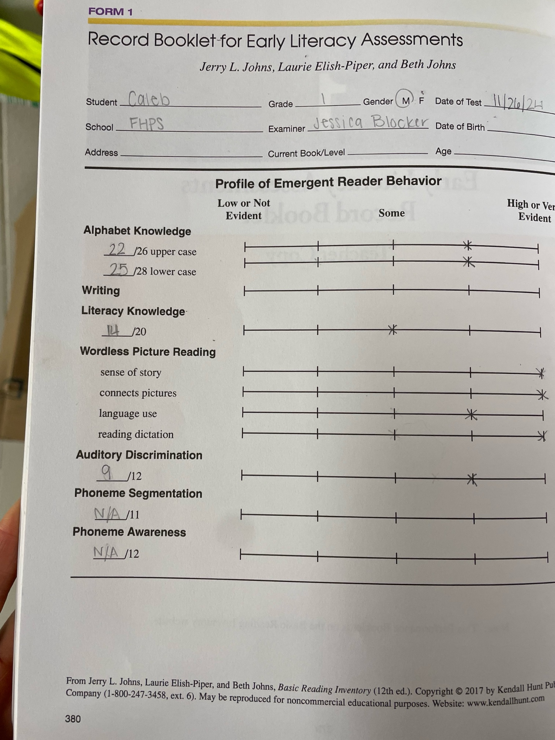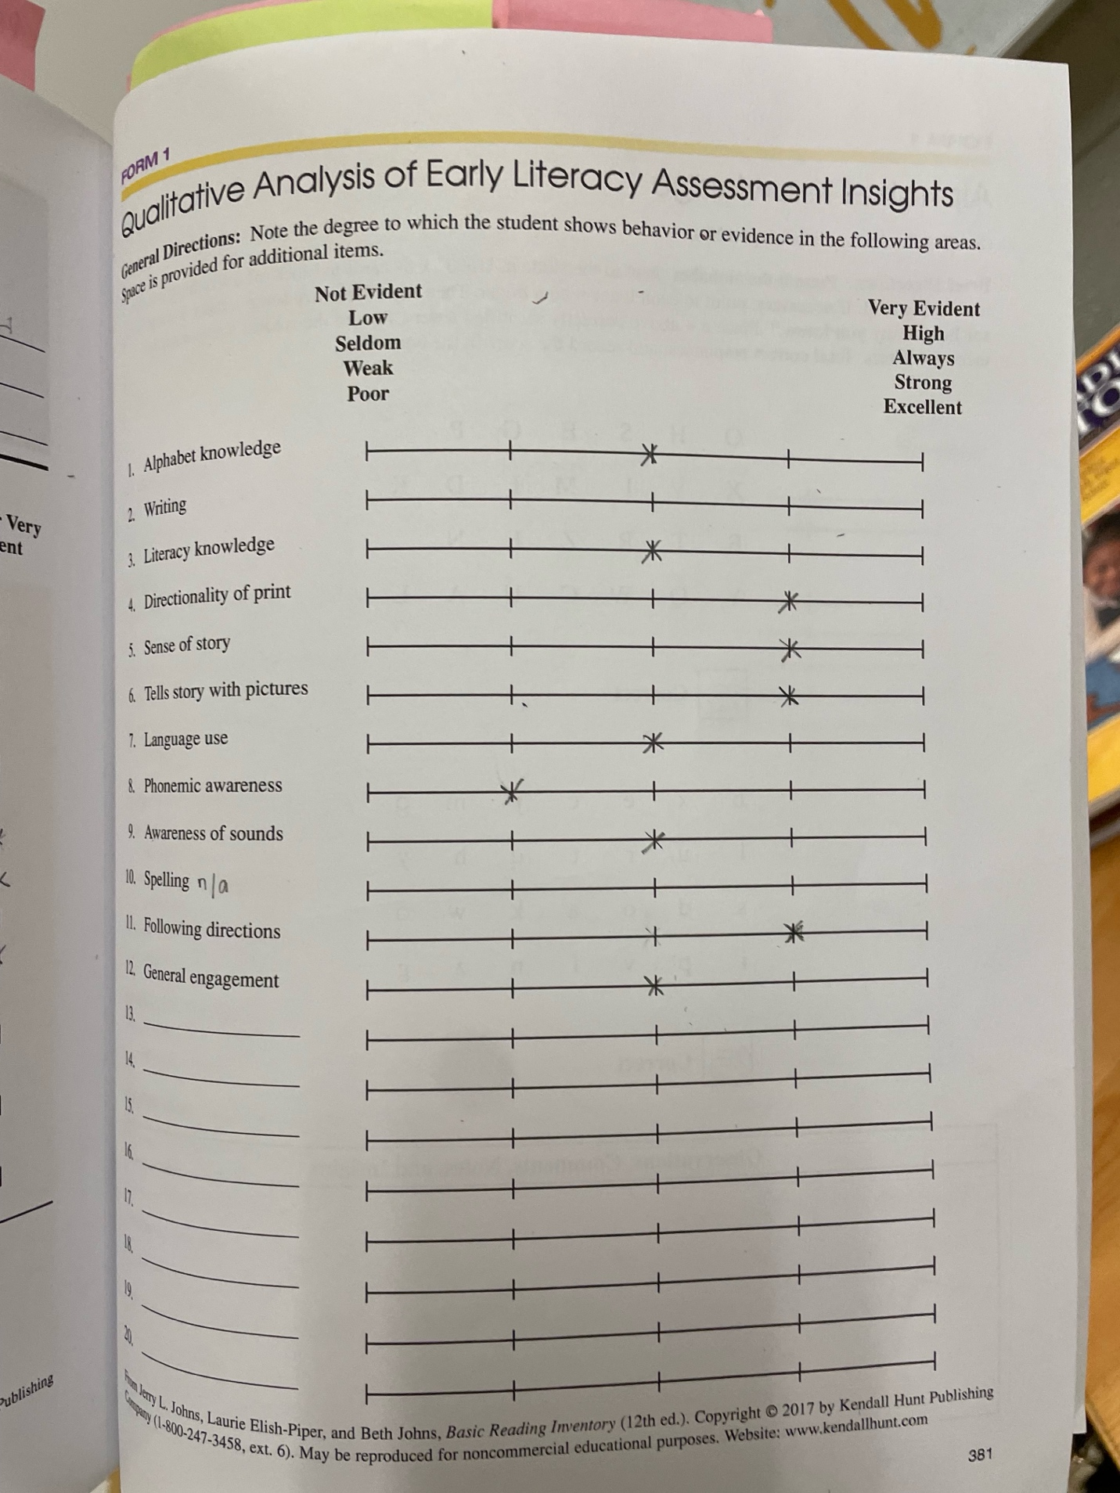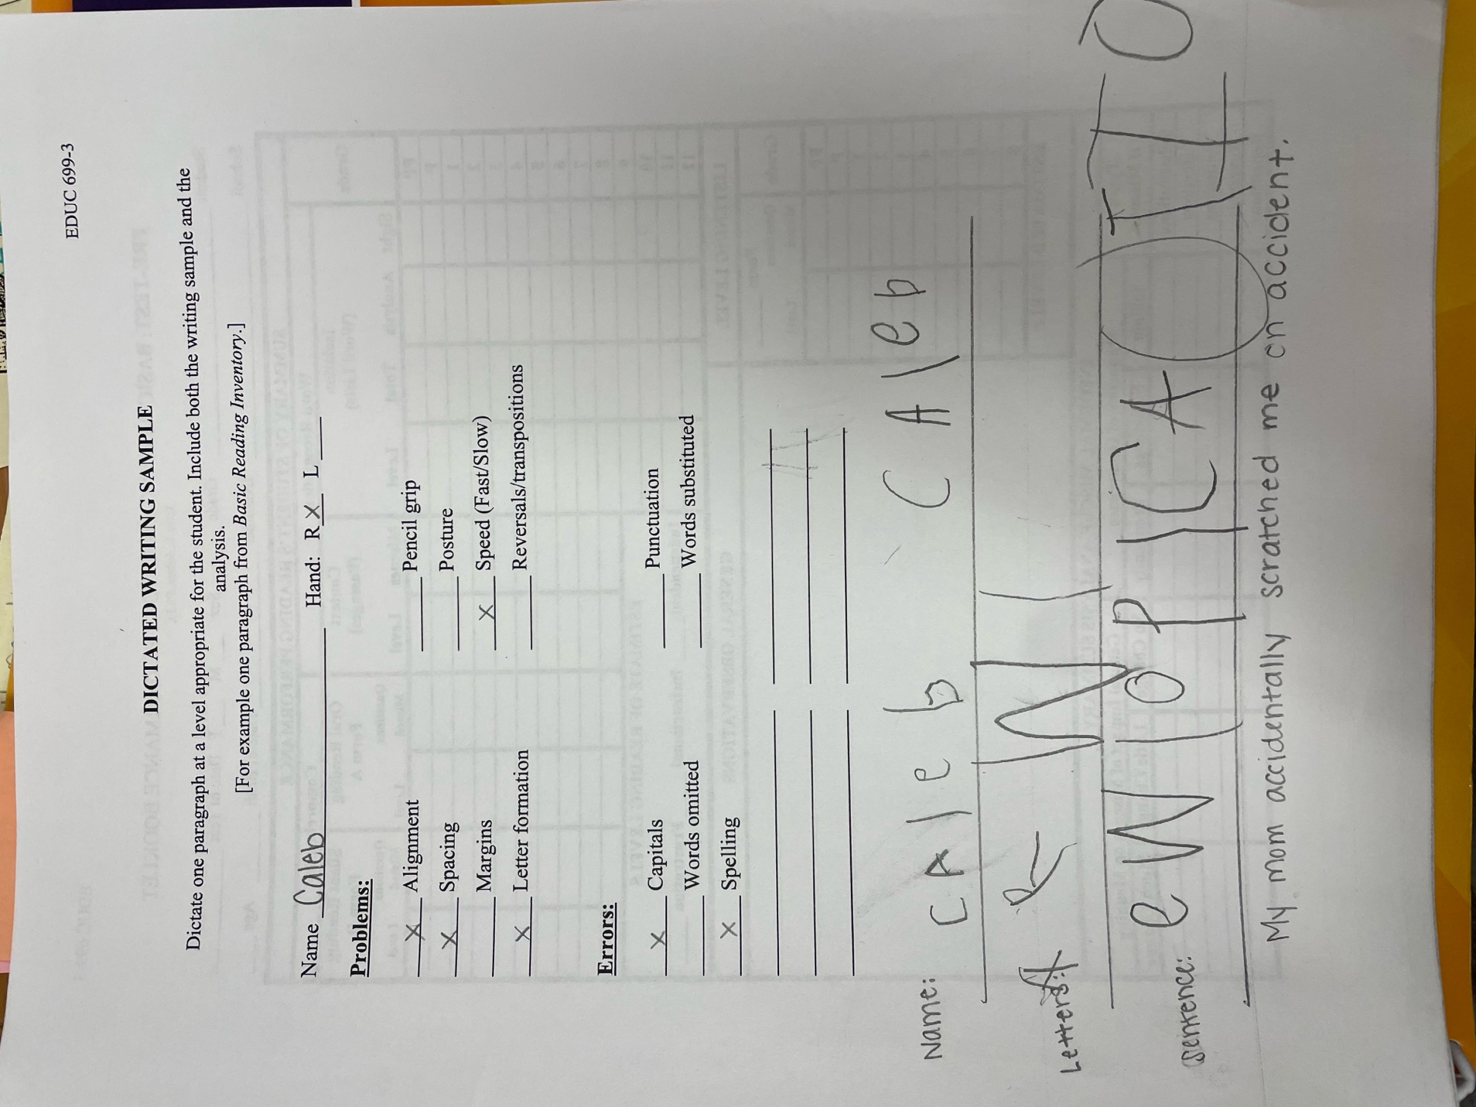

Reflection of Post-Assessment:

Even with inconsistent school attendance and recently qualifying for special education, access to classroom education and our one-on-one sessions have helped Caleb’s growth tremendously. Caleb went from knowing 14/26 to 22/26 capital letters and recognizing 7/28 to 25/28 lowercase letters. Caleb also grew in literacy knowledge and print awareness, improving rom correctly answering 11/20 to 14/20 literacy knowledge questions. In wordless picture writing, he displayed progress in narrative skills by dictating emotions, quotes, and a plotline when describing wordless picture stories, showcasing growth in expressive language and understanding of story. Caleb grew from 7/12 to 9/12 in auditory discrimination tasks, showing enhanced ability to distinguish and process sounds. In writing, Caleb was able to articulate the meanings of the letters he writes on a line, demonstrating an emerging awareness of how letters form words. In addition to the academic growth, Caleb grew leaps and bounds in motivation, enthusiasm for school, and determination.
In the time between school starting and mid-November, Caleb was struggling. His teacher was unable to provide the one on one attention he needs with a full class of students to teach. Our time together was the only intervention he was receiving, and 30 minutes a week is better than none. I do think it was able to make an impact on his scores as well as his motivation. Our lessons revolved around letter identification and concepts of print, and growth in those areas is reflected in his testing scores. I was not surprised by these scores – they were broken up into two days to keep Caleb’s attention fresh, so I do believe he could score even higher in the categories of auditory discrimination and writing with more time.
My suggestions for improvement for Caleb are as follows. First, for letter formation and spacing, incorporating more multisensory writing strategies to support fine motor development, spatial awareness, and letter formation. For auditory discrimination, practicing listening games and phonemic awareness activities to further develop his sound differentiation skills. Then, encouraging storytelling through wordless picture books, expanding opportunities for Caleb to practice sequencing, vocabulary expansion, and expressive language. Lastly, building on Caleb’s growing confidence by celebrating small successes and providing consistent encouragement to reinforce his positive mindset with the use of verbal affirmation and fine motor skill-based rewards as an incentive.

PART 5:

COMMUNICATING ASSESSMENT RESULTS

Dates of Assessment Results Meetings: 12/4/2024

Names of Parents, Teachers, and Administrators with whom Assessment Results were shared:
Heather Hossler – classroom teacher
Ashley Jones – administration, MTSS Instructional Coach
Parents did not wish to attend.

Written Report of Assessment Results
Data Slides

Overview
This report highlights the progress of Caleb in key areas of literacy development over 2.5 months The data indicates significant growth in both academic and personal development.

Areas of Data Growth
- Letter Recognition
  - Capital Letters: Improved from recognizing 14/26 to 22/26 letters.
  - Lowercase Letters: Demonstrated growth from recognizing 7/28 to 25/28 lowercase letters.
- Literacy Knowledge
  - Improved from correctly answering 11/20 to 14/20 literacy knowledge questions, reflecting a deeper understanding of key literacy concepts and increased engagement with learning materials.
- Wordless Picture Writing
  - Caleb displayed notable progress in narrative skills by dictating emotions, quotes, and a coherent plotline when describing wordless picture stories, indicating growth in expressive language and storytelling abilities.
- Auditory Discrimination
  - Improved from scoring 7/12 to 9/12 in auditory discrimination tasks, showing enhanced ability to distinguish and process sounds.
- Writing Skills
  - While challenges remain with letter formation and spacing, Caleb demonstrated an understanding of the function of written language. He can articulate the meanings of the letters he writes on a line, demonstrating an emerging awareness of how letters form words.
- Confidence and Mindset
  - In addition to academic growth, Caleb exhibited significant improvements in confidence, mindset, and determination. These qualities have positively influenced his approach to problem solving and his overall enjoyment/engagement in learning activities.

Suggestions for Continued Growth
Included in Google Slides presentation.

Summary of Conferences to Share Assessment Results:
In this conference, Ashley attended via Google Meet and I went to Heather’s room to discuss Caleb’s growth. We reviewed my slides and his growth, as well as talked about his Child Study Team and his qualification for special education. While reviewing suggestions for growth, Heather and I came up with more ideas of how to provide tools for Caleb to help him pay attention both in the classroom and as a physical brain break. We talked about Velcro dots in the hallway to jump between, hands on the wall for pushups, Velcro strips under his desk for sensory input, a weighted vest, and having the school counselor teach an emotional regulation lesson to introduce these new tools to the whole class.
Heather shared her gratitude for my work with Caleb and my flexibility this semester and was delighted to see the growth in Caleb. Hearing that the interventions implemented after Caleb’s qualification were already making a difference seemed to bring her satisfaction. Overall, the meeting went very well.

PART 6:

CASE STUDY REPORT

CASE STUDY REPORT

Examiner’s name: Jessica Blocker
Client’s name [FIRST NAME ONLY]: Caleb
Client’s age: 6/7 | Grade: 1

Client background
Caleb began kindergarten halfway through the year last year. It was recommended that he was held back, but mom wanted him to continue to first grade. Caleb is McKinney-Vento and currently receives meals and counseling at school. He does not have any intervention. His teacher is concerned about big emotions, attention, and all academic subjects. His school attendance is poor. Caleb is very sweet and has one close friend in his class. He does not remember the names of other students.

Test behavior and test results
These tests took three sessions to complete due to both timing and focus. Caleb recognized 14/26 capital letters and 7/28 lowercase letters. He answered 11/20 questions about literacy knowledge correctly and identified 7/12 auditory discrimination tasks correctly. In writing, Caleb dictated a 4 picture story by stating a short sentence of exactly what was happening in the photo, and when writing he struggled to both write his name and any letters, struggling with directionality.
Summary of instruction
In Caleb’s sessions, we focused on goals of learning the alphabet letter names and sounds as well as focusing on concepts of print. Each session included multisensory learning as well as a clear and concise systematic routine. The books used matched student interests, the skills practiced included necessary and needed fine motor skills, and each lesson included skill-related incentives.
The research behind the goals is what built the strategies the teacher used. The teacher worked to model the skills needed to orally respond to reading, fostering comprehension and constructing meaning with literacy discussion (Cooper et al., 2018). The teacher worked to place emphasis on time spent providing prompt feedback to the student and build a strong relationship with student to build confidence in his skills (Moats, 2020), The teacher worked to incorporate weekly phonological awareness routines (International Dyslexia Association, 2020). This will be used weekly in our alphabet song as well as building a routine within our session. The teacher worked to incorporate multisensory methods: learning with more than one sense (Schlesinger and Gray, 2017).
The resources used were the Better Alphabet Song, a myriad of alphabet sound and name related activities, 10 separate children’s books, and teacher-created questions based on knowledge of the student. Most activities utilized materials to create a multisensory experience focused on fine motor skills. The activities chosen were based on teacher experience and past use with students.
Recommendations
My suggestions for improvement for Caleb are as follows. First, for letter formation and spacing, incorporating more multisensory writing strategies to support fine motor development, spatial awareness, and letter formation. For auditory discrimination, practicing listening games and phonemic awareness activities to further develop his sound differentiation skills. Then, encouraging storytelling through wordless picture books, expanding opportunities for Caleb to practice sequencing, vocabulary expansion, and expressive language. Lastly, building on Caleb’s growing confidence by celebrating small successes and providing consistent encouragement to reinforce his positive mindset with the use of verbal affirmation and fine motor skill-based rewards as an incentive.
Summaries and reflections
Part 1: Pre-Assessment
Each assessment had different purposes, ranging from relationship building to concrete evidence of student performance. I began with the teacher referral form, which gave me a brief idea of why the classroom teachers had chosen this child to work with me in small group or one on one time. The interview assessment, based on a short briefing I had about the student’s background, I quickly realized would be too long and not be appropriate for the type of home he comes from. I rewrote some of the questions before asking and was able to discern some favorites, attitude about school, important values, and attitude about learning. The writing assessment showed me information about his letter identification and handwriting he is capable of, and quickly realized I would be capped at asking him for a few letters and getting him to write his first name.
For reading, I realized I would not be able to use the BRI provided for us and set a second session to administer the early literacy version of the test. In this, we dove deep into letter names and sounds, concepts of print, verbal dictation skills of storytelling, and an auditory assessment. We were unable to complete any phonemic awareness, as he refused after three unknown answers and his stamina had depleted.
Each of these instruments was beneficial in building well-rounded knowledge of this student’s literacy skills.. Each test truly uncovered more of the “puzzle”, allowing me to understand the student as a whole with each new assessment. This is all incredibly useful information as I set up goals and a plan for this student.
This particular set of assessments was difficult to administer to this student. He comes from a difficult background and missed half of kindergarten, also struggling from trauma and potential attention deficits. Even the questions of the interview needed to be rephrased, as to not be a potential trigger. The early childhood test did give me much more information necessary to work with the student on very specific goals and I am thankful to have had that resource available.

Part 2: Teacher Collaboration
Heather and I were able to sit down and conference about Caleb, each showing the other some recently collected data. I began with having Heather tell me a few more details about his background and what the school was able to work on right now. The mother is currently open to creating an IEP as of the past 10 days, and the child study team is currently collecting data to support that decision. Though I had had some previous conversations with her about background and expectations, this was a good debrief of how to frame and structure each of our sessions.
I first showed Heather our data, which corresponded well with what she is seeing in the classroom. She was able to pull up his NEWA MAP testing, which showed Caleb in the 2nd percentile for first graders. Based on his strengths and weaknesses in the scoring and what the test was prioritizing for him, it corresponded similarly to the goals I had outlined based on my own data.
Together, we decided a short time at the beginning of the mornings was best, as he is able to give about 5 minutes of attention to any lesson currently. I will be working with him for 15 minutes, adding an extra 5 of fine motor skill play as incentive and extra needed motor skill practice. We will ensure it is talked about very positively, that if he is emotionally regulated, he will get to come work with me on designated days. We came up with an overall incentive for attending and working during our sessions as well. In this time, we also discussed sending his mother a growth report instead of hosting a meeting, as she has often changed her mind on decisions at school.
Our academic goals will focus on letter names and sounds as well as letter writing/handwriting. We discussed their handwriting program and Caleb’s need for kinesthetic and multisensory learning. We believe this program would be easiest done activity based, based on LETRS principles and activities from FCRR, which is a district supported resource.

Part 3: Instruction
Teaching Caleb kept me on my toes, and I am very grateful for this experience. I had written out all ten lessons after assessing Caleb, adding in plenty of fun and best practices. I consistently had to edit and refine lessons as I learned Caleb’s learning styles, attention span, need of movement, and academic frustrations. I found that keeping the activities similar with less fuss and flair ended up growing his knowledge the most in letter work and keeping a tight routine while reading books that piqued his interest while working on concepts of print.
Caleb was gone for over a month for both family reasons and illness, and shortly after our times moved around and changed as he qualified for special education and began resource room work twice daily. I find that Caleb works best in a tight routine with systematic and explicit instruction, and I was unable to give that to him due to absence.
I observed pleasant and unexpected results of a huge demeanor change in Caleb after qualifying for special education. I believe the time he spent in the classroom with his peers was overwhelming and overstimulating, and getting interventions as his level in an open space with less distractions has put a light in his eye, smile on his face, and a significantly longer attention span.
After Caleb masters the letters and sounds in the alphabet, I would recommend the program UFLI. He just began the first lessons with his teacher one on one and I think the explicit approach with a structured routine will help him greatly. The program spirals its concepts, and I believe that will be wonderful for memory retention.
Both case study participants struggle with big emotions, short attention spans, and plenty of physical energy. I ended up using similar phrasing, brain breaks, and motivators for both students. The students’ academic goals were different with similar needs for the heart and attitude.
Overall, the experience was mildly successful. I was the only intervention Caleb received prior to November and we were able to focus on his current data, where he was feeling overwhelmed in his Tier 1 instruction. This experience taught me increased flexibility and need of understanding what my student can handle through a lesson, picking and choosing important tasks and refining or editing as the lesson progresses. Due to Caleb’s significant absences this semester, I do not think the time spent together was as effective as it could have been. I do think he thrives off consistent and structured routines in learning, and I was unable to provide that for him. A learning experience for all!
Part 4: Post-Assessment
Even with inconsistent school attendance and recently qualifying for special education, access to classroom education and our one-on-one sessions have helped Caleb’s growth tremendously. Caleb went from knowing 14/26 to 22/26 capital letters and recognizing 7/28 to 25/28 lowercase letters. Caleb also grew in literacy knowledge and print awareness, improving rom correctly answering 11/20 to 14/20 literacy knowledge questions. In wordless picture writing, he displayed progress in narrative skills by dictating emotions, quotes, and a plotline when describing wordless picture stories, showcasing growth in expressive language and understanding of story. Caleb grew from 7/12 to 9/12 in auditory discrimination tasks, showing enhanced ability to distinguish and process sounds. In writing, Caleb was able to articulate the meanings of the letters he writes on a line, demonstrating an emerging awareness of how letters form words. In addition to the academic growth, Caleb grew leaps and bounds in motivation, enthusiasm for school, and determination.
In the time between school starting and mid-November, Caleb was struggling. His teacher was unable to provide the one on one attention he needs with a full class of students to teach. Our time together was the only intervention he was receiving, and 30 minutes a week is better than none. I do think it was able to make an impact on his scores as well as his motivation. Our lessons revolved around letter identification and concepts of print, and growth in those areas is reflected in his testing scores. I was not surprised by these scores – they were broken up into two days to keep Caleb’s attention fresh, so I do believe he could score even higher in the categories of auditory discrimination and writing with more time.
Part 5: Communicating Assessment Results
In this conference, Ashley attended via Google Meet and I went to Heather’s room to discuss Caleb’s growth. We reviewed my slides and his growth, as well as talked about his Child Study Team and his qualification for special education. While reviewing suggestions for growth, Heather and I came up with more ideas of how to provide tools for Caleb to help him pay attention both in the classroom and as a physical brain break. We talked about Velcro dots in the hallway to jump between, hands on the wall for pushups, Velcro strips under his desk for sensory input, a weighted vest, and having the school counselor teach an emotional regulation lesson to introduce these new tools to the whole class.
Heather shared her gratitude for my work with Caleb and my flexibility this semester and was delighted to see the growth in Caleb. Hearing that the interventions implemented after Caleb’s qualification were already making a difference seemed to bring her satisfaction. Overall, the meeting went very well.
Part 6: Case Study Report
Overall, my experience was incredibly beneficial in putting my coursework knowledge to use. I was able to use what I have learned through Liberty’s classes, combined with my own experiences, to create goals and a plan for a student. I was also able to learn what can and will go wrong, even with all the best lesson plans, goals, and intentions. Through this experience, I’ve learned increased flexibility, the importance of both collecting and using data, and quality communication with guardians and educators.

References
Cooper, J. D., Robinson, M., Slansky, J., & Kiger, N. (2018a). Literacy: Helping students construct meaning. Cengage Learning.
International Literacy Association (2017). Standards of preparation of literacy professionals International Reading Association.
Moats, L. (2020, July 15). Structured literacy: Effective instruction for students with dyslexia and related reading difficulties. International Dyslexia Association. https://dyslexiaida.org/structured-literacy-effective-instruction-for-students-with-dyslexia-and-related-reading-difficulties/
Schlesinger, N.W., Gray, S. The impact of multisensory instruction on learning letter names and sounds, word reading, and spelling. Ann. of Dyslexia 67, 219–258 (2017). https://doi.org/10.1007/s11881-017-0140-z

