Apology Letter for Conflict Resolution

According to Sande’s (2002) Peacemakers in Training manual, conflict resolution has several parts. One part includes making the right choices in a conflict and applying the principles of honesty, change, and forgiveness (Sande, 2002). Change is understanding you made a choice that is harmful and you are willing to take responsibility and you want to behave differently (Sande, 2002). Honesty, is openly admitting, to the people you have hurt or offended, you know you were wrong. Forgiveness is making a commitment to not hold a grudge against another person (Sande, 2002). These are illustrated by Sande’s 5A’s for conflict resolution, diagram pasted on page two. Please note the diagram was slightly altered to omit a religious part for a secular public school setting.
5A’s:
- Admit
- Apologize
- Accept (the consequences)
- Ask (for forgiveness)
- Alter (your choices)
Using the 5A’s write out an admission that you could give to _____________________.”

- “I admit I was wrong when I ____________________________________________.”

- “I am sorry for ________________________________________________________.”

- “I understand why _____________________________________________________.”

- “Will you please forgive me?

- “Next time I will ________________________________________________________.”

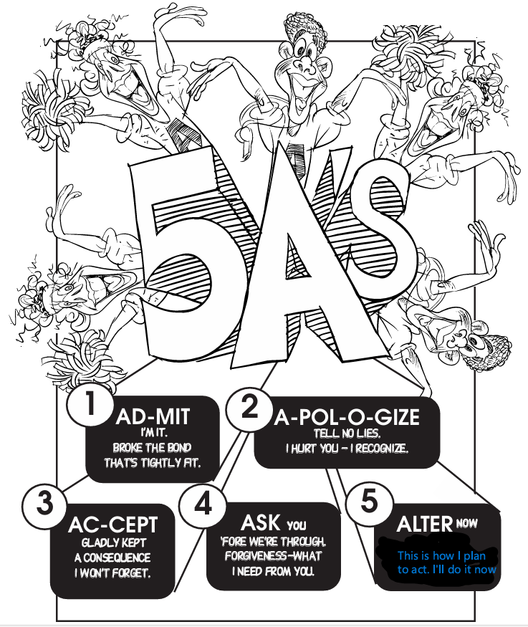

References
Sande, C. (2002). Peacemakers in training: Teaching students in grades 4-8 peaceable
solutions to conflict. National Center for Youth Issues.

