Community Resources Alignment: Demographic Analysis
Christine E. Gardner
School of Education, Liberty University

Author Note

Christine E. Gardner
I have no known conflict of interest to disclose.
Correspondence concerning this article should be addressed to Christine E. Gardner
Email: cegardner4@liberty.edu

Abstract
Community resources must be aligned with the building level and high school level plans to make sure there is an inclusive and supportive culture for all students. A demographic analysis was done, where data was collected from the US Census Bureau (2020) and the Idaho Report Card (2025), to determine the percentages of ethnic groups, employment rates, students from low income familiies, students with disabilities, multilanguage learners, and military families in both the surrounding community and at McCall-Donnelly High School. Implications were made that suggest the need for initiatives and programs that provide supportive and inclusive environments, at the high school, for all students. The demographic data reveals a high percentage of disabled students and those from low-income families, so a particular focus should occur for these minority groups.

Community Resources Alignment: Demographic Analysis
The following demographic analysis contains statistical data collected about McCall-Donnelly High School and the surrounding area. The data was analyzed, and implications were made that refer to the demographics of the high school and its impact on student learning at the building and district levels. The building and district level plans should support an inclusive and supportive culture for all students, with varying demographics.
Demographic Data Report
Community Demographic Data Report
McCall and Donnelly are cities in Idaho that feed into the McCall-Donnelly School District. Data was collected from the United States Census Bureau (2020) and includes demographic data for McCall and Donnelly which make up the surrounding community of McCall-Donnelly High School. Total population, median household income, bachelor’s degree or higher, employment rate, total housing units and without health care coverage (United States Census Bureau, 2020). The following maps and tables were copied from the United States Census Bureau (2020) website.
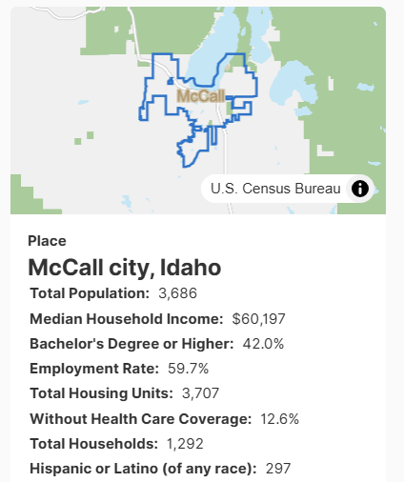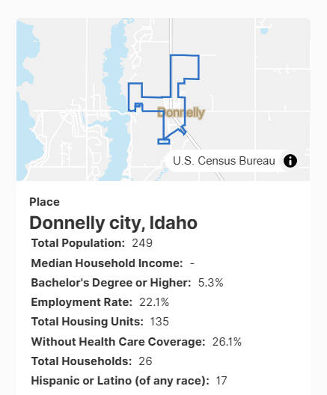

School Demographic Data Report
McCall-Donnelly High School is a traditional school with 418 students enrolled and is in a rural setting (Idaho Report Card,2025). The following tables and graphs were copied from the Idaho Report Card (2025) website and includes demographic data with percentages of ethnicity categories, low-income families, English learners, students with disabilities, students in foster care, migrant families, students who are homeless, and military families.
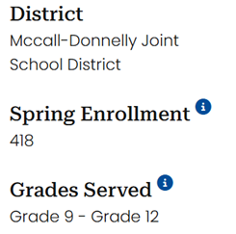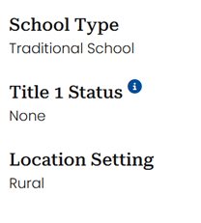
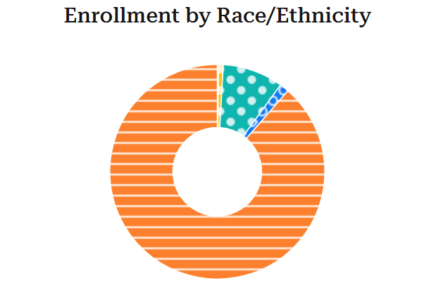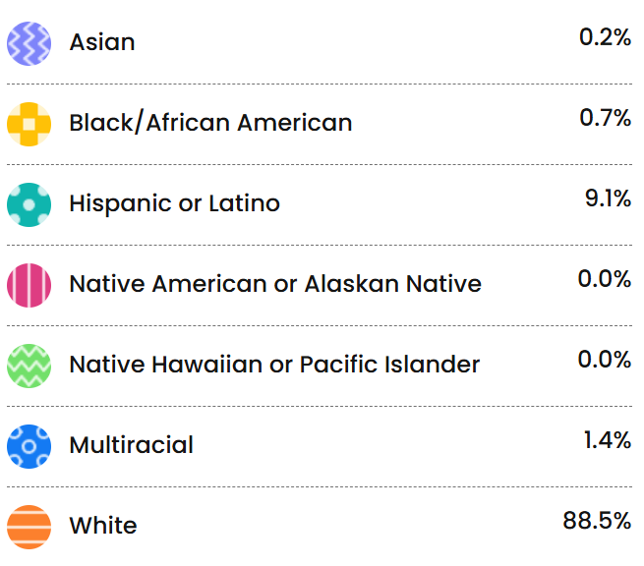

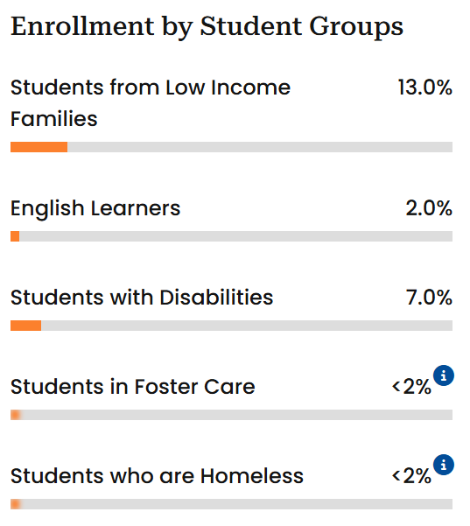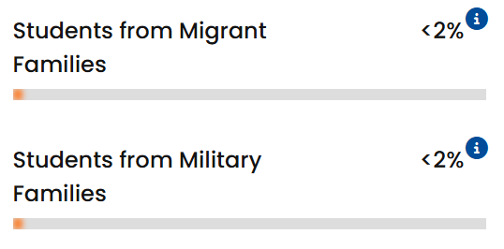
Demographic Data Analysis
The community demographic data which includes the cities of McCall and Donnelly immediately show disparity among the towns themselves. Donnelly has only 249 residents, while McCall had close to 4000 in 2020. There has been significant growth since then so both numbers are higher but they are still relatively different in sizes. McCall has much higher employment rates at 59% whereas Donnelly is only at 22.1%. McCall has eight percent Hispanic or Latino and Donnelly has six percent, which is relatively close to the nine percent of Hispanic or Latinos that attend McCall-Donnelly High School. The median household income for McCall is $60,000, and the Donnelly median household income was not provided.
McCall-Donnelly High School has less than two percent for each of the demographic categories such as students who are in foster care, homeless, migrant families, military families, and English Learners (Idaho Report Card, 2025). The high school does however have 13% of students coming from low-income families. The numbers for the high school show that about 54 students out of 418 come from low-income families. The data is probably determined by the number of students qualifying for free and reduced lunches. This is a sizeable number of students considering that this is a small resort mountain town with 80% of the homes being second homes. Many of the students do, however, live here and there is a very wide gap in wealth. The US Census Bureau (2020) does not provide low-income data about the community, but does show the percentage of people without health care, which could imply little to no income.
McCall-Donnelly High School showed seven percent of its students having disabilities (Idaho Report card, 2025). Roughly 30 students having disabilities is a fairly substantial number for a student body consisting of 418 total students. Eighty eight percent of the students are white with the second largest ethnic group is Hispanic or Latino at nine percent.
Implications
The demographic data reveals characteristics of the high school which includes high percentages of low-income families at 13%, students with disabilities at seven percent, and number of white students at 88.5% with Hispanic Latino coming in second at nine percent (Idaho Report Card, 2025). The implication here is that with a majority of students being white, with about 40 students being Hispanic Latino out of 418, there needs to be programs that make sure the school culture is welcoming and inclusive for these minority groups. The leadership of the school principal is important for enhancing teaching staff disposition and creating advantageous learning environments for students (Qi et al., 2025). The high school principal needs to make sure there is the right number of staff to work with the multilanguage learners (ML) and that the general classroom teachers have the resources and support they need to ensure the ML students in their classes are getting an inclusive and supportive education. The district is currently offering a multi-day summer training opportunity for any teacher that wants; to go to a city a few hours away and work with the teachers whose students are majority ML. The district is also hiring another half-time ML teacher to be able to offer more support to the four schools offering K-12 classes. After discussion with the current ML teacher for the district and a colleague who came from a Colorado school this year, we have noticed the need for a more inclusive culture for the students in the classrooms and overall, at school.
The data also shows a fairly high percent of disabled students, and our current school culture welcomes this group of students. There is a team of two full-time special education teachers and three paraprofessionals that only work with these students and other special education students at the high school. Most of these students attend general education classrooms with support if needed and teachers and students alike openly encourage them and include them in the variety of school activities that are implemented during the school day. For a program to be successful, like the special education departments and ML groups, they must include a “processes that allow for the development of new solutions and embracing changes in conceptual framing, product development, or initiative implementation (Milroy, p.4, 2024). The demographic data reveals the need for programs and initiatives to be developed at the high school in conjunction with the communities of McCall and Donnelly, to further develop an inclusive and supportive culture for all students.

References
Idaho Report Card. (2025). McCall-Donnelly High School.
https://www.idahoreportcard.org/about-us/school?schoolId=0189
Milroy, J. J., Davoren, A. K., Hebard, S., Grist, P., Kelly, S., Weaver, G., & Wyrick, D. L.
(2024). National initiative pivots amid a global pandemic: Lessons learned from the InSideOut Initiative. Health Promotion Practice. https://doi.org/10.1177/15248399241285058
Qi, W., Zhang, Y., & Arshad, M. Z. (2025). Sustainable education in action: Principal
leadership, teacher wellbeing, and altruism in the sports context. Acta Psychologica., 254. https://doi.org/10.1016/j.actpsy.2025.104846
United States Census Bureau. (2020). McCall, Idaho.
https://data.census.gov/all?q=McCall+Idaho

Community Resources Alignment: Needs Assessment
Christine E. Gardner
School of Education, Liberty University

Author Note

Christine E. Gardner
I have no known conflict of interest to disclose.
Correspondence concerning this article should be addressed to Christine E. Gardner
Email: cegardner4@liberty.edu

Community Resources Alignment: Needs Assessment
The following needs assessment information refers to the McCall-Donnelly School District and surrounding community. The PTO president and librarian of McCall-Donnelly High School was interviewed for the collaboration and communication portion of the needs assessment. A school board member was interviewed to identify school and community needs as well as emerging trends that affect the school district.
Collaboration and Communication
The needs assessment revealed several needs by the community and school district that can be solved by collaboration among these two entities. The community of McCall is a beautiful mountain town, but one need, observed by the PTO president, is the state of the post office and its need for weeding (Stephanie Sorenson, personal communication, June 2nd, 2025). This observation led to discussion of how the post office is short-staffed, which could be why the grounds aren’t properly maintained. Other businesses or community buildings might also require help with weeding and other maintenance tasks. This obligation could be carried out by high school students who would benefit by providing service to others. A benefit of this community and high school collaboration would be to bridge a gap between members of the community and the perspective of high school students. Many high schoolers appear to be just running a muck in the town, but by providing services to the post office, senior center, and library, they will be viewed differently.
Connecting with the library to offer programs for high school students is a need that was also identified. Currently, the library offers reading programs, science days, craft days, and more for elementary and middle school students, but nothing for high school aged students. “Family, school, and community partnerships enhance educational experiences” (Morris & Shockley, p. 51, 2022). The leadership class offered at the high school does a community outreach project, so this would be a good form of communication to connect with the library, post office, and potentially other businesses in the area.
Interview
A school board member was interviewed and identified several school and community needs, most of which can be addressed by school and community partnerships. She mentioned mental health needs for the school district, indoor recreation space, a formal library and school district program to benefit students, and a big brother big sister to address community needs using high school students (Laura McGeorge, personal communication, June 6th, 2025) . The mental health needs for the school district is currently being discussed as the district hires a mental health provider from St Lukes Hospital, but the position is currently in process, because the original person they hired needs housing. The indoor recreation space is also being addressed by an organization, who is trying to get a tax levy to pay for a building. McCall’s winters are very long, so there is a real school district and community need for indoor recreation space. The library currently offers programs for younger children, but Laura, the school board member mentioned making an effort to make it more formal to enhance student learning. School and community parenerships that offer out of school programs can lead to a reduction in absenteeism (Kim & Gentle‐Genitty, 2020). While our high schools attendance rates are really high, they could always improve. Finally, she had a great idea to form a big brother big sister mentor program. Currently, our multilanguage teacher does offer a mentor program for high school students to work with Spanish-speaking students at the elementary and middle school levels. The big brother or big sister could be formed by the National Honor Society or student council to include all students. Galations 6:2 tell us, “Bear one another’s burdens, and so fulfill the law of Christ” (ESV Bible, 2001/2025).
The emerging trends identified by the school board member include a national and state level trend against public schools. If we form partnerships with the community they will likely see the benefit of public schools. Funding is going down for our school district, because we are no longer receiving National Forest money. There seems to be a divide as people are paying more in taxes while also hearing scrutiny of libraries and teachers. The school board member thinks it should be a priority for the community to be aware that 75% of the homes are vacation homes and those people are paying property taxes that go to the school district, but their kids are not attending our schools.
Identified Needs
Five school and community needs that affect student learning outcomes or meet the needs of the community while establishing a school community partnership include the following:
- Community need for weeding and other cleanup ideas for the local agencies and businesses, who might not have the necessary staffing or money to have it done. High school students, in the National Honor Society or leadership class could meet this need while fulfilling service hours.
- Formal library program that partners with the high school to offer programs to these aged students that improve student learning an.
- Expand on the multilanguage mentor program to include all students, for example all kindergarteners get a big brother or sister from the high school.
- Mental health support is being addressed by St Luke’s, and we currently have what’s called the Hope Squad which has students lead mental health awareness initiatives. We could work to bring this out to the community as we wait for a mental health professional to be contracted.
- The indoor recreation space is a big need that benefits the community and the school district. A building project is currently being saught out, but the school board member mentioned using the schools for community recreation as well as for other projects so that they are seen as an asset to the community. We could allow for projects and other community events to happen at the high school or in the gym.

References
English Standard Version Bible. (2024). ESV Online. https://esv.org (Original work published
2001).
Kim, J., & Gentle‐Genitty, C. (2020). Transformative school–community collaboration as a
positive school climate to prevent school absenteeism. Journal of Community Psychology., 48(8), 2678–2691. https://doi.org/10.1002/jcop.22444
Morris, R. V., & Shockley, D. (2022). Intergenerational learning for community and school
collaboration: Winterfest! Childhood Education, 98(6), 50–55. https://doi.org/10.1080/00094056.2022.2144610

Community Resources Alignment: Resources Report
Christine E. Gardner
School of Education, Liberty University

Author Note

Christine E. Gardner
I have no known conflict of interest to disclose.
Correspondence concerning this article should be addressed to Christine E. Gardner
Email: cegardner4@liberty.edu

Abstract
Community resources must be aligned with the building level and high school level plans to make sure there is an inclusive and supportive culture for all students. The following report provides a list of resources available in the community. An analysis of the available resources as well as areas where there is a need for more resources will be discussed.
Keywords: community, resources, family services, education

Community Resources Alignment: Resources Report
The following report provides a list of resources that will benefit school programs and student learning for the McCall-Donnelly School District. The list contains four categories, which include government and public agencies, faith-based services, educational institutions, and family and individual support services. The government agencies include Idaho Fish and Game, Idaho Power, McCall Chamber of Commerce, and Stibnite Advisory Council, all of which can work with the schools to provide educational school programs, field trip opportunities, service opportunities and grants for students. Faith-based organizations have buildings that can be used by the school district for music events, drama plays, and even basketball and other sporting events. The educational institutions provide educational classes as well as alternative methods of education, community service opportunities, GED courses, and other courses outside of the regular public school system. Family and support services offer foster care, volunteer opportunities, groceries, and counseling. All of these resources can collaborate with the local school district to improve student outcomes and create shared benefits from the relationship.
Annotated Directory
Directory of Resources
Benefiting School Programs and School Learning
Organization or Service | Resources or Services Provided | Contact Information | Website/Link | Potential Link to the School
Government/Public Agencies
Idaho Fish and Game | Hunting and Fishing Licenses and Education | McCall Location  (208) 634-8137 | https://idfg.idaho.gov/visit/hatchery/mccall | Provide Educational resources and classes – Field trips
Idaho Power | Power and Energy Provider | Taylor Dunn  208-642-6291  tdunn@idahopower.com | https://www.idahopower.com/energy-environment/ways-to-save/savings-for-your-home/tips-and-resources/invite-idaho-power-event/ | Provide educational presentations to students K-12  *Potential donations and grants for students
McCall Chamber of Commerce | Provides community information and events in McCall and surrounding areas | Ph: (208) 634-7631  Email: info@mccallchamber.org | https://visitmccall.org/ | *Potential to form relationship with the school district to promote school learning as well as work together on service projects for the community
Stibnite Advisory Council | Perpetua created group to collaborate with the community | info@stibniteadvisorycouncil.com | https://stibniteadvisorycouncil.com/ | Provide educational programs to students at the schools
Faith Based Services
Elk Creek Church | Non-denominational Christian church with adult and youth ministries | 14102 Highway 55 McCall ID 83638 - McCall  PH: 208-634-1938  info@elkcreekchurch.com | https://elkcreekchurch.com/ | *Work with school district and sports groups to donate time in the large gymnasium. *Currently prices are very high
Community Congregation Church | Christian church with you and adult ministries  *Music | PH: 208.634.5430  901 North 1st Street  McCall, ID 83638 | https://mccallcommunitychurch.com/ | *Provides location for symphonies and other musical events  Could partner with the school district to provide concerts that raise money for local institutions like the Shepherd’s home
Mountain Life Church | Christian church with you and adult ministries  *Music |  | https://www.mymlc.org/ | *Provides location for symphonies and other musical events  Could partner with the school district to provide concerts that raise money for local institutions like the Shepherd’s home
Mountain Valley Refuge | Christian Church | 411 Deinhard Lane F346  McCall, ID 83638  office@mountainvalleyrefuge.org | https://www.mountainvalleyrefuge.org/ | *Currently uses the public high school to meet on Sundays
Educational Institutions
McCall Outdoor Science School | Community outreach and science classes for K-12  Adventure Camps | Beth Kochevar  K12 Program Development Coordinator  ekochevar@uidaho.edu | https://www.uidaho.edu/cnr/mccall-field-campus/programs-and-services/moss/outreach-programs | Currently give science classes to both elementary schools  Possible apprenticeship opportunities for high school students in the district
McCall College | Business and Computer Science Classes, GED prep classes and official testing site | info@McCallCollege.org  PHONE NUMBER  208-634-3456 | https://mccallcollege.org/ | *Provide apprenticeship opportunities through the district’s high schools  *Currently offers courses for enrichment
The North Fork School | Private accredited middle through high school Language, Language Arts and Social Studies courses | PH: 208-630-4028 northforkschool@gmail.com | https://www.thenorthforkschool.com/ | Currently enrolls students from the district into classes  *Potential for stronger relationships and united community service projects from students
McCall-Donnelly School District | Public school district serving Prek-12 | 120 Idaho St, McCall, ID 83638  Phone: (208) 634-2161 | https://www.mdsd.org/ | Currently serving the local area with two elementary schools, one middle school and two high schools
Family and Individual Support Services
Family Advocates | Recruit, train, and support volunteer child advocates | (208) 345-3344 | https://www.familyadvocates.org/ | Provide talks with for teachers and students – potentially recruit volunteers
Central Idaho Counseling | Counseling Services | (208)-634-2962 | https://www.centralidahocounseling.com/ | Provide in house counseling talks to students and teachers, for example assemblies or professional work days
Ignite Family Resource Center | Behavioral Family Sciences, After Care | Ph: (208)-994-5537 ignite@igniteidahofrc.org | https://igniteidahofrc.org/ | Counseling services to students within the district  *Potential for more collaboration with the schools to provide in house services.
Shepherd’s Home | Foster Care and Volunteer opportunities | Ph: 208-634-1152  PO Box 2011, McCall ID 83638  shadmin@shepherds-home.org | https://shepherds-home.org/ | *Form partnerships with the middle and high schools to provide students volunteer opportunities  *Have students develop fundraisers to donate money to this care center
Heartland Hunger | Provides food, from donations, to people in need. | 556 Deinhard Ln  McCall, ID 83638  United States  Ph: 208-634-3037 | https://healthandwelfare.idaho.gov/food-banks-food-sites-and-food-pantries/heartland-hunger-resource-center | A group at the high school collects cans for the food bank. *Potential partnership with schools to be open more than just one day per week with student volunteers

Analysis of Community Resources & Advocacy
The McCall-Donnelly School District has access to many community resources that will improve student learning and outcomes. There are professional organizations that already provide science classes, workshops, and presentations. The directory lists organizations that provide food services to underprivileged families as well as free counseling services from others. One shortcoming would be physical activities for impoverished families. According to Olson et al. (2021), many of the nation’s families have poor physical and mental health and one way to combat this would be for the school to partner with the community to help teachers and staff implement physical and mental health activities at school. The churches listed in the directory that have large spaces for activities could offer free yoga and sleep wellness classes. The classes could accept donations to help cover facilities and instructor fees and even work to fundraise for places like the Shepherd’s Home and Heartland Hungry that serve and feed foster children and the poor.
Along with physical and mental wellness community resources needed, there is a need for more family support for money, food, and safety for children and families in the community. The family advocacy group listed is located two hours away and does not provide shelter to abused children and mothers in our local area. We have long, harsh cold winters and there is a shelter in Donnelly that would be too far to walk to in the winter. Peer exposure to domestic violence has a strong influence over student achievement and internalizing behaviors leading to depression, increased dropout rates, and lower math and reading scores (Gutierrez & Molina, 2021). Community resources are needed to educate students about domestic violence as well as have shelters that help our local community and these victims. The victims need to know about these shelters and the support that is out there. The food bank is great for families, but it only provides shopping for food for families in need, once a week for two hours. I think with the number of wealthy families in our community we can do better for those families that do not have enough money to pay their rent and buy food for their families.
Conclusion
There are many community resources to support student programs and learning for McCall-Donnelly School District. We are lacking in resources for recreation and physical and mental health options for students, teachers, and staff. We could also use improvements in helping disadvantaged families have better access to healthy food. There is also a need for domestic abuse shelters and the education of students and teachers about what domestic abuse is and to help these families find out about resources and know they are not alone. Overall, the community is doing a superb job working with the school district to partner and improve student learning, but there is room for improvement.

References
Gutierrez, I. A. & Molina, O. (2021). Does domestic violence jeopardize the
learning environment of peers within the school? Peer effects of exposure to domestic violence in urban Peru. Economics of Education Review, 84. https://doi.org/10.1016/j.econedurev.2021.102147
Olson, T., Hegbloom, C., & Egan, C. A. (2021). Whole school approach: Connecting schools to
community resources to enhance school health. Journal of Physical Education, Recreation & Dance, 92(3), 5–12. https://doi.org/10.1080/07303084.2020.1866721

Community Resources Alignment: Advocacy Plan
Christine E. Gardner
School of Education, Liberty University

Author Note

Christine E. Gardner
I have no known conflict of interest to disclose.
Correspondence concerning this article should be addressed to Christine E. Gardner
Email: cegardner4@liberty.edu

Abstract
To make community resources available for partnerships that contribute to student learning, they must be communicated to and accessible to all stakeholders. A plan to distribute a list of resources and ensure sustainability of access to this list is discussed.
Keywords: advocate, community resources

Community Resources Alignment: Advocacy Plan
School and community partnerships are important for improving the lives of families in the area by providing services that improve student learning outcomes as well as enhanced functionality of business and institutions in the area. Two areas to be addressed in the local community of McCall-Donnelly School District is a formal library program that partners with the high school as well as an internal mentor program that will address the mental health and relationship needs of all students.
Advocacy for Meeting School-Community Needs
The internal mentor program was suggested by the school board member who was interviewed, as she participated in a similar program when she was a high school student. The main high school as well as the alternative high school will partner with the two elementary schools in the district. The science classes at both schools have partnered with particular kindergarten, first grade and fourth grade classes to read their astronomy books, which was a final unit project, as well as dissect cow eyeballs. The full mentorship program would need to have a lead coordinator at each school to facilitate meeting times and transportation to and from each school. The committee of team members would need to be formed at the start of the school year. The athletic director for the high school would need to arrange for the transportation of high school students to each elementary school once a month where high school mentors will read to and do activities with the younger elementary school students. The committee will have to produce ideas for what specific activities to do that would align with what the elementary schools already do or aim to implement. The administrators from each school will need to be involved with the approval of the plan.
The school community needs to be addressed is to work with the library to develop a formal partnership with the high school to offer programs that enhance student learning as well as provide service opportunities for students which benefit the library and create a mutually beneficial relationship. The head librarian of the city library could coordinate with the librarian at the high school as she is the one that produced this need. The library is in walking distance to the high school so the programs could be during the school day with specific classes or after school and during the summer. A revolutionary idea for a partnership with the public library and the elementary and middle school is having a delivery service from the library to the elementary and middle school for books the students want to check out (Kimery & Winston, 2024). The mentors could be part of the delivery team that brings books to these students. The timeline for starting the planning of activities is when teachers go back to school and meet in committees on teacher workdays to create a calendar of activities and service opportunities for the school year.
Community Advocacy for Communication & Distribution
The resources available, that specifically relate to school and community needs for better student learning, can be found in the annotated directory. To be of service this directory needs to be published and distributed to members of the community and school districts. A formal print option will be created by a member of the student council and the school management system will deliver this flyer to all staff members in the school district. The link will also be put on the school district website and a quick email to parents with the notification of its location. The McCall Chamber of Commerce will also be asked to post the directory under school and community partnership services. The resources will be verbalized at staff meetings and parent teacher conferences at each school at the beginning of the next school year. To make sure that families and school staff members maintain access to these resources specific staff members will be required to discuss these services with students and families as needed and meet with team members to discuss the use of at least one or more of the services at professional learning community meetings. The following section will outline a specific plan and timeline for having sustained access to the resources available from the school and community.
Advocacy for Sustained Access
Sustained access to the services suggested in the directory will require partnerships among schools within the school district as well as between the school district and the community. The district office should maintain the list and make changes and updates as needed. The lists will be distributed to counselors for each school in the district. As far as meeting the school district and school community needs for student learning, the resource lists will be used within the committees in charge of these plans. For example, the high school and library partnership group can access the Idaho Fish and Game resource as part of the educational program that is offered to high school students during the school year and for a summer program. The student council and librarians will make sure that resource lists are available and distributed annually. The mentorship program will also access resources, for example counseling services, to provide ideas for building the relationships between the younger elementary students and the high schoolers. Often just calling local businesses to ask for donations can be successful As this relationship develops using counseling services there will be a trickle effect of awareness of this resource to families as the needs of individuals are revealed. As high school students mentor younger students they will experience different students and could help to identify where resources might be needed for that student and their families.
Conclusion
Community and school partnerships can provide services to the students and organizations involved by providing service opportunities and programs that enhance student learning. A school and community need that is addressed is a program at the city library that benefits high school students with educational programs and also an opportunity to serve. Another need addressed involving schools within the school district is a mentorship program, where high school students build relationships and mentor younger elementary students. All resources available to families and district staff, which benefit student learning and build community school partnerships, are to be formally listed and distributed on the school district website, in the library, on the McCall Chamber of Commerce, and through the school management system.

References
Kimery, L., & Winston, J. (2024). MORE THAN ACCESS: Limitless Libraries, a school
district and public library partnership that shines. Knowledge Quest, 52(4), 34-40. https://go.openathens.net/redirector/liberty.edu?url=https://www.proquest.com/scholarly-journals/more-than-access-limitless-libraries-school/docview/3197855655/se-2
Olson, T., Hegbloom, C., & Egan, C. A. (2021). Whole school approach: Connecting schools to
community resources to enhance school health. Journal of Physical Education, Recreation & Dance, 92(3), 5–12. https://doi.org/10.1080/07303084.2020.1866721

