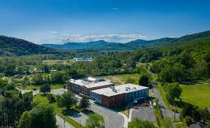
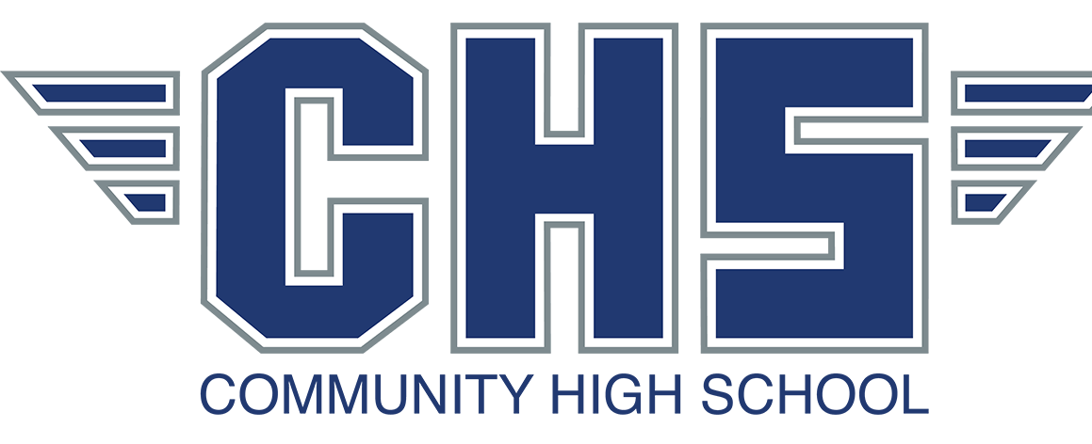
CHS Counseling Department
Beliefs (COSC 660) | Vision (COSC 660)
- All students are capable of learning and being successful  - All students have the right to participate in a comprehensive school counseling program delivered by certified school counseling professionals  - All students should feel safe, valued, and connected within their school community  - All students should be treated as individuals  - School counseling programs should be data driven and designed, implemented, and evaluated based on the needs of the school community  - All students should be respected regardless of race, religion, socioeconomic status, disability, or gender identity/orientation  - School counselors should be advocates for all students | Our students will become successful, responsible citizens in an ever-changing global society.

Mission (COSC 660)
Increase promotion and graduation
Use Technology to Motivate Students.
Differentiate Your Instruction
Use Standards-Based Assessments for Benchmarking Personalize Student learning.
Consider Virtual Options. Host Tutoring Sessions. Build Connections with the
“At Community High School we provide students with equitable opportunities to find their purpose and grow to their full potential in a safe
and caring learning
environment supported by staff, parents, families, and the community.”
https://chs.buncombescho ols.org/o/chs

School support programs will be done in various ways including peer support programs. We believe it to be vital that students learn from each other.
New student support group
Tutoring groups Peer support
groups for struggling students

Community High School
•••
235 Old U.S. 70
Swannanoa, NC 28778
•••
828.686.7734
••• https://chs.buncombeschool s.org/o/chs

Career, Social-Emotional, & Academic & Services
Competencies to Advocate for SC roles
The listed below are what the counselors of CHS will use when working to enhance our professional careers.
- M 1. Every student can learn, and every student can succeed.
- M 5. Effective school counseling is a collaborative process involving school counselors, students, families, teachers, administrators, other school staff and education stakeholders.
- M 7. School counseling programs promote and enhance student academic, career and social/emotional outcomes.
- ASCA School Counselor Professional Standards & Competencies. (n.d.). Retrieved March 27, 2023, from https://www.schoolcounse lor.org/getmedia/a8d59c2 c-51de-4ec3-a565-a3235f3b93c3/SC-Competencies.pdf
Students will be given lessons plans from teachers based on SEL criteria to help them socially and emotionally.
Each week your senior will meet with graduation coach for update on graduation plan and to ensure they are on track.
Scholarship workshops available each month.
Job opportunities posted outside counseling department on bulletin.

School counselors promote equitable treatment of all students by:
Using data to identify gaps in achievement, opportunity and attainment Advocating for rigorous course and higher education for underrepresented groups.
Maintaining professional knowledge of the ever-changing and complex world of students’ culture

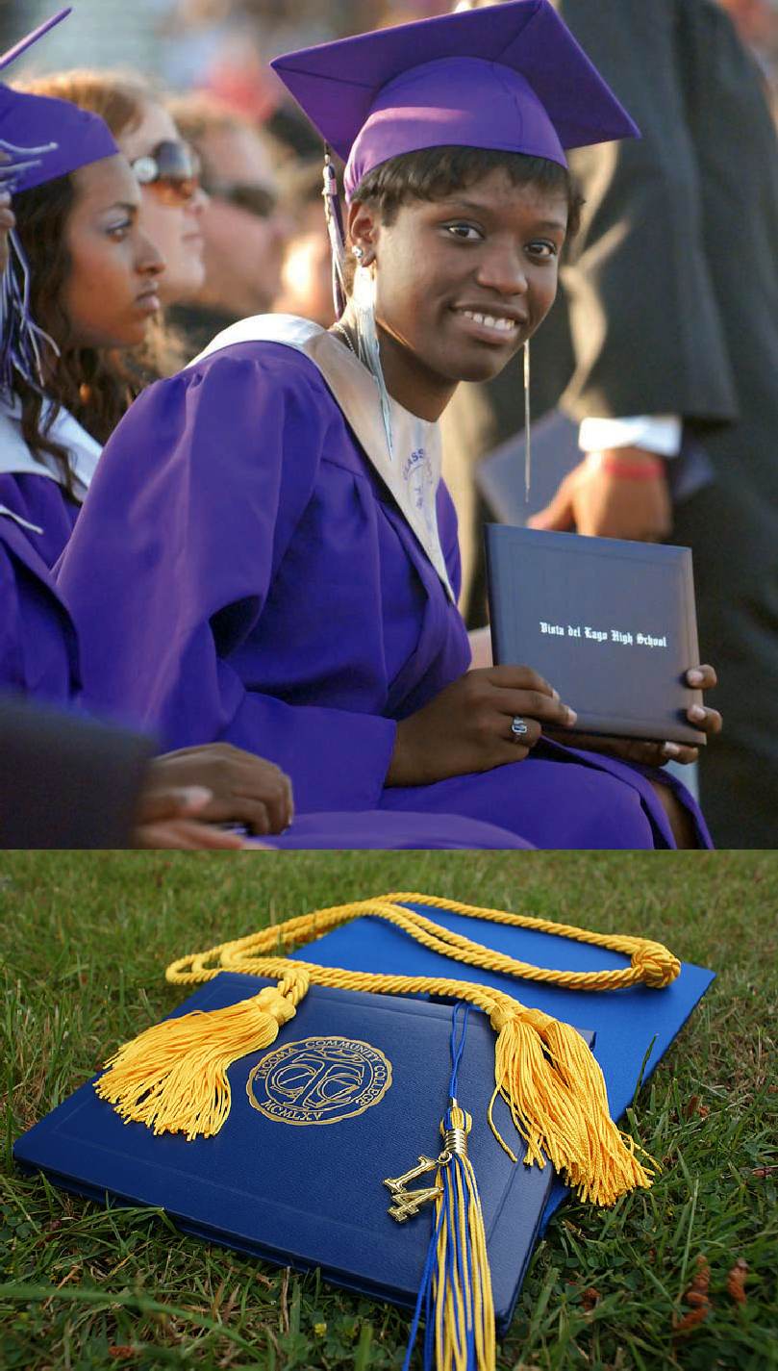
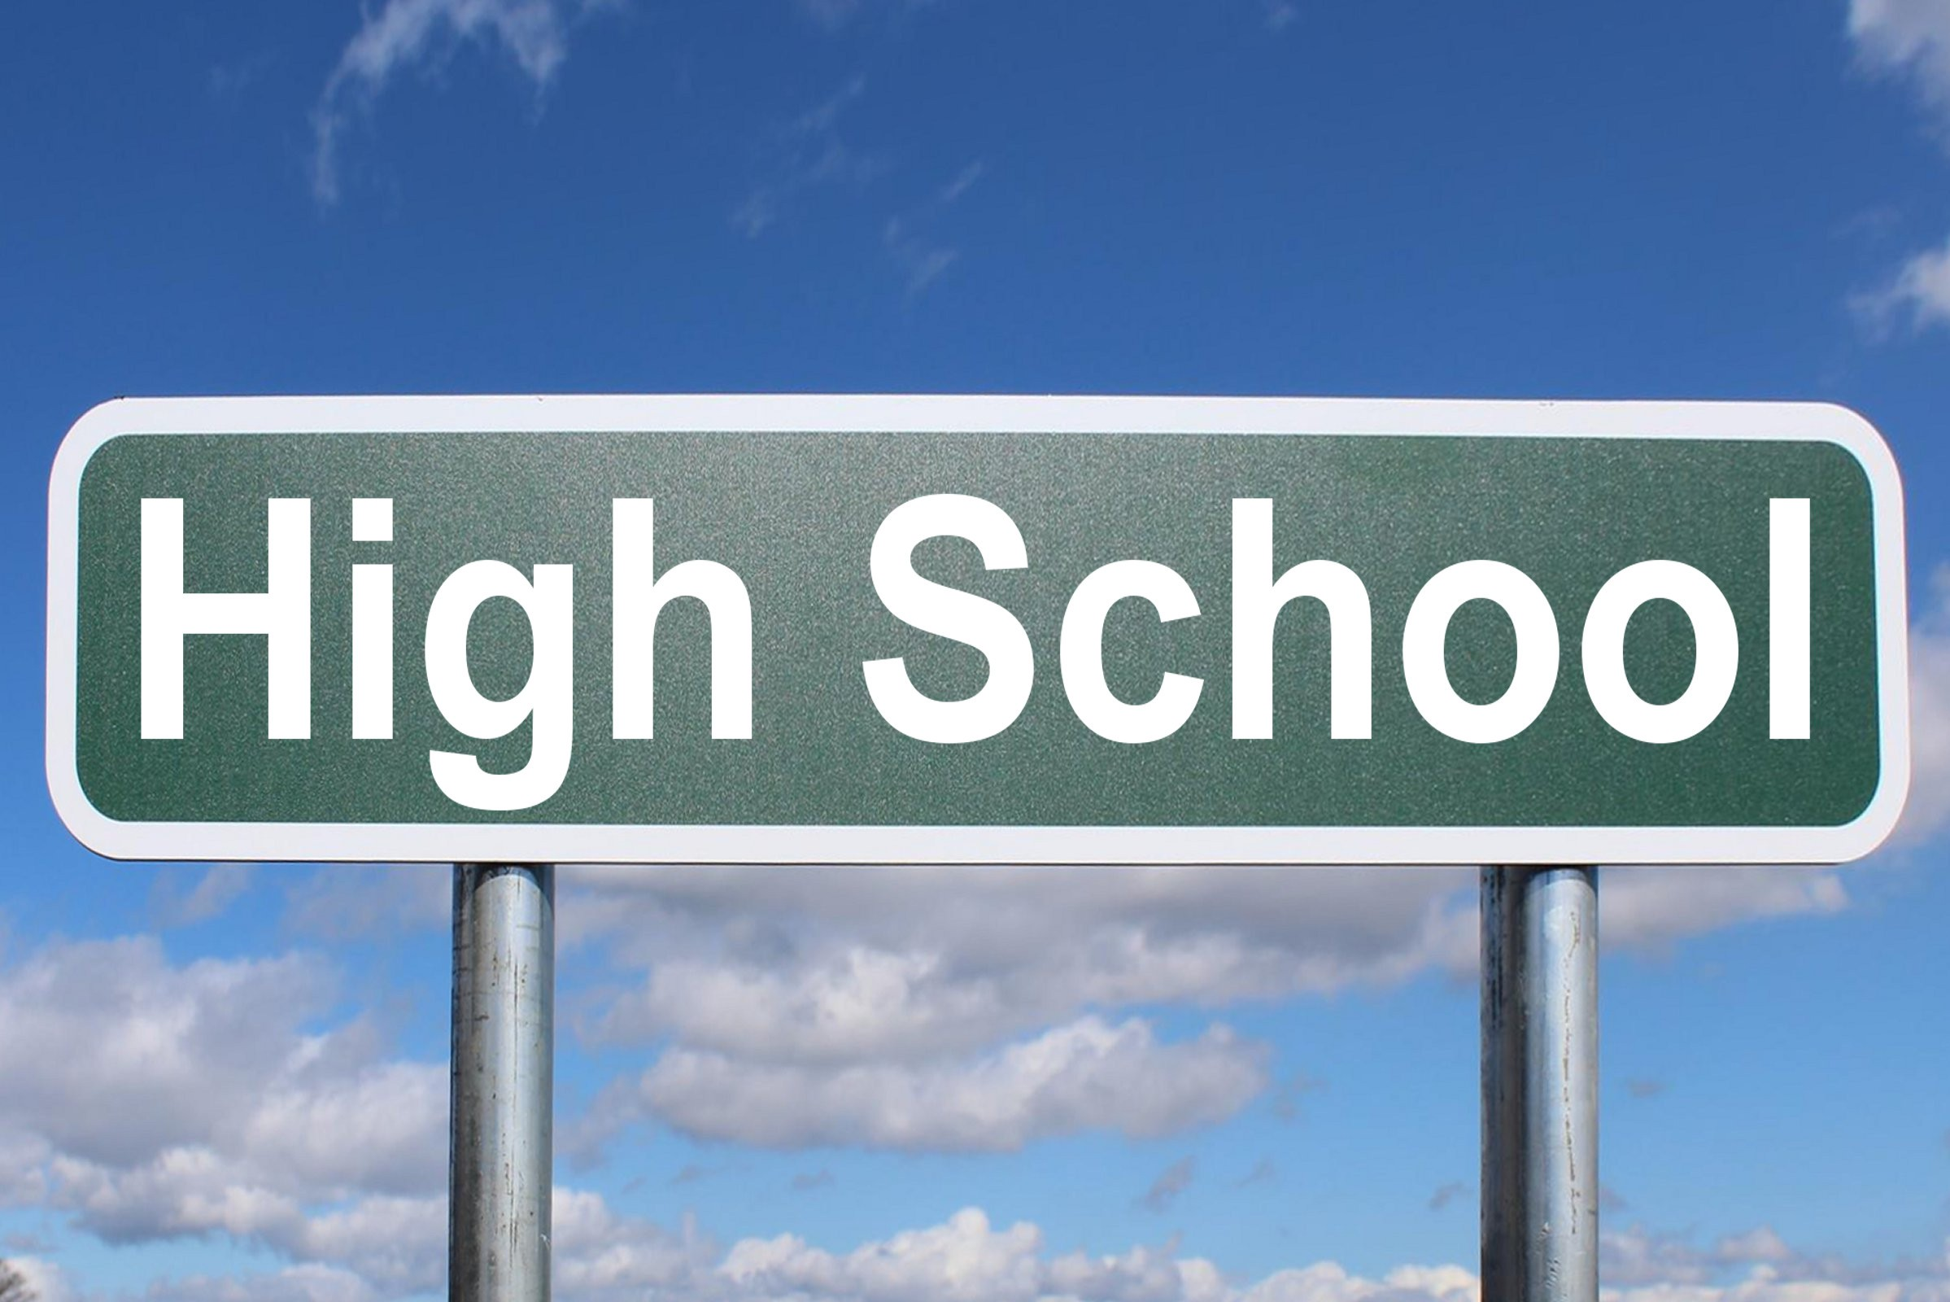
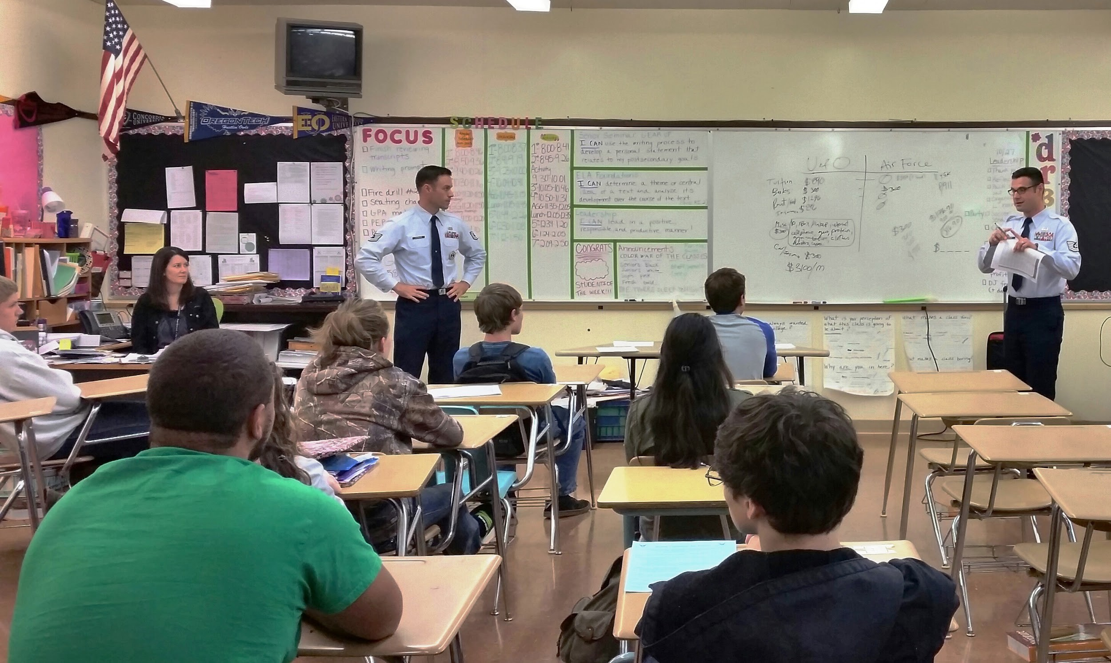
“ Our students will become successful, responsible citizens in an ever-changing global society.”

Direct services are “face-to-face” interactions and include the application of counseling, consultation, or human development skills.
Data will be collected and monitored by student services to ensure that students are being provided services that are productive. We will look to use this data to enhance students as a whole and we will send out updates via newsletters to the families each sunday night on the upcoming events for our school programs.
Indirect services are less directly involved with students and are more involved with schools, boards of directors, etc Individual:
Meet with individual student to address needs, concerns, and barriers to success
Meet with individual student to address attendance and school performance
Check in with student to identify progress (brief contacts)
Group:
Specific topic small group sessions
Academic Study Skills Groups
Peer mediation training with students
Classroom:
Facilitating the implementation of Career or College Day
Presentations to students for

the transition to middle and high school
Bullying prevention classroom guidance collab/consult: Coordination and planning of school wide activities and programs
Creating and maintaining a program calendar Conducting analysis of data to drive program

Module 7

Data Presentation: Needs Assessment Data
COSC 661
David Beachboard

Explanation of Survey
- The purpose of the survey that was sent out is to enhance the school atmosphere and learn the needs from the students as they see it.
- The format that was used was a google form consisting of multiple choice questions as well as a short answer. This was to gain feedback that pertained to the questions about needs in the building through technology to easily gather data.

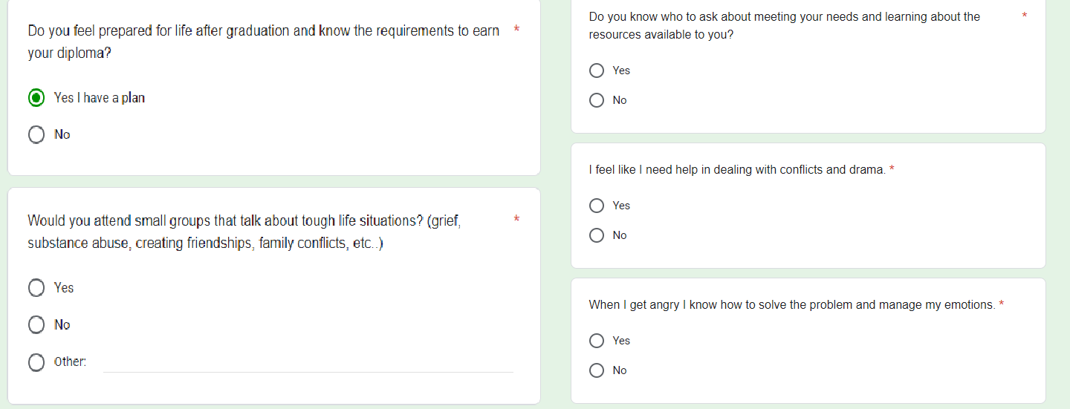
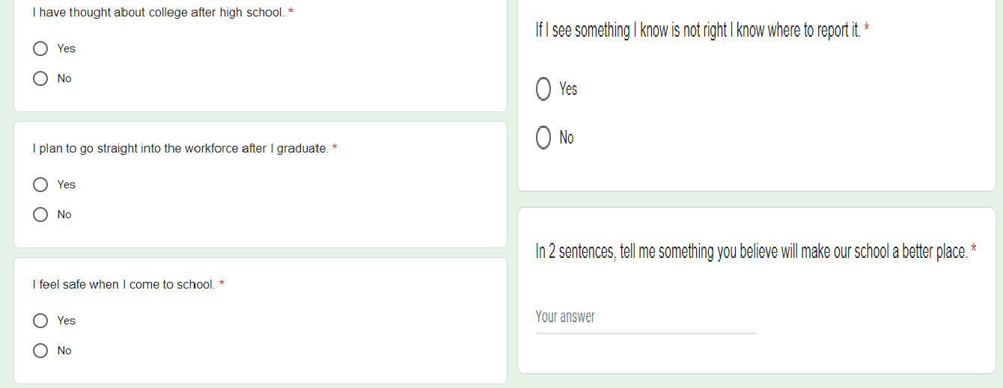
Survey Examples
- Here is an example of the needs assessment questions listed.




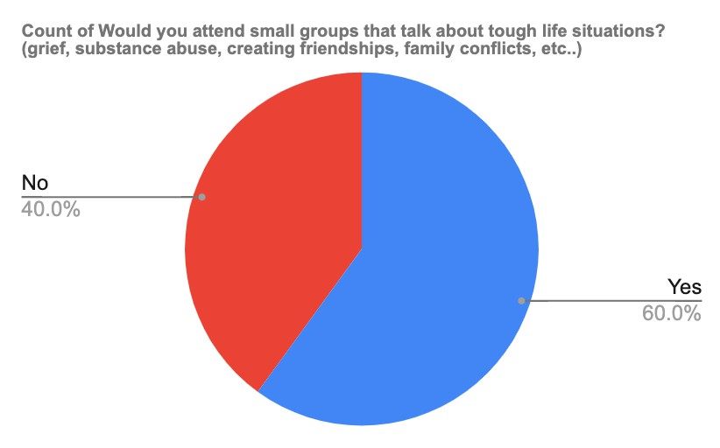
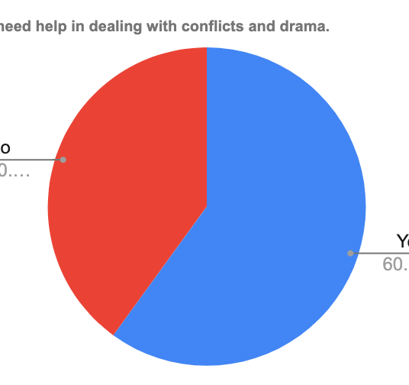
Survey results
Students rated highly in these two options showing the various high needs within the school.

Interpretation of results
- My major takeaways from this data are that students within our school have struggled in dealing with social matters and need a program focusing on the social emotional needs of our students.
  - Students could benefit from small groups
  - Lots of community building activities
  - Enhance culture within the school and have events to build rapport.

Interventions for addressing the need- must include 3 of each. These should be evidence-based.

Direct student services
- Small groups (SEL)
- Resilience classroom lessons
- Classroom workshops for relationship building
Indirect student services
- Community Resources list
- Consultation with parents and teachers to help engage students
- Working with teachers to create SEL friendly lesson plans.

Systemic Focus
  - The systemic inequalities that could interfere come from teachers that may be unwilling to work with us on the SEL plans. This would hinder the learning for all students. The teachers not allowing us to come into the classroom or help plan would hurt the student progression.
    - I would suggest that we work with the teachers during planning periods.
    - Create a workshop that teachers can attend to show evidence and introduce SEL plan.
    - Work with teachers in the classroom to show how this will be effective in everyday classes.

Implementation plan and how you will assess for effectiveness
Assessment plan Must include the following types of data:
- All 125 students will participate as we visit all classrooms over 9-week period.
- ASCA Mindsets ad Behavior data
  - B-SMS 6. Ability to identify and overcome barriers
  - B-SS 2. Positive, respectful and supportive relationships with students who are similar to and different from them
  - B-SS 6. Effective collaboration and cooperation skills
  - These will be measured by the results below showing decrease in referrals and increase in social engagement.
- Student referrals will be measured after implementation to see if they decrease due to drama. Students that are not engaged in class will increase grades due to higher engagement.

ASCA Mindsets and Behaviors
- Which SPECIFIC ASCA Student Standards: Mindsets and Behaviors for Student Success does your implementation plan address? List and discuss the specific standards.
  - B-SMS 6. Ability to identify and overcome barriers
    - Students will be attending small groups that will help them learn strategies that pursue resilience and how to work through difficulty
  - B-SS 2. Positive, respectful and supportive relationships with students who are similar to and different from them
    - Students will engage in activities that are SEL focused to build relationships among peers within the classrooms.
  - B-SS 6. Effective collaboration and cooperation skills
    - Students will engage in working with others to complete lessons based on building teamwork amongst classmates.

Announce
- Teachers/ administration
  - Teachers and Admin will be called to a meeting to announce this program and to highlight the reasoning for implementing this SEL driven intervention
- Parents/ community members
  - Parents will be sent out a phone call and newsletter that will identify the goals of the school through the student service department.
- Students
  - Students will be introduced to this by the counselors visiting the individual classrooms and teaching the students about why this is being implemented as well as how it ties into what they answered.

Use of Data to Advocate for Programs and Students
“Engagement in Early Childhood Education and Care (ECEC) services can strengthen children’s social-emotional and cognitive development, with benefits that persist over time”.. This statement highlights the importance of SEL within the schools and how at an early age it can be successful. This program defined by SEL will be vital to the students lifelong success beyond school (Blewitt et al., 2020).
- I am collecting this data to better the school climate as well as create successful students that are socially and emotional ready for the next step in life.
- I will use this data to help make changes as I see fit to enhance the program or create a new one if it is ineffective.
- I will maintain reliability and look to avoid the implications of teacher buy in, student engagement, and parental involvement by examining each and ways to prevent them from hindering this program.

References
- American School Counselor Association (2021). ASCA Student Standards; Mindsets and Behaviors for Student Success. Alexandria, VA: Author.
- Blewitt, C., O’connor, A., Morris, H., Mousa, A., Bergmeier, H., Nolan, A., ... & Skouteris, H. (2020). Do curriculum-based social and emotional learning programs in early childhood education and care strengthen teacher outcomes? A systematic literature review. International journal of environmental research and public health, 17(3), 1049.
- Chae, N. (2021). Fostering potential: How school counselors can supplement the ASCA Mindsets & Behaviors. Journal of Creativity in Mental Health, 16(4), 428-443.
- Young, A.A., & Kaffenberger, C.J. (2013). Making DATA Work: A Process for Conducting Action Research. Journal of school counseling, 11.

