LESSON 1- science
Subject/Topic: Science- earth and space systems- weather and seasonal changes. | Grade Level: 1st
Lesson Structure or Grouping:  Whole Class ☒ Small Group ☐ 1:1 ☐  Other (specify): Click or tap here to enter text. | Learning Segment Theme:  Science
Resources and Materials:
- Notes sheet
- Power point
- Pencil/ paper
- Notebook
Standards: 1.7 The student will investigate and understand that there are weather and seasonal changes. Key ideas include.
a) changes in temperature, light, and precipitation occur over time
; b) there are relationships between daily weather and the season; and
c) changes in temperature, light, and precipitation affect plants and animals, including humans.

Objective:
The student will learn and understand what each season of the year is and fill out a notes page with 100% participation.
ACADEMIC LANGUAGE DEMANDS
Language Demands: the student will need to know English well and be able to speak and start writing words from the board.

Language Supports: the student will have a notes sheet and power point presented by me to ensure correct terminology. For students struggling with English as their first language, the student will have a one on one in the classroom to help translate and teach the English version of the material.

Essential Vocabulary: the student will need to know the terms, summer, winter, fall, spring, weather, snow, rain, sunshine, and storm.
INSTRUCTION
Direct Instruction/Modeling: at the beginning of the lesson I will start the class by asking if any of the students have heard of the four seasons before. If they have, I will ask which ones they have heard of and what weather goes along with each season. We will go through a power point introducing each season of the year. It will go over what each season is and how to spell it. The students will then practice writing out each season on a piece of paper to practice memorizing the spelling. Then the power point will go over different weather patterns that come with each season of the year.
Guided Practice: for the guided practice portion of class the students will be given a guided notes sheet with fill in the blanks on what the power point will be about. These guided notes sheet will include what each season is, the definition of each season, how to spell it, and the weather that goes along with each season.
Independent Practice: for the independent class time the students will be given a work sheet. On the front side of the worksheet will be blanks for them to practice writing each season out. They will be given multiple blanks to practice their spelling of each season word. The back of the worksheet will be split into four parts. One of winter, spring, fall and summer. They will be asked to draw what kind of weather they would typically see during this season. They can use their notes page they filled out during the guided practice portion of class.
Closure: to close this lesson out we will have a class discussion about the different seasons and what they all include when it comes to weather. This will give me an idea on what each student has learned during the lesson and what they need to work on in the future for the next lesson. They will be asked to place all their materials that they received in class in their folders to move on.
CONNECTION TO RESEARCH
Research Base (Theory): brain pop jr. all about seasons

Research Application to Lesson: this website gives a lot of great content aimed for younger learners. This specific video is about seasons and the weather that goes along with each season. This can be shown at the beginning of the lesson to give them some starter knowledge about what a season is and what goes into each one. It also gives a good terminology for younger learners to understand and comprehend.

APA research citation: BrainPOP JR. (2025). Brainpop.com. https://jr.brainpop.com/topic/seasons

DIFFERENTIATION
Supporting Students with Special Needs: for the students that have special needs the instruction will be the same just with some extra assistants. The students will have assistance filling out the notes page and with practicing writing their seasons. They will be able to draw the weather that goes with the season on their own and give it their creativity.

Challenging Above-Average Students: the students who are above grade level will be asked to do a few extra things that challenge them in their learning. They will be challenged to give me more than one indicator of weather for each season. For example: snow falling, and ice on the ground. This will help them to challenge their brains and what they know.

Facilitating a Classroom Environment that Supports Student Learning: facilitating a classroom environment that supports students learning is very important. To do that for this lesson I will make sure that every student can answer a question or give an example of what they know. I won’t just call on the same students every time. I will also go around and make sure everyone gets the help that they need during the lesson and guided practice. This ensures that their questions are being heard and that I can help them.

Extension: if the student has finished his or her work early and there is still extra time left, they are encouraged to take out a piece of paper and practice writing out the seasons and practice spelling them. if they still have extra time after they can sit quietly until the teacher is ready to move on with the lesson.
ASSESSMENT
Diagnostic/Pre-Assessment: the pre-assessment for this lesson is going to be the discussion before we begin the lesson. The students will be asked if they have heard of the four seasons and if they know any of them. This will give me a gage on what they know before I begin teaching the lesson and what they need to focus on.

Formative Assessment: the formative assessment for this lesson will be the guided notes page that is given to them to fill out during the power point. Since they are so young this is a good way to see them taking direction and to see if they understand how to fill out a notes sheet. They will also be able to keep this and use it to study for the test at the end of the unit.

Summative Assessment: the summative assessment for this lesson will be the worksheet they are given at the end of the lesson. This includes them practicing their spelling of each season with little to no help. It also includes them drawing the weather that goes with each season. For example: drawing a snowy day for winter.

LESSON 2- science
Subject/Topic: Science- earth and space systems- weather and seasonal changes | Grade Level: 1st grade
Lesson Structure or Grouping:  Whole Class ☒ Small Group ☐ 1:1 ☒  Other (specify): Click or tap here to enter text. | Learning Segment Theme:  Science
Resources and Materials:
- Notebook
- Notes given the day before.
- Pencil
- Worksheet for tracking the weather.
- Blank piece of paper
- Coloring utensils (crayons, pens, markers, colored pencils etc.)

Standards:
State:
1.7 The student will investigate and understand that there are weather and seasonal changes. Key ideas include.
a) changes in temperature, light, and precipitation occur over time
; b) there are relationships between daily weather and the season; and
c) changes in temperature, light, and precipitation affect plants and animals, including humans

Objective:
The students will learn to observe and track the current weather outside filling out a worksheet with 100% participation and accuracy.

ACADEMIC LANGUAGE DEMANDS
Language Demands: the student will need to know English well and be able to speak and start writing words from the board.

Language Supports: the student will have their previous notes page from the lesson before. The student will also have their observation page that they will include their essential vocabulary into use for their mini poster and presentation. At the beginning of class, we will briefly go over the things they learned beforehand in the previous lesson that will help them in the current one.

Essential Vocabulary: the essential vocabulary for this lesson will be
- summer, winter, fall, spring, snow, rain, sunshine, storm, weather, and observe.
INSTRUCTION
Direct Instruction/Modeling: for this part of the lesson I will start off the day recapping on what we talked about the day prior. Go over what each season of the year is and what weather pattern goes along with each season. Doing this I can get a gage on what the students have learned through the lesson the other day and what they need to work on more. We will also review the power point again to go over any missed information from the notes page. After, we go over the power point and review we will move onto the guided practice portion of the day.
Guided Practice: for the guided practice in this lesson we will go outside and observe the weather. The students will be given a worksheet with places to write down words that describe the weather outside. Some of the words being used can be sunny or rainy or cloudy. This practice is used to help them try and write down words that they may have not spelt out before. This will also help them to use descriptive words to match with the weather. The last thing this will help with is their observation skills. They have already learned about each season, but now it is time for them to identify what season and what weather goes along with that season.
Independent Practice: for the independent practice portion of the class they will take their observations that they just took from the weather outside and create a poster. This poster will include their name at the top and a title at the top of the page that is engaging. Under the title, the students will write a short sentence that tells their classmates what season they observed outside. Since they are young this sentence will be short and most likely vague. This poster will also include what weather could go along with the season that they are in. For example: if it is summer, it could include a sunny day or maybe go even further with saying that there might be a sun shower during this season. The last thing that they will include in this poster is a picture of their example of the weather from that day. They should include details that they saw outside and use the details that they wrote down on their worksheet provided.
Closure: at the end of the lesson we will present our small posters from the independent practice to a partner. This will give them good practice for when they present items in the future. After they present their posters to a partner, we will end with a class discussion. This will include what they have learned and observed during this portion of the class about weather and seasons. They should have a better understanding about this concept of science through the two days of learning.
CONNECTION TO RESEARCH
Research Base (Theory): introduction to weather. generationgenius.com

Research Application to Lesson: I will use this website to show the kids before the lesson as a little recap of what they learned the night before. This will help them to get into the right mindset and understand more about weather and the seasons.

APA research citation: Introduction to Weather | Science Video For Kids | Grades K-2. (n.d.). Generation Genius. https://www.generationgenius.com/videolessons/introduction-to-weather-video-for-kids/

DIFFERENTIATION
Supporting Students with Special Needs: for the students with special needs they will do the same assignments just a little modified. The students will still review all the concepts of weather and seasons with the class and go outside to observe the weather with their class. If they have a one on one, they can help them to write down things they are observing like plants, weather and the season. For the independent practice they will only be required to draw a picture of their observations. They are required to add details they observed outside.

Challenging Above-Average Students: for the students who are above grade level they will be challenged more than the on-level students. They will be required to think of more descriptive ways to describe the weather and the seasons. They will also be required to try their hardest and write a longer sentence that includes these descriptive words. They can also help students who are struggling with the assignment or instructions and guide them on what to do.

Facilitating a Classroom Environment that Supports Student Learning: facilitating a classroom environment that supports students learning is very important. For this lesson, I will ensure that the students get the help that they need if they are struggling and encourage them throughout the process. I will also push them to be the best that they can be when it comes to new things. They will be observing the weather, and this might be a new skill for. I will make sure that they understand before we go outdoors and help whenever they need since they are so young.

Extension: if the students end their assignments early there will be some extra activities that they can complete. If they claim they are done observing outside I will encourage them to look deeper into things, for example, like looking at if flowers are blooming or if the grass is wet from past rain. This will help them to be more observant and put more detail into their mini poster. If they are done with their mini poster before class time is up they will practice writing sentences using the different seasons. For example: the sun was shining so I knew it was summer, or the wind was blowing, and snow was falling so I knew it was winter.
ASSESSMENT
Diagnostic/Pre-Assessment: the diagnostic assessment for this lesson is the discussion at the beginning of the lesson that goes over what the students have learned in the previous lesson. This gives me a look into what the students need to work on more before including different subjects into the unit.

Formative Assessment: the formative assessment in this lesson is the students observing the weather and writing down adjectives about the season and the weather that goes along with it. This helps them to practice observing what they have learned in the classroom and applying it to real life practice. this also helps them to practice writing out descriptive words that have maybe not ever used before.

Summative Assessment: the summative assessment for this lesson is the mini poster that the students will create at the end of the lesson. This will include an engaging name at the top of the page, the students name, a short sentence about what they have observed and a picture depicting the weather pattern that could go along with that season and some details about what they observed outside.

LESSON 3- math
Subject/Topic: math | Grade Level: 1st grade
Lesson Structure or Grouping:  Whole Class ☒ Small Group ☒ 1:1 ☐  Other (specify): Click or tap here to enter text. | Learning Segment Theme:  Graphing and measuring
Resources and Materials:
- Notebook
- Pencil
- Worksheet
- Items found outside.
- Notes from prior science lessons.
Standards:
State: 1.MG.1 The student will reason mathematically using nonstandard units to measure and compare objects by length, weight, and volume.
a) Use nonstandard units to measure the: i) lengths of two objects (units laid end to end with no gaps or overlaps) and compare the measurements using the terms longer/shorter, taller/shorter, or the same as;
b) Measure the length, weight, or volume of the same object or container with two different units and describe how and why the measurements differ.

National: Measure lengths indirectly and by iterating length units.
Order three objects by length; compare the lengths of two objects indirectly by using a third object
.
Express the length of an object as a whole number of length units, by laying multiple copies of a shorter object (the length unit) end to end; understand that the length measurement of an object is the number of same-size length units that span it with no gaps or overlaps. Limit to contexts where the object being measured is spanned by a whole number of length units with no gaps or overlaps.
Represent and interpret data.
4.Organize, represent, and interpret data with up to three categories; ask and answer questions about the total number of data points, how many in each category, and how many more or less are in one category than in another
Objective:
The student will find objects from outside and measure them with a ruler comparing lengths with 100% accuracy. The student also will observe the weather outside for a week and create a graph depicting what the changes in weather were for the whole seven days with 100% participation.
ACADEMIC LANGUAGE DEMANDS
Language Demands: the student will need to know English well and be able to speak and start writing words from the board.

Language Supports: the students will have their notes from the power point and the worksheets that they will use for their formative and summative assessments. They will also have their

Essential Vocabulary: the essential vocabulary for this lesson will be:
- measurement
- graphing
- weather
- fall, summer, spring, and winter
INSTRUCTION
Direct Instruction/Modeling: at the beginning of the lesson we will go over some of the standards we will be looking at in today’s lesson. This will help the students see what they are utilizing while learning today. Then I will explain to them what the day looks like and what we will be doing. We will then watch a short video about measuring and practice measuring objects around the classroom. We will then go through a power point and fill out a worksheet that will help the students understand measuring more. After we do some practice, we will move onto graphing. We will watch a short video and go through a power point and practice filling in a graph. During the second part of the lesson the students will fill out a notes page going over the logistics of graphing and how to do it.
Guided Practice: for the guided portion of the lesson we will split it into two parts. For the first part we will go outside to gather some objects to compare measurements of. For example: leaves, flowers, sticks, etc. They will gather two or more of the same objects and measure them. they will then put all their data into a worksheet provided for them. The next part of the guided practice will still be held outside, but now with a focus on graphing. The students will split up into groups of 4 or 5 and find multiple objects all different in shape color and size. They will then come together and create a graph categorizing each object.
Independent Practice: for the independent practice of the class I will give them a cut and paste worksheet of different things you would find outside. it also includes a graph on another piece of paper that they will place each object into. It is their job to cut them out and glue them where they belong on the graph. This will help them get more practice on graphing and understand how to do it.
Closure: at the end of the day we will have a class discussion about what they have learned about graphing and measurement. We did a lot during this math class, so I want to end the day with just a discussion about anything they found interesting about the lesson. I will also give them an exit ticket asking what they found the most interesting about today’s lesson with two choices, measurement, or graphing.
CONNECTION TO RESEARCH
Research Base (Theory): graphs for kids. Learn bright. And intro to measurement. Generation genius

Research Application to Lesson: the students will watch both introduction videos to measurement and graphing before taking notes and practicing these skills.

APA research citation: Learn Bright. (2022, March 1). Graphs for Kids | Learn all about basic graphs. Www.youtube.com. https://www.youtube.com/watch?v=bmY28wdGL9M
Intro to Measurements: Weight & Length - Lesson Plan. (2022, January 10). Generation Genius. https://www.generationgenius.com/videolessons/intro-to-measurements-weight-length/

DIFFERENTIATION
Supporting Students with Special Needs: for students who have special needs, they will ultimately be doing the same thing as everyone else but with a few different changes. They will still participate with going outside and collecting objects for their measurements and graphing. They will create a graph with their aid in the classroom and practice measurement with the aid as well.

Challenging Above-Average Students: for the students who are above age level there will be a few changes. They will be challenged to take more items from outside and create a more elaborate graph and measure more items. They will be challenged to write a sentence at the end of finishing their cut and paste about what they have learned today.

Facilitating a Classroom Environment that Supports Student Learning: facilitating a classroom environment that supports students learning is very important. For the students they will have support from me and any classroom aids. They will try their hardest and we will be here to support them in their work.

Extension: if the students have finished their work early they will practice their graphing skills on their own. I will also have a fun coloring page that they can complete if they have finished all of their work assigned that day.
ASSESSMENT
Diagnostic/Pre-Assessment: for the diagnostic assessment we will watch a video at the beginning of class and talk about what they think todays lesson will be. I will then ask them if they have ever heard about graphing or measurement, and we will have a short discussion about the two and this will give me a gage on if they know what any of them are.

Formative Assessment: the formative assessment for this lesson will be the students going outside to retrieve their objects for the graphing and measurement portion of the class. They will then fill out their worksheets for each activity. This will help me to see what they have learned and what they can do better for next time.

Summative Assessment: for the summative portion of class the students will do a cut and paste worksheet of different items they would find outside. They will glue them onto a piece of paper and create a graph from their knowledge about what they have learned about graphing. At the very end of the day, I will give the students an exit ticket asking what they found most interesting from that day, either measurement, or graphing.

LESSON 4
Subject/Topic: English | Grade Level: 1st grade
Lesson Structure or Grouping:  Whole Class ☒ Small Group ☐ 1:1 ☒  Other (specify): Click or tap here to enter text. | Learning Segment Theme:  Weather and seasonal changes
Resources and Materials:
- Book on weather and seasonal changes called Weather and the Seasons by DK
- Notebook
- Graphic organizer
- Pencil
Standards:
State: 1. W The student will write in a variety of forms for diverse audiences and purposes linked to grade one content and texts.
B. Use a combination of drawing, dictating, and writing to compose informative/expository texts that name a topic and supply some facts about the topic and supply some facts about the topic
D. Use a combination of drawing, dictating, and writing about text(s) read or heard in which students share their thinking with a couple of supporting details from the text.
1.C.1 Communication, Listening, and Collaboration
ii. Respectfully building on others’ ideas and expressing their own clearly
iii. Asking questions to seek help, get information, or clarify information for further understanding.
1.7 The student will investigate and understand that there are weather and seasonal changes. Key ideas include.
a) changes in temperature, light, and precipitation occur over time
; b) there are relationships between daily weather and the season; and
c) changes in temperature, light, and precipitation affect plants and animals, including humans.
National: Ask and answer questions about key details in a text.
compare and contrast the adventures and experiences of characters in stories.
Objective:
The student will listen to the reading of the book Weather and the Seasons and give 4 characteristics about weather and the seasons that they learned with a partner with at least 2 facts out of 4 facts correct.
ACADEMIC LANGUAGE DEMANDS
Language Demands: the student will need to know English well and be able to speak and start writing words from the board.
Language Supports: the student will have the book we read in class and then their journal that has their sentences in it. For the students who struggle with English they will be given the book in their first language. They will be encouraged to learn the words in English and start writing sentences in English.
Essential Vocabulary: the student will need to know the terms, summer, winter, fall, spring, weather, snow, rain, sunshine, and storm
INSTRUCTION
Direct Instruction/Modeling:
at the beginning of this lesson we will go over all the notes they have from the previous science lessons on weather and seasonal changes. After that they will all sit on the carpet to do a guided reading of the book Weather and the Seasons. They will sit and listen and think about what the book is about. They will think of 4 facts they learned about this book. One from each season. They will share this with the class, and this will help me to see if they understand the seasons and the weather that goes along with each season.
Guided Practice:
the guided practice will be in their journals. On the board I will write down four prompts, “my favorite part of fall is ______”, “my favorite part about summer is _____”, “my favorite part about winter is ______”, “my favorite part about spring is ______”. They will write down what they want to say in their journals. For example, a student could write “my favorite part about fall is the leaves changing colors.” This will help the students to take what they have learned in the book and start the process of writing
sentences. I will walk around and help them to write their sentences.
Independent Practice:
for the students’ independent practice the students will be given a coloring sheet with a tree. The students will pick a season they like best and color that tree what that season and weather would look like. They will then write two to three sentences about that season and what they like best about that season. This will help them to learn about these seasons and practice writing in full sentences by themselves.
Closure:
for the closing of this lesson the students and I will discuss the characteristics they have learned from the book and from other lessons about weather and the seasons that go along with it. We will go around and each share at least two things they have learned from class today. This will help me to see what they have learned and what they need to work on more.
CONNECTION TO RESEARCH
Research Base (Theory): Weather and the Seasons by DK
Research Application to Lesson:
this book will be read in class and will help the students to begin creating sentences about the season and the weather. This book gives them a good basis on the seasons and the weather that goes along with each season. They will use this book to write sentences about their favorite season utilizing details and characteristics listed within the book.
APA research citation:
Huda Harajli, & Sanders, J. (2020). All about weather: a first weather book for kids. Rockridge Press.

DIFFERENTIATION
Supporting Students with Special Needs:
for the students who have special needs there will be a few accommodations for them during the lesson. if the student needs a one on one, they will have them in the classroom during the entire lesson. they will be able to help with the students in taking notes and creating their sentences. They will do all the same activities, just with some extra assistance.
Challenging Above-Average Students:
to challenge the students who are above grade level they will be challenged to be more descriptive in their guided practice portion of class. They will also be encouraged to write more sentences and use more descriptive words in their independent practice portion of class. This will help them to use their brain and take words in the book and think of longer and harder words to use.
Facilitating a Classroom Environment that Supports Student Learning:
a classroom environment that supports students learning is something you want to be looking for as a teacher and as a student. For this lesson I will make sure the students get all the support they need through my teaching and the material and notes. This will help them to feel more ready for tests/ quizzes that are coming up in the next few weeks.
Extension:
if the students have finished their work early, they will be given a seasons/ weather coloring page. This will help them to differentiate between each season and what weather goes with what season.
ASSESSMENT
Diagnostic/Pre-Assessment:
the diagnostic assessment will be the students and I talking about what they have learned thus far about season and weather. We will also discuss what they don’t know yet. This will give me a better understanding of what they know and what they need to know in the upcoming lessons.
Formative Assessment:
the formative assessment that is aligned with this lesson is the guided sentence writing the students will do. They will be given a guided prompt and asked the fill in what they like best about each season. This will help them to begin writing with bigger words and will help me to see as a teacher what their vocabulary is thus far.
Summative Assessment:
for the summative portion of class the students will be given a sheet of paper with a blank tree on it and asked to pick a season of year. They will be asked to color the tree based off the season they picked. Then they will be asked to write two to three sentences on why they like that season the most and the characteristics that go along with it.

LESSON 5
Subject/Topic: writing and communication | Grade Level: 1st
Lesson Structure or Grouping:  Whole Class ☒ Small Group ☒ 1:1 ☒  Other (specify): Click or tap here to enter text. | Learning Segment Theme:  Weather and seasonal changes
Resources and Materials:
- chrome book
- poster
- Pencil/ writing utensil
- Article
Standards:
State:
1. W.2 Organization and Composition
A. With guidance and support, use a variety of prewriting activities, such as brainstorming, drawing and graphic organizers, to generate ideas and draft writing or dictation
ii. Composing a series of simple sentences focused on the topic, including sentences with a subject and predicate, subject/verb agreement, and one or more descriptive adjectives.
1. W.3 Usage and Mechanics
A. With guidance and support from adults, edit writing for conventions e.g., spelling, capitalization, usage, punctuation). (See Language Usage for grade level expectations)
National:
1. Write opinion pieces in which they introduce the topic or name the book they are writing about, state an opinion, supply a reason for the opinion, and provide some sense of closure
2. Write informative/explanatory texts in which they name a topic, supply some facts about the topic, and provide some sense of closure.
1.7 The student will investigate and understand that there are weather and seasonal changes. Key ideas include
a) changes in temperature, light, and precipitation occur over time
b) there are relationships between daily weather and the season; and
c) changes in temperature, light, and precipitation affect plants and animals, including humans.
Objective:
given the article and information about seasons and weather the student will create a poster detailing characteristics about a specific season with at least 5 characteristics listed. They will then take what they learned from the poster and create a short paragraph utilizing the 5 characteristics with at least 3/5 characteristics correct.
ACADEMIC LANGUAGE DEMANDS
Language Demands:
the student will need to know English well and be able to speak and start writing words from the board, and from the article provided.
Language Supports:
the students will be given an article, and it will be given in English. If this is not their first language, they will be with an ELL teacher who will help translate and teach the English version for each sentence.
Essential Vocabulary:
the student will need to know the terms, summer, winter, fall, spring, weather, snow, rain, sunshine, and storm
INSTRUCTION
Direct Instruction/Modeling:
at the beginning of the lesson we, as a class, will review all that they have learned about the seasons and the weather that goes along with each season. After the review, we will read an educational article that gives details on each season and the different types of weather. The student will take notes on each season and ultimately pick one season that they would like to focus on. After we have finished the article, each student should have notes on each season and have picked a season they think is the most interesting or is their favorite. This will help them to complete the next portion of class.
Guided Practice:
during the guided practice portion of class the students will be creating a poster about that specific season they picked with a group. The groups depend on what season they all picked. Their goal is to create a poster giving as much information as possible about that specific season. This will include their 5 characteristics each student has chosen and illustrations of that season with details. This will include details from the article and should be in quotes if it comes straight from the article.
Independent Practice:
for the independent practice portion of the class the students will take what they have learned from reading the article and creating their posters and write a short paragraph of at least 3- 4 sentences. This will be over the season they chose to focus on for their poster and will include the 5 characteristics they wrote down in their notes they took. I will be there to assist the students if they need but they are encouraged to try on their own before asking for help.
Closure:
at the end of the lesson we will present the posters that they students came up with as a group. This will help me to see what they have learned before reading their short paragraphs. This will also help me to see how their teamwork skills are, and how they work as a group rather than as a whole class or just alone. After everyone presents, we will review each season and get ready to move on.
CONNECTION TO RESEARCH
Research Base (Theory): The Four Season: Change marks the Pass of a Year by Live Science
Research Application to Lesson:
this article will be used by the students to create a poster and then write a short paragraph about the season they like, or think is the most interesting. They will take information from this article to directly quote or use within their paragraph.
APA research citation:
Nola Taylor Redd. (2016, March 22). The Four Seasons: Change Marks the Passing of a Year. Live Science; Live Science. https://www.livescience.com/25202-seasons.html

DIFFERENTIATION
Supporting Students with Special Needs:
for the students who have special needs, the lesson might look a little different. They might have a hard time working in a group or writing their own paragraph so having a one on one there to assist would be recommended. The one-on-one can help them to create a paragraph by writing the sentences down for the student, or if they are unable to create sentences on their own they can have a conversation with the aid to make sure they are learning what is needed to be learned. They are encouraged to try and work in a group for the posters.
Challenging Above-Average Students:
the above average students will be encouraged to use stronger vocabulary in their paragraph than what they have used before. They are encouraged to use more complex synonyms for words they may use too many times within a sentence. If they finish fast, they will be asked to pick a different season and complete the same task. Their second season paragraph will not be graded but is a good practice strategy to help them grow as learners and writers.
Facilitating a Classroom Environment that Supports Student Learning:
creating a classroom that supports student learning is very important. To do this for this lesson would be to walk around the room and ensure that each student understands the assignment and is doing the right work. If they miss a step, they could be doing the wrong thing going forward. I will help them to create sentences if they need and find information through the text for their notes.
Extension:
if the students are done early, they will be encouraged to try writing a paragraph about a different season. This will help them to dive deeper into a different season of the year and give them more opportunity to practice writing.
ASSESSMENT
Diagnostic/Pre-Assessment:
the diagnostic assessment at the beginning of the class will be a discussion with the students about the seasons and the weather. I will ask they what they know and will take one answer from each student. this will help me to see what they students are struggling with and what they already know before going into the lesson.
Formative Assessment:
for the formative assessment part of class the students will be split into groups to create posters explaining each season and why it is important. Each student will choose a season and then be placed with other students who also chose that season. They will use their notes they took while reading the article to create a poster with the required 5 characteristics they took from the article. It should also include a detailed illustration of that season and the weather that goes along with it. At the end of the lesson, they will present their posters to the class.
Summative Assessment:
for the student’s summative assessment they will be required to create a short paragraph of 3-4 sentences describing the season they chose to do their poster on. This should include all the characteristics they wrote down in their notes and details they learned through classmates from creating their poster. This will help me to see what they can do on their own, writing wise, and what they know about the topic of seasons. This will also show me how well they do with starting to take information from an article.

LESSON 6
Subject/Topic: art | Grade Level: 1st
Lesson Structure or Grouping:  Whole Class ☒ Small Group ☐ 1:1 ☒  Other (specify): Click or tap here to enter text. | Learning Segment Theme:  Weather and seasonal changes
Resources and Materials:
- Paint
- Canvas
- Instructions
- Prior knowledge
Standards:
State:
Students will develop skills and techniques for multiple means of expression in visual arts. Students will explore and develop ideas and skills for various media, subject matter, styles, and techniques for visual communication and creative expression
14.Draw from observation.
17. Explore a variety of subject matter.
1.7 The student will investigate and understand that there are weather and seasonal changes. Key ideas include
a) changes in temperature, light, and precipitation occur over time
b) there are relationships between daily weather and the season; and
c) changes in temperature, light, and precipitation affect plants and animals, including humans.
National: N/A
Objective:
The student will create a piece of artwork using paints and other utensils to create a picture of a season with 100% participation.
ACADEMIC LANGUAGE DEMANDS
Language Demands:
the student will need to know English well and be able to speak and start writing words from the board.
Language Supports:
if the student struggles with English they will have an ELL teacher in the class with them helping them to translate and begin teaching English. They will be encouraged to participate and create a piece of art with the rest of the class.
Essential Vocabulary:
the student will need to know the terms, summer, winter, fall, spring, weather, snow, rain, sunshine, and storm.
INSTRUCTION
Direct Instruction/Modeling:
this lesson will be a lot of fun because the students are creating a piece of artwork over their favorite season. At the beginning of the lesson, I will ask the students what their favorite season of the year is and why. They are required to give me some type of reason why they like this season the most. After this we will move onto the guided practice portion of class.
Guided Practice:
for this portion of class we will begin to brainstorm what elements we want to incorporate in each piece of art. I will guide the discussion and ask things like “what do the trees look like at this time of year?” what does the sky look like at this time of year?” etc. These types of question should help the students to see what things they want to add to their painting. I will then show a few pictures on the board of each season to give them ideas on what they could create. The students will write down a few things on a piece of paper they want to see in their piece of artwork. Then we will move onto the independent practice part of class.
Independent Practice:
this part of class will be the students creating their pieces of art. They will have the opportunity to use paints, colored pencils, crayons, or markers to create their art. they will choose their season and sketch what they want on the page first. Then they will have time to color/ paint their piece of art. they are encouraged to add as much detail as possible to their artwork. They can use their notes and their chrome books to research additional pictures of their chosen season.
Closure:
at the end of the lesson each student will go up in front of the class to present their piece of art. they will explain why it is their favorite season and what details they added to the piece of art to depict what the weather might be during this time of year.
CONNECTION TO RESEARCH
Research Base (Theory): Weather Seasons Stock Photos by iStock
Research Application to Lesson:
this website is the website we will use to look up pictures from each season of the year. The students will use this website to find ideas and details that will help them to create a piece of artwork representing one season of year.
APA research citation:
Weather Seasons Stock Photos, Pictures & Royalty-Free Images - iStock. (2025). Istockphoto.com. https://www.istockphoto.com/photos/weather-seasons

DIFFERENTIATION
Supporting Students with Special Needs:
for the students who have special needs they will be able to participate 100% in this lesson. this lesson is based off creativity and every student has creativity. If they are required to have a one on one in the class, they will be present and able to assist with any needs the student has. They will pick a season they like most and create a piece of art using the weather and details about that specific season.
Challenging Above-Average Students:
for the students who are above average in their learning, they will have the opportunity to add more detail to their piece of art. they are encouraged to research more about that specific season and add more color to the trees or more dimension to the plants. They will challenge their creativity and push what they think they can do.
Facilitating a Classroom Environment that Supports Student Learning:
facilitating a classroom environment that supports student learning is a very important thing to remember as a teacher. For this lesson it would be heavily based on me walking around asking if anyone needed help on their sketch or on their final product. I will also be there to give them ideas on what they could added to their artwork to make it more detailed or add creativity.
Extension:
for the students who complete their work before the time is up they will be have the opportunity to free draw quietly at their desk. They can grab a piece of paper and utensils provided to do a free draw of whatever they want.
ASSESSMENT
Diagnostic/Pre-Assessment:
for the diagnostic assessment the students will be asked what their favorite season is and why. They will be required to give details about their favorite season and write them down to help them create their art piece in the next portion of class.
Formative Assessment:
the formative assessment will still be before they begin creating their artwork. This will be a research-based portion of class. As a class, we will brainstorm what they want to include in their piece of art. any details or creative based ideas. They will write these details down and include any more that they want to illustrate in their art.
Summative Assessment:
for the summative assessment portion of class the students will create a piece of artwork that is based off their favorite season of the year. They will use their brainstorming notes and pictures provided to create a piece of art that shows details and characteristics to the weather during this season of year. This will help me to see what the students are able to grasp during their research time and their prior knowledge of the topic of weather and seasonal changes.

LESSON 7
Subject/Topic: writing | Grade Level: 1st
Lesson Structure or Grouping:  Whole Class ☒ Small Group ☐ 1:1 ☐  Other (specify): Click or tap here to enter text. | Learning Segment Theme:  Weather and seasonal changes
Resources and Materials:
- Book about the weather and seasonal changes
- Pencil
- Graphic organizer
- Journal for paragraph
Standards:
State:
1.W.2 Organization and Composition
A. With guidance and support, use a variety of prewriting activities, such as brainstorming, drawing and graphic organizers, to generate ideas and draft writing or dictation
ii. Composing a series of simple sentences focused on the topic, including sentences with a subject and predicate, subject/verb agreement, and one or more descriptive adjectives
1.W.3 Usage and Mechanics
A. With guidance and support from adults, edit writing for conventions e.g., spelling, capitalization, usage, punctuation). (See Language Usage for grade level expectations)
1.7 The student will investigate and understand that there are weather and seasonal changes. Key ideas include
a) changes in temperature, light, and precipitation occur over time
; b) there are relationships between daily weather and the season; and
c) changes in temperature, light, and precipitation affect plants and animals, including humans.
National:
1. Write opinion pieces in which they introduce the topic or name the book they are writing about, state an opinion, supply a reason for the opinion, and provide some sense of closure.
2. Write informative/explanatory texts in which they name a topic, supply some facts about the topic, and provide some sense of closure.
Objective:
Given a book about weather and the seasonal changes the student will write a opinion paragraph including 3 facts about their favorite season with 100% participation and accuracy.
ACADEMIC LANGUAGE DEMANDS
Language Demands:
the student will need to know English well and be able to speak and start to write paragraphs using literature provided in class.
Language Supports:
the student will have a book to read about the weather and seasons. We will read it chorally together and take notes on the subject.
Essential Vocabulary:
: the student will need to know the terms, summer, winter, fall, spring, weather, snow, rain, sunshine, and storm
INSTRUCTION
Direct Instruction/Modeling:
at the beginning of the lesson we will go over what each season is and the weather that correlates with that season. We will have a short discussion about each season. After I will discuss what this lesson will be about and the instructions. the students and I will read a book about the seasons. We will choral read the book and the students are required to remember facts about each season.
Guided Practice:
the guided practice portion of class will include the students’ taking notes on a graphic organizer provided to me. This graphic organizer will include a part for each season of the year. The students will choose three facts to include about their favorite season and write it on the back of their graphic organizer. They will then move onto the independent practice portion of class.
Independent Practice:
the independent practice portion of class will be writing a opinion paragraph about a season of their choice. This will be a 3-4 sentence paragraph. This will help them in their writing abilities and prepare them for more advance work. This will include their 3 facts they chose to write on the back of their graphic organizer. I will be there walking around able to help the students if they need.
Closure:
once the students have finished writing their paragraphs, we will do a short discussion time at the end of class. If they choose they will have the opportunity to share their work. I will be looking for their three facts they chose and if they are accurate to the book and their prior knowledge.
CONNECTION TO RESEARCH
Research Base (Theory): Tree: Seasons Come, Seasons Go by Britta Teckentrup and Patricia Hegarty.
Research Application to Lesson:
this book will be used during the lesson to help students see the different season through a trees leaves. They will read this book and use it to write their notes and paragraph at the end.
APA research citation:
Seasons Come, Seasons Go. (n.d.). https://readwj.wordpress.com/wp-content/uploads/2022/03/seasons-come-seasons-go-britta-teckentrup.pdf

DIFFERENTIATION
Supporting Students with Special Needs:
to support students with special needs will look slightly different than other students in the class. If the student has a one on one they will join the lesson. the one on one will be able to help them write their paragraph and read the book.
Challenging Above-Average Students:
the students who are above grade level the lesson will be the same just with a few extra steps. They will be encouraged to write more than 3-4 sentences in their paragraphs. This will push them to think harder. They will also be encouraged to include more than 3 facts about their favorite season.
Facilitating a Classroom Environment that Supports Student Learning:
a classroom environment that supports students learning is something you want to be looking for as a teacher and as a student. For this lesson I will make sure the students get all the support they need through my teaching and the material and notes. This will help them to feel more ready for tests/ quizzes that are coming up in the next few weeks.
Extension:
once the students have finished their paragraph they will be encouraged to do what the above average grade level students are challenged to do. They will be challenged to add to their paragraph and add more sentences and facts from their book.
ASSESSMENT
Diagnostic/Pre-Assessment:
the pre-assessment for this lesson will be the discussion at the beginning of class. The students and I will discuss what their favorite season is and why. This will show me what prior knowledge the students have and what they need extra assistance on.
Formative Assessment:
the formative assessment for this lesson will be the students filling out their graphic organizer provided by me. This will be a guided notes page for each season. It will also be the three facts they chose about the season they chose on the back of the page. This will show me that they can take information from a book or article and use it.
Summative Assessment:
the summative assessment for this lesson will be the paragraph they wrote on their favorite season. I will be looking for the minimum of 3-4 sentences, the three facts they chose, and why this season is their favorite season.

LESSON 8
Subject/Topic: English | Grade Level: 1st
Lesson Structure or Grouping:  Whole Class ☒ Small Group ☐ 1:1 ☐  Other (specify): Click or tap here to enter text. | Learning Segment Theme:  Weather and seasonal changes
Resources and Materials:
- Pencil
- Graphic organizer (super sentences)
- Notes from previous lessons

Standards:
State:
1.W The student will write in a variety of forms for diverse audiences and purposes linked to grade one content and texts.
B. Use a combination of drawing, dictating, and writing to compose informative/expository texts that name a topic and supply some facts about the topic
D. Use a combination of drawing, dictating, and writing about text(s) read or heard in which students share their thinking with a couple of supporting details from the text
1.C.1 Communication, Listening, and Collaboration
ii. Respectfully building on others’ ideas and expressing their own clearly
iii. Asking questions to seek help, get information, or clarify information for further understanding.
1.7 The student will investigate and understand that there are weather and seasonal changes. Key ideas include
a) changes in temperature, light, and precipitation occur over time
; b) there are relationships between daily weather and the season; and
c) changes in temperature, light, and precipitation affect plants and animals, including humans.
National:
1.Ask and answer questions about key details in a text.
2.Compare and contrast the adventures and experiences of characters in stories.
Objective:
Given the lesson on super sentences the students will begin to take words given by me to create sentences using a subject, verb, where and when in a sentence with 3 out of 5 sentences correct.
ACADEMIC LANGUAGE DEMANDS
Language Demands:
the student will need to know English well and be able to speak and start to write super sentences using information they have learned through the lesson.
Language Supports:
the student will have the book we read in class and then their journal that has their sentences in it. For the students who struggle with English they will be given the book in their first language. They will be encouraged to learn the words in English and start writing sentences in English
Essential Vocabulary:
the student will need to know the terms, summer, winter, fall, spring, weather, snow, rain, sunshine, and storm
INSTRUCTION
Direct Instruction/Modeling:
at the beginning of the lesson the students and I will have a brief discussion about the seasons and the weather pattern that goes along with each season. They will give me some facts about each season. After, we will begin the lesson on super sentences and what they will be required to learn during this time. They will learn what a super sentence is and how to write one. I will show them some examples on the board.
Guided Practice:
for the guided practice portion of class the students will be required to fill out a notes page about what a super sentence is and some components that are included in a super sentence. After, they will practice with me with writing beginner super sentences. These will include a word given by me and they will write a sentence using a verb, subject, where and when. We will practice a few times.
Independent Practice:
for the independent practice portion of class the students will be challenged by writing beginner super sentences on their own. They will be given a graphic organizer with the words snow, summer, and storm. They will have to try on their own and I will be there to help them if needed.
Closure:
at the end of the lesson the students and I will go over what a super sentence is and the parts there are required to know. We will also have a quick discussion about the seasons and the weather that goes along with each season.
CONNECTION TO RESEARCH
Research Base (Theory): Super Sentence Graphic Organizer
Research Application to Lesson:
the students will use this graphic organizer to start writing their super sentences. They will use words pertaining to the seasons and weather to write them.
APA research citation:
Super sentences - Open Up Resources. (2024). Open up Resources. https://www.openupresources.org/?s=super+sentences
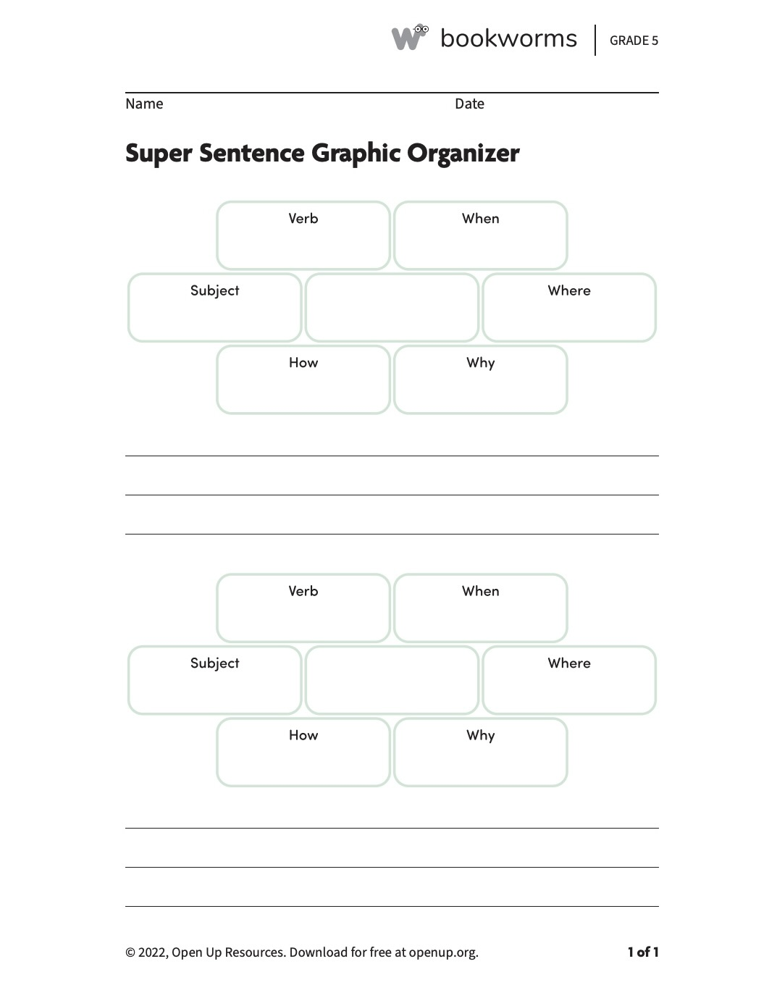

DIFFERENTIATION
Supporting Students with Special Needs:
for the students who have special needs the lesson will look slightly different. If they need a one on one the students will have them to support in class. They will be encouraged to try and learn about super sentences and write them together.
Challenging Above-Average Students:
the students who are above grade level they will be challenged to write more super sentences than what are on the page. They are encouraged to add more detail and information in their sentences.
Facilitating a Classroom Environment that Supports Student Learning:
a classroom environment that supports students learning is something you want to be looking for as a teacher and as a student. For this lesson I will make sure the students get all the support they need through my teaching and the material and notes. This will help them to feel more ready for tests/ quizzes that are coming up in the next few weeks
Extension:
once the students have finished their worksheet they will be encouraged to practice writing more super sentences. Also, they will be encouraged to share their super sentences with a partner and see if they completed it correctly.
ASSESSMENT
Diagnostic/Pre-Assessment:
the diagnostic assessment for this lesson will be at the beginning of the lesson where we will have a short discussion about what we have learned. This will help me to see where the students are with their prior knowledge and what they need to practice more.
Formative Assessment:
the formative assessment for this lesson will be the students taking notes on super sentences and what goes into one. They will also practice writing super sentences with me as a class to see how they are supposed to be written.
Summative Assessment:
the summative assessment will be a worksheet where the students will practice writing super sentences on their own. I will be there to assist if needed, but they are required to try and write them on their own.

LESSON 9
Subject/Topic: math/ virtual | Grade Level: 1st
Lesson Structure or Grouping:  Whole Class ☒ Small Group ☐ 1:1 ☒  Other (specify): Click or tap here to enter text. | Learning Segment Theme:  Weather and seasonal changes
Resources and Materials:
- Chrome book
- Pencil and paper
- Graphing website
- Data collected.

Standards:
State:
1.MG.1 The student will reason mathematically using nonstandard units to measure and compare objects by length, weight, and volume.
a) Use nonstandard units to measure the: i) lengths of two objects (units laid end to end with no gaps or overlaps) and compare the measurements using the terms longer/shorter, taller/shorter, or the same as;
ii) weights of two objects (using a balance scale or a pan scale) and compare the measurements using the terms lighter, heavier, or the same as; and
b) Measure the length, weight, or volume of the same object or container with two different units and describe how and why the measurements differ.
1.MG.2 The student will describe, sort, draw, and name plane figures (circles, triangles, squares, and rectangles), and compose larger plane figures by combining simple plane figures
b) Sort plane figures based on their characteristics (e.g., number of sides, vertices, angles, curved).
e) Recognize and name the angles found in rectangles and squares as right angles.
1.7 The student will investigate and understand that there are weather and seasonal changes. Key ideas include
a) changes in temperature, light, and precipitation occur over time
b) there are relationships between daily weather and the season; and
c) changes in temperature, light, and precipitation affect plants and animals, including humans.
National:
Measure lengths indirectly and by iterating length units
1.Order three objects by length; compare the lengths of two objects indirectly by using a third object
2. Express the length of an object as a whole number of length units, by laying multiple copies of a shorter object (the length unit) end to end; understand that the length measurement of an object is the number of same-size length units that span it with no gaps or overlaps. Limit to contexts where the object being measured is spanned by a whole number of length units with no gaps or overlaps.
Represent and interpret data.
4. Organize, represent, and interpret data with up to three categories; ask and answer questions about the total number of data points, how many in each category, and how many more or less are in one category than in another
Reason with shapes and their attributes.
1. Distinguish between defining attributes (e.g., triangles are closed and three-sided) versus non-defining attributes (e.g., color, orientation, overall size); build and draw shapes to possess defining attributes.
2. Compose two-dimensional shapes (rectangles, squares, trapezoids, triangles, half-circles, and quarter-circles) or three-dimensional shapes (cubes, right rectangular prisms, right circular cones, and right circular cylinders) to create a composite shape, and compose new shapes from the composite shape.
Objective:
Given the data the student have collected the student will input their data into a graphing website to create an object graph with 100% accuracy.
ACADEMIC LANGUAGE DEMANDS
Language Demands:
the student will need to know English well and be able to read and write it.
Language Supports:
the student will have the instructions and assignment details that will help them complete this lesson. this will help them in the future in utilizing technology and learning more.
Essential Vocabulary:
the student will need to know the terms, summer, winter, fall, spring, weather, snow, rain, sunshine, storm, and graph.
INSTRUCTION
Direct Instruction/Modeling:
this lesson will be virtual and the students will complete it on their own. They will be given instructions about the lesson and the website they are required to use. This lesson will be used to help students use technology on their own. They will be required to collect data and create an object graph on a website provided.
Guided Practice:
the guided practice portion of class will be the student collecting their data. The student will be required to collect data about the weather for the next seven days. They will keep track in a journal. They will keep track and on the seventh day they will utilize a graphing website to create a graph about their findings.
Independent Practice:
the independent practice portion of class will be the student using a software that creates graphs utilizing their data findings. They will also write a sentence showing what weather pattern they noticed the most.
Closure:
after the student has finished creating their graph and writing their sentence, they will submit their final project. They will review what they have created and make sure they have done it write.
CONNECTION TO RESEARCH
Research Base (Theory): Free Graph Maker
Research Application to Lesson: .
the students will use this free graph making website to put their findings into a graph. They will observe the weather for seven days and track their findings using this website.
APA research citation:
Live Make charts and reports. (2018, January 16). Visme. https://www.visme.co/graph-maker/

DIFFERENTIATION
Supporting Students with Special Needs:
this lesson will be harder for students who have special needs. They will still be required to observe the weather for the next week and track their findings.
Challenging Above-Average Students:
for the students who are above grade level they will be challenged to write more sentence in their review about the weather. They will also be required to look deeper into the weather and add more detail to their graph.
Facilitating a Classroom Environment that Supports Student Learning:
it will be harder to help the student out in their learning because this lesson is virtual. I will be available to email, but it is on them to read the directions and follow them. we will go over this project in class time and I can answer any other questions they have.
Extension:
if the student wants to go further in their learning, they can write a more detailed sentence about what they have learned during this lesson on graphing. They can also add more detail about the weather into their graph.
ASSESSMENT
Diagnostic/Pre-Assessment:
the pre-assessment for this lesson will be them on their own going over each season and the weather that corresponds with that season. This will help them in collecting their data.
Formative Assessment:
the formative assessment for this lesson will be the students collecting their data for their graph. They are required to observe the weather for the next seven days and write down their findings.
Summative Assessment:
the summative assessment for this lesson will be their final graph and sentence explaining the most common weather pattern their observed. This will help them to practice utilizing technology while also creating a graph.

LESSON 10
Subject/Topic: PE | Grade Level: 1st
Lesson Structure or Grouping:  Whole Class ☒ Small Group ☐ 1:1 ☐  Other (specify): Click or tap here to enter text. | Learning Segment Theme:  Weather and seasonal changes
Resources and Materials:
- Pencil and paper
- Prior knowledge
Standards:
State:
1.3 The student will identify changes in the body that occur during moderate to vigorous physical activity
1.5 The student will identify basic nutrition concepts of energy balance.
a. Explain why the body needs water.
explain that food provides energy for physical
1.7 The student will investigate and understand that there are weather and seasonal changes. Key ideas include
a) changes in temperature, light, and precipitation occur over time
b) there are relationships between daily weather and the season; and
c) changes in temperature, light, and precipitation affect plants and animals, including humans.
National:
N/A
Objective:
Given a hike as a class, the student will be able to observe the weather and seasons and some objects that go along with it with 100% participation.
ACADEMIC LANGUAGE DEMANDS
Language Demands: the student will need to know English well and be able to listen and comprehend directions.
Language Supports:
some supports for language would be me going around asking if studens need any help spelling any words or reading any signs along the way.
Essential Vocabulary:
the student will need to know the terms, summer, winter, fall, spring, weather, snow, rain, sunshine, and storm
INSTRUCTION
Direct Instruction/Modeling:
the students will participate in a field trip today where they will observe the weather and some nature as well. Before we begin we will have a brief discussion about what we have learned so far about weather and the seasonal changes and how this can help us in today’s PE lesson. The students will bring their paper and pencil with them. we will all participate in this hike and take observations in their journal.
Guided Practice:
for the guided practice portion of class the students will be required to write down and observe as many objects as possible they see during their hike. They will observe what the weather is and write that down. Then they will write down as many nature characteristics as they can that correlate with the current weather. For example, if the weather and season is fall maybe you can observe color changing leaves or colder weather.
Independent Practice:
the independent practice portion of class will include the students sharing their findings at the end of the hike. We will circle up and go over what each student found. This will show me that they understand what the directions were.
Closure:
at the end of the lesson and after the students have finished sharing their findings, we will do a head count and get back on the bus. We will head back to the school and finish the rest of the day.
CONNECTION TO RESEARCH
Research Base (Theory):
Hike to Blackwater Creek
Research Application to Lesson:
the students will hike blackwater creek and observe the seasons, weather, and characteristics that go along with the season at the time.
APA research citation:
434 Marketing. (2024, October 17). Trails of Blackwater Creek. Lynchburg Parks & Recreation. https://www.lynchburgparksandrec.com/trails/trails-of-blackwater-creek/

DIFFERENTIATION
Supporting Students with Special Needs:
the students who have special needs will have their one on one with them on the field trip assisting them. if they don’t have a one on one I will assist them in writing down their findings and presenting them at the end.
Challenging Above-Average Students:
the students who are above grade level will be challenged to write a sentence about their findings rather than just writing a word. This will push their brains to use prior knowledge from previous lessons.
Facilitating a Classroom Environment that Supports Student Learning:
a classroom environment that supports students learning is something you want to be looking for as a teacher and as a student. For this lesson, we will not be in the classroom, but outside in nature. I will ensure that each kid is on their best behavior, but also have a good time.
Extension:
the extension for this lesson will be the same as the above average students. They will write a sentence of their findings rather than just a single word.
ASSESSMENT
Diagnostic/Pre-Assessment:
the pre-assessment for this lesson will be at the very beginning before we begin the hike. The discussion will help me to see what prior knowledge they have and help me to get a better understanding of what they need more help on during the lesson.
Formative Assessment:
the formative assessment will be the students collecting their data and observing the weather, season, and objects that help them to know why it is that season. This will show me that they can take their prior knowledge and directions to complete this assignment.
Summative Assessment:
the summative assessment will be the students sharing their findings at the end of the hike. They will circle up and we will go through each students’ findings. This will show me what they have learned today and what help they need in future lessons.

Interdisciplinary Instructional Planning Block Template
 | Day 1 | Day 2 | Day 3 | Day 4 | Day 5
A. Topic | Science | Writing | Reading and research | math | Arts
B. Content Focus Standard | 1.7 The student will investigate and understand that there are weather and seasonal changes. Key ideas include.  a) changes in temperature, light, and precipitation occur over time | 1.W.2 Organization and Composition  ii. Composing a series of simple sentences focused on the topic, including sentences with a subject and predicate, subject/verb agreement, and one or more descriptive adjectives | ii. Respectfully building on others’ ideas and expressing their own clearly. | a) Use nonstandard units to measure the: i) lengths of two objects (units laid end to end with no gaps or overlaps) and compare the measurements using the terms longer/shorter, taller/shorter, or the same as. | Students will develop skills and techniques for multiple means of expression in visual arts. Students will explore and develop ideas and skills for various media, subject matter, styles, and techniques for visual communication and creative expression.
C. Interdisciplinary Standard (Literacy) | B. Use a combination of drawing, dictating, and writing to compose informative/expository texts that name a topic and supply some facts about the topic. | B. Use a combination of drawing, dictating, and writing to compose informative/expository texts that name a topic and supply some facts about the topic. | 1.W The student will write in a variety of forms for diverse audiences and purposes linked to grade one | 1.C.1 Communication, Listening, and Collaboration  ii. Respectfully building on others’ ideas and expressing their own clearly.  iii. Asking questions to seek help, get information, or clarify information for further understanding. | B. Use a combination of drawing, dictating, and writing to compose informative/expository texts that name a topic and supply some facts about the topic.
D. Learning Outcome | Given a lesson on changes in temperature the student will fill out a graphic organizer and observe the weather with 100% participation. | Given an article about changes of temperature the student will write 2 simple sentences about what they learned with 2 out of 2 simple sentences written correctly. | Given their prior knowledge about weather and seasonal changes the student will participate in writing a paragraph with the teacher about what they know with 100% accuracy. | Given a lesson on measurement the student will measure different lengths and heights of objects with 6 out of 8 correctly measured. | Given multiple examples of each season the student will create an art piece based on their favorite season with 100% participation.
E. Instructional Idea | -We will go through a power point about changes in precipitation.  -They will complete an informational graphic organizer that they will keep in their folders.  -We will observe the weather outside and look up what the past seven days have looked like in correlation to precipitation. | -We will read an article about changes in temperature.  They will fill out a notes page.  -They will write 2 simple sentences about changes in temperature.  -They will look in the text to find 2 facts they will utilize in their sentences. | -We will go over all the students notes about weather and seasonal changes.  -Then we will review what are the important parts of a paragraph, and what it all should include.  -We will all as a class write a paragraph going over each season. | -We will go through a power point about measurement.  - we will practice how to compare and measure different objects from outside, like leaves, flowers, and grass.  - the student will practice with a partner on how to measure. | - we will go through a PowerPoint of different examples of what each season could look like.  - the student will pick which season they would like to base their artwork off of.  - they will draw their art first and then color it in at the end.
F. Assessment Idea | The assessments for this lesson will be them observing the weather currently and telling me about the precipitation level. Also, the graphic organizer they will complete. | The assessments for this lesson will be them chorally reading the article with me. Another will be them filling out their graphic organizer for notes. And the last will be their simple sentences. | The assessment for this lesson will be their participation in the creating of the paragraph with me. They will be graded on how much they participate and how accurate the facts are. | The assessments for this lesson will be their engagement with the guided practice. then it will be them practicing on their own. | The assessment for this lesson will be them paying attention and giving me examples of what they would possibly see during each season. Then they will create their artwork and present it to the class.
 | Day 6 | Day 7 | Day 8 | Day 9 | Day 10
A. Topic | Writing | PE/ virtual | Reading and research | Math | Writing
B. Content Focus Standard | .W.2 Organization and Composition  A. With guidance and support, use a variety of prewriting activities, such as brainstorming, drawing and graphic organizers, to generate ideas and draft writing or dictation. | 1.3 The student will identify changes in the body that occur during moderate to vigorous physical activity. | 1.C.1 Communication, Listening, and Collaboration  ii. Respectfully building on others’ ideas and expressing their own clearly. | 1.MG.1 The student will reason mathematically using nonstandard units to measure and compare objects by length, weight, and volume. | ii. Composing a series of simple sentences focused on the topic, including sentences with a subject and predicate, subject/verb agreement, and one or more descriptive adjectives.
C. Interdisciplinary Standard (Literacy) | B. Use a combination of drawing, dictating, and writing to compose informative/expository texts that name a topic and supply some facts about the topic. | B. Use a combination of drawing, dictating, and writing to compose informative/expository texts that name a topic and supply some facts about the topic. | iii. Asking questions to seek help, get information, or clarify information for further understanding. | ii. Respectfully building on others’ ideas and expressing their own clearly.  iii. Asking questions to seek help, get information, or clarify information for further understanding. | B. Use a combination of drawing, dictating, and writing to compose informative/expository texts that name a topic and supply some facts about the topic
D. Learning Outcome | Given an prior knowledge about weather and seasonal changes the student will write an informational paragraph about one assigned season with 2 out of 3 facts correctly stated. | Given physical education instructions the student will take a walk outside and observe the current weather and season and draw what they see with 100% participation. | Given a lesson on synonyms and antonyms the student will complete a graphic organizer with 100 % participation and effort. | Given a lesson on identifying shapes the student will take different weather-related shapes and sort them into categories with little to no error. | Given a lesson on weather and seasonal changes the student will write 3 sentences telling the sequence of a specific season with each sentence including a subject, verb, and one or more descriptive adjectives.
E. Instructional Idea | The student will review notes about weather and seasonal changes.  They will be assigned a specific season and be required to write a short paragraph about that season.  They will use their notes from different lessons for facts.  They are required to use three facts from their notes in their paragraph. | The student will be completing this assignment at home making it virtual.  They will take a walk around their neighborhood or a trail and observe the weather patterns they see.  They will also observe what this weather/season does to our bodies and the changes that it makes.  They will come back home and draw and color a picture showing what they observed outside. | The student will be given a lesson on what a synonym and antonym is.  They will practice with me as the teacher for a few examples.  Then they will be given a graphic organizer to try on their own or with a partner.  They are encouraged to try on their own. | The students will be given a lesson on shapes.  They will cut out different weather-related shapes and place them into categories.  These will be based off of how many sides each shape has.  We will share with the class on how many categories they have and why they placed each item where it is. | The student will have a brief lesson about the weather and seasonal changes.  They will then be assigned a specific season to write about.  They will take what they know and write three simple sentences telling the sequence of that specific season each consisting of a subject, verb, and one or more descriptive adjectives.  They will then share their sentences with a partner.
F. Assessment Idea | The assessments for this lesson will be the students and I discussing each season and the weather pattern that goes along with it. The next assessment will be them writing their paragraph with little to no help from me. | The assessments for this lesson will be them observing the weather outside and how this weather affects our bodies. they will also draw and color a picture that they can bring to class that shows what they observed. | The assessments for this lesson will be when we are practicing as a class. I will be able to see what they have learned without trying on their own. The next assessment will be the graphic organizer provided to the students. | The assessments for this lesson will be the students and I discussing each shape they have learned and how many sides each has. The next assessment will be them cutting and sorting each weather-related shape into the categories they create and presenting at the end of class. | The assessments for this lesson will be the students learning about each season again. The next assessment will be the students writing their three simple sentences about their given season. Each sentence should have a subject, verb, and descriptive adjectives imbedded. The last assessment will be the students sharing their sentences with a partner.

Integrated Unit Plan Template
Grade
2nd

Subjects
History/social science, art, English

Topic
the topics of this unit is to focus on the innovations of the US through transportation and communication. We will focus on the history portion while also focusing on the English and art parts of the unit. All three will go together but will have very different activities and as assessments aligned with the unit.
State Standard(s)
History:
2.2 The student will demonstrate knowledge of the United States by describing important developments and innovations in United States history, including developments and innovations related to communication and transportation.
Art:
2.1 The student will apply creative thinking to artmaking. a) Incorporate unanticipated results of artmaking into works of art. b) Depict imaginary characters, scenes, or experiences.
English:
2.DSR The student will build knowledge and comprehension skills from reading and listening to a range of challenging, content-rich texts. This includes fluently reading and gathering evidence from grade-level complex texts and reading widely (through read alouds) on topics to gain purposeful knowledge and vocabulary.
- When responding to texts through discussion and/or writing, draw several pieces of evidence from read-alouds and grade-level texts to support claims, conclusions, and inferences, including quoting or paraphrasing from texts accurately and tracing where relevant evidence is located (Textual Evidence, K-12).

General Goals
The general goal for this unit is to identify the different developments and innovations created in the US that are incorporated with transportation and communication. Students will build knowledge through reading content rich texts and comprehend skills from reading. They will also apply creative thinking skills into artmaking that depicts characters, and scenery from the texts.
Three Specific Objectives
History:
Given the specific US developments and innovations describing communication and transportation the student will get a score of 18/20 on a multiple-choice test that helps them understand the important facts on this topic.
Art:
Given the concept of artmaking the student will depict the importance of the innovations of the US in communication and transportation through a piece of artwork with 100% participation.
English:
Given the concept of English the student will comprehend and build knowledge from reading and listening to texts on the US innovations on communication and transportation by writing an essay that helps them understand the main ideas with a score of 25/30.
Key Concepts
History:
- To focus on the transportation and communication innovations in the US and what is important about them
Art:
- To create artwork that coincides with the history subject.
- To focus on the transportation and communication innovations that were created in the US and to create artwork that depicts them.
English:
- The English portion of this unit will also go along with the history portion of the unit
- The students will be required to write an essay that explains the importance of each communication and transportation innovation in the US.

Course Map
During this unit the students will learn about the different innovations in transportation and communication in the US. I will split this unit up into time periods. These will be the 17th, 18th, 19th, 20th, and 21st century. They will learn a few innovations for each and complete different activities and assessments throughout the unit.
Unit Map/Unit Duration Planning
 | History/ social science | Art | English
Day #1: | Students will first start by a presentation given by me explaining the different communication and transportation devices used in the 17th century.  These include:  Transportation- horse-drawn carriages, ships, and waterways.  Communication- oral communication, written communication (letters), and the printing press.  Students will write and fill out a notes page catered to these innovations and have a discussion at the end of class about them.  45 minutes | Students will be shown multiple pictures of each transportation and communication innovation.  They will then be encouraged to pick out what they want their art piece to be.  They will plan how they want to draw, color, and name it.  This day will mainly be a planning period for their project.  It will just be on paper using pencils, crayons, colored pencils, and markers.  25 minutes | During this part of class, the students will rely on their notes from the history portion.  They will be required to write a 2-paragraph essay by the end of day 2 explaining the importance of each innovation of the 17th century.  They will be able to collaborate with their neighbor but are required to write the essay on their own.  35 minutes
Day #2: | Students will still learn about the 17th century innovations of communication and transportation in the US.  Today we will finish the power point of notes.  Then the students will be given a matching worksheet that they will fill out with a partner  This matching worksheet will include students to match the definition of the innovation to the picture of it.  At the end of class students will talk and discuss what they have learned and how will it help them in other subject areas.  35 minutes | Students will keep working on their piece of artwork.  They will aim to finish it today.  They should be onto coloring and making their final touches on their piece of artwork.  If the student has not finished their piece of artwork by the end of the period, they will have a few minutes of the next art period to finish it.  30 minutes | During this portion of class students will finish their 2-paragraph essay and put the final touches on it.  It should be checked by the teacher and edited completely.  After they are done writing they will get with a partner and read their essay with one another.  They will discuss the importance of each innovation and share what they think was the most important innovation during this time.  45 minutes
Day #3: | During class today the students will begin to learn about the 18th century innovations of communication and transportation in the US.  These include:  Communication: postal services, newspapers, and letter writing.  Transportation: steamboats, canals, roads, and horse- drawn vehicles.  Like before students will fill out a notes page and discuss the importance of each innovation in the US.  50 minutes | No art class | During this part of the day students will be preparing for a short speech they will make to the class.  Students will research and find what they think is the most important innovation during this period of time.  They will form a persuasive argument that will show their other classmates why their innovation is the most important.  They will use key details from their research and be able to answer different questions I or their classmates might have on the topic.  50 minutes
Day #4: | This class period will be short today.  Students will review their notes and we will have a discussion with the entire class.  The topic of the discussion will be “what is the most important innovation within this time period and why?”  This topic aligns with what they are doing in English and gives them the opportunity to share what they have learned so far.  This will be lowkey and not structured.  It gives them time to express to their classmates what they think is the most important and gives them practice on speaking in front of their peers.  25 minutes | During art students will be shown different pictures of the innovations of this time  They will be given a choice of coloring sheet that aligns with the topic.  They will have the chance to color a  - Steamboat  - Canal  - Road  - Letter  - Newspaper  The hope is to have them more informed about what they will be choosing for their English portion of class.  It helps them get the visual and allows them to be creative to what these innovations looked like at the time.  If time permits, they will be able to do an additional coloring page.  20 minutes | Students will continue to work on their speeches.  Their speech does not have to be any longer than 2-3 minutes.  Once they have finished writing their speech, they will have the chance to practice with a classmate before presenting to the entire class.  We will then move onto the presentations.  If they truly do not want to present to the whole class, I will set aside some time for a one-on-one presentation with just me.  Students are encouraged to ask questions after each presenter.  After everyone has presented students can discuss if they have a different opinion on what is the most important innovation or if their opinions have stayed the same.  1 hour
Day #5: | This next part of the unit will be over the 19th century innovations in communication and transportation.  These innovations include:  Communication: telegraph, telephone, and print media.  Transportation: canals, steamboats, railroads, turnpikes.  During this portion of class students will do individual research to fill out a graphic organizer provided to them by me.  The graphic organizer will include filling in definitions of each innovation, why they are important, and what purpose do they serve to people.  After they are done, we will go over the answers as a class to ensure they have the write notes.  35 minutes | For todays art class I will begin it by showing them pictures of the different innovations during this time.  They will then be given time to create a painting that depicts one or more of these innovations.  For example, students can paint a picture of a telephone. They can also paint a picture of a railroad or steamboat.  It is up to them to be creative and as realistic as possible.  I will be there for any additional help with sketching or drawing the beginning of their painting.  If they do not finish this they will have time in the next art class to finish their painting.  35 minutes | No English class
Day #6: | Students will continue their research over the 19th century innovations.  Once they have finished their notes and research, they will have time to prepare for a short quiz.  This quiz will incorporate all that they have learned so far over the 17th, 18th and 19th century innovations over communications and transportation.  This quiz will have multiple choice, true and false, and matching questions.  It will not be very difficult, but students are encouraged to remember what they have learned in previous days and be prepared for this short quiz.  After this the students will have some time to work on any missing assignments in other classes or subjects.  1 hour | Students will finish up their paintings of their innovation of the 19th century.  Adding final touches and naming their piece of artwork.  They will then be able to free draw or color for the remaining time of class.  20 minutes | Students will be required to look over all their notes from each century they have learned about so far.  They will have to pick one innovation from each century and write a paragraph explaining its use and why it is important to society today.  This will be 3 paragraphs total and if not done in class that day they will be able to finish it in the next class for a few extra minutes.  They will be encouraged to write about different innovations from the previous days.  For example, if they are writing their 17th century innovation if they chose the horse-drawn carriage the first day, to write about a different innovation for this assignment.  1 hour
Day #7: | In class today the students will learn about the 20th century innovations.  These include:  Communication: radio and television, telephone, and newspaper and magazines.  Transportation: automobile, interstate highway system, airplane, railroads, and steam technology.  Students will fill out a notes graphic organizer that I will provide them.  I will review a power point over these specific innovations made during this century.  Students will then complete a cut and paste graphic organizer of the different innovations during the 20th century.  This will be the names of the innovations with pictures that they will cut out and match with the correct name.  1.5 hours. | No art class | Today in English class the students will go over each definition of each innovation during the 20th century.  They will write these definitions on their own piece of paper for their notes.  Then we will play jeopardy as a class on the different innovations during this time and the last ones.  This will help them differentiate between the different innovations and why they are important to today’s society.  This will also help them for their quiz on day 10 over the 20th, and 21st century.  1 hour
Day #8: | This portion of class will not be as long as normal. Students will continue to review and go over their notes of the 20th century.  This time period will be mostly for studying and understanding the different innovations during this time period.  After a short study period we will hold a class discussing about all the things that they have learned about this time period.  The discussion will be about “what makes each innovation different from the other? What are each innovations main purpose?”  30 minutes | Today in art class the students will begin to create a paper mache sculpture of a innovation from the 20th century of their choosing.  They will be required to work in groups of 3-4 students.  They will choose an innovation from this period of time and begin to create their plan for how they will create it.  They can use things around the class and materials provided by me.  Their goal is to make it fun and interesting and to be creative on what they choose and how they will go about it.  I will be around for help if they need.  This period is mainly to plan what they will create and how they will go about it.  1 hour | No English class.
Day #9: | During this portion of the lesson the students will learn about all the different innovations of the 21st century in the US over communications and transportation.  Communications: digital infrastructure, mobile apps and websites, smart city solutions.  Transportation: autonomous vehicles, ride- hailing services (uber, lyft), electric vehicles and zero emissions technologies, drones, high-speed rail, and connected vehicles.  The students will listen and take notes on a power point about the innovations about the communications and transportation in the US in the 21st century. This notes page will be a fill in the blank over the information.  They will fill in the sheet while also taking notes on other information they think is important for their upcoming quiz.  45 minutes | During the art portion of the day the students will continue to work on their paper mache art project with their group.  The students should be mostly finished with their artwork and be putting the final touches on it with their group.  After they are finished with it they will name it and let it sit out to dry.  During the next class they will present their projects to their peers.  45 minutes | Today in class students will have a class discussion about what they think is the most influential innovation from the 21st century.  They will have time to look over their notes and decide what they think.  We will then hold a discussion with the topics of:  “What is the most influential innovation of the 21st century?”  “Why is this the most influential?”  “How does this innovation affect society today?”  Students will have this discussion for about 20 minutes and then have the rest of the time to study for the quiz given the following day.  45 minutes
Day #10: | During the last day of this unit the students will review all that they have learned over the 20th and 21st century.  They will do a matching worksheet over the 21st century innovations to help them prepare for their quiz in English.  30 minutes | During this portion of class, the students will present their paper mache art to their peers.  They are encouraged to present for at least 5 minutes explaining what led them to pick this innovation for their project and tell us all about it.  After each person has presented, they can put their artwork away and if time permits, they can color a coloring sheet or free draw/color for the rest of the time.  45 minutes | In class students will start by reviewing all of their notes from history and English.  They will have the opportunity to ask any last-minute questions right before the quiz.  They will have around 30 minutes to complete the quiz.  This quiz will contain multiple choice, true and false, and matching questions over the 20th and 21st century innovations in communications and transportation.  45 minutes

Unit Launching Activity
The unit launching activity will be them beginning to learn about what they will be learning about. They will get an overview of the unit. They will see that they are learning about the 17th, 18th, 19th, 20th, and 21st century innovations in the US in communications and transportation. I will show them pictures from each century. We will then start to learn about the 17th century innovation and begin our unit there.

Learning Activities
The learning activities for this unit will all differ. Some might be the similar, but all of them will be both engaging and fun for students. Some examples of activities the students will do during this unit are:
- Notes pages
- Matching worksheets
- Small quizzes
- Coloring sheets
- Paper mache art
- Essays
- Speeches
- Games
All these activities will go along with the main unit being innovations in the US over communication and transportation. Students will have the opportunity to work as a class, in small groups, with partners and by themselves on different assignments.

Resources and Materials
During this unit students will be required to use different resource and materials throughout the duration of the time. These will include:
- Paper, notes, worksheets provided by me.
- Writing and coloring utensils (pencils, crayons, colored pencils, pens, markers, paint, paper mache materials.)
- Computer
- Quiz materials
- Jeopardy game
- Coloring sheets
- Power point
- Glue
- Scissors

Curricular Connections
Students will be connecting this unit in History/ social science, art, and English. Each assignment and information provided will correlate to the standards and all have a similar feel. The students are learning about innovations in the US on communications and transportation. Each lesson will have something to do with this. In history the students will learn about each innovation, in art the students will illustrate something that has to do with that innovation, and in English they will write or give a speech about one of these innovations. All of the different subjects will be related in information just having different assignments that go along with it.

Character Principle
During this unit students will learn about all the different innovations in the US over communications and transportation. They will do activities that will help them get out of their comfort zone and see these innovations in different subject areas. Students will have the opportunity to write essays, give speeches, complete worksheets, and create artwork that coincides with this unit. They will be able to develop different skills like speaking, reading and writing during this unit.

LESSON 1
Subject/Topic: Social studies | Grade Level: 1st grade
Lesson Structure or Grouping:  Whole Class ☒ Small Group ☐ 1:1 ☐  Other (specify): Click or tap here to enter text. | Learning Segment Theme:  Barrier breakers- Maggie Walker
Resources and Materials:
- Pencil
- Informational video on Maggie Walker
- Maggie Walker true and false page
- Maggie Walker assessment
Standards:
State: 1.5 The student will apply history and social science skills to describe contributions of Virginia’s diverse people and the stories of changemakers in the history of Virginia and their contributions to our Commonwealth including, but not limited to
d. barrier breakers: John Mercer Langston, Booker T Washington, Maggie L. Walker, Barbara Johns, Arthur R. Ashe jr, and L. Douglas Wilder.
National: N/A
Objective:
Given the informational video on who Maggie walker is the student will take the information and fill out a true or false graphic organizer with 100% accuracy.
INSTRUCTION
Direct Instruction/Modeling:
At the beginning of the lesson I will give a brief overview of who Maggie walker is. I will give facts like
- was born in Virginia
- became the first African American woman to charter and serve as president of a bank in the US in 1903
- started a bank
Then we will watch a short informational video about who Maggie Walker is and why she is an important barrier breaker in America. This will give a brief backstory about her and why she was such an important person in America’s history.
https://www.youtube.com/watch?v=SXk_lXG8UTs
Guided Practice:
We will then move onto the guided practice portion of class which will be a cut and paste graphic organizer. It is true and false based and gives students options that are either true or false about Maggie Walker. I will briefly go over a few of the options and this will give me a gage on if they are understanding the content and information they just learned.
answer key:
- born in Virginia (true)
- born in Georgia (false)
- played tennis (false)
-- was the bank president (true)
- started a bank (true)
- 1st president of the United States (false)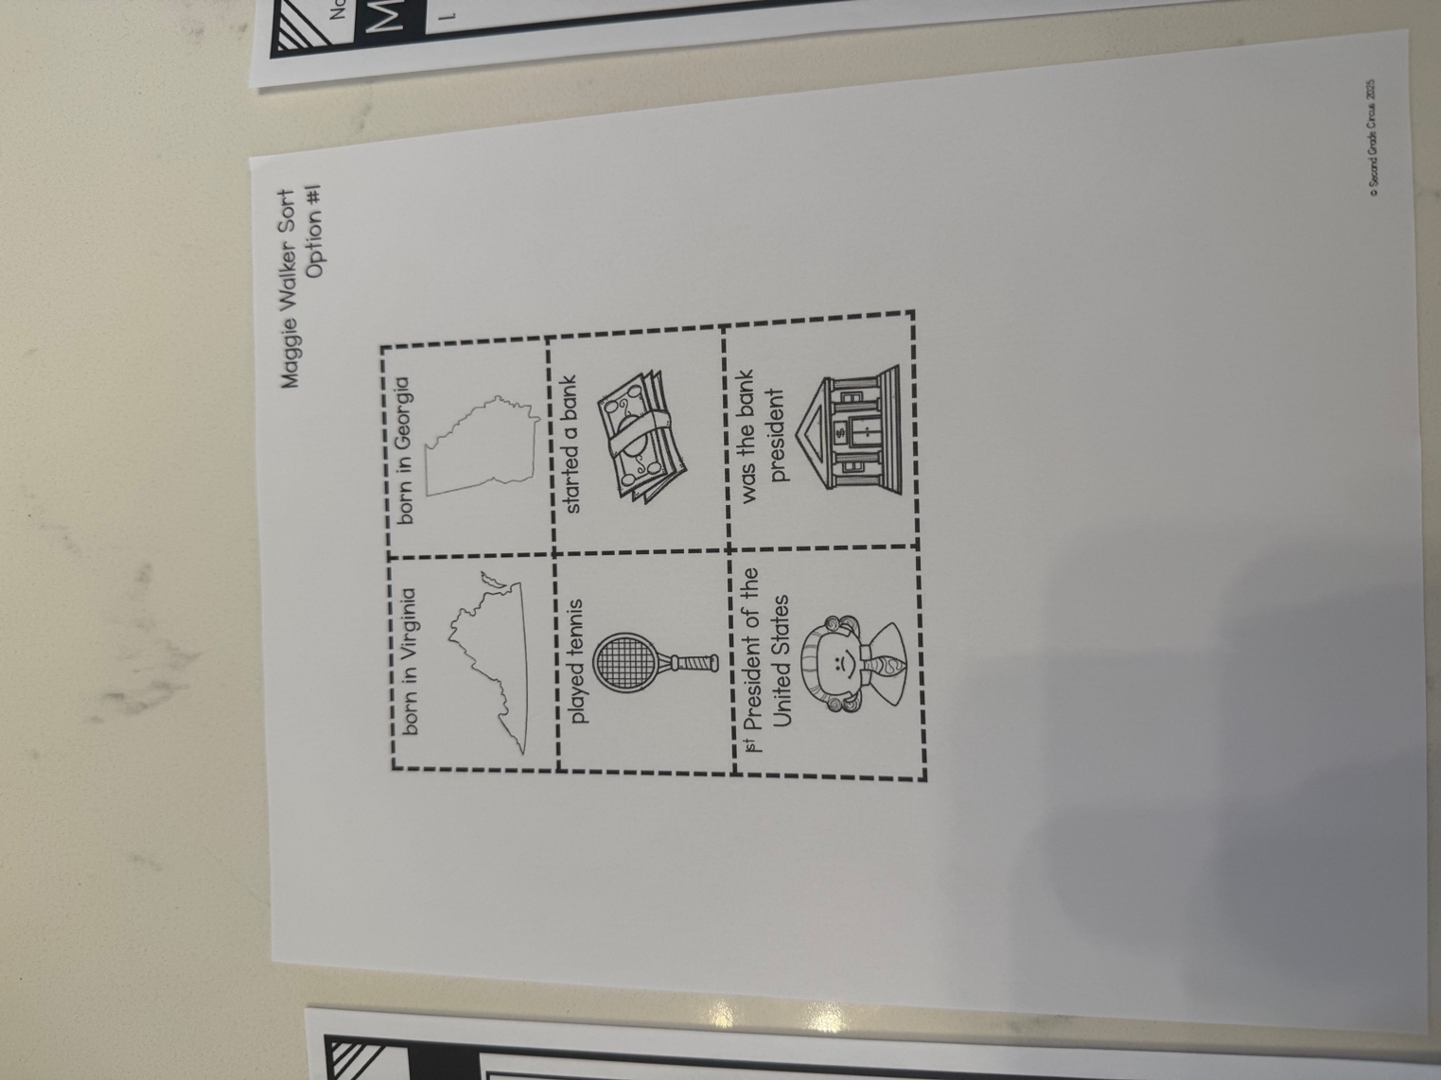
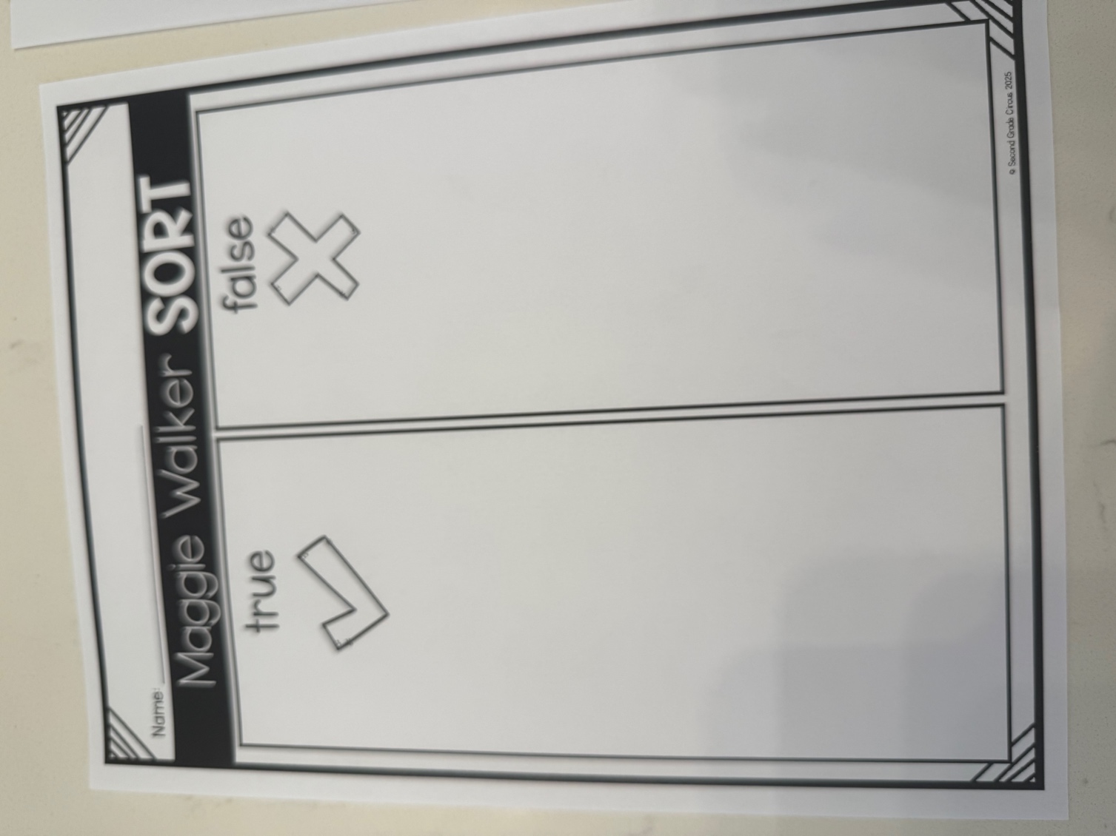
Independent Practice:
Before working on their own we will go over a few of the answer choices given on the sheet to ensure they know what they are doing. Then they will have about 10 minutes to work on their own cutting and pasting the answer choices. Once they have finished, they will turn in their work.
Closure:
After all the students have turned in their work, we will do a short assessment as their exit ticket for the day. I will assist them in taking this assessment. I will ask them the questions and then they will circle the correct answer, based on what they have learned throughout the lesson. I will be taking this assessment as a grade, so they are encouraged to try their best. Once they are done, they will put their name on the paper and turn it in. After everyone has their work, we will do a brief discussion about Maggie Walker and why she is very important in history. 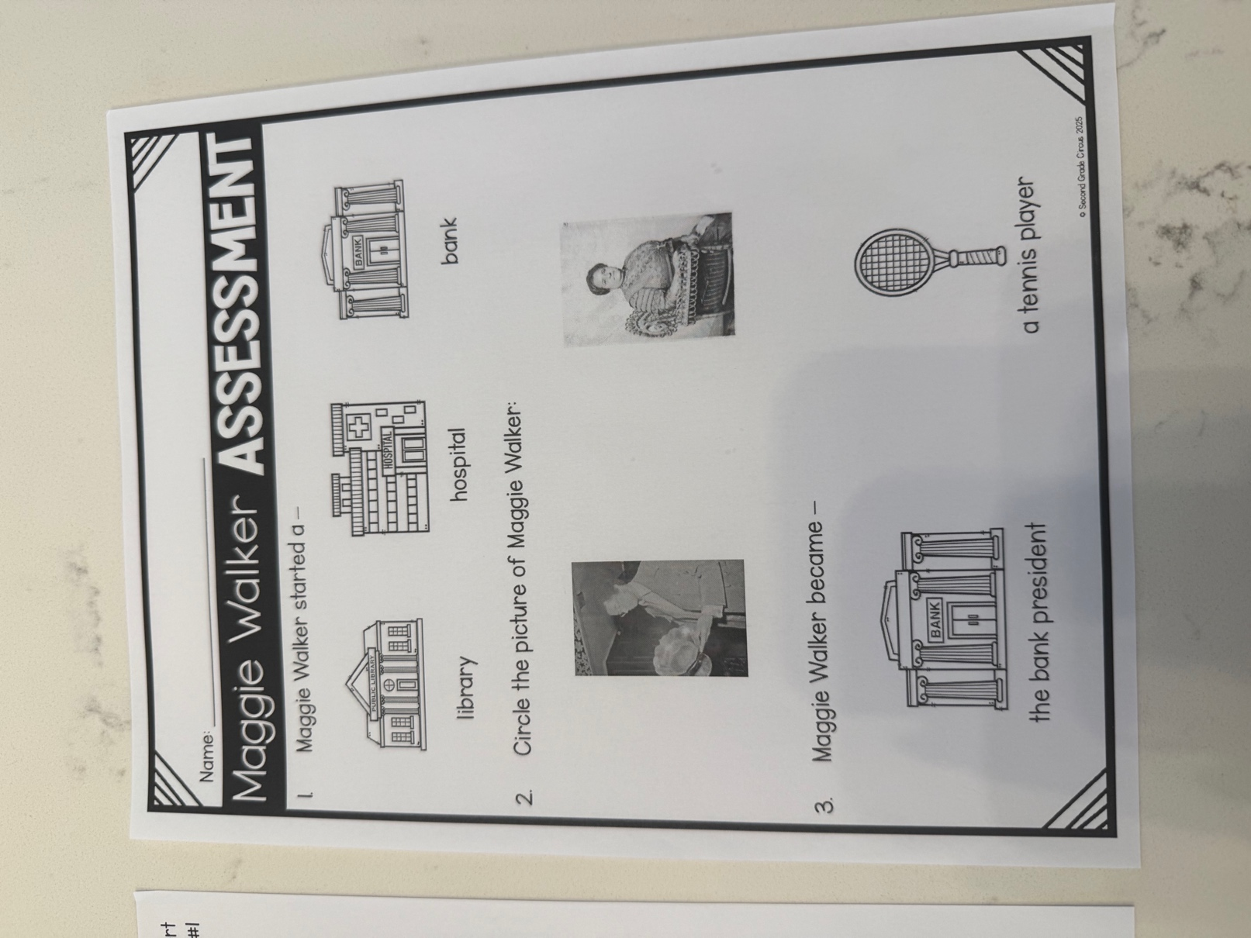
ASSESSMENT
Diagnostic/Pre-Assessment:
for this assessment I will ask if anyone has ever heard of who Maggie Walker is and what she has accomplished in her lifetime. This will give me a gage of if students have any prior knowledge on the topic of Maggie Walker.
Formative Assessment:
the formative assessment for this lesson will be the discussions we have over who she is and what she accomplished. It will also include the cut and paste graphic organizer that they will complete in class. This will show me how much they have learned about this important barrier breaker.
Summative Assessment:
the summative assessment that I will be taking for a grade will be the Maggie Walker assessment given at the end of the class. This is a way for them the show me what they have learned without my assistance. I will read them the questions, but it is up to them to show me what they have learned on the topic.

