Improvement Plan: Part B
Timothy LaGasse
School of Education, Liberty University

Author Note
Timothy LaGasse
I have no known conflict of interest to disclose.
Correspondence concerning this article should be addressed to Timothy LaGasse.
Email: tlagasse@liberty.edu

Data collection & Goals
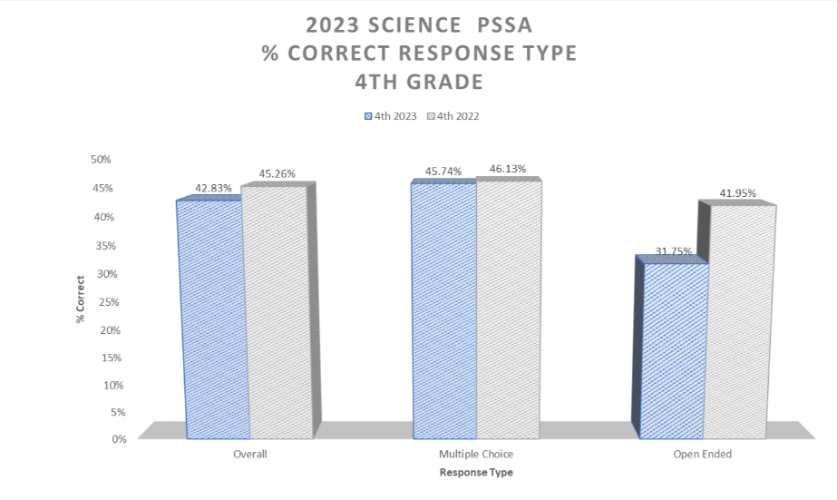
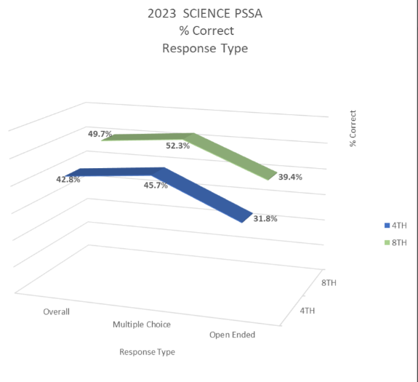
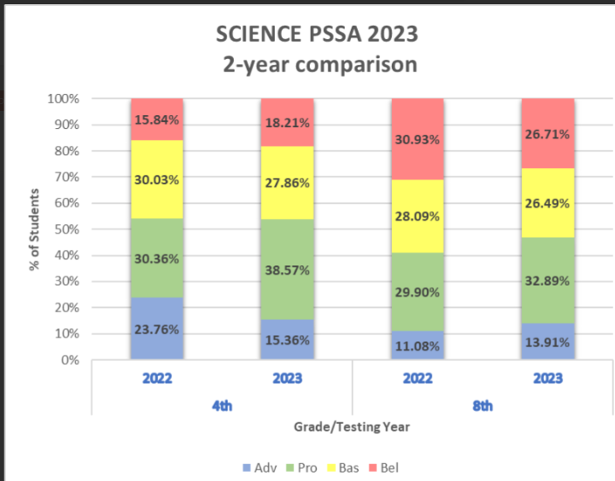
Data Analysis
At Reach Cyber Charter School, our 8th grade science data tells a story that we can’t overlook, being how our students are performing on the open-ended sections of the PSSA. Most of our students scored below proficient, and only about 30% received a score of 3 on the open-ended responses. That shows an apparent struggle when it comes to using what they’ve learned to explain their thinking in writing, which plays a considerable part in scientific literacy.
Attendance data backs this up. When students utilize asynchronous days, they are expected to work independently. However, we see lower engagement with science and writing assignments overall. These are the same tasks we practice in live lessons, and when students are not in class, they lose valuable time practicing these skills that require thoughtful explanation and effort. Many teachers have noticed the same thing and agree that we could use more training to help students use claim evidence-reasoning (CER) in their writing. Without consistent support and resources, it’s tough to give students the tools they need to succeed on these performance-based assessments.
There’s also a gap when it comes to family involvement. Many parents aren’t sure how to support their kids with science writing, and participation in science is low. In a virtual setting, that disconnect becomes even more noticeable. While the flexibility of cyberlearning is a huge plus, we’re missing some of the targeted digital tools that could walk students through how to build solid, structured science responses.
Though this fall in academics, we pride ourselves on building a community and supporting students through all challenges; we’re doing well in behavior and creating a positive classroom environment. Building a strong community is pivotal in reaching our more difficult students and supporting them with encouragement and grace. Through our consistency, we will help break down those barriers to ensure students can succeed and reach their potential. But that’s only part of the picture. If we genuinely want to prepare our students for the PSSA and align with the STEELS standards, we need to focus in on improving how we teach scientific writing. That means better PD, revisiting our curriculum, and building in stronger supports for both students and families. That’s where we’ll start to see real growth.
SMART Goals for School Improvement
- By the end of the 2026 PSSA testing cycle, increase the percentage of 8th grade students scoring a 3 or higher on science open-ended responses from 30% to 45% or higher through targeted writing interventions and CER instructional strategies.
- By December 2025, provide a minimum of three professional development sessions focused on scientific writing and CER strategies for middle school science teachers, with post-PD surveys and lesson plan audits to assess implementation.
- By February 2026, implement a digital CER practice tool or scaffolded writing module across all middle school science classes to provide weekly practice with teacher feedback and real-time analytics on student growth.
- By May 2026, increase family engagement in science writing support by 25% through the introduction of monthly virtual science-writing workshops and parent guides explaining CER writing and how to help at home.

