Legal Entanglement Project: Part 1 – Preliminary Communication and Advocacy Plan

Timothy J LaGasse
School of Education, Liberty University

Author Note
Timothy J LaGasse
I have no known conflict of interest to disclose.
Correspondence concerning this article should be addressed to Timothy J LaGasse. Email: tlagasse@liberty.edu

Legal Entanglement Project: Part 1 – Preliminary Communication and Advocacy Plan
Stakeholder Interview #1
Stakeholder(s) Name(s): Mr. Andrew Hinshaw
Stakeholder Position or Group: Director of Student Safety
Date of Interview: [5/28]
Summary of Interview
Stakeholder feedback highlights the critical importance of robust and well-communicated acceptable use policies for technology in our school. Parents, students, teachers, and administrative staff all recognize these policies' essential role in creating a safe and productive learning environment. Mr. Hinshaw emphasized the necessity of cybersecurity to ensure that students can pursue their education freely and without fear. The insights underscore the need for ongoing education, clarity, and community involvement to adapt to the ever-evolving digital landscape. This collective input underscores the importance of maintaining and updating our policies to ensure they remain relevant and effective in promoting responsible technology use. By incorporating this feedback, we can enhance our policies to protect our school community better and foster a culture of digital citizenship, leading to a more secure and confident digital learning environment.
Follow-Up Communication
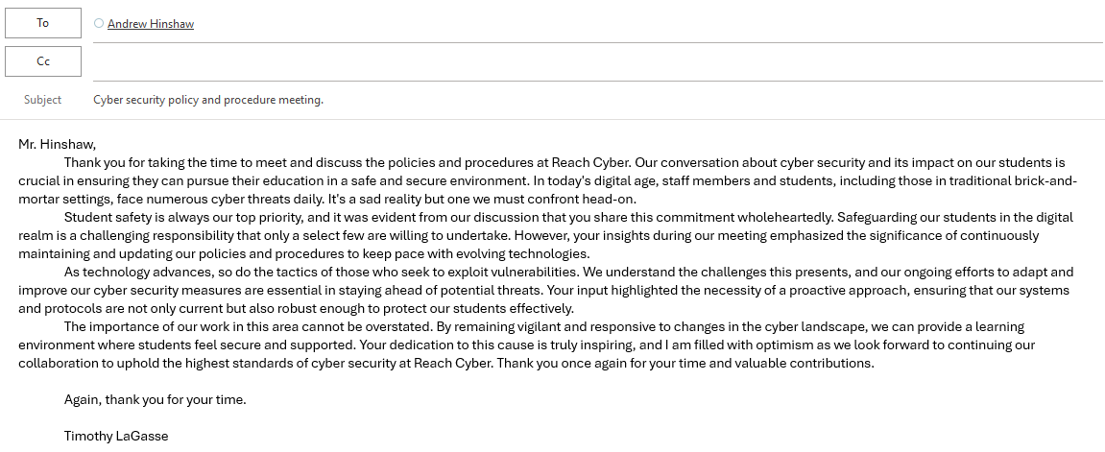

Stakeholder Interview #2
Stakeholder(s) Name(s): Elyse Goodman
Stakeholder Position or Group: Elementary Electives Department Chair
Date of Interview: 5/30
Summary of Interview
The feedback from our valued stakeholders plays a pivotal role in shaping the acceptable use of technology policy. Their emphasis on making the policy more accessible and understandable for younger students through the use of simpler language and visual aids is a testament to the collaborative nature of our policy development. This approach ensures that all students can effectively grasp the guidelines, thereby reinforcing the policy's meaningfulness in promoting safe and responsible technology use.
Moreover, the stakeholder's suggestion to incorporate more positive reinforcement alongside clear consequences is a key aspect of our policy. This approach underscores our aim to create a balanced and supportive environment. By recognizing and rewarding good behavior, we can motivate students to adhere to the guidelines, thereby reinforcing the policy's significance in fostering a positive digital culture.
The stakeholder also pointed out the necessity for regular workshops and training sessions for teachers and parents, illustrating how crucial it is for the entire school community to be informed and involved. This recommendation supports the meaningfulness of the policy by ensuring consistent and comprehensive guidance for students from both educators and parents.
Finally, integrating digital citizenship into the curriculum was suggested to deepen students' understanding of technology use. This approach helps students follow the rules and cultivates a responsible and informed attitude toward technology, further enhancing the policy's significance in the educational experience.
Overall, the feedback clearly supports the idea that the acceptable use of technology policy is significant and meaningful, providing a robust framework for safe, responsible, and positive technology use in the school environment.
Follow-Up Communication
